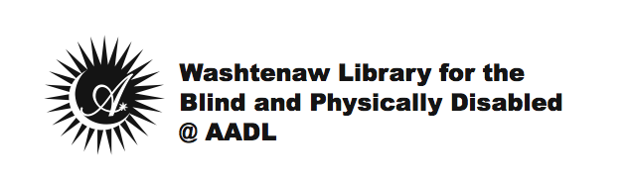

Date

Dear Patron,

Thank you for using WLBPD@AADL! We’re glad to see you’re actively circulating materials, and we want to make sure that you continue getting the most out of that experience. In order to do this, occasionally WLBPD@AADL staff may call to see how things are working out for you. Unfortunately, our most recent attempt to contact you was unsuccessful.

In order that we may better serve you, and to update your account information, we would like to encourage you to please call (734) 327-4209; or if you prefer, you may email us at: wlbpd@aadl.org.

Thanks again for using WLBPD@AADL and we look forward to hearing from you!

Sincerely,

Washtenaw Library for the Blind & Physically Disabled @
Ann Arbor District Library

