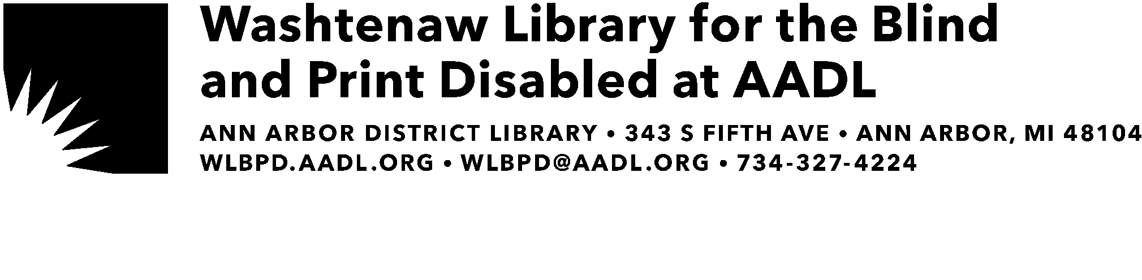

05/5/2025

Dear :

We are contacting you regarding your account with the Washtenaw Library for the Blind and Print Disabled. Your account status has been inactivated because you have not checked out or downloaded a book in a year.

To reactivate your account, please contact the library at 734-327-4224 to order a book, or to sign up for the free BARD Mobile App to download books directly.

We look forward to serving you in the future.

Sincerely,

WLBPD Staff