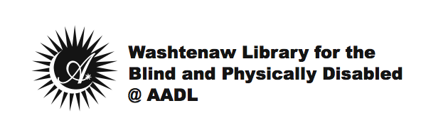
Date

Dear Patron,

In order to maintain an “Active” status as a member of the WLBPD@AADL, it is required that you check out materials at least one time during the previous twelve-month period.

You’re receiving this letter today because our records indicate you have not checked out any materials or subscribed to a magazine in at least the last twelve months. Additionally, all attempts to reach you by phone to update your account have been unsuccessful. For these reasons, your account has been set to “Inactive.”

An Inactive status means that you will no longer receive any materials or correspondence from WLBPD@AADL, and if after five years your account has not been “Re-activated” you will be required to re-apply to receive services again.

If you no longer wish to receive services through the WLBPD@AADL and you still have books or equipment in your possession, please return them as soon as possible. If you require return labels or boxes, please call (734) 327-4209; or you may also request these items by emailing wlbpd@aadl.org.

If you believe you received this notice in error, or if you would like to update your contact information and “Re-activate” your account, please call (734) 327-4209, or email wlbpd@aadl.org, and we will be happy to assist you!

Sincerely,

Washtenaw Library for the Blind & Physically Disabled @
Ann Arbor District Library

