Agenda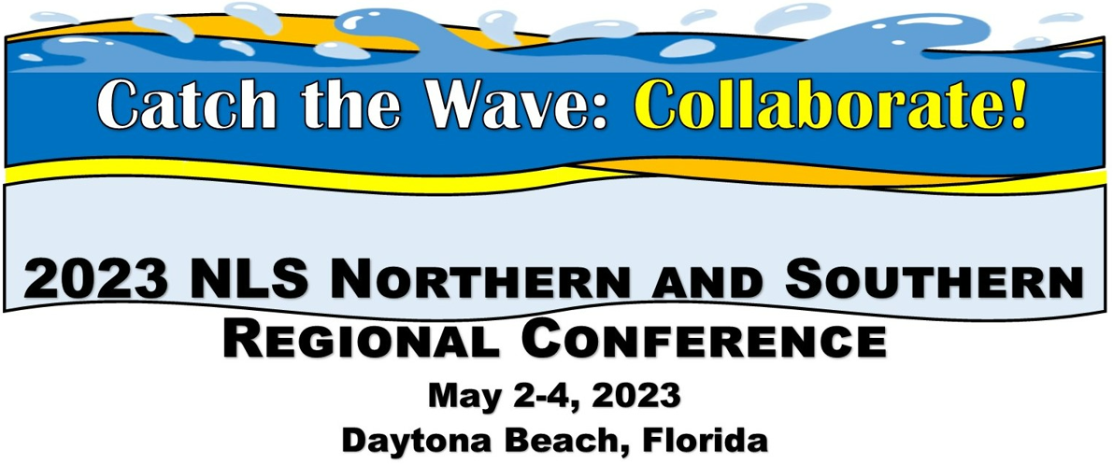
Location: The Shores Resort and Spa, 2637 South Atlantic Avenue, Daytona Beach Shores, FL 32118

Tuesday May 2:
Preconference activity: Post on Surfing for Answers challenge board
8:00 Breakfast with Colleagues, provided. Registration table open
9:00 Welcome remarks State Librarian of Florida Amy Johnson; Message from Sec. of State Cord Byrd (tentative); or DOE Division of Blind Services Director Robert Doyle III, Deputy Director NLS Jason Yasner
9:30 Roll Call of states
10:00 NLS updates: Jason Yasner, Steve Prine, MaryBeth Wise, Meredith Beckhardt
10:45 Break
11:00 Speed Networking
12:00: Lunch Provided at the FL Braille and Talking Book Library, and Tour
2:00 NLS: Wave of Equipment. Includes DS1 and DA1 basic repair and operation, updates on inventory, and special sneak peak of the DA2! E Readers introduced. Led by Joseph Dorsey, Kevin Watson.
Back to Hotel
3:00 (Panel) Wave of Support: Ereader Examined. Network led. Includes lessons learned on distribution, ways to maximize use, encourage braille literacy, etc. (Angela Fisher Hall, AL, Barbara Penegor and Tracey Mania, KY)
3:30 Break
3:45 (Presentation/ Panel) Turn the Tide: Youth Engagement! (Call for network presenters, panel includes Donna Koh)
4:30 – 5:00 Tidepool: Q and A session with NLS Staff and Network Consultant

6:00 Welcome reception and dinner, provided. (blind services advocate Paul Kurtz, speaker, trumpeter will perform)

Wednesday May 3:

8:00 Breakfast with Colleagues, provided.
9:00 -(Panel) -Wave of Success: Remote Strategies. Includes best practices for Remote programming, Hybrid programming, and creating digital communities.
10:00 Turn the Tide: Best of what's new in tech (call for network presenters, Jason Yasner NLS)
10:30 Turn the Tide: Podcasting in Libraries (Craig Hayward NC)
11:15 Break
11:30 ILS meetups (KLAS and WebReads)
12:30 Lunch provided.
1:45 - NLS: Summer Reading (Donna Koh, NLS, Mary Beth Parks, PA, and LaShawn Myles, MD)
2:30 - (Panel)- Wave of Information: Outreach Initiatives includes remote outreach, new approaches that worked, proven success stories (Sarah Smedley, FL) (call for presenters)
3:15 Brain Coral Roundtable: Call for presenters, moderators
1. Applications Digital from the Start and Electronic Storage; Steve Prine for NLS plan
2.Tactiles in the Library (Mark Lee and Steven McMillan PA)
3. Leads session with Meredith Beckhardt
3:45 -break
4:00 (Panel) Turn the Tide: Programming. Panel including NLS and presenters from the networks (Pandemic and beyond, Sarah Smedley, FL) (call for more presenters)
4:30: Regional conference business meetings
5:00: Tidepool: Q&A with NLS staff and Network Consultant
5:30 end

Thursday May 4:
8:00 Breakfast with Colleagues, provided.
9:00 Brain Coral Roundtable: Call for presenters, moderators
1. NLS: Advanced Machine Repair and Other Topics battery life, etc. Joseph Dorsey, Kevin Watson, NLS
2. Planning a conference of disabled authors
3. Collaborative programming across network libraries and cross-advertising initiatives.
9:30: NFB Newsline updates
10:00 Local author keynote: TBA
11:00: Break
11:15 Treading Water: Surfing for Answers Selection of topics for discussion (collected on board from start of conference).
11:45 Open Waters: Small group discussion tables, discuss the solutions to “Treading Water”.
12:45: Closing Remarks
1:00 - END.

