Agenda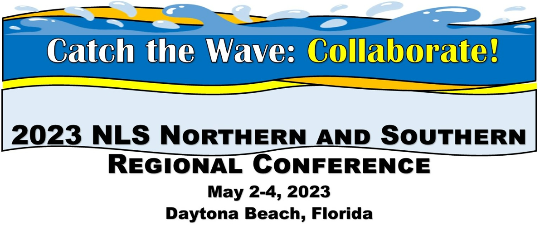
Location: The Shores Resort and Spa, 2637 South Atlantic Avenue, Daytona Beach Shores, FL 32118

Tuesday May 2:
Preconference activity: Post on Surfing for Answers question board

8:00 Breakfast with Colleagues, provided. Registration table open
9:00 Welcome remarks State Librarian of Florida Amy Johnson; Message from Sec. of State Cord Byrd (tentative); Deputy Director NLS Jason Yasner
9:30 Roll Call of states
10:00 NLS updates: Jason Yasner, Steve Prine, MaryBeth Wise, Meredith Beckhardt
10:45 Break
11:00-11:45 Speed Networking
Bus loads at Noon
12:15-1:15: Lunch Provided at the FL Braille and Talking Book Library, and Tour
2:00-2:30 NLS: Wave of Equipment. Includes DS1 and DA1 basic repair and operation, updates on inventory, the DA2! E Readers introduced. Joseph Dorsey, Kevin Watson.
Back to Hotel
3:15 (Panel) Wave of Support: Ereader Examined. Network led. Includes lessons learned on distribution, ways to maximize use, encourage braille literacy, etc. (Angela Fisher Hall, AL, Tracey Mania, KY, Kim Charlson Perkins)
3:45 Break
3:45 (Presentation) Standards and Guidelines of Service Revision (Steve Prine, NLS, and Mark Lee, PA) Listen for thoughts from the working group, and bring your recommendations!
4:30 – 5:00 Tidepool: Q and A session with NLS Staff and Network Consultant

6:00 Welcome reception and dinner, provided. (blind services advocate Paul Kurtz, speaker, trumpeter will perform)

Wednesday May 3:

8:00 Breakfast with Colleagues, provided.
9:00-9:30 -(Panel) -Wave of Success: Programming. Presenters from the networks (Pandemic and beyond, Sarah Smedley, FL) (call for more presenters).
9:30- 10:30 (Panel) Barrier Reef: Subject Headings Maureen Dorosinski FL and Barbara Penegor KY. Description of current cataloging practices for KLAS and WebREADS in different size libraries and how to surmount the challenges posed by the future of NLS cataloging. Bring your comments!
10:30-11:15 Turn the Tide: Podcasting in Libraries (Craig Hayward, NC) Ever wonder if a podcast would be something your library could do? The next wave could be an NLS library podcast network. Hear how you can break into this new content offering.
11:15 Break
11:30 ILS meetups (KLAS and WebReads)
12:30 Lunch provided.
2:00 NLS: Summer Reading (Donna Koh, NLS, Mary Beth Parks, PA, and LaShawn Myles, MD) Hear the latest initiative on the first ever NLS Summer Reading program, and what it can do for your patrons this summer!
2:30 - (Panel)- Wave of Information: Outreach Initiatives Includes remote outreach, new approaches that worked, proven success stories (Sarah Smedley, FL) (Jaclyn Owusu, TX)
3:15 Brain Coral Roundtable: Call for presenters, moderators
1. Applications Digital from the Start and Electronic Storage; Call for network presenters, moderators; Steve Prine for NLS plan
2. Leads session with Meredith Beckhardt
3. Open Waters small tables for focused discussion: Subject Headings, Standards of Service, or Other.
3:45 -break
4:00 Turn the Tide: Tactiles in Libraries (Mark Lee and Steven McMillen PA) PA’s use and work with tactile images, the technology and hardware used to produce them, and our patrons interactions and input. Examples of the work will be provided.
4:30: Regional conference business meetings
5:00: Tidepool: Q&A with NLS staff and Network Consultant
5:30 end

Thursday May 4:
8:00 Breakfast with Colleagues, provided.
9:00 Brain Coral Roundtable:
1. NLS: Advanced Machine Repair and More DA2 hands on time. Joseph Dorsey, Kevin Watson, NLS
2. Tidepool: Q and A session with NLS Staff and Network Consultant
9:30: NFB-NEWSLINE®. Scott White, Director of Sponsored Technology Programs
10:00 Surfing for Answers Selection of topics for discussion (collected on board from start of conference) Break into small group discussion tables, create the solutions.
10:45 Solutions for Surfing for Answers
11:15 Closing Remarks.
11:30 Wave Break: Open Collaboration Time.
12:00: END.

