Agenda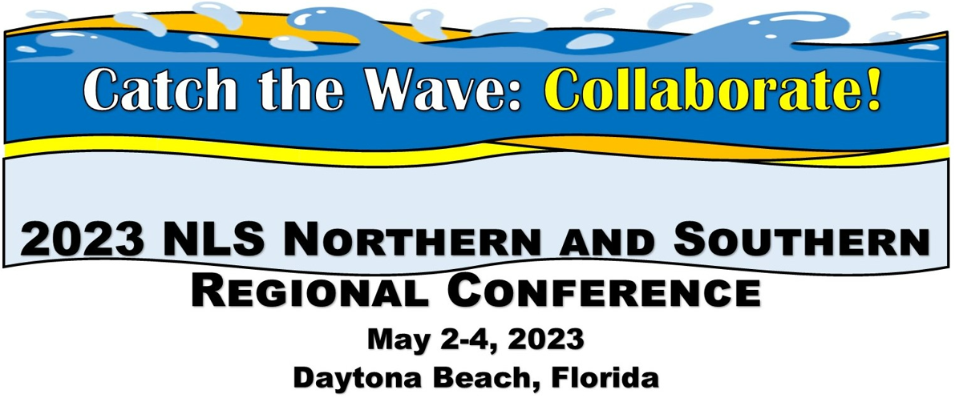
Location: The Shores Resort and Spa, 2637 South Atlantic Avenue, Daytona Beach Shores, FL 32118
NLS Staff pending, times/sessions may be shifted as needed.

Tuesday May 2:

8:00 Breakfast with Colleagues, Registration table open
9:00 Welcome remarks State Librarian Amy Johnson; Message from Sec. of State Cord Byrd (tentative); What’s Unique About FL (Steve Prine) ; Roll Call of states
10:00 NLS updates
10:45 Break
11:00 Speed Networking
12:00: Lunch at the FL Braille and Talking Book Library, Tour of Blind Services campus
2:00 NLS: Wave of Equipment. Includes DS1 and DA1 basic repair and operation, updates on inventory, and special sneak peak of the DA2! E Readers introduced. Led by Joseph Dorsey, Kevin Watson, Neal Graham.
Back to Hotel
3:00 (Panel) Wave of Support: Ereader Examined. Network led. Includes lessons learned on distribution, ways to maximize use, encourage braille literacy, etc. (Angela Fisher Hall, AL, Barbara Penegor and Tracey Mania, KY, Mark Santagelo, NLS)
3:30 Break
3:45 Tidepool: Q and A session with NLS staff and Network Consultant
4 - 5 (Presentation/ Panel) Turn the Tide: Youth Engagement! (Call for network presenters, panel includes preview of Summer Reading Donna Koh)

-End for day-

6:00 Welcome reception and dinner (blind services advocate Paul Kurtz, speaker, trumpeter will perform)

Wednesday May 3:

8:00 Breakfast with Colleagues
9:00 -(Panel/ Presentation) -Wave of Success: Remote Strategies. Includes best practices for Remote programming, Hybrid programming, and creating digital communities.
10:00 Turn the Tide: Best of what's new in tech (call for network presenters, Steve Prine NLS)
10:30 Turn the Tide: Podcasting in Libraries (Craig Hayward NC)
11:15 Break
11:30 ILS meetups (KLAS and WebReads)
12:30 lunch
1:45 - NLS: Summer Reading (Donna Koh, NLS, Mary Beth Parks, PA, and LaShawn Myles, MD)
2:30 - (Panel)- Wave of Information: Outreach Initiatives includes remote outreach, new approaches that worked, proven success stories (call for presenters, Steve Prine, Mark Santagelo, NLS)
3:15 Brain Coral Sessions:
1. Applications Digital from the Start and Electronic Storage (call for presenters, (Neal Graham,
2.Tactiles in the Library (call for network presenters)
3. Working with patrons with multiple disabilities.,)
3:45 -break
4:00 Turn the Tide: Programming. Panel including NLS and presenters from the networks (call for proposals)
4:45: Regional conference business meetings
5:15: Tidepool: Q&A with NLS staff and Network Consultant
5:30 end

6:30 Group dinner option TBD

Thursday May 4:

8:00 Breakfast with Colleagues
9:00 Brain Coral Sessions
1. NLS: Advanced Machine Repair and Other Topics battery life, etc.Neal Graham, Joseph Dorsey, Kevin Watson, NLS
2. Planning a conference of disabled authors, Network Consultant Marybeth Wise and Steve Prine on panel.
3. Collaborative programming across network libraries and cross-advertising initiatives. NLS staff to brainstorm TBD.
9:30: Turn the Tide: Innovative Partnerships (call for network presenters, Steve Prine NLS)
10:00 Local author keynote: TBA
11:00: Break
11:15 NFB Newsline updates
11:45 Bookshare updates
12:15 Tidepool: Small group discussion tables: Suggested Themes: NLS staff and network. Assistive Technology news and coaching (Steve Prine); Summer Reading follow up (Donna Koh); Programming Follow Up, Outreach Follow Up.
12:45: Closing Remarks
1:00 - END.

