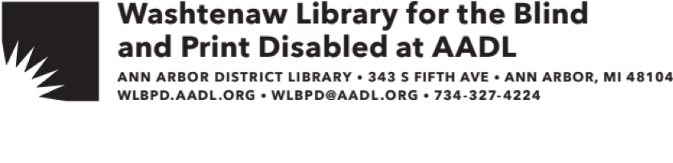

Welcome to the Washtenaw Library for the Blind and Print Disabled (WLBPD) at the Ann Arbor District Library (AADL)!

You are currently signed up to receive Large Print titles through the mail. These books will be mailed to you and can be returned to us as Free Matter for the Blind and Handicapped (no postage required). To return the books, flip over the address card in the reusable zippered bag and put it back in the mail.

You may browse or search the titles that are available in the collection at the Ann Arbor District Library Catalog at www.aadl.org. To request titles, create an account on our website and set your pick-up library to “Downtown.” Or contact us via phone or email, and we’d be happy to request titles for you.

If you completed a new application for an Ann Arbor District Library (AADL) card, that card is enclosed in this packet. Your family members living at the same address are also eligible for an AADL card. Family members may apply at any of our locations by presenting a photo I.D., proof of address, and completing an application. Be sure to let the library desk staff know that the address is shared with a WLBPD cardholder.

Soon an AADL staff member will contact you by phone as a follow-up to this letter. We at the WLBPD at AADL look forward to serving you!

If you have any questions about our services or would like to order materials, please contact us:

Email: wlbpd@aadl.org Mail: WLBPD at AADL

Phone: (734) 327-4224 343 SOUTH FIFTH AVE

ANN ARBOR, MI 48104