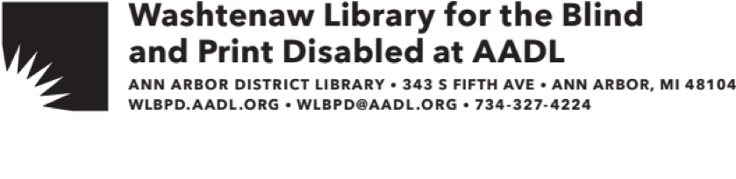

Welcome to the Washtenaw Library for the Blind and Print Disabled (WLBPD) at the Ann Arbor District Library (AADL)!

The talking book equipment and accessories you requested are on their way, as well as an initial shipment of books based on the reading interests you provided.

Multiple digital books will arrive to you on a single digital cartridge. Instructions will come with your initial delivery, but please contact us if you need further assistance accessing your books.

Digital books may be returned postage-free by removing the mailing card on the outside of the box and placing them back in the mail.

You may browse or search the titles that are available in the collection at the National Library Service Catalog: https://nlscatalog.loc.gov/

Your membership also allows you to access BARD, (Braille and Audio Reading Download). This is a free library service that provides access to downloadable Braille and audio reading materials, special-format books, magazines and musical scores. Files can be downloaded from the BARD website or accessed through the BARD app on a personal device. Visit https://nlsbard.loc.gov for more information.

If you completed the application for an Ann Arbor District Library card, that card is enclosed in this packet. Your family members living at the same address are also eligible for an AADL card. Family members may apply at any of our locations by presenting photo I.D., proof of address, and completing an application.

Soon an AADL staff member will contact you by phone as a follow-up to this letter. We at the WLBPD at AADL look forward to serving you!

If you have any questions about our services or would like to order materials, please contact us:

Email: wlbpd@aadl.org Mail: WLBPD at AADL

Phone: (734) 327-4224 343 SOUTH FIFTH AVE

ANN ARBOR, MI 48104