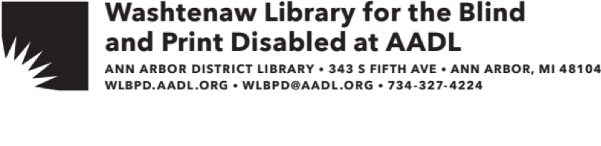

Welcome to the Washtenaw Library for the Blind and Print Disabled (WLBPD) at the Ann Arbor District Library (AADL)!

You should have received an email granting you access to the Braille and Audio Reading Download (BARD). The enclosed information sheet has more details about using the BARD app on iphone and android devices. You can also find more information at nlsbard.loc.gov.

If you completed the application for an Ann Arbor District Library card, that card is enclosed in this packet. If you did not and would like a card, please give us a call. Your family members living at the same address are also eligible for an AADL card. Family members may apply at any of our locations by presenting a photo I.D., proof of address, and completing an application.

We at the WLBPD at AADL look forward to serving you!

If you have any questions about our services or would like to order materials, please contact us:

Email: wlbpd@aadl.org Mail: WLBPD at AADL

Phone: (734) 327-4224 343 SOUTH FIFTH AVE

ANN ARBOR, MI 48104