Week 9: We’re Gonna Need a Bigger Book

Books for Adults

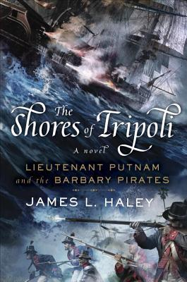
DB 86275 The shores of Tripoli: Lieutenant Putnam and the Barbary pirates: Bliven Putnam, book 1 by James L. Haley
Annotation: In 1801, Midshipman Bliven Putnam, the great-nephew of a Revolutionary War hero, heads to the Mediterranean on the USS Enterprise to engage with the Barbary pirates. He returns, years later, on the USS Constitution to cross the Libyan desert with General Eaton and assault Dema. Some strong language, some violence, and some descriptions of sex.. Commercial audiobook. 2016.

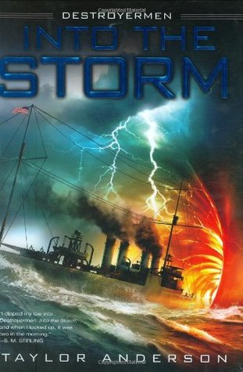
DB 69109 Into the storm: Destroyermen series, book 1 by Taylor Anderson (15 books series)
Annotation: World War II. Ordered to escort HMS Exeter, Lieutenant Commander Matthew Reddy captains the damaged vintage WWI destroyer USS Walker as both ships flee Japanese vessels. Retreating, the Walker heads into a squall for cover but exits into a completely different world and war. Violence and some strong language. 2008.

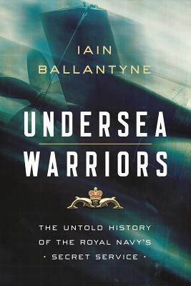
DB 98538 Undersea warriors: the untold history of the Royal Navy’s Secret Service by Iain Ballantyne
Annotation: A journalist recounts the adventurous careers of four British submarine captains throughout the Cold War. Describes voyages under Arctic ice, nuclear-powered espionage missions, and dangerous encounters with Russian spy ships. Commercial audiobook. 2019.

DB 32630 The king’s coat: Alan Lewrie series, book 1 by Dewey Lambdin (25 book series)
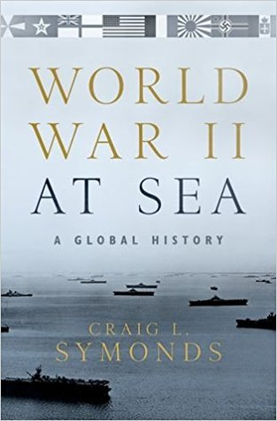
Annotation: Having compromised his half-sister, Alan Lewrie is shipped off to the British navy, with unacknowledged hopes he will be drowned at sea. Much to everyone's surprise, most of all his own, Alan flourishes aboard ship. His adventures include skirmishes with the French and the Dutch as well as amorous dalliances with the daughter of the Jamaican governor. Strong language and descriptions of sex. 1989.

DB 93007 World War II at sea: a global history by Craig L. Symonds
Annotation: Historian chronicles worldwide naval history leading up to and through World War II. Details events beginning with the London Conference of 1930 to Japan's surrender to the Allies in Tokyo Bay in 1945. Unrated. Commercial audiobook. 2018.

DB 34184 Moby-Dick, or the white whale by Herman Melville
Annotation: Sailor Ishmael narrates this allegory of human potential and limitations. Seeking adventure, Ishmael signs on as a harpooner with Captain Ahab's whaling ship. Once at sea, the crew discovers that, despite dire warnings from other ships and a prophet, Captain Ahab is obsessed with killing Moby Dick, the white whale responsible for his missing leg. Violence.

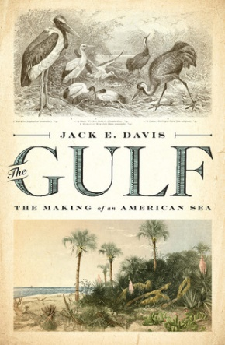
DB 88197 The Gulf: the making of an American sea by Jack E. Davis
Annotation: A history of the Gulf of Mexico, extending from the Pleistocene age until the twenty-first century. Discusses the marine environment, its role in human society, and many of the individuals whose lives were intertwined with the Gulf. 2017.

DB 54352 Aquagenesis: the origin and evolution of life in the sea by Richard Ellis
Annotation: Marine biologist traces the evolution of ocean life from the earliest microbes to the myriad species discovered in the twentieth century. Includes discussion of hydrothermal vents, land mammals that adapted to the sea, and the humans who study these creatures. 2001.

DB 87938 The war for all the oceans by Roy Adkins
Annotation: An account of the naval struggle that lasted from 1798 to 1815--a period beginning with Napoleon's seizure of power and ending with the War of 1812. The author uses eyewitness records to portray battles, daily life at sea, shipwrecks, press-gangs, and more. Contains some violence. Commercial audiobook. 2007.

Books for Youths

DB 89387 Undertow trilogy, books 1-3 by Michael Buckley
Annotation: Trilogy, written between 2015 and 2017, featuring a society of undersea warriors that marches out of the ocean into modern-day Coney Island. Includes Undertow, Raging Sea, and Heart of the Storm. Some violence and some strong language. For senior high and older readers. 2017.

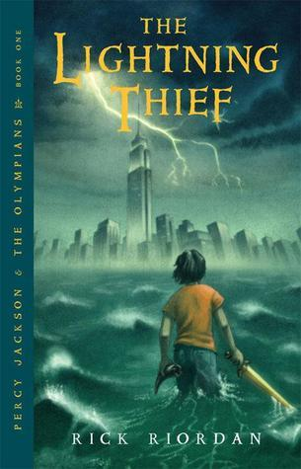
DB 63443 The lightning thief: Percy Jackson and the Olympians, book 1 by Rick Riordan (5 book series)
Annotation: Upstate New York, 2005. Sixth-grader Percy Jackson, the son of Poseidon and a mortal mother, attends a summer camp for demigods. After Percy angers Zeus, his friends Grover, a satyr, and Annabeth, daughter of Athena, join him to resolve the problem. For grades 5-8. 2005.

DB 83581 Titanic young survivors: ten true tales by Allan Zullo
Annotation: The stories of ten real-life survivors of the Titanic disaster in 1912. Includes an account from seventeen-year-old Jack Thayer, who managed to survive after he leaped into the icy waters. For grades 3-6. 2012.

DB 86888 Wicked history, books 13-15 by Enid A. Goldberg, Norman Itzkowitz, Charles Nick, and Kimberley Heuston
Annotation: Three biographies, written between 2008 and 2010, featuring some of history's most destructive leaders. Includes Napoleon: Emperor and Conqueror, Sir Francis Drake: Slave Trader and Pirate, and Vlad the Impaler: The Real Count Dracula. For grades 6-9. 2010.

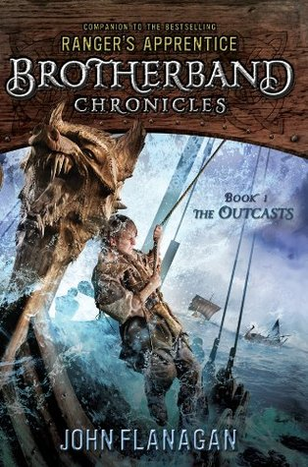
DB 75826 The outcasts: Brotherband chronicles, book 1 by John Flanagan (8 book series)
Annotation: Teenage Skandian outcasts Hal and Stig train to become warriors with a group of other misfits. As they learn to work together, they must compete against two other brotherbands--the Wolves and the Sharks--in a series of challenges that includes the ultimate race across icy waters. For grades 5-8. 2011.

DB 61462 Dove by Robin Lee Graham
Annotation: Author's true account of adventure when, at age sixteen, he set sail from California for a solo, around-the-world voyage aboard his 24-foot sloop, Dove. Chronicles the five-year, 36,000-mile trip during which he met and fell in love with American Patti Ratterree--his future wife. For senior high and older readers. 1972.

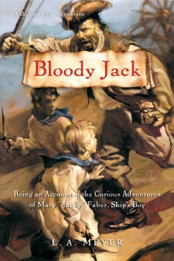
DB 103794 Bloody Jack, book 1: being an account of the curious adventures of Mary “Jacky” Faber, ship’s boy by L. A. Meyer (12 book series)
Annotation: England, 1797. Mary begs on the streets of London with a gang of fellow orphans. At thirteen she disguises herself as a boy and joins a British warship setting sail to search for pirates. Mary maintains her deception--even battling buccaneers. Commercial audiobook. For grades 6-9. 2002.

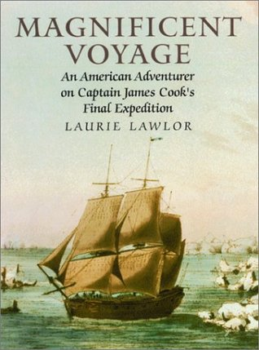
DB 57145 Magnificent voyage: an American adventurer on Captain James Cook’s final expedition by Laurie Lawlor
Annotation: An account of English explorer James Cook's last voyage--begun in 1776 to search for the Northwest Passage--that led to the discovery of the Hawaiian Islands and Cook's grisly murder. Based on the journals of John Ledyard, a twenty-four-year-old American marine who joined the trip. For grades 6-9 and older readers. 2002.

