Week 8: Familial bonds: families of blood, families of choice
Note: All BR (braille) books are available from BARD.

Books for Adults

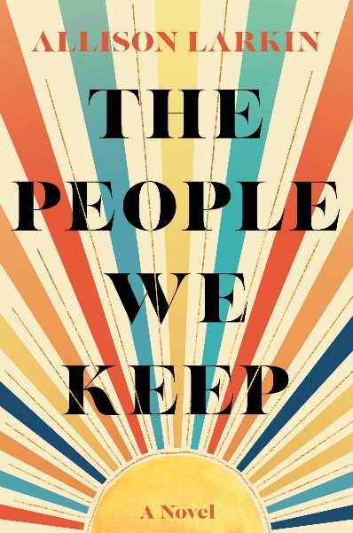
DB 111869 The people we keep by Allie Larkin
Annotation: "Little River, New York, 1994: April Sawicki is living in a motorless motorhome that her father won in a poker game. Failing out of school, picking up shifts at Margo's diner, she's left fending for herself in a town where she's never quite felt at home. When she "borrows" her neighbor's car to perform at an open mic night, she realizes her life could be much bigger than where she came from. After a fight with her dad, April packs her stuff and leaves for good, setting off on a journey to find a life that's all hers. As April moves through the world, meeting people who feel like home, she chronicles her life in the songs she writes and discovers that where she came from doesn't dictate who she has to be." -- Provided by publisher. -- Unrated. Commercial audiobook.

DB 98805 Chilling effect by Valerie Valdes
Annotation: Captain Eva Innocente and the ragtag crew of her cargo ship undergo a series of dangerous missions in an attempt to pay the ransom on Eva's kidnapped sister. In the end, Eva must risk her crew, her ship, and the life she's built to save Mari. Unrated. Commercial audiobook. 2019.

DB 103267 A history of what comes next by Sylvain Newell
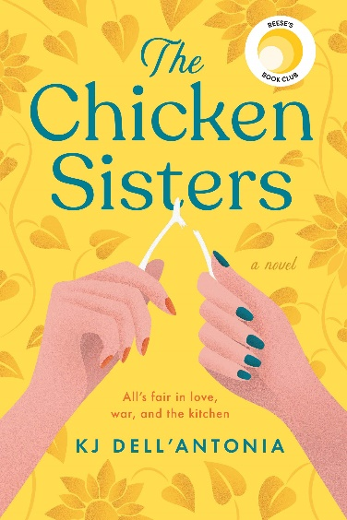
Annotation: Over the course of ninety-nine generations consisting of mother-daughter pairs, Mia's mysterious family has pushed humanity ever closer to achieving spaceflight. Mia's turn comes at the dawn of rocketry, and her mission is to secure the future of the space race. Meanwhile, a rival family seeks to eliminate Mia and her family. Unrated. Commercial audiobook. 2021.

DB 101580 The chicken sisters by K.J. Dell’Antonia
Annotation: In tiny Merimac, Kansas, the Moore and Pogociello families have vied to serve the best fried chicken in the state in their restaurants for generations. Widow Amanda Moore, long caught in the middle of the family feud, enters the two restaurants into a reality TV competition. Unrated. Commercial audiobook. 2020.

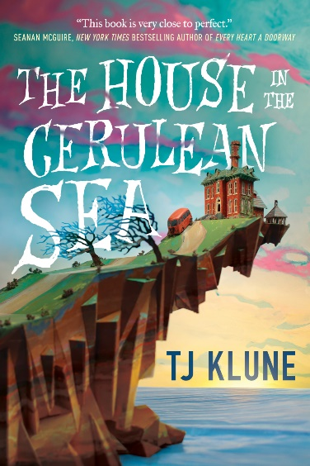
DB 98951 The house in the Cerulean Sea by TJ Klune
Annotation: As a case worker at the Department in Charge Of Magical Youth, Linus Baker spends his days overseeing the well-being of children in government-sanctioned orphanages. He is unexpectedly given a highly classified assignment: travel to a remote island orphanage where six dangerous children reside. Unrated. Commercial audiobook. 2020.
Also available as BR23320.

DB 103557 How the penguins saved Veronica by Hazel Prior
Annotation: Eighty-five-year-old Veronica McCreedy is estranged from her family and wants to find a worthwhile cause to leave her fortune to. When she sees a documentary about penguins being studied in Antarctica, she tells the scientists she's coming to visit and won't take no for an answer. Some strong language. Commercial audiobook. 2020.

DB 113976 Saturday night at the Lakeside Supper Club by J. Ryan Stradal
Annotation: "Mariel Prager needs a break. Her husband Ned is having an identity crisis, her spunky, beloved restaurant is bleeding money by the day, and her mother Florence is stubbornly refusing to leave the church where she's been holed up for more than a week. The Lakeside Supper Club has been in her family for decades, and while Mariel's grandmother embraced the business, seeing it as a saving grace, Florence never took to it. When Mariel inherited the restaurant, skipping Florence, it created a rift between mother and daughter that never quite healed. Ned is also an heir--to a chain of home-style diners--and while he doesn't have a head for business, he knows his family's chain could provide a better future than his wife's fading restaurant. In the aftermath of a devastating tragedy, Ned and Mariel lose almost everything they hold dear, and the hard-won victories of each family hang in the balance. With their dreams dashed, can one fractured family find a way to rebuild despite their losses, and will the Lakeside Supper Club be their salvation? In this colorful, vanishing world of relish trays and brandy Old Fashioneds, J. Ryan Stradal has once again given us a story full of his signature honest, lovable yet fallible Midwestern characters as they grapple with love, loss, and marriage; what we hold onto and what we leave behind; and what our legacy will be when we are gone." -- Provided by publisher. -- Unrated. Commercial audiobook.

BR22488 Only time will tell by Jeffrey Archer
Annotation: England, 1919-1940. Fatherless Harry Clifton grows up in Bristol with his mother Maisie's poor family. Harry receives a scholarship to boarding school, where he befriends Giles, son of wealthy Hugo Barrington. However, family secrets unknown to the boys create problems that last through their acceptance to Oxford. 2011.

BR15130 Say when by Elizabeth Berg
Annotation: Frank Griffin's wife, Ellen, informs him one morning that she has fallen in love with another man--and wants a divorce. Numbed by the revelation but unwilling to leave his eight-year-old daughter, Griffin refuses to move out, creating an awkward living situation rectified only when he reevaluates life and love. Some strong language. 2003.

BRG04233 The great alone by Kristin Hannah
Annotation: Lenora Allbright is 13 when her father convinces her mother, Cora, to forgo their inauspicious existence in Seattle and move to Kaneq, Alaska. It's 1974, and the former Vietnam POW sees a better future away from the noise and nightmares that plague him. Having been left a homestead by a buddy who died in the war, Ernt is secure in his beliefs, but never was a family less prepared for the reality of Alaska, the long, cold winters and isolation. Locals want to help out, especially classmate Matthew Walker, who likes everything about Leni. Yet the harsh conditions bring out the worst in Ernt, whose paranoia takes over their lives and exacerbates what Leni sees as the toxic relationship between her parents. 2018. Unrated. Marrakesh title.

BR21711 Commonwealth by Ann Pratchett
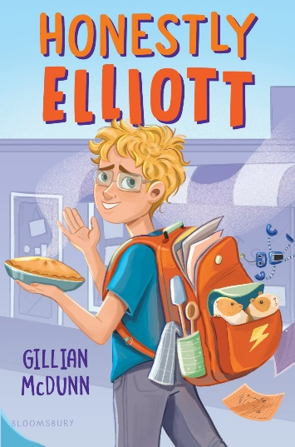
Annotation: Deputy District Attorney Burt Cousins unexpectedly shows up at the christening party for cop Fix Keating's baby daughter. Burt meets Fix's beautiful wife, Beverly, and steals a kiss. The ramifications of this play out for both families over five decades. Strong language. Bestseller. 2016.

Books for Youth

DB 113465 Honestly Elliott by Gillian McDunn
Annotation: "Struggling with ADHD, loneliness, and connecting with his divorced father who would rather see him embrace sports instead of cooking, sixth-grader Elliott finds an unlikely friend in popular, perfect Maribel when the two are paired in a school-wide contest." -- Provided by publisher. -- Commercial audiobook. For grades 4-7.

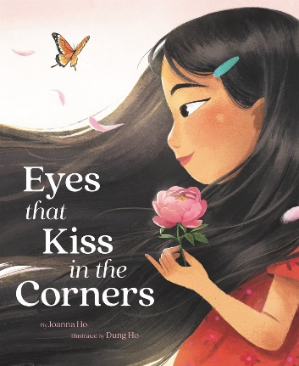
DB 112504 Eyes that kiss in the corners by Joanna Ho
Annotation: "A young Asian girl recounts how she shares her eyes--and so much more--with the other women in her family." -- Provided by NLS. -- Commercial audiobook. For Preschool-grade 2.

DB 112590 Black bird, blue road by Sofiya Pasternack
Annotation: "As the daughter of a prominent judge of Khazaria, twelve-year-old Ziva is expected to focus on learning etiquette and decorum in hopes of finding a good husband. But she doesn't care about any of that. Instead, she spends her days with her twin brother, Pesah, as they work to try to find a cure for his leprosy. Now Pesah's getting worse. The best doctors have given him mere weeks to live, and even more alarming, Pesah has a vision: the Angel of Death is coming to collect him on Rosh Hashanah, only one month away. In a panic, Ziva runs away with Pesah to the Byzantine Empire, home to hundreds of doctors. Surely one of them must have a cure. But when Ziva accidentally frees a half-demon boy named Almas on their journey, unintentionally binding him to her until his debt is paid, Almas tells her about the legendary city of Luz, where the Angel of Death is forbidden to tread. If the three of them can get there by Rosh Hashanah, they can cure Pesah for good. They just need to run faster than the Angel of Death can fly." -- Provided by publisher. -- Commercial audiobook. For grades 4-7.

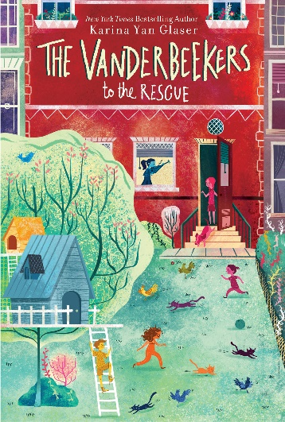
DB 112035 The Vanderbeekers to the rescue by Karina Yan Glaser
Annotation: "The Vanderbeeker children, ages six to thirteen, race to help save their mother's baking business from closure after it fails an inspection." -- Provided by publisher. -- Commercial audiobook. For grades 3-6.

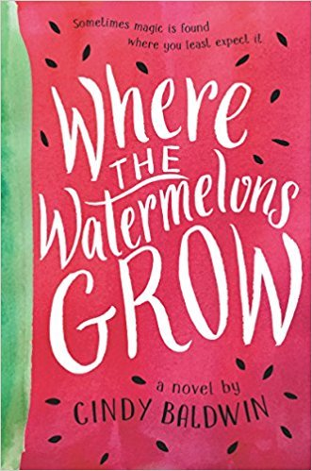
DB 95345 Where the watermelons grow by Cindy Baldwin
Annotation: Twelve-year-old Della Kelly of Maryville, North Carolina, tries to come to terms with her mother's mental illness while her father struggles to save the farm from a record-breaking drought. Commercial audiobook. For grades 4-7. 2018.

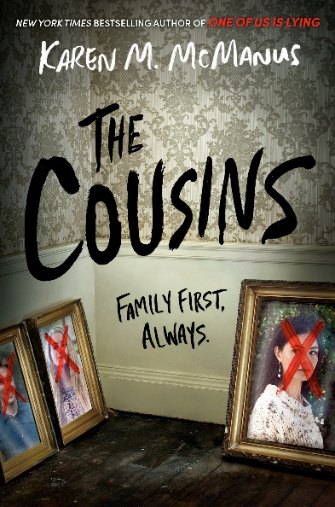
DB 101673 The cousins by Karen M. McManus
Annotation: After receiving an invitation to spend the summer working for their estranged grandmother, the Story cousins arrive at her island resort and realize their mysterious family history has some deadly secrets. Strong language. Commercial audiobook. For senior high and older readers. 2020.

DB 99823 Clap when you land by Elizabeth Acevedo
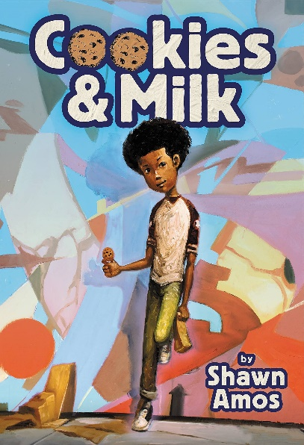
Annotation: A novel in verse. Teens Camino Rios, of the Dominican Republic, and Yahaira Rios, of New York City, are devastated to learn of their father's death in a plane crash and stunned to learn of each other's existence. Some strong language. Commercial audiobook. For senior high and older readers. 2020.

DB 109005 Cookies & milk by Shawn Amos
Annotation: "Eleven-year-old Ellis discovers family secrets, makes new friends, and adjusts to his parents' recent divorce during a hijinks-filled summer helping his father open the world's first chocolate chip cookie store in 1976 Hollywood." -- Provided by publisher. -- Includes supplemental material. Commercial audiobook. For grades 4-7. 2022.

DB 110504 The epic story of every living thing by Deb Caletti
Annotation: "When Harper Proulx and her newfound sibling travel to Hawaii to track down their sperm donor father, Harper finds a deep-sea diver obsessed with solving the mystery of a shipwreck and the experience forces her to face even bigger questions." -- Provided by publisher. -- Unrated. Commercial audiobook. For senior high and older readers.

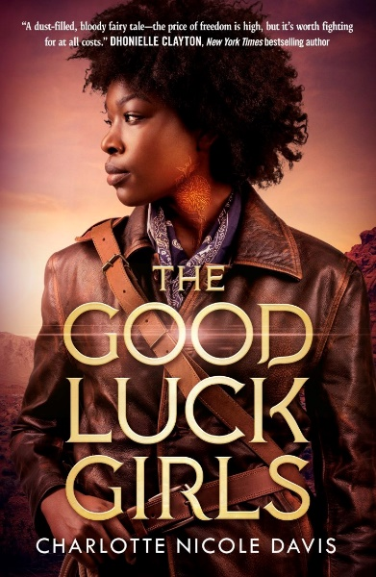
DB 97143 The good luck girls by Charlotte Nicole Davis
Annotation: When one of the Good Luck Girls--girls sold to houses as children and branded with cursed markings--accidentally kills a man, the girls risk everything to find freedom, justice, and revenge in a country that wants them to have none of those things. Violence and strong language. Commercial audiobook. For senior high and older readers. 2019.
Also available as BR22869.

BR22420 Poet X by Elizabeth Acevedo
Annotation: A novel in verse. Frustrated by her Mami's religious aspirations for her, Xiomara copes by writing poetry. When her school starts a poetry club, Xiomara looks for a way to participate in this forbidden activity. Strong language and descriptions of sex. For senior high and older readers. 2018.

BR13382 Harley, like a person by Cat Bauer
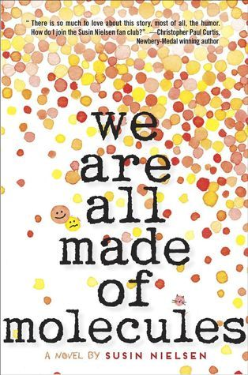
Annotation: Fourteen-year-old Harley discovers that her alcoholic dad is not her birth father and searches for the truth. As she struggles to come to terms with her turbulent family life, her grades plummet and she becomes involved with an older boy. For senior high readers. 2000.

BR21129 We are all made of molecules by Susin Nielsen-Formlund
Annotation: Brilliant but socially-challenged Stewart and mean-girl Ashley must find common ground when his father moves in with her mother. For grades 6-9 and older readers. 2015.

BR20747 Caught: the missing by Margaret Peterson Haddix
Annotation: Time travelers Jonah and Katherine plan to return Albert Einstein's daughter, Lieserl, to history. But her mother, Mileva, knows too much about time travel and has no intention of letting her daughter go. Sequel to Torn (BR 20680). For grades 5-8 and older readers. 2013.

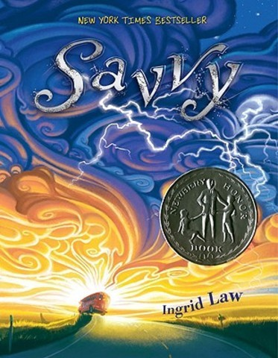
BR18369 Savvy by Ingrid Law
Annotation: Thirteenth birthdays in the Beaumont family reveal a magical power unique to the honoree. After Fish learns to cause hurricanes and Rocket to make electricity, Mibs eagerly awaits her turn. But Poppa has a terrible accident and all Mibs wants is to save him. For grades 4-7. Newbery Honor Book. 2008.

