Week 8: Waters of Life

Books for Adults

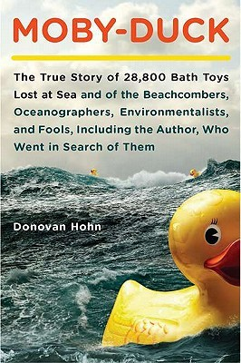
DB 88563 Moby-duck: the true story of 28,800 bath toys lost at sea and the beachcombers, oceanographers, environmentalists, and fools, including the author, who went in search of them by Donovan Hohn
Annotation: A journalist tracks the journey of over 28,000 bath toys--including rubber ducks. These toys were released into the sea when a ship lost a number of containers during a storm in 1992. Details the author's findings about ocean currents, maritime regulations, weather, climate, the novel Moby Dick, and fatherhood. Strong language. Commercial audiobook. 2011.

DB 86331 Drowned worlds: tales from the Anthropocene and beyond by Jonathan Strahan
Annotation: An anthology of short fiction focused on the subject of climate change. Each story features a future wracked by the deluge. Includes stories from, among others, Kim Stanley Robinson, Ken Liu, Lavie Tidhar, and Jeffrey Ford. Some violence. 2016.

DB 68409 Watermind by M. M. Buckner
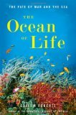
Annotation: From computers and technological waste a dangerous intelligence dubbed the Watermind forms in the Louisiana swamps. MIT dropout CJ Reilly and her boyfriend Max discover the life-form while cleaning up a chemical spill in Devil's Pond. They are intrigued--until the Watermind kills. Strong language and some explicit descriptions of sex. Commercial audiobook. 2008.

DB 76162 The ocean of life: the fate of man and the sea by Callum Roberts
Annotation: Marine scientist and author of The Unnatural History of the Sea (DB 67600) considers the future of the earth's oceans and the impact that overfishing, pollution, climate change, and other problems are having on human life. Examines industrial farming and aquaculture initiatives, recreation and conservation efforts, and more. 2012.

DB 65051 Tracking trash: flotsam, jetsam, and the science of ocean motion (scientists in the field series) by Loree Griffin Burns
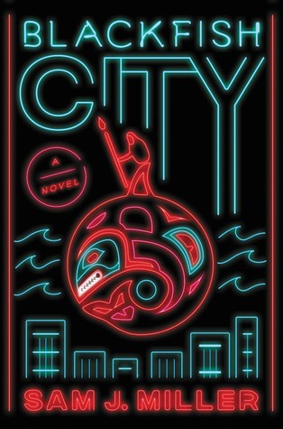
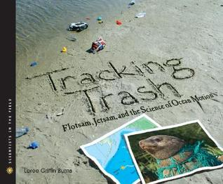
Annotation: Relates how hundreds of sneakers washing up on Pacific coast beaches inspired oceanographer Curt Ebbesmeyer to conduct new experiments on ocean currents. Explains the relevant scientific terms--latitude, longitude, tides, waves, and gyres--and the environmental destruction caused by ocean debris such as tangled fishing nets. For grades 5-8. 2007.

DB 93246 Blackfish City by Sam J. Miller
Annotation: A sustainable floating city, located in the Arctic Circle, begins to experience heightened levels of disease, crime, and corruption. A woman riding an orca arrives and unites the city's factions. If they band together, they may be able to save the city from crumbling. Unrated. Commercial audiobook. 2018.

DB 73912 Oceana: our endangered oceans and what we can do to save them by Ted Danson
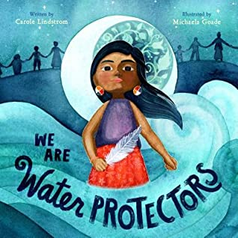
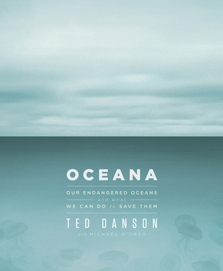
Annotation: Environmental activist and star of the long-running television series Cheers discusses threats to the world's oceans, including pollution, overfishing, offshore drilling, and acidification. Suggests ways that readers can support conservation and explains the work of Oceana, an international organization dedicated to saving the seas. 2011.

Books for Youths

DB 103823 We are water protectors by Carole Lindstrom
Annotation: When a black snake threatens to destroy the Earth and poison her people's water, one young water protector takes a stand to defend Earth's most sacred resource. Commercial audiobook. Caldecott Medal. For grades K-3. 2020.

DB 98550 Stella Díaz never gives up by Angela Dominguez
Annotation: During summer camp, Stella Díaz reaffirms her dream to become a marine biologist. After learning the oceans and marine life are in danger from pollution, Stella and her friends turn to activism. Sequel to Stella Díaz Has Something To Say (DB 90557). For grades 3-6. 2020.

DB 74355 Environmental issues, global perspectives: wetlands, forests, mountains, oceans, freshwater by James Fargo Balliett
Annotation: Five-volume series explores the predominantly negative impact of human behavior and population growth on natural areas. Examines modern society's response to these changes through increased education, conservation efforts, and environmental management. For grades 6-9 and older readers. 2010.

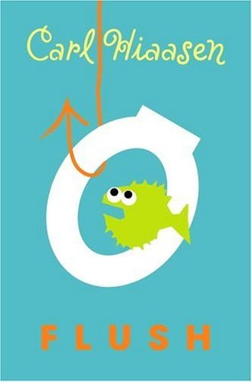
DB 60792 Flush by Carl Hiassen
Annotation: The Florida Keys. With their father jailed for sinking a gambling boat, Noah Underwood and his sister Abbey gather evidence that casino owner Dusty Muleman is illegally emptying sewage tanks into coastal waters. They receive help from a former card dealer, a pirate, and Dusty's ex-girlfriend. For grades 5-8. 2005.

DB 36248 Environmental awareness-water pollution by Mary Ellen Snodgrass
Annotation: Discusses the importance of water to plants and animals and the need for a clean water supply. Describes salt water desalinization, cloud seeding experiments, and fresh water extraction from glaciers and polar icecaps. The author also examines sources of water pollution and explains what individuals can do to help stop the waste and pollution of water supplies. For grades 3-6 and older readers. 1991.

DB 52382 Lockie Leonard, scumbuster by Tim Winton
Annotation: Thirteen-year-old Australian Lockie loves surfing and misses Vicki, his former girlfriend. He meets Egg, a heavy-metal fan who is as lonely as Lockie is. The unlikely duo work together to stop the dumping of industrial sludge into the harbor. Some strong language. For grades 5-8. 1993.

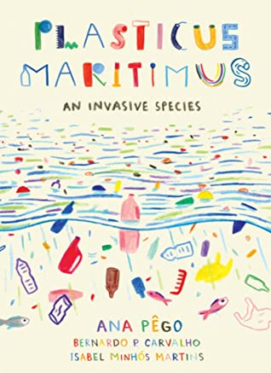
DB 103937 Plasticus maritimus: an invasive species by Ana Pêgo
Annotation: A marine biologist and an award-winning author explain how plastic is made, offer a field guide to help young people identify the Plasticus maritimus species, and take a critical look at our current "solutions" to plastic contamination in the oceans. Translated from the 2018 Portuguese edition. For grades 5-8. 2020.

DB 95958 What a waste: trash, recycling, and protecting our planet by Jess French
Annotation: Explains what we're doing to our environment, both the good and the bad. Discusses the different types of pollution and waste streams and the progress we've made in renewable energy and recycling. For grades 2-4. 2019.

