Week 7: Intergalactic Connections
Note: All BR (braille) books are available from BARD.

Books for Adults

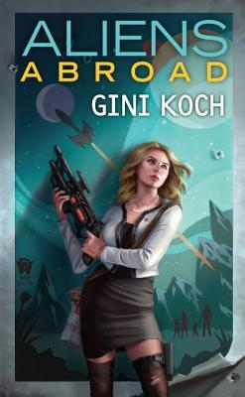
DB 93072 Aliens abroad by Gini Koch
Annotation: Earth has become overcrowded due to a growing human population and the endless stream of alien refugees. A mission to explore new planets becomes much more after a call for help comes from a distant planet. Sequel to Alien Education (DB 92651). Violence, strong language, and some explicit descriptions of sex. 2018.

DB 97574 Class 5, books 1-4 by Michelle Diener
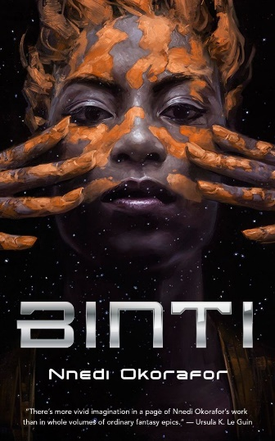
Annotation: Four books of science fiction romance written between 2015 and 2019. In Dark Horse, Rose has been kidnapped from Earth and must work with a rogue AI to gain her freedom. Also includes Dark Deeds, Dark Minds, and Dark Matters. Some violence, some strong language, and some explicit descriptions of sex. 2019.

DB 96190 Binti by Nnedi Okorafor
Annotation: Binti is the first of the Himba people ever offered a place at the elite Oomza University. She must leave her family and travel to a world at war with the nightmarish, alien Meduse people, where she will need all her assets to survive. Contains some strong language and some violence. Commercial audiobook. 2015.

DB 97681 Steel crow saga by Paul Krueger
Annotation: A soldier, a prince, a detective, and a thief unite for a common purpose: to defeat an unstoppable killer who defies the laws of magic. In this battle they will forge unexpected bonds of friendship and love that will change their lives, and begin to change the world. Unrated. Commercial audiobook. 2019.

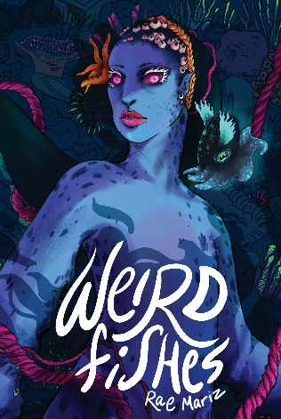
DB 111001 Weird fishes by Rae Mariz
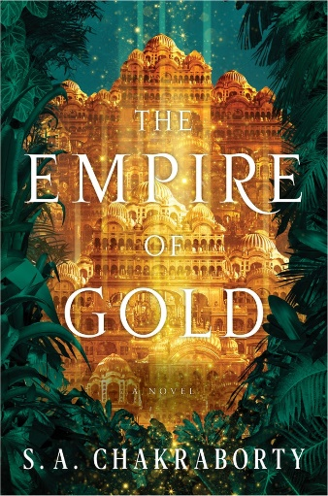
Annotation: "When Ceph, a squid-like scientist, discovers proof of the ocean's slowing currents, she makes the dangerous ascent from her deep-sea civilization to the uncharted surface above. Out of her depths and helpless in her symbiotic mech suit, Ceph relies on Iliokai, a seal-folk storyteller, who sings the state of the sea and has seen evidence of clogged currents as she surfs the time gyres throughout the lonely blue. Navigating the perils of their damaged ocean environment, and seemingly insurmountable cultural differences, Ceph and Iliokai realize that the activities of terrestrial beings are slowing the spiralling currents of time. On a journey that connects future and past, the surface and the deep, the unlikely friends struggle to solve a problem so big it needs a leviathan solution." -- Provided by publisher. -- Violence, strong language and descriptions of sex.

DB 100078 The empire of gold by S.A. Chakraborty
Annotation: Daevabad has fallen. After a brutal conquest stripped the city of its magic, Nahid leader Banu Manizheh and her resurrected commander, Dara, must try to repair their fraying alliance and stabilize a fractious, warring people. Sequel to The Kingdom of Copper (DB 93701). Contains strong language, violence, and some descriptions of sex. Commercial audiobook. 2020.

DB 109636 A prayer for the crown-shy by Becky Chambers
Annotation: "After touring the rural areas of Panga, Sibling Dex (a Tea Monk of some renown) and Mosscap (a robot sent on a quest to determine what humanity really needs) turn their attention to the villages and cities of the little moon they call home. They hope to find the answers they seek, while making new friends, learning new concepts, and experiencing the entropic nature of the universe. Becky Chambers's new series continues to ask: in a world where people have what they want, does having more even matter?" -- Provided by publisher. -- Some strong language. Contains some violence. Commercial audiobook.

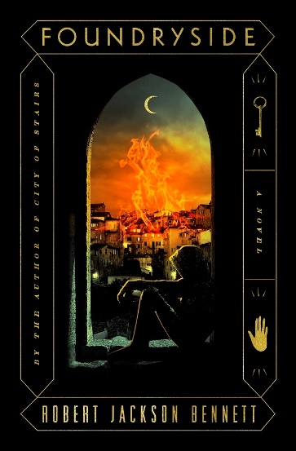
DB 92246 Foundryside by Robert Jackson Bennett
Annotation: Sancia is a talented thief, but her last job had her stealing an artifact of immense power. This artifact could rewrite the rules of scriving, the magic that imbues inanimate things with sentience. Now the ruling merchant houses want Sancia dead and the artifact for themselves. Violence and strong language. Commercial audiobook. 2018.

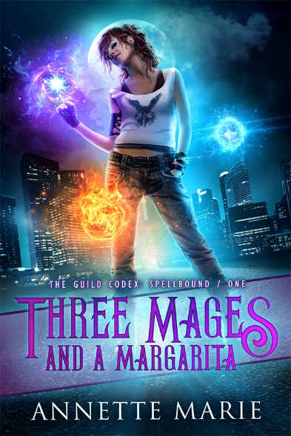
DB 113986 Three mages and a margarita by Annette Marie
Annotation: "Broke, almost homeless, and recently fired. Those are my official reasons for answering a wanted ad for a skeevy-looking bartender gig. It went downhill the moment they asked me to do a trial shift instead of an interview-to see if I'd mesh with their "special" clientele. I think that part went great. Their customers were complete dickheads, and I was an asshole right back. That's the definition of fitting in, right? I expected to get thrown out on my ass. Instead, they . . . offered me the job? It turns out this place isn't a bar. It's a guild. And the three cocky guys I drenched with a margarita during my trial? Yeah, they were mages. Either I'm exactly the kind of takes-no-shit bartender this guild needs, or there's a good reason no one else wants to work here. So what's a broke girl to do? Take the job, of course-with a pay raise." -- Provided by publisher. -- Unrated. Commercial audiobook.

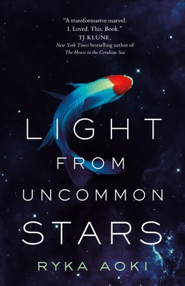
DB 105930 Light from uncommon stars by Ryka Aoki
Annotation: Shizuka has made a deal with the devil to deliver the souls of violin prodigies, and when she meets a talented young transgender runaway, she knows she's found her final candidate. But when Shizuka meets retired starship captain Lan Tran, her plans are soon derailed. Some violence and some strong language. Commercial audiobook. 2021.
Also available as BR24241.

DB 103718 Project Hail Mary by Andy Weir
Annotation: Ryland Grace awakens on a spaceship far from Earth with no memory and two dead crewmates. As he begins to remember the details of his impossible mission to try to save humanity from an extinction-level threat, he encounters an unexpected ally. Strong language. Contains some violence. Commercial audiobook. Bestseller. 2021.
Also available as BR24103.

BR14438 The hitchhiker’s guide to the galaxy by Douglas Adams
Annotation: When Earth is demolished to make room for a galactic freeway, sole survivor Arthur Dent is forced to take up a life of hitchhiking around the cosmos with the aid of his alien friend, Ford Prefect, and a book called the Hitchhiker's Guide to the Galaxy. 1980.

Books for Youth

DB 74327 The invasion by Katherine Applegate
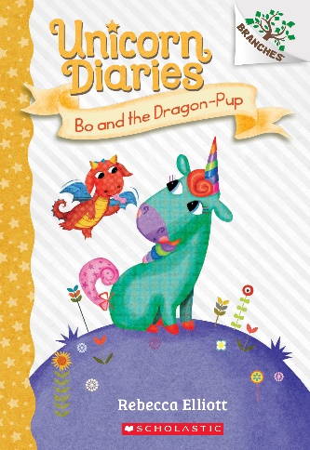
Annotation: While walking home from the mall, Jake and his friends encounter an Andalite alien who warns them that the parasitic Yeerks are about to invade. The dying extraterrestrial gives them the power to morph into animals, which they use to defend their planet. For grades 3-6 and older readers. 1996.

DB 106254 Bo and the dragon-pup by Rebecca Elliott
Annotation: When items go missing from the Sparklegrove School for Unicorns, all the clues left behind point to dragons. Although they have never seen one, the unicorns come up with a plan to investigate. For grades K-3. 2020.

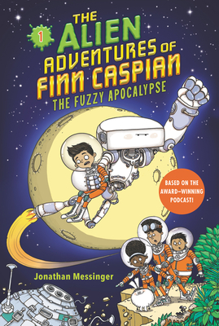
DB 101298 The fuzzy apocalypse by Jonathan Messinger
Annotation: Born in space, Finn and his friends look for a new planet to call home. But when Explorer Troop 301 gets stuck on a planet that's about to explode, they will have to face giant aliens and one evil, fluffy bunny rabbit in order to save the planet. Commercial audiobook. For grades K-3. 2020.

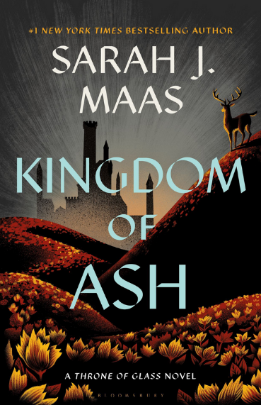
DB 92759 Kingdom of ash by Sarah J. Maas
Annotation: Aelin Galathynius's journey from slave to king's assassin to the queen of a once-great kingdom reaches its heartrending finale as war erupts across her world. Aelin risks everything to save her people--at a tremendous cost. Sequel to Tower of Dawn (DB 89310). Commercial audiobook. For senior high and older readers. 2018.
Also available as BR22476.

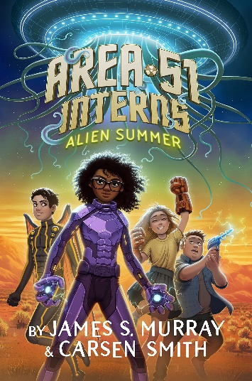
DB 111066 Alien summer by James S. Murray
Annotation: "On the first day of summer vacation twelve-year-old Viv Harlow just wants to relax, but when a whole race of aliens escape from the famous Area 51 where her mom works, Viv and her friends will have to gear up, work together, and save their parents from alien abduction." -- Provided by publisher. -- Commercial audiobook. For grades 4-7.

DB 102748 Flood city by Daniel José Older
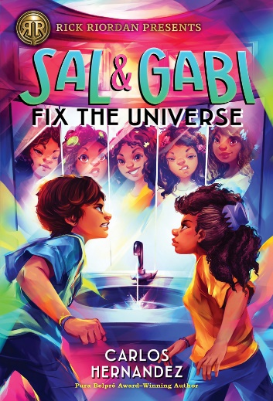
Annotation: Flood City, a battleground between the Star Guard and the Chemical Barons, remains the only habitable place left on Earth. Circumstances force Max, a musician in Flood City, and Ato, a young Chemical Baron, to work together to save their flooded planet. Commercial audiobook. For grades 4-7. 2021.

DB 99475 Sal and Gabi fix the universe by Carlos Alberto Hernandez
Annotation: When best friends Sal and Gabi try to repair the damage they created when they altered the universe to help their families, they end up creating even more chaos. Sequel to Sal & Gabi Break the Universe (DB 94118). Commercial audiobook. For grades 4-7. 2020.

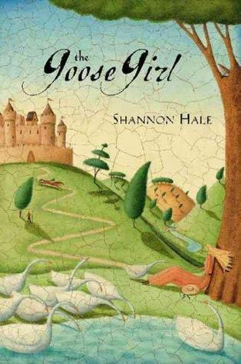
DB 58713 The goose girl by Shannon Hale
Annotation: Sixteen-year-old Princess Ani travels to another kingdom to marry a prince she has never met. Along the way her lady-in-waiting attempts to kill her, then takes her place. Ani escapes and becomes a goose tender at the palace, where she falls in love with her betrothed. For grades 6-9. 2003.

DB 100644 The shadow crosser by Jennifer Cervantes
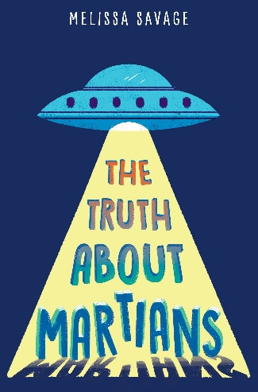
Annotation: When a few Mexica gods try to put their Maya counterparts out of commission, it's up to Zane and some godborns-in-training to save the universe. Sequel to The Fire Keeper (DB 96728). Commercial audiobook. For grades 4-7. 2020.

DB 92618 The truth about Martians by Melissa Savage
Annotation: Corona, New Mexico; 1947. When a flying saucer crash-lands next to his family's ranch, Mylo and his best friend, Dibs, set out to find and help the Martians. Commercial audiobook. For grades 4-7. 2018.

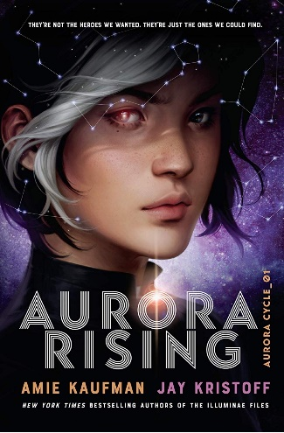
DB 95059 Aurora rising by Amie Kaufman
Annotation: Tyler Jones, star pupil of Aurora Academy, and a group of misfits and troublemakers that make up his squad, embark on their first mission. They rescue a girl from a long cryo-sleep who could be the catalyst for war. Unrated. Commercial audiobook. For senior high and older readers. 2019.

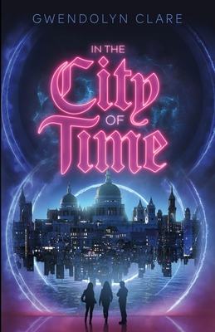
DB 111817 In the city of time by Gwendolyn Clare
Annotation: "After an experiment goes wrong, three science prodigies from two different time periods meet in a strange, seemingly abandoned city, and burdened with a glitchy time machine, an android time cop hot on their trail, and some tangled temporal mechanics to unravel, they set out to save the Earth." -- Provided by publisher. -- Strong language, some violence and some descriptions of sex. For senior high and older readers.

BR19789 A mutiny in time by James Dashner
Annotation: In an area controlled by a shadowy group called the SQ, best friends Dak and Sera stumble onto a time-travel device--the Infinity Ring. The Hystorians, a secret society, recruit the pair to right some wrongs, known as "breaks," throughout history. For grades 4-7 and older readers. 2012.

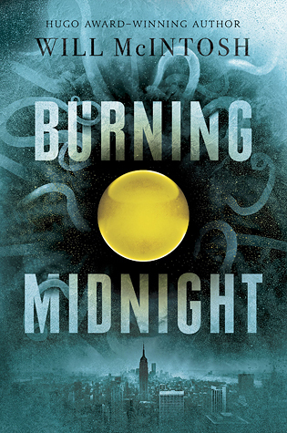
BR21406 Burning midnight by Will McIntosh
Annotation: When an unscrupulous billionaire, CEO Alex Holliday, will stop at nothing to obtain rare spheres that can grant the owner enhanced abilities, four teens--Sully, Hunter, Dom, and Mandy--team up to beat him at his own game. Violence and strong language. For senior high and older readers. 2016.
No one knows where the brilliant-colored spheres came from. One day they were just there, hidden all over the earth like huge gemstones. Burn a pair and they make you a little better: an inch taller, skilled at math, better-looking. The rarer the sphere, the greater the improvement-- and the more expensive the sphere. Sully is a sphere dealer; Hunter is a girl with a natural talent for finding spheres. One day they find a Gold-- a color no one has ever seen. They're not aware of it yet, but the fate of the world rests on this little golden orb.

