Week 7: Ocean Battles

Books for Adults

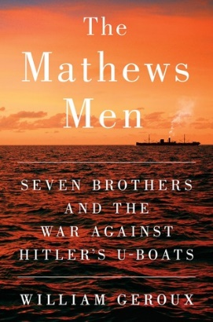
DB 97933 The Mathews men: seven brothers and the war against Hitler’s U-boats by William Geroux
Annotation: An account of a Nazi U-boat attack off the coast of Virginia through the experiences of one family and their neighbors who were all US merchant mariners critical for Allied fuel, food, and munitions. Also describes the mariners' experiences making dangerous sea crossings during World War II. Contains some violence and some strong language. Commercial audiobook. 2016.

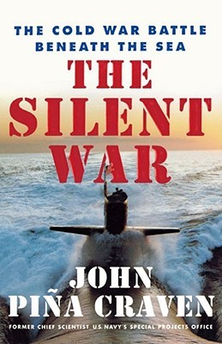
DB 58686 The silent war: the cold war battle beneath the sea by John P. Craven
Annotation: Firsthand recollections of submarine-based espionage and nuclear deterrence from former chief civilian scientist of the U.S. Navy's Special Projects Office. Author recounts clandestine operations including Polaris missile activities and pursuit of the rogue Soviet sub that inspired Tom Clancy's The Hunt for Red October (DB 21513). 2001.

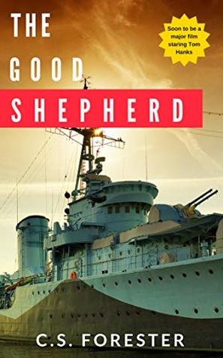
DB 100833 Greyhound by C. S. Forester
Annotation: United States Navy Commander George Krause is ordered to escort a convoy of thirty-seven merchant ships from America to England through the Nazi submarine-infested waters of the North Atlantic. Originally published as The Good Shepherd. Source for 2020 movie of the same name starring Tom Hanks. Unrated. Commercial audiobook. 1955.

DB 78269 A sea unto itself by Jay Worrall
Annotation: After the events in Any Approaching Enemy (DB 63450), newly appointed captain Charles Edgemont leaves his Quaker wife and sails to the Red Sea to prevent Napoleon from invading India. Edgemont also battles murder and near-mutiny. Some violence and some strong language. 2013.

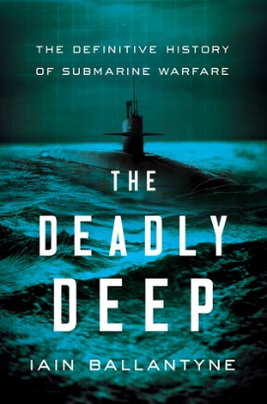
DB 94251 The deadly deep: the definitive history of submarine warfare by Iain Ballantyne
Annotation: An account of the development, improvement, and use of submarines, particularly in war. Discusses notable examples, including David Bushnell's combat submarine, developed for use against the British by the American colonies. Also examines modern-day nuclear submarines. Unrated. Commercial audiobook. 2018.

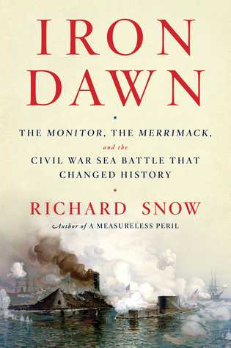
DB 88035 Iron dawn: the Monitor, the Merrimack, and the Civil War sea battle that changed history by Richard Snow
Annotation: An examination of the American Civil War sea battle fought in the harbor at Hampton Roads, Virginia, in March 1862. After the Confederacy built an iron fort atop a captured frigate, the Union developed a revolutionary iron warship that changed the course of naval warfare worldwide. 2016.

DB 93044 No traveller returns by Louis L’Amour
Annotation: 1939. The SS Lichenfield carries thirty-three crewmen and a cargo of eighty thousand barrels of naphtha from San Pedro to Manila. The danger from the cargo pales in comparison to the secrets and hidden connections among the crew. Unrated. Commercial audiobook. 2018.

DB 96655 The eye of the tiger by Wilbur A. Smith
Annotation: Reformed thief Harry is now skipper of a charter boat in the Indian Ocean. When his latest clients go after a treasure under the sea, Harry is soon dealing with bloodthirsty villains, scuba diving, coral poisoning, fights with sharks, and hand-to-hand encounters with human monsters. Some strong language. 1974.

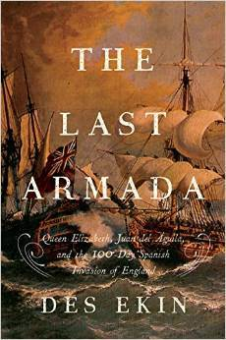
DB 84279 Last armada: Queen Elizabeth, Juan del Aguila, and Hugh O’Neill: the story of the one-hundred-day Spanish invasion by Des Ekin
Annotation: Historian and journalist recounts the story of the last great naval battle fought between England and Spain. Also examines the three commanders who fought in it: General Juan del Águila for Spain, Charles Blount for England, and Irish insurgent Hugh O'Neill. Contains some violence. 2015

Books for Youths

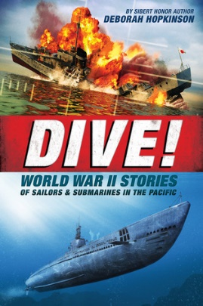
DB 86181 Dive!: World War II stories of sailors & submarines in the Pacific by Deborah Hopkinson
Annotation: Recounts the story and events of America's little-known submarine warfare, also known as "silent service," in the Pacific during World War II. Includes personal accounts from U. S. Navy personnel serving aboard the vessels, submarine design, and descriptions of weaponry. For grades 6-9. 2016.

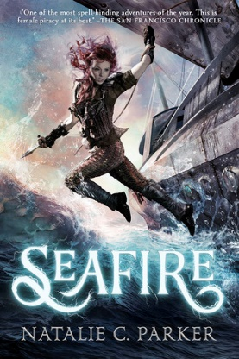
DB 92267 Seafire by Natalie C. Parker
Annotation: Caledonia Styx, captain of her own ship, the Mors Navis, and its all-female crew strive to defeat the powerful fleet of Aric Athair, the vicious warlord who has taken their homes and families. Commercial audiobook. Violence and some strong language. For senior high and older readers. 2018.

DB 96100 The last voyage of Poe Blythe by Allyson Braithwaite Condie
Annotation: Seeking to avenge the murder of her true love while on a dredge ship searching for gold, teenage captain Poe Blythe becomes the architect of new defenses designed to destroy her enemies. Unrated. Commercial audiobook. For senior high and older readers. 2019.

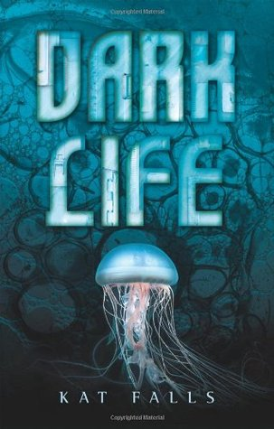
DB 71820 Dark Life by Kat Falls
Annotation: Fifteen-year-old Ty, who has always lived in an ocean-floor community, meets Gemma, a Topsider or land dweller, who is searching for her missing brother. They foray by submarine into the dark undersea frontier's rough underworld, battle outlaws, and discover secrets that threaten to destroy everything. For grades 6-9. 2010.

DB 92009 In harm’s way: JFK, World War II, and the heroic rescue of PT 109 by Iain C. Martin
Annotation: An account of John F. Kennedy's true survival story during World War II. As a Lieutenant (junior grade) in the Navy, he fought to save his PT 109 crew after a deadly collision with an enemy ship in the Pacific. For grades 4-7. 2018.

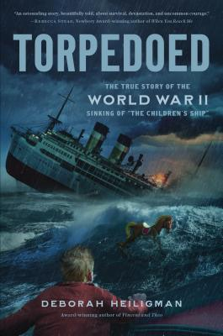
DB 97154 Torpedoed: the true story of the World War II sinking of “The Children’s Ship” by Deborah Heiligman
Annotation: Chronicles the attack and sinking of the passenger ship SS City of Benares, which was evacuating children from England during WWII. Commercial audiobook. For grades 5-8. 2019.

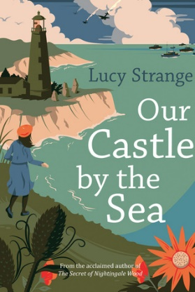
DB 95299 Our castle by the sea by Lucy Strange
Annotation: 1939. Growing up in a lighthouse on England's shore, Pet's world has been one of storms, secret tunnels, and stories about sea monsters. But now the clifftops are a terrifying battleground, as the war rages and her family is torn apart. Commercial audiobook. For grades 5-8. 2019.

