Week 6: Uncommon Kindness: Acts of Kindness that Changed the World
Note: All BR (braille) books are available from BARD.

Books for Adults

DB 89179 The firebrand the First Lady: portrait of a friendship: Pauli Murray, Eleanor Roosevelt, and the struggle for social justice by Patricia Bell-Scott
Annotation: An examination of Eleanor Roosevelt's enduring friendship with Pauli Murray, which began with a letter written by Murray to the First Lady protesting racial segregation in the South. The author draws on letters, journals, diaries, interviews, and more to provide a detailed portrait of this relationship. Contains some violence and some strong language. Commercial audiobook. 2016.

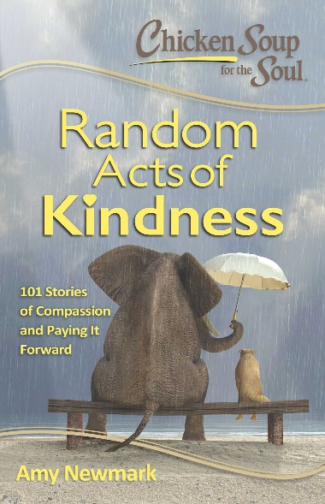
DB 113223 Chicken soup for the soul: random acts of kindness: 101 stories of compassion and paying it forward edited by Amy Newmark
Annotation: "The best way to make yourself feel great? Do a random act of kindness for someone! These 101 stories will make you smile and get you excited about what you can do, too. Make miracles happen for yourself and others. It's easy. Just think outside the box and look around. There are so many ways that you can help-and it turns out the biggest beneficiary may be you! Scientific studies have shown that "doing good" is not only good for the recipient of the good deed, but also for the person doing it, making that person happier and healthier. So dive into these 101 stories of kindness, from the everyday to the extraordinary. If you need some help, you'll find hope in these pages. And if you can give help, you'll feel energized and inspired to find your own opportunities to perform random acts of kindness-every day!" -- Provided by publisher. -- Unrated. Commercial audiobook.

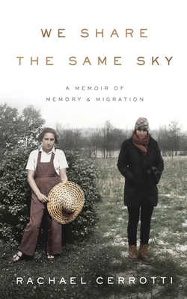
DB 108867 We share the same sky: a memoir of memory & migration by Rachael Cerrotti
Annotation: "In 2009, Rachael Cerrotti, a college student pursuing a career in photojournalism, asked her grandmother, Hana, if she could record her story. Rachael knew that her grandmother was a Holocaust survivor and the only one in her family alive at the end of the war. Rachael also knew that she survived because of the kindness of strangers. It wasn't a secret. Hana spoke about her history publicly and regularly. But, Rachael wanted to document it as only a granddaughter could. So, that's what they did: Hana talked and Rachael wrote. Upon Hana's passing in 2010, Rachael discovered an incredible archive of her life. There were preserved albums and hundreds of photographs dating back to the 1920s. There were letters waiting to be translated, journals, diaries, deportation and immigration papers as well as creative writings from various stages of Hana's life. Rachael digitized and organized it all, plucking it from the past and placing it into her present. Then, she began retracing her grandmother's story, following her through Central Europe, Scandinavia, and across the United States. She tracked down the descendants of those who helped save her grandmother's life during the war. Rachael went in pursuit of her grandmother's memory to explore how the retelling of family stories becomes the history itself. We Share the Same Sky weaves together the stories of these two young women--Hana as a refugee who remains one step ahead of the Nazis at every turn, and Rachael, whose insatiable curiosity to touch the past guides her into the lives of countless strangers, bringing her love and tragic loss. Throughout the course of her twenties, Hana's history becomes a guidebook for Rachael in how to live a life empowered by grief." -- Provided by publisher. -- Some strong language. Commercial audiobook. 2021.

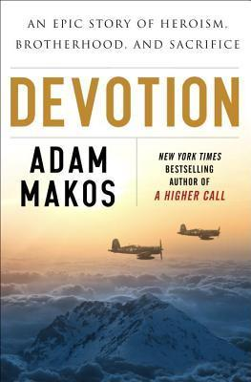
DB 83006 Devotion: an epic story of heroism, friendship, and sacrifice by Adam Makos
Annotation: Recounts the story of U. S. Navy aviator duo Lieutenant Tom Hudner and Ensign Jesse Brown, the first black carrier pilot. While much of America remained segregated, these two pilots joined forces from the very beginning and remained a team into the midst of the Korean War. Contains some violence and some strong language. Commercial audiobook. 2015.

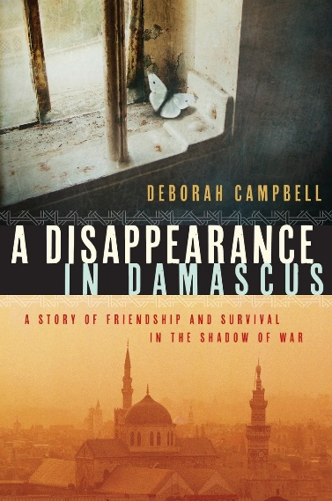
DBG09808 A disappearance in Damascus: a story of friendship and survival in the shadow of war by Deborah Campbell
Annotation: 2007. Deborah Campbell, known for her "lion-hearted" reporting on international conflicts, travels undercover to Damascus to report on the exodus of Iraqi refugees into Syria following the fall of Baghdad. There she meets and hires Ahlam, a refugee working in Damascus as a "fixer"--providing Western media with information and trustworthy contacts to get the news out. Ahlam, a charismatic woman who fled to Syria after being kidnapped for her work running a humanitarian centre in Iraq, uses the income to support her husband and 2 children and to start a school for teenaged girls. But the Syrian Secret Police are watching, and they seize Ahlam. Campbell, fearing that her work with Ahlam has led to her friend's kidnapping, spends the months that follow desperately trying to find Ahlam--all the while fearing she could be next. Winner of the 2016 Hilary Weston Writers' Trust Prize for Nonfiction. Winner of the 2017 Hubert Evans Non-Fiction Prize. 2016. Unrated. Marrakesh title.

DB 105965 Floating twigs by Charles Tabb
Annotation: Denton, Florida, 1968. Twelve-year-old Jack finds a starving dog named Bones while fishing, promising his oft-absent alcoholic parents that he'll get a job to pay for the dog's care. In the process of finding work, Jack meets two people who show him the kindness he never received at home. Some strong language. 2018.

DB 102687 West with giraffes by Lynda Rutledge
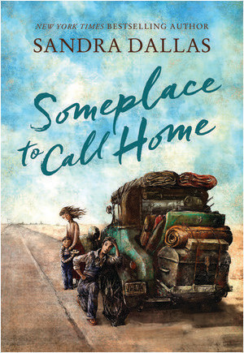
Annotation: As the Great Depression lingers, Americans long for wonder. They find it in two giraffes who miraculously survive a hurricane while crossing the Atlantic. In a twelve-day road trip, Woodrow Wilson Nickel drives a custom truck to deliver the giraffes to the San Diego Zoo. Some violence and some strong language. 2021.

Books for Youth

DB 109993 Someplace to call home by Sandra Dallas
Annotation: "In 1933, when twelve-year-old Hallie Turner and her brothers, Tom and Benny, take to the road seeking whatever work they can get, they find kindness in small-town Kansas." -- Provided by publisher. -- For grades 4-7.

DB 103572 Nicky & Vera: a quiet hero of the Holocaust and the children he rescued by Peter Sís
Annotation: An award-winning author chronicles the life of Nicholas Winton, a man who, in 1938, helped save the lives of almost 700 children trapped in Nazi-occupied Czechoslovakia. For grades 2-4. 2021.

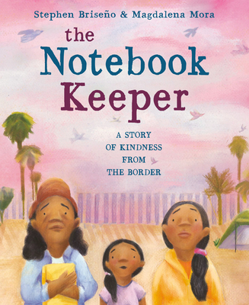
DB 113095 The notebook keeper: a story of kindness from the border by Stephen Briseño
Annotation: "After traveling to Tijuana, Mexico, Noemi and her mother are denied entry at the border and must find the refugee in charge of the notebook, an unofficial ledger of those waiting to cross into the United States. Includes author's note." -- Provided by publisher. -- Commercial audiobook. For grades K-3.

DBC11574 Mercy: the incredible story of Henry Bergh, founder of the ASPCA and friend to animals by Nancy Furstinger
Annotation: A 19th century New Yorker who never even owned a pet, Henry Bergh was an unlikely advocate for animal rights, but he used his millions and his flare for publicity to safeguard work horses, service dogs, and other four-legged creatures. Contains some violence and some descriptions of violence toward animals. For grades 5-8.

DBC14030 Calamity Jane: a study in historical criticism by Roberta Beed Sollid
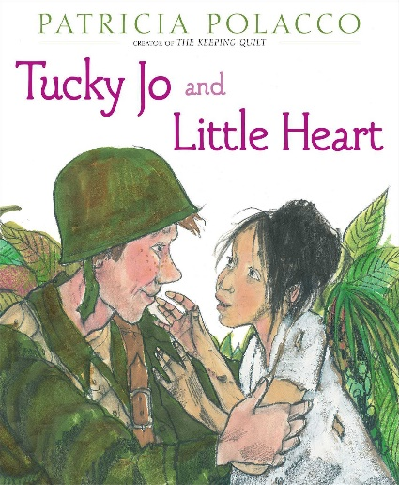
Annotation: A scholarly biography, written in 1951 as a master's thesis in history, this book is the illusive story of Martha Jane Canary, also known as Calamity Jane. Born somewhere in the mid-west in the 1850's, Calamity Jane moved to Virginia City, Montana, about 1865. She lived a hard and neglected childhood, surviving to be known as a wild drunk, but equally known for her kindness to the sick and the poor. For high school and adult readers.

DBC05965 Tucky Jo and Little Heart by Patricia Polacco
Annotation: A fifteen-year-old soldier in World War II meets a sweet young girl in the Philippines who helps him remember what he is fighting for as he helps her and others of her village avoid starvation, and many years later she returns his kindness. For grades 2-4. 2015.

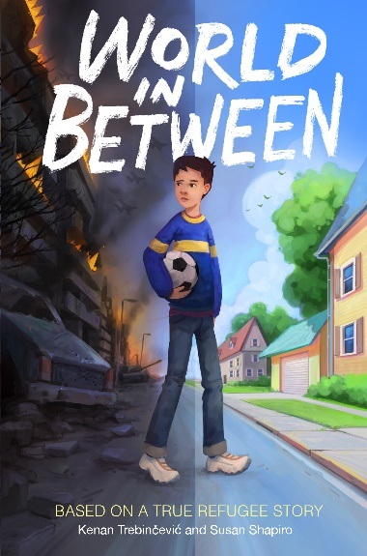
DB 112285 World in between: based on a true refugee story by Kenan Trebinčević
Annotation: "Kenan loves drawing and playing soccer with his friends. He wants to be a famous athlete, hates it when his classmates trash his buck teeth by calling him Bugs Bunny, and fights with his big brother, who's too busy and cool for him lately. Sometimes his parents drive him crazy, but he feels loved and protected--until the war ruins everything. Soon, Kenan's family is trapped in their home with little food or water, surrounded by enemies. Ten long months will pass before they finally make it out of the country alive, with help from friends and strangers. And that's only the beginning of their journey. A riveting story of a Muslim boy's exile from war-torn Bosnia to the United States, World in Between celebrates the power of community and resilience, hope and kindness." -- Provided by publisher. -- Commercial audiobook. For grades 4-7.

DB 31580 Number the stars by Lois Lowry
Annotation: For ten-year-old Annemarie, life in occupied Copenhagen in 1943 is not much changed by the war--until the Nazi persecution of Danish Jews begins. Annemarie's family helps a Jewish friend by having her pose as Annemarie's dead sis- ter. When a packet must be taken to the captain of a ship smuggling Jews to Sweden, Annemarie learns that being brave means "not thinking about the dangers. Just thinking about what you must do." For grades 3-6 and older readers. Newbery Medal. 1989.
Also available as BR12658.

