Week 6: Oh Ship!

Books for Adults

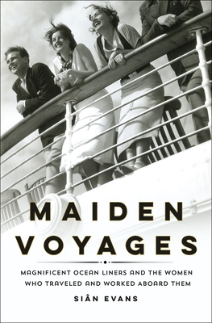
DB 107217 Maiden voyages: the magnificent ocean liners and the women who traveled and worked aboard them by Siân Evans
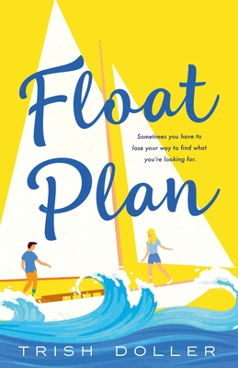
Annotation: The author explores how women's lives were transformed by the golden age of ocean liner travel between Europe and North America. Some traveled for leisure, some for work; others to reinvent themselves or find new opportunities. They were celebrities, migrants and millionaires, refugees, aristocrats, and crew members whose stories remained mostly untold until now. Unrated. Commercial audiobook. 2021.

DB 102228 Float plan by Trish Doller
Annotation: Heartbroken after her fiancé's suicide, Anna decides to take the sailing trip they had planned together. But after a treacherous night's sail, she realizes she can't do it by herself and hires Keane, a professional sailor, to help. Unrated. Commercial audiobook. 2021.

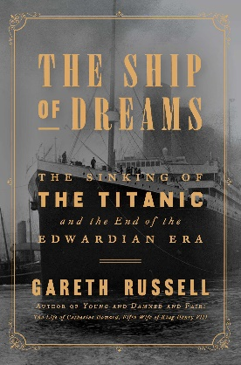
DB 100674 The ship of dreams: the sinking of the Titanic and the end of the Edwardian era by Gareth Russell
Annotation: The author explores the experiences of six first-class travelers aboard the infamous RMS Titanic. Draws on archival documents, deck plans, journal entries, and surviving artifacts to examine the passengers' intertwining lives, the nuances of the British class system, competition within the shipping trade, the Irish Home Rule Crisis, and more. Contains some violence. Commercial audiobook. 2019.

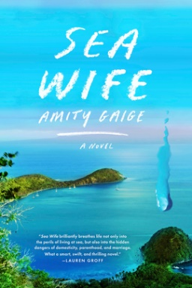
DB 99402 Sea wife by Amity Gaige
Annotation: Juliet is juggling motherhood, a stalled-out dissertation, and depression when her husband, Michael, informs her that he wants to leave his job and buy a sailboat. With their two kids, the pair set off on a risky adventure. Strong language. Commercial audiobook. 2020.

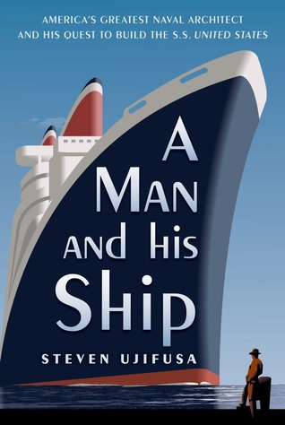
DB 75118 A man and his ship: America’s greatest naval architect and his quest to build the SS United States by Steven Ujifusa
Annotation: Historian examines the life of William Francis Gibbs (1886-1967), who designed some of the most famous ships in American naval history. Details his development of World War II Liberty ships and refitting of military ships for commercial service. Relates the creation of Gibbs's greatest achievement: the SS United States. 2012.

DB 88215 All by myself, alone by Mary Higgins Clark
Annotation: A month after her soon-to-be husband is arrested for fraud, gems expert Celia Kilbride accepts a last-minute invitation to lecture aboard a cruise ship on its maiden voyage. But instead of enjoying the escape, Celia soon realizes that she is on board with a murderous thief. Willy and Alvirah Meehan help investigate. Bestseller. 2017.

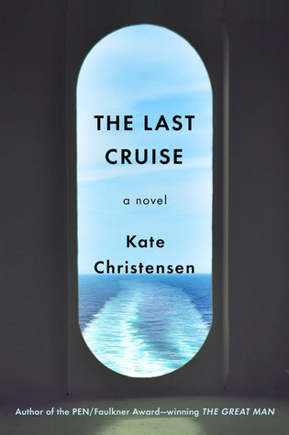
DB 91643 The last cruise by Kate Christensen
Annotation: The vintage luxury ocean liner Queen Isabella is making its final voyage before being scrapped. Among the passengers is Israeli violinist Miriam Koslow, who becomes aware of vulnerabilities on the aging ship. Meanwhile, chef Mick Szabo watches tensions escalate among the crew. Contains some violence, strong language, and explicit descriptions of sex. Commercial audiobook. 2018.

DB 43934 The sea hunters by Clive Cussler
Annotation: A hunter of shipwrecks documents the discovery or survey of twelve major ships in deep waters. Each ship's story begins with an account of its final voyage, then describes how the ship was found. Featured are the Confederate submarine Hunley and the Allied troop transport Leopoldville, among others.

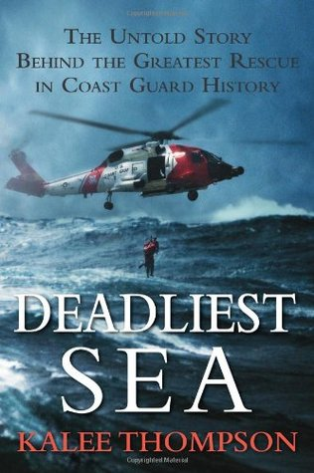
DB 73020 Deadliest sea: the untold story behind the greatest rescue in coast guard history by Kalee Thompson
Annotation: Details the March 2008 Coast Guard rescue of forty-two fishermen from the Bering Sea as their factory trawler, the Alaska Ranger, sank. Describes the tactics of helicopter crews and rescue swimmers, who battled snow squalls, ocean swells, and gale-force winds to save the shipwrecked men. Some strong language. 2010.

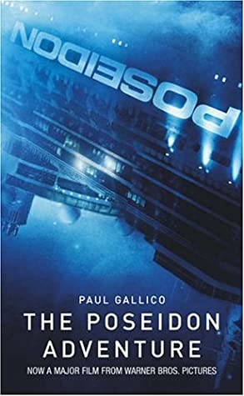
DB 57051 The Poseidon adventure by Paul Gallico
Annotation: The SS Poseidon, a giant ocean liner-turned-cruise ship, capsizes when caught by a tidal wave. The few remaining survivors struggle to remain alive until rescuers arrive. Some strong language. 1969.

DB 72873 Shipwreck: a saga of sea tragedy and sunken treasure by Dave Horner
Annotation: Maritime historian draws on the diary of Spanish priest Diego Portichuelo de Rivadeneira to recount the sinking of the galleons Limpia Concepción in October 1654 and Maravillas in January 1656. Discusses modern-day exploration of shipwreck sites and searches for buried treasure. 1999.

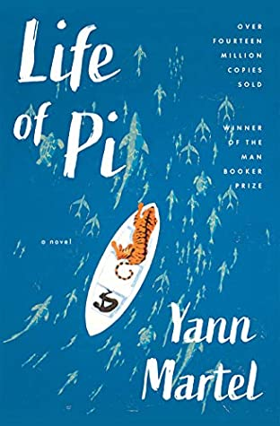
DB 54950 Life of Pi by Yann Martel
Annotation: Pi Patel, the sole human survivor of a shipwreck, is in a lifeboat with an injured zebra, a hyena, an orangutan, and an adult Bengal tiger. Strangely, after 227 days in the Pacific, the boy and the tiger make landfall. Some violence. 2001.

Books for Youths

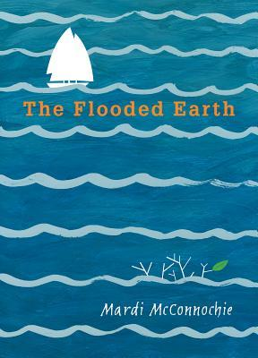
DB 96547 Flooded Earth, books 1-2 by Mardi McConnochie
Annotation: Two books, written in 2016-17, featuring a world where devastating floods have changed the face of the planet. In The Flooded Earth, twins search for their missing father. In The Castle in the Sea, the twins and their friends must evade capture and pirates. For grades 4-7. 2017.

DBC16906 Hurricane dancers: the first Caribbean pirate shipwreck by Margarita Engle
Annotation: Quebrado, a slave on a ship in the Caribbean, escapes when a hurricane sinks the boat. He befriends a fisherman and the village chieftain's daughter. Quebrado learns how to live on the land and among people who treat him well. Told in verse. For grades 5-8.

DB 98518 Curse of the Arctic Star: Nancy Drew diaries, book 1 by Carolyn Keene
Annotation: Nancy, Bess, and George are on the maiden voyage of Arctic Star when strange things begin to happen. They suspect a saboteur is onboard. Commercial audiobook. For grades 3-6. 2013.

DB 102728 Titanic, books 1-2 by Gordon Korman
Annotation: In Unsinkable, the lives of four young passengers aboard the maiden voyage of the RMS Titanic become linked. Paddy, Sophie, Juliana, and Alfie try to determine if a killer is on board--and then an iceberg appears in Collision Course. For grades 4-7. 2011.

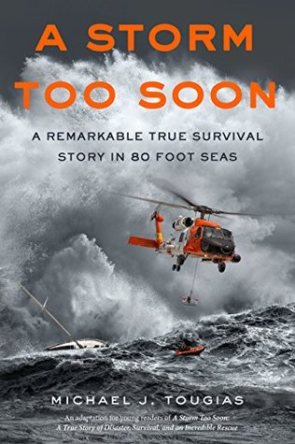
DB 87202 A storm too soon: a remarkable true survival story in 80-foot seas by Mike Tougias
Annotation: Tougias tells the story of four coastguardsmen and their search for three veteran sailors who were on a forty-seven-foot sailboat that disappeared in the Gulf Stream during a calamitous storm in 2007. Adaptation for a younger audience. For grades 4-7. 2016.

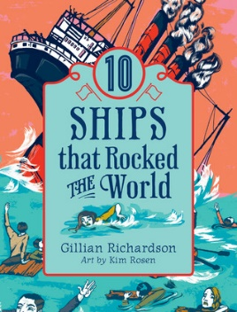
DB 83419 Ten ships that rocked the world by Gillian Richardson
Annotation: Profiles ten ships that influenced human history. Explores maritime adventures from the voyages led by Commander Zheng He's Chinese treasure ships in the fifteenth century to the twenty-first-century Somali pirate hijacking of the Saudi Arabian supertanker Sirius Star. For grades 4-7 and older readers. 2015.

DB 78614 Shipwreck by Gordon Korman
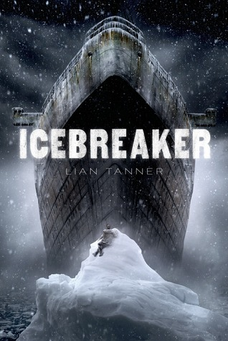
Annotation: Six troubled kids who were sent out to sea for a character-building experience are shipwrecked on a desert island. The adults are gone, and the quest for survival begins. Commercial audiobook. For grades 5-8 and older readers. 2001.

DB 82940 Icebreaker by Lian Tanner
Annotation: On board an ancient icebreaker that has been following the same course for three hundred years, young outcast Petrel spots the impossible--a boy lying on an iceberg. Sent to destroy the ship, the lad and Petrel become unlikely friends and uncover the ship's secret. For grades 5-8. 2013.

DB 88476 Shackles from the deep: tracing the path of a sunken slave ship, a bitter past, and a rich legacy by Michael H. Cottman
Annotation: Pulitzer Prize-winning author shares the wonders of diving, detective work, and the discovery of the remnants of the slave ship Henrietta Marie, while shedding light on the history of slavery. For grades 6-9. 2017.

