Week 5: Partners in Crime…Solving
Note: All BR (braille) books are available from BARD.

Books for Adults

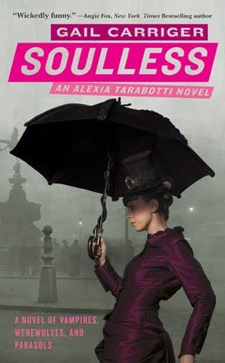
DB 81166 Soulless; Changeless; Blameless: Parasol Protectorate, books 1-3 by Gail Garriger
Annotation: First three books in a romantic steampunk series. In Soulless, Alexia Tarabotti accidentally kills a vampire, and Lord Maccon--a werewolf--investigates. In Changeless, Alexia's new husband disappears in Scotland. In Blameless, a scandal forces Alexia from her home, and vampires want her dead. Descriptions of sex and some violence. 2014.

DB 59293 Skeleton man by Tony Hillerman
Annotation: A 1956 plane collision over the Grand Canyon left 128 dead and a briefcase of diamonds missing. Decades later, after a Hopi man tries to pawn one of the gems, retired Navajo tribal policeman Joe Leaphorn assists sergeant Jim Chee in tracking down the jewels. Some violence. Bestseller. 2004.
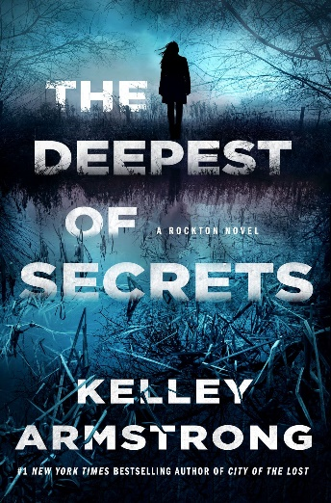
Also available as BR 21307.

DB 106777 The deepest of secrets by Kelley Armstrong
Annotation: Detective Casey Duncan knows that secrets typically stay buried in the town of Rockton. But when those secrets begin coming to light, she and her boyfriend, Sheriff Eric Dalton, must find the person responsible. The townspeople begin turning on each other, and a killer is on the loose. Unrated. Commercial audiobook. 2022.

DB 107535 The investigator by John Sandford
Annotation: Letty Davenport--adopted daughter of Lucas Davenport--is restless and bored in the desk job she has working for US Senator Christopher Colles. He offers her the chance to investigate the theft of crude oil with a partner from the Department of Homeland Security. Letty and her partner, John Kaiser, soon encounter murder. Unrated. Commercial audiobook. 2022.

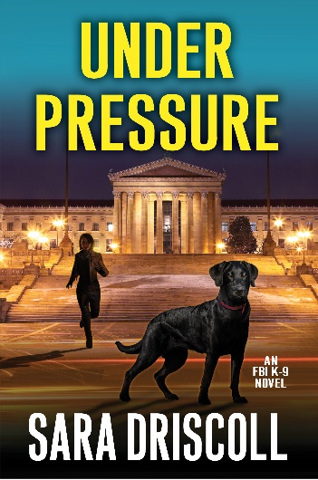
DB 112684 Under pressure by Sara Driscoll
Annotation: "FBI handler Meg Jennings and her K-9 partner, Hawk, are drawn into a case that involves a fortune in uncut gems, and an enemy whose power and ruthlessness know no bounds. Diamonds are no one's best friend when the jewels in question are smuggled conflict gems. Meg Jennings and her Labrador, Hawk, have undertaken many search-and-rescue missions, but this case has an unusual twist. A Philadelphia syndicate is importing diamonds from war-torn African nations and selling them with fake certificates to Stateside dealers. Agent Finn Pierce of the Organized Crime Program is embedded with the syndicate, but being caught with a wire or tracking device would mean instant execution. If Meg, her partner Brian Foster, and their dogs can track Pierce to a deal location, they can break the smuggling chain while maintaining Pierce's cover. With the syndicate monitoring every move, it's a risky operation with more players than Meg and Brian first assumed-on both sides of the law. And when one of their own gets caught in the line of fire, the team embarks on a desperate rescue mission, knowing that mere seconds are all that separate life and death." -- Provided by publisher. -- Unrated. Commercial audiobook.

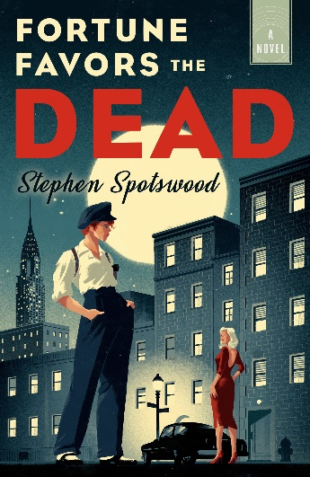
DB 106039 Fortune favors the dead by Stephen Spotswood
Annotation: Willowjean "Will" Parker has run away from the circus and encounters private detective Lillian Pentecost while working a job. Lillian proposes a partnership to Will as her multiple sclerosis diagnosis no longer allows her to work. Will accepts, and they are soon on the hunt for a killer. Unrated. Commercial audiobook. 2020.

DBC24646 On the run with Bonnie & Clyde by John Gilmore
Annotation: A fast moving and gut-wrenching, highly original exploration into the personalities of the star-crossed lovers and "public enemies" Bonnie Parker and Clyde Barrow. Adult. Unrated.

DB 107236 Hell’s half-acre: the untold story of the Benders, a serial killer family on the American frontier by Susan Jonusas
Annotation: Study of the Bender family, whose homestead in Labette County, Kansas, was the site of numerous murders and a mass grave. Discusses the social environment of the early 1870s, the Bender family and their victims, and the investigation and search for the family after neighbors discovered the crime. Some violence. Commercial audiobook. 2022.

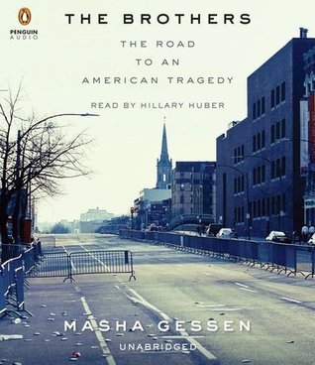
DB 81069 The brothers: the road to an American tragedy by Masha Gessen
Annotation: A Russian-American journalist examines the events surrounding the 2013 Boston Marathon, when two homemade bombs killed three people and wounded hundreds. In the ensuing manhunt, Tamerlan Tsarnaev died and his younger brother Dzhokhar was captured and charged. Gessen discusses how the young immigrants evolved into terrorists. Strong language and some violence.. Commercial audiobook. 2015.

DB 99469 Blonde rattlesnake: Burmah Adams, Tom White, and the 1933 crime spree that terrorized Los Angeles by Julia Bricklin
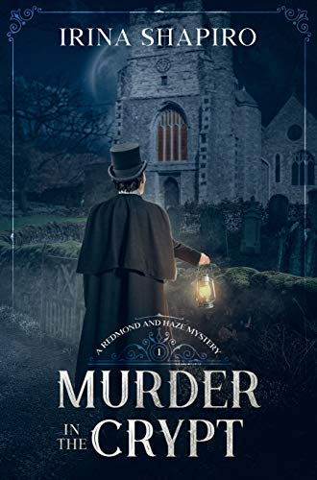
Annotation: Reveals the events that brought nineteen-year-old hairdresser Burmah Adams and ex-con Thomas White together and details the robbing spree and two shootings the newlyweds committed in the sweltering hot days and nights of Los Angeles in the height of the Great Depression. Contains some violence. Commercial audiobook. 2019.

DB 111467 Murder in the crypt by Irina Shapiro
Annotation: "When the body of a young man is found stuffed into the tomb of a medieval knight, Parish Constable Daniel Haze is tasked with investigating his first solo murder case. Suspicion instantly falls on the only stranger to arrive in the village of Birch Hill just before the crime took place, but the American captain proves to be an unexpected asset. A former soldier and a skilled surgeon, Jason Redmond is not only willing to assist Haze with the investigation but will risk his own safety to apprehend the killer. With no suspects, no motive, and few leads to follow, Redmond and Haze must solve the crime before one of them becomes the murderer's next victim. Murder in the Crypt is the exciting first installment of this Victorian murder mystery series set in a quaint British village." -- Provided by publisher. -- Some violence and some strong language.

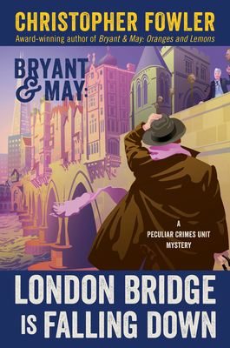
DB 111435 London Bridge is falling down by Christopher Fowler
Annotation: "91 year-old Alice Hoffman died alone in her top floor flat. Social services say she slipped through the cracks in a failing system. But detectives Arthur Bryant & John May of the Peculiar Crimes Unit have their suspicions. Mrs Hoffman was not as innocent as she appeared. A former government security expert, she had once worked for their own unit, but there's no-one left who can remember her. And when they uncover a link between her and a diplomat desperate to leave the country it begins to look as if someone might have committed an impossible murder. But Mrs Hoffman wasn't acting alone. Arthur Bryant is convinced that a group of talented women have been working together for decades and now the others are in danger. With the help of some of his more certifiable contacts and historical experts, he and John May embark on an investigation that will lead them down forgotten alleyways to riverside buildings and on to the city's oldest bridge. But just when the case appears to have been solved and unit chief Raymond Land can congratulate everyone on ending a threat to international security, the detectives discover that they've been the victims of the biggest deception of all. For even after her death, Mrs Hoffman would prove too clever for them . . . . Bryant & May's twentieth anniversary case brings an ending and a new beginning to London's most peculiar crimes unit and all who work there." -- Provided by publisher. -- Unrated. Commercial audiobook.

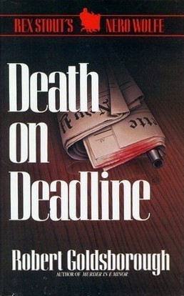
DB 110432 Death on deadline by Robert Goldsborough
Annotation: "To save his favorite newspaper, Nero Wolfe steps into the crossfire of a tabloid war. Master sleuth Nero Wolfe's small circle of friends is limited to his assistant, Archie Goodwin; his chef, Fritz; and Lon Cohen, the head man at the New York Gazette. Cohen knows more about the city's power structure than any man in Manhattan, and for years, he happily passed Wolfe information in return for the odd exclusive scoop. But now Cohen needs Wolfe's help, for the Gazette is ailing and the vultures have begun to circle. Scottish newspaper magnate Ian MacLaren plans to gut the paper and turn it into a sex-filled conservative rag. Standing in his way is the company's chief shareholder, Gazette heir Harriet Haverhill. But when the aged Ms. Haverhill dies in an apparent suicide, no one remains to resist the Scot's advances except Wolfe. MacLaren may be fierce, but when the cause is just, Nero Wolfe knows how to play dirty too." -- Provided by publisher. -- Unrated. Commercial audiobook.

BRG01127 In a dry season by Peter Robinson
Annotation: When a drought dries up a reservoir that covers the abandoned English village of Hobb's End, a skeleton is found in a crumbling building. Detective Chief Inspector Alan Banks and local detective Annie Cabbot untangle the World War II mystery that led to the young woman's death. Some strong language. 1999. Marrakesh title.

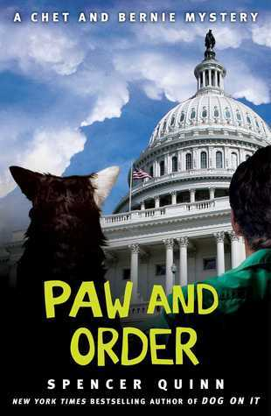
BR22385 Paw and order by Spencer Quinn
Annotation: P.I. Bernie Little and his faithful canine companion Chet visit Bernie's girlfriend, journalist Suzie Sanchez, in Washington, D.C. Suzie is working on a big hush-hush story and when her source--a mysterious Brit with possible intelligence connections--runs into trouble of the worst kind, Bernie suddenly finds himself under arrest. Strong language. 2014.

BRG01625 Hour game by David Baldacci
Annotation: Former Virginia secret service agents and now private detectives Michelle Maxwell and Sean King from "Split Second" attempt to solve a burglary when they are solicited to investigate another case--a series of murders that strongly resemble other infamous crimes. Some violence and some strong language. Bestseller. c2004. Marrakesh title.

BRG00136 Mortal sins by Anna Porter
Annotation: Judith Hayes is writing a feature story on wealthy Paul Zimmerman when he dies mysteriously. Judith and her boyfriend, Detective Inspector David Parr, suspect murder, but their investigation is hindered by Zimmerman's uncooperative family and friends. Some strong language. Marrakesh title.

BR23604 Ocean prey by John Sandford
Annotation: While fishing with his family, an off-duty Coast Guardsman notices suspicious behavior. His feelings are confirmed when three of his colleagues are shot and killed. When the FBI's investigation stalls out, they call in Lucas Davenport who, in turn, calls on Virgil Flowers. Strong language. Bestseller. 2021.

Books for Youth

DB 83073 Chasing Vermeer by Blue Balliett
Annotation: When strange and seemingly unrelated events start to happen and a precious Vermeer painting disappears, sixth-grade classmates Petra and Calder combine their talents to investigate an international art scandal. Commercial audiobook. For grades 4-7. 2004.
Also available as BRG00685.

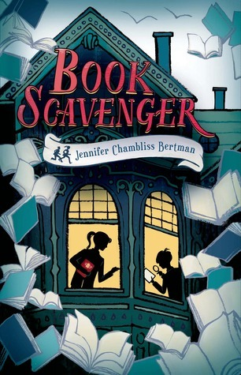
DB 87363 Book scavenger by Jennifer Chambliss Bertman
Annotation: Just after twelve-year-old Emily's family moves to San Francisco, she learns that her hero, Garrison Griswold, creator of the online game Book Scavenger, has been attacked. Emily and her new friend, James, discover that the attack is tied to a special book, and they race to solve the mystery. For grades 4-7. 2015.

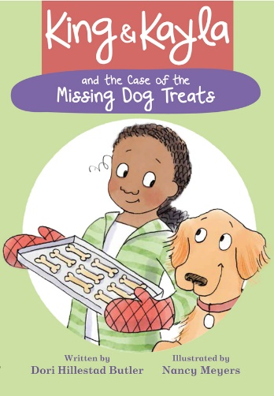
DB 90439 King and Kayla series, books 1-4 by Dori Hillestad Butler
Annotation: Books one through four, written in 2017 and 2018, feature canine King and his human, Kayla, as they solve everyday mysteries. Includes King and Kayla and the Case of the Missing Dog Treats, King and Kayla and the Case of the Secret Code, and two more. For grades K-3. 2018.
Also available as BR22211.

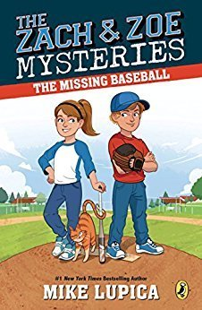
DB 90894 The Zach and Zoe mysteries, books 1-2 by Mike Lupica
Annotation: Two mysteries featuring sports-loving eight-year-old twins Zach and Zoe. In The Missing Baseball, when a signed baseball goes missing, the duo searches for clues. In The Half-Court Hero, the twins search for who is behind a basketball-court renovation. Commercial audiobook. For grades K-3. 2018.

DB 88069 The absent author by Ron Roy
Annotation: After famous mystery writer Wallis Wallace fails to appear at the bookstore to autograph books, Dink figures out that he's been kidnapped. Dink and his best friends, Josh and Ruth Rose, trace Wallace's itinerary, hoping they will arrive in time to rescue him. For grades 2-4. 1997.
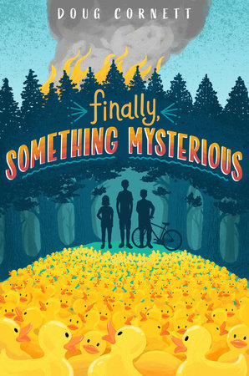
Also available as BR17952.

DB 111269 Finally, something mysterious by Doug Cornett
Annotation: "Paul Marconi and his two friends are amateur detectives and find their biggest case when their neighbor wakes up to lawn full of rubber duckies. The kids set out to discover the culprit." -- Provided by publisher. -- Commercial audiobook. For grades 3-6.

DB 94052 Zap! by Martha Freeman
Annotation: Eleven-year-olds Luis and Maura investigate the cause of a long-term citywide power outage in Hampton, New Jersey. Includes facts about electric power and instructions for assembling an emergency kit. For grades 5-8. 2018.

DB 88343 The shadow cipher by Laura Ruby
Annotation: In an alternate history of New York City, three kids--Tess, Theo, and Jaime--try to solve the Old York Cipher and complete a treasure hunt laid into the streets and buildings of the city by two eccentric siblings, Theresa and Theodore Morningstarr. Some violence. For grades 5-8. 2017.

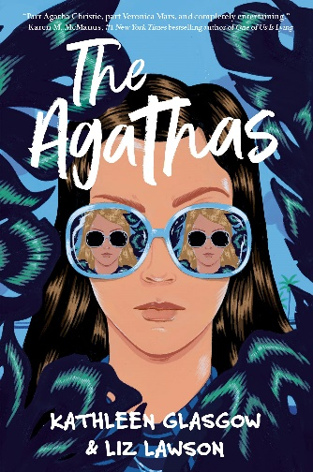
DB 108238 The Agathas by Liz Lawson and Kathleen Glasgow
Annotation: "Alice Ogilvie's disappearance last summer is the biggest scandal at Castle Cove High School--until her ex-boyfriend is accused of murdering his new girlfriend, and Alice must pair up with her tutor Iris Adams to clear his name by relying on the wisdom of Agatha Christie." -- Provided by publisher. -- Unrated. Commercial audiobook. For senior high and older readers. 2022.

DB 98673 No true believers by Rabiah York Lumbard
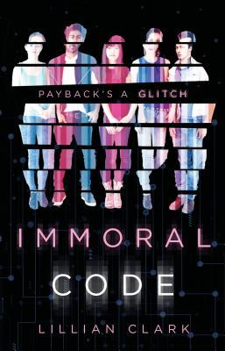
Annotation: Salma, a high school senior, faces prejudice and hidden danger after being framed for a Muslim terrorist act that she did not commit. With the help of her boyfriend, Amir, the two search for who is responsible for the bombing. Strong language. Commercial audiobook. For senior high and older readers. 2020.

DB 95076 Immoral code by Lillian Clark
Annotation: Five high school friends--Bellamy, Nari, Reese, Keagan, and Santiago--team up to hack into Bellamy's billionaire father's business accounts to skim enough money for her MIT tuition. Strong language. For senior high and older readers. 2019.

BR22186 Turtles all the way down by John Green
Annotation: Sixteen-year-old Aza never intended to pursue the mystery of fugitive billionaire Russell Pickett, but there's a hundred-thousand-dollar reward at stake, and her best and most fearless friend, Daisy, is eager to investigate. Meanwhile, Aza obsesses about everything. Strong language. For senior high and older readers. 2017.

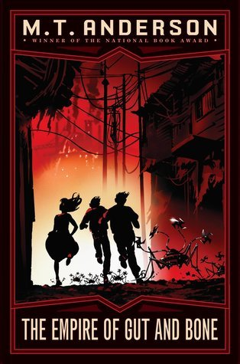
BR19553 The empire of gut and bone by M.T. Anderson
Annotation: Brian and Gregory enter the land of New Norumbega, located inside a vast organic body, to recruit allies against Earth's alien invaders. In the process they are drawn into a robot rebellion and a murder mystery. Sequel to The Suburb beyond the Stars (BR 19157). For grades 5-8. 2011.

BR019972 The one-hundred-year-old secret by Tracy Barrett
Annotation: Xena and Xander Holmes, American siblings who recently moved to London, are welcomed by the Society for the Preservation of Famous Detectives. After discovering that they are descendants of Sherlock Holmes, Xena and Xander attempt to solve the case of a missing famous painting. For grades 4-7. 2008.

BRG03081 Missing by Becky Citra
Annotation: Thea and her dad are always on the move, from one small Cariboo town to another, trying to leave behind the pain of Thea's mom's death. When her dad gets work renovating a guest ranch on Gumboot Lake, she makes friends with Van, a local boy, and works hard to build the trust of an abused horse named Renegade. When Thea unearths the decades-old story of a four-year-old girl who disappeared from the ranch and was never seen again, she enlists Van to help her solve the mystery. For junior high readers. Winner of the 2013 Silver Birch Fiction Honour Book Award. 2011. Marrakesh title.

