Week 5: A Pirate’s Life for Me

Books for Adults

DB 100120 The sin in the steel by Ryan Van Loan
Annotation: To avoid execution, seventeen-year-old Buc and her partner Eld agree to help the Kanados Trading Company solve the mystery of why some of their ships have disappeared. They discover that the trade routes have become the domain of a pirate queen who sinks all who defy her. Unrated. Commercial audiobook. 2020.

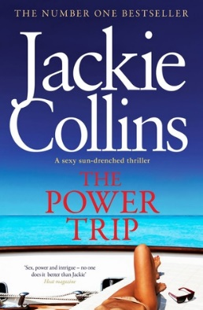
DB 76354 The power trip by Jackie Collins
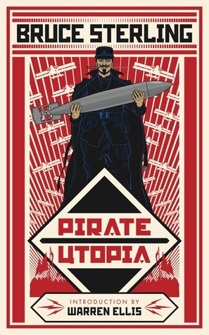
Annotation: Pirates attack Aleksandr Kasianenko's yacht in the Sea of Cortez, where he is hosting a birthday party for his lover. Aboard are an American senator, a movie star, a reporter, a British soccer player, a Latin singer, and their partners. Violence, strong language, and explicit descriptions of sex. 2013.

DB 88645 Pirate utopia by Bruce Sterling
Annotation: The Futurists are utopian pirate warriors, the mortal enemies of communists, capitalists, and even fascists. These citizens of Carnaro are led by engineering genius Lorenzo Secondari, torpedo manufacturer Frau Piffer, spymaster Ace of Hearts, and the seductive warrior-poet the Prophet. They hope to establish world domination with the help of American traitors. Some violence. 2016.

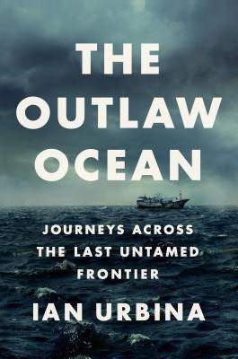
DB 96211 Outlaw ocean: journeys across the last untamed frontier by Ian Urbina
Annotation: Author of Life's Little Annoyances (DB 66199) investigates the criminal enterprises which operate in international waters, often under the cover of legitimate industries. Discusses human trafficking, smuggling, piracy, mercenaries, wreckers, vigilante conservationists, clandestine oil-dumpers, slavery, and stowaways who are cast adrift after being found. Unrated. Commercial audiobook. 2019.

DB 95726 The last pirate of New York: a ghost ship, a killer, and the birth of a gangster nation by Rich Cohen
Annotation: Narrative about charismatic Albert Hicks, whose maritime Manhattan criminal career reached its peak in 1860. But Hicks's plan to rob an oyster sloop went awry--the ship was found listing and unmanned in the foggy straits of Coney Island--and led to the notorious underworld figure's last desperate flight. Unrated. Commercial audiobook. 2019.

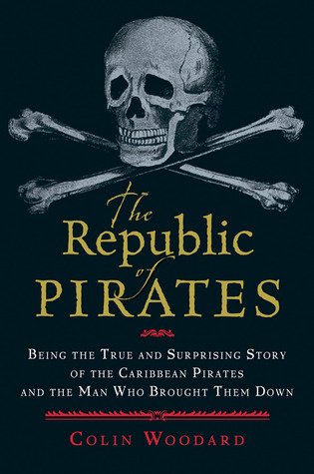
DB 88736 The republic of pirates: being the true and surprising story of the Caribbean pirates and the man who brought them down by Colin Woodard
Annotation: An account of the Golden Age of Piracy and the "Flying Gang," a group of eighteenth-century pirate captains who joined forces, including Edward "Blackbeard" Thatch and "Black Sam" Bellamy. Examines why many of those involved turned to piracy and how they self-governed before their ultimate downfall at the hands of Captain Woodes Rogers. 2007.

DB 82496 Chronicles of Captain Blood by Rafael Sabatini
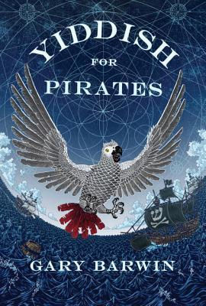
Annotation: Collection of ten short stories featuring Captain Peter Blood from Captain Blood (DB 56172), a former surgeon turned buccaneer. Some violence. 1931.

DB 101521 Yiddish for pirates by Gary Barwin
Annotation: Aaron, a polyglot parrot who has noshed from the Fountain of Eternal youth, recounts meeting up with Moishe a sea captain who grew up in Inquisition Spain. They have many adventures as they seek out treasure, Moishe's lost love Sarah, and a life safe for Jews. Unrated. Commercial audiobook. 2016.

DB 75188 The pirates of Somalia: insider their hidden world by Jay Bahadur
Annotation: Bahadur, a marketer-turned-journalist, recounts embedding himself among a small group of Somali pirates who prey on ships off their country's coast. Relates his discovery of a failed state in anarchy, where clans make a living robbing ships after foreign fleets have destroyed their fishing grounds. 2011.

DB 81865 Pirate hunters: treasure, obsession, and the search for a legendary pirate ship by Robert Kurson
Annotation: Author of Shadow Divers (DB 58650) chronicles the story of John Chatterton (born 1951) and John Mattera (born 1962) and their search for the Golden Fleece, a pirate ship sunk off the coast of the Dominican Republic in the 1680s. Discusses challenges faced until the ship's 2008 discovery. Commercial audiobook. 2015.

Books for Youths

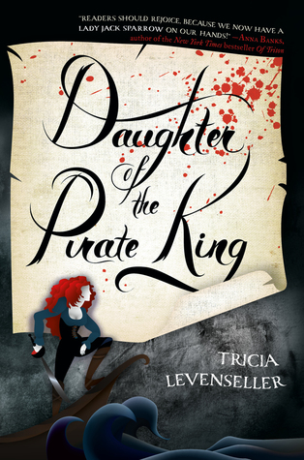
DB 88582 Daughter of the pirate king by Tricia Levenseller
Annotation: When her father, a ruthless pirate king, discovers that a legendary treasure map can be found on an enemy ship, Alosa knows that there's only one pirate for the job--herself. Violence, some strong language, and some descriptions of sex. Commercial audiobook. For senior high and older readers. 2017.

DB 83851 Pirates around the world, books 1-8: terror on the high seas by Laura Perdew, John Bankston, Tammy Gagne
Annotation: Eight books recount the adventures of famous pirates and identify the truths behind the legends. Includes Anne Bonny, Black Bart (Bartholomew Roberts), Blackbeard (Edward Teach), FrancÌois l'Olonnais, Long Ben (Henry Every), Sir Francis Drake, Sir Henry Morgan, and William Kidd. For grades 3-6. 2016.

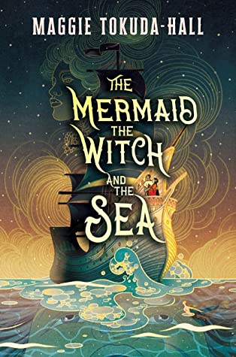
DB 99393 The mermaid, the witch, and the sea by Maggie Tokuda-Hall
Annotation: A desperate orphan turned pirate and a rebellious Imperial daughter find a connection on the high seas in a world divided by colonialism and threaded with magic. Violence, strong language, and some descriptions of sex. For senior high and older readers. 2020.

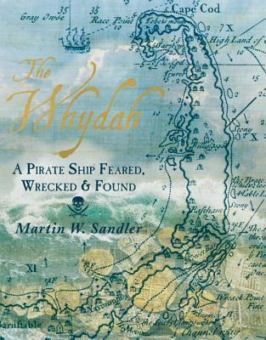
DB 88088 The Whydah: a pirate ship feared, wrecked, and found by Martin W. Sandler
Annotation: In 1984, the pirate ship the Whydah was found, nearly three hundred years after it sank in a storm off the coast of Cape Cod in 1717. Previously used by Captain Price as an infamous slave-trading ship, the vessel was taken over by pirate Black Sam Bellamy. For grades 6-9. 2017.

DB 102523 Pirate stew by Neil Gaiman
Annotation: Long John, the ship's cook, has a whole crew of wild pirates and two kids in tow. He's about to transform a perfectly ordinary evening into a riotous adventure beneath a pirate moon! Commercial audiobook. For preschool-grade 2. 2020.

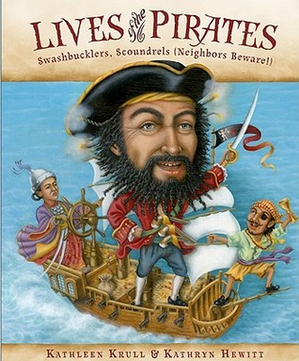
DB 71979 Lives of the pirates: swashbucklers, scoundrels (neighbors beware!) by Kathleen Krull
Annotation: Discusses twenty raiders who roamed the seven seas long before Hollywood glamorized their image. Includes one who wore pajamas on deck, another who pulled a two-foot-long parasite out of his leg, a pirate known as a teetotaler, and the Chinese woman who commanded two thousand ships. For grades 3-6. 2010.

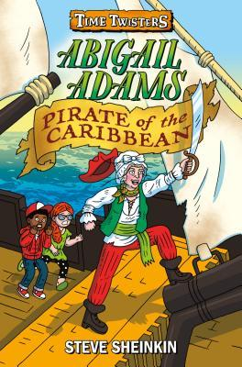
DB 99154 Abigail Adams, pirate of the Caribbean by Steve Sheinkin
Annotation: When Abigail Adams, tired of doing chores in the White House, travels back in time to join Anne Bonny and her crew of Caribbean pirates, stepsiblings Abby and Doc try to set history straight. Sequel to Abraham Lincoln, Pro Wrestler (DB 99153). Commercial audiobook. For grades 3-6. 2018.

