Week 4: United Frontiers
Note: All BR (braille) books are available from BARD.

Books for Adults

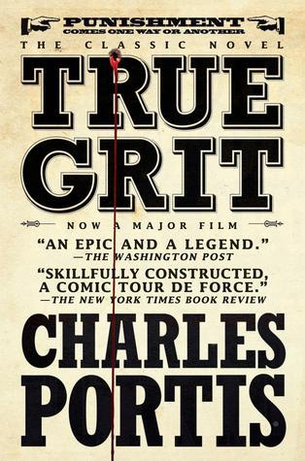
DB 44219 True grit by Charles Portis
Annotation: Fifty years afterward, a woman tells how, as a girl of fourteen, she, a federal marshal, and a Texas Ranger tracked her father's murderer from Arkansas into Indian territory. Some violence.
Also available as BR19212.

DB 111495 Firestick by J. A. Johnstone
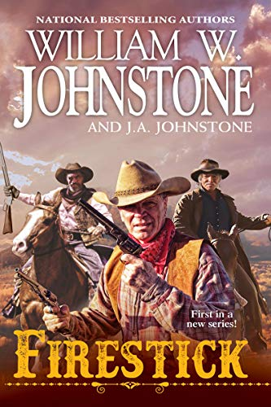
Annotation: "Johnstone Justice. What America Needs Now. In this exciting new series, bestselling authors William W. Johnstone and J.A. Johnstone pay homage to America's trail-hardened backwoodsmen who, like a fine grain whiskey, only get better with age.... REAL MEN DON'T RIDE INTO THE SUNSET In his mountain-man days, Elwood "Firestick" McQueen was practically a living legend. His hunting, tracking, and trapping skills were known far and wide. But it was his deadly accuracy with a rifle that earned him the Indian name "Firestick." His two best buddies are Malachi "Beartooth" Skinner-whose knife was as fatal as a grizzly's chompers-and Jim "Moosejaw" Hendricks, who once wielded the jawbone of a moose to crush his enemies in the heat of battle. Of course, things are different nowadays. The trio have finally settled down, running a horse ranch in West Texas-and spending quality time with their lady friends. But if you think these old boys are ready for lives of leisure, think again.... Firestick is the town marshal. Beartooth and Moosejaw are his deputies. And when a hired gunman shows up with bullets blazing, these three hard-cases are ready to prove they aren't getting older. They're getting deadlier." -- Provided by publisher. -- Unrated. Commercial audiobook.

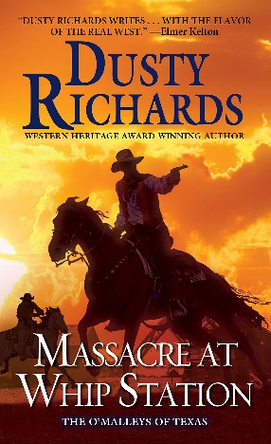
DB 101315 Massacre at Whip Station by Dusty Richards
Annotation: Joe O'Malley and his family attempt to plant roots at Whip Station, a critical stop on the Butterfield stagecoach line. Unfortunately, Whip Station is hunting ground for Mexican revolutionaries, Indians, renegade Confederates, and deadly outlaws. Sequel to Dead Aim (DB 93819). Some strong language, some violence. Commercial audiobook. 2020.

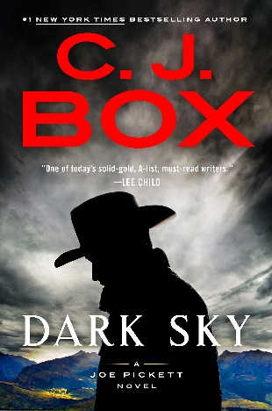
DB 102652 Dark sky by C. J. Box
Annotation: Game warden Joe Pickett is coerced by Wyoming's governor to take a tech baron into the wilderness on an elk hunting trip. But as they venture further away from society, Joe realizes they are the ones being hunted. Nate Romanowski and his daughter Sheridan follow Joe to help. Contains violence and strong language. Commercial audiobook. Bestseller. 2021.
Also available as BR23603.

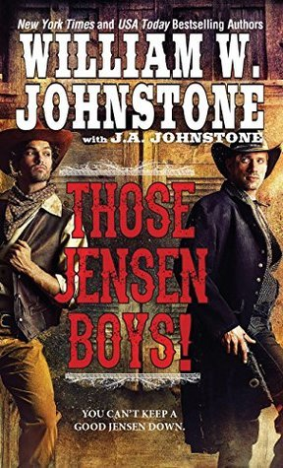
DB 94008 Those Jensen Boys! by William W. Johnstone
Annotation: Ace and Chance--the sons of Luke Jensen and the nephews of Smoke Jensen--are reckless and wild gunfighters. Their skills are put to the test when two young ladies ask them to protect their stagecoach line from a despicable and powerful mine owner. Commercial audiobook. 2015.

DB 107555 One for the blackbird, one for the crow by Olivia Hawker
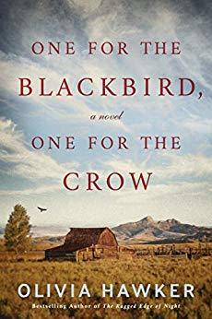
Annotation: Wyoming, 1876. The Bemis and Webber families have relied on each other to survive on the frontier. But then Ernest Bemis finds his wife, Cora, in a compromising situation with their neighbor. In one impulsive moment, a man is dead, Ernest is off to prison, and the women left behind are divided by rage and remorse. Some violence and some strong language. 2019.

DB 87906 Days without end by Sebastian Barry
Annotation: Thomas McNulty arrives in America from famine-starved Ireland and makes friends with John Cole. They team up to survive the harsh times on the Missouri frontier. Eventually, they both join the Army and see war. Their connection to each other helps them endure. Violence and some strong language. 2016.

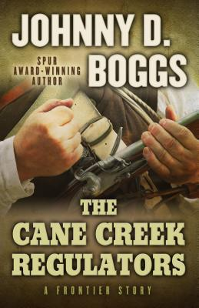
DB 83354 The Cane Creek Regulators by Johnny D. Boggs
Annotation: The South Carolina back country is a difficult place to live in the 1760s--gangs of criminals terrorize the country, and the government in Charlestown refuses to send help. Desperate, Breck Stewart decides to take a stand and forms a vigilante group called the Cane Creek Regulators. Some violence. 2014.

DB 32009 Dances with wolves by Michael Blake
Annotation: When Lieutenant Dunbar arrives at Fort Hays, the drunken, half- crazed major in charge immediately assigns him to Fort Sedgewick, an abandoned army outpost. Then the major is sent back east because of mental incompetence, and the army is unaware of Dunbar's presence at the fort. Alone, with only a wolf and Indian friends, Dunbar finds himself adapting to the Indian way of life--a life in which he is happy until his past comes back to haunt him. Bestseller.

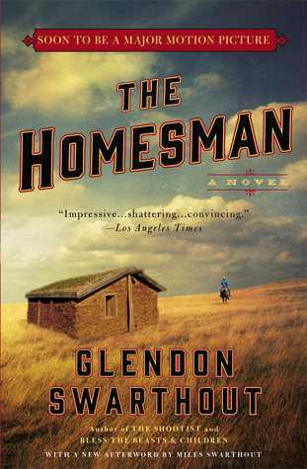
DB 29819 The homesman by Glendon Swarthout
Annotation: For many women attempting to settle in the West, the rigors of frontier life proved to be too much, and they went mad. To Mary Lee Cuddy falls the task of escorting four of these women back to Iowa. To help out she takes along John Briggs, whom she saved from lynching. The many difficulties they face along the way destroys one person and rejuvenates another. Strong language and some descriptions of sex.

BR12160 Chinook by Max Brand
Annotation: Joe Harney is a greenhorn, heading for the Alaskan goldfields. On the way he joins up with Andrew Steen and his great husky dog, Chinook. Together they come to the aid of a young woman, Kate Winslow. Joe falls for Kate and helps her out of many jams.

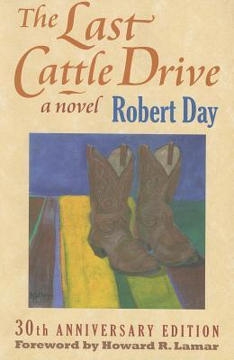
BR07976 The last cattle drive by Robert Dey
Annotation: An ornery cattle rancher in western Kansas is determined to get his herd to market without paying outrageous trucking charges. He, his tiny wife, a seventy-year-old ranch hand, and a greenhorn schoolteacher set out to drive 250 steers over highways, parking lots, and cloverleafs to the Kansas City stockyards. A rip-roaring tale told with humor by the schoolteacher. Strong language.

BR08295 Bitter trumpet by Fred Grove
Annotation: When the Civil War ends, Jesse Wilder returns home to Tennessee. Because he had joined the Union Army in order to escape certain death in the Yankee prison camp, he is not welcome back home. Drifting west, Jesse ends up in El Paso where he joins up with Cullen Floyd, who is running weapons to the Juaristas in Mexico. As they train troops led by Father Graza, Jesse again finds himself caught up in the horrors of war. Some strong language.

Books for Youth

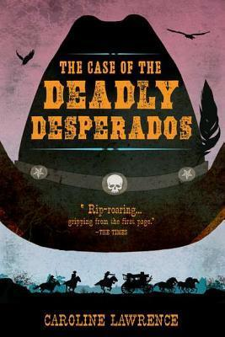
DB 75506 The case of the deadly desperados by Caroline Lawrence
Annotation: Nevada Territory, 1862. After finding his foster parents scalped and left for dead, twelve-year-old Pinky Pinkerton, son of a railroad detective and a Sioux Indian, inherits a valuable deed. But now murderous Whittlin Walt and his gang are after Pinky. Some violence. For grades 5-8 and older readers. 2011.
Also available as BR19633.

DB 57492 Stop the train! by Geraldine McCaughrean
Annotation: Cissy Sissney and her parents join other homesteaders and head for the Oklahoma territories. In Florence they discover the town hasn't been built yet, so they set to work. When the railroad threatens to pass it by, everyone schemes to force it to schedule stops there. For grades 5-8. 2001.

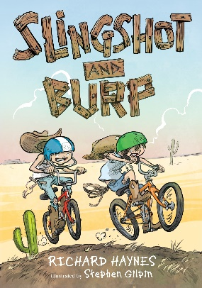
DB 85398 Slingshot and Burp by Richard Haynes
Annotation: Best friends and neighbors Slingshot and Burp spend the summer as cowboys looking for Old West adventures filled with outlaws, ghosts, and coyotes. For grades K-3. 2016.

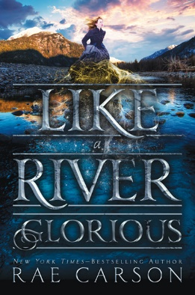
DB 87452 Like a river glorious by Rae Carson
Annotation: After her dangerous journey to California, Lee Westfall's magical power to sense gold continues to grow. When her villainous Uncle Hiram kidnaps her, Lee hopes her ability and her friends can stop him. Sequel to Walk on Earth a Stranger (DB 83092). Some violence. For grades 6-9 and older readers. 2016.

DB 12844 The tale of Lazy Lizard Canyon by Doris Burn
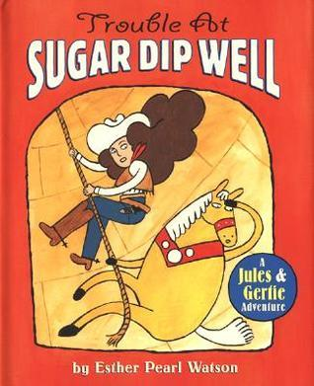
Annotation: A sweet-talking, fun-loving cowboy and a lovely young girl outsmart both their families and settle a long feud over Lazy Lizard Canyon. A humorous spoof of the West that was. For grades 3-6.

DBC06624 Trouble at Sugar Dip Well by Esther Watson
Annotation: Cowgirl Jules and her clever horse Gertie save the townsfolk when Mean Bulldog Pike and his greedy horse Bullet escape from jail and steal the water supply. For grades K-3.

DBC07192 Diablo, the devil steer by William J. Buchanan
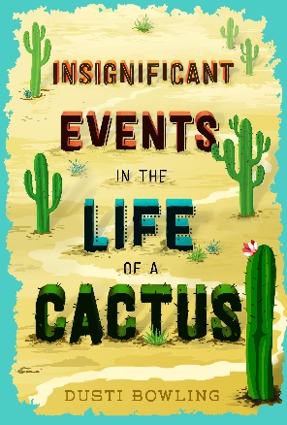
Annotation: Brought together by a mutual love of Horses, David an Isleta Indian, and Steven, an Anglo boy, forge a close friendship that is tested in the aftermath of a near-fatal attempt to capture a mad bull.

BR22120 Insignificant events in the life of a cactus by Dusti Bowling
Annotation: Born without arms, spunky thirteen-year-old Aven worries about making friends at her new school after her family moves to Arizona to manage the run-down Stagecoach Pass theme park. Aven bonds with classmate Connor, and the two soon find themselves immersed in a mystery at the park. For grades 5-8. 2017.

