# Week 4: Beastly Journeys

## Books for Adults / Libros para Adultos

### Audio

#### Killing Dragons book cover. A gigantic sea creature with a long nose and many sharp teeth has its mouth open to bite the dolphin or submersible device in front of it. A ghostly strand of DNA in the background. DB 110777 [*Killing dragons*](https://kstb.klas.com/title/summary.jsf?id=290170869.6232) by Kristie Clark

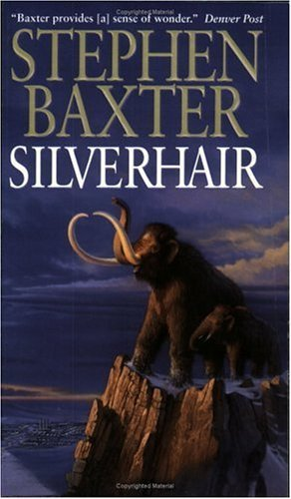"In a world where sea dragons terrorize dolphins, you enter the reef at your own risk. Marine biologist Eva Paz is on the verge of revolutionizing linguistics by cracking the dolphin communication code. Then police call her away to investigate a dead fisherman. It's her mother's boyfriend, but Eva is running out of time to complete her dolphin whistle library by the deadline, putting her grant at risk. Without funding, her dolphins will soon be turned loose in the deadly Caribbean. A cartel leader makes Eva an offer she can't refuse. He'll fund her dolphin research if she'll help him capture the sea dragon. His aid comes with a catch, and he doesn't count the cost. Then geneticist Thomas Sternberg arrives on sabbatical to lead a dive school. He wants to help Eva, but they share a tragic past. While on his watch as a Navy Seal, Eva's brother was killed, and her dolphin was wounded. Eva doesn't trust Thomas, but can she set that aside to work with him to stop the sea dragon and save her dolphins?" -- Provided by publisher. -- Unrated. Commercial audiobook.

#### DB 65056 [*Silverhair*](https://kstb.klas.com/title/summary.jsf?id=48495850.6232) by Stephen Baxter

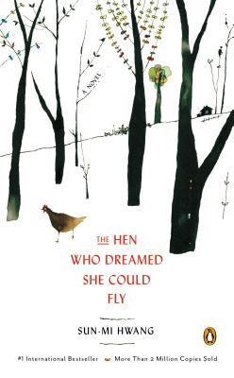The woolly mammoths have survived many springs, but their numbers are dwindling. Only one family remains, and Silverhair, soon to become a mother, looks to the future. But first, the mammoths must face the two-legged menace Silverhair calls the Lost. 1999.

#### DB 77919 [*The hen who dreamed she could fly*](https://kstb.klas.com/title/summary.jsf?id=107678210.6232) by Son-mi Hwangg

Sprout, an egg-laying hen, longs to escape from the coop, hatch an egg, and watch the birth of her chick. One day she breaks free into the wider world and learns to survive with other animals. Translated from Korean. 2013.

#### Deception Cover book cover. Cliffs and large rocks at the beach with rough waves. fog, and dark sky.DB 95384 [*Deception Cove*](https://kstb.klas.com/title/summary.jsf?id=188850350.6232) by Owen Laukkanen

Newly widowed ex-marine Jess Winslow counts on her loyal service dog, Lucy, who was trained by prisoner Mason Burke. Now released, Mason heads to Deception Cove, Washington, to see the dog. But the sheriff's department has seized Lucy until Jess can find a package stolen by her late husband. Violence, strong language, and explicit descriptions of sex. Commercial audiobook. 2019.

#### Walking the Big Wild book cover. A person hiking over mountains with flowers blooming and a puddle of mud with bear paw prints in it.DB 60530 [*Walking the Big Wild: from Yellowstone to the Yukon on the Grizzly Bears’ Trail*](https://kstb.klas.com/title/summary.jsf?id=47806468.6232) by Karsten Heuer

Wildlife biologist and park warden documents his eighteen-month journey along the Rocky Mountains to assess the health of the ecosystem and the feasibility of a wildlife reserve network. Chronicles his personal and wilderness adventures over thousands of ms by foot, skis, and ca

#### DB 61509 [*The tale of Holly How*](https://kstb.klas.com/title/summary.jsf?id=47954470.6232) by Susan Wittig Albert

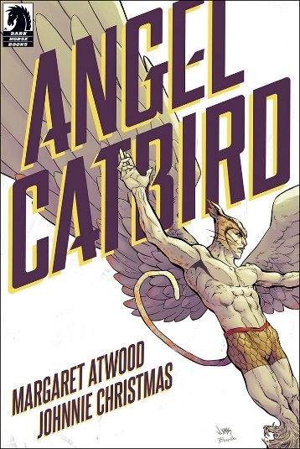English Lake District, 1906. Author Beatrix Potter and her pets are busy restoring Hill Top Farm, near the village of Sawrey, when they discover the body of a local shepherd. While investigating they also befriend an orphaned girl who is ignored by her grandmother, Lady Longford. 2005.

#### DBG10929 [*Angel catbird*](https://kstb.klas.com/title/summary.jsf?id=292126035.6232) by Margaret Atwood

On a dark night, young genetic engineer Strig Feleedus is accidentally mutated by his own experiment when his DNA is merged with that of a cat and an owl. Followed by "To Castle Catula". 2016. Unrated. Marrakesh title.

### Braille

#### BRC00679 The world’s greatest elephant by Ralph Heifer

Recounts the true and astonishing world adventures of Bram and Modoc, a boy and an elephant who became best of friends while growing up together in a German circus.

## Books for Youths / Libros Juveniles

### Audio

#### Sydney and Taylor explore the whole wide world book cover. A skunk wearing sunglasses and a bandanna holds a rolled-up paper in one hand as it's walking. Next to it, there is a hedgehog holding a staff in one hand while it wears a bandanna with its sunglasses clipped to it.DB 108329 [*Sydney & Taylor explore the whole wide world*](https://kstb.klas.com/title/summary.jsf?id=277468690.6232) by Jacqueline Davies

"Sydney is a skunk and Taylor is a hedgehog, but no matter how odd the pairing may seem, their friendship comes naturally. They live happily in their cozy burrow until the day Taylor gets his Big Idea to go see the whole wide world. From mountains taller than a hundred hedgehogs, valleys wider than a thousand skunks, to the dangers that lie in the human world, Sydney and Taylor wanted to see it all. With a map and a dream, they bravely set off, soon discovering that the world is much bigger than they realized." -- Provided by publisher. -- For grades K-3. 2021.

#### Into the wild book cover. Two cats stand facing each other, one with its mouth open like it's hissing. They are standing in the grass with trees in the distance. A rectangle is overlayed on top with an orange cat sitting in the clearing between trees.DB 66677 [*Into the wild*](https://kstb.klas.com/title/summary.jsf?id=32674523.6232) by Erin Hunter

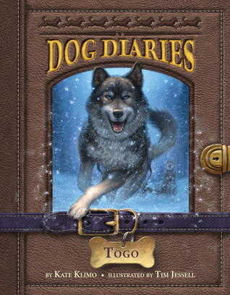A young house cat, Rusty--later renamed Firepaw and then Fireheart--leaves home to join the endangered ThunderClan, one of four rival clans of wildcats claiming the forest. With noble warrior cats mysteriously dying, Rusty trains to become a warrior, a hunter, and a survivor. Some violence. For grades 4-7. 2003.

#### DB 117093 [*Togo*](https://kstb.klas.com/title/summary.jsf?id=307840880.6232) by Kate Klimo

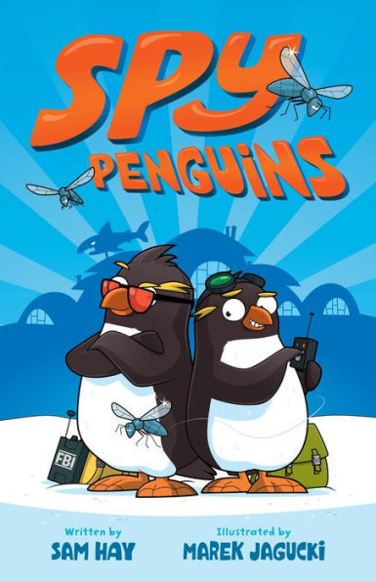"Sled dog Togo--the true hero of the 1925 Serum Run--narrates the story of his life working with musher Leonard Seppala." -- Provided by publisher. -- For grades 3-6.

#### DB 93125 [*Spy penguins*](https://kstb.klas.com/title/summary.jsf?id=180006441.6232) by Sam Hay

Young penguins Jackson, also known as Secret Agent 00Zero, and Quigley, an inventor, investigate who is stealing rare fish from the Rookeryville aquarium, hoping to prove themselves to the Frosty Bureau of Investigation. Commercial audiobook. For grades 2-4. 2018.

#### Violet and Jobie book cover. Two mice perch on top of a sign in a field of grass and flowers as an owl flies overhead and a fox looks at them from below.DB 112863 [*Violet and Jobie in the wild*](https://kstb.klas.com/title/summary.jsf?id=293659357.6232) by Lynne Rae Perkins

"Violet and Jobie, sibling mice accustomed to living comfortably in a human home, find themselves uprooted and must quickly adapt to an unfamiliar world." -- Provided by publisher. -- Commercial audiobook. For grades 2-4.

#### Whale down book cover. A whale with a concerned expression lets air out of its blowhole, spraying water and air.DB 113783 [*Whale done*](https://kstb.klas.com/title/summary.jsf?id=296662630.6232) by Stuart Gibbs

"While visiting his girlfriend Summer in Malibu, Teddy stumbles upon two mysteries involving a blown up whale explosion and a string of beach sand thefts, but his investigation is sidetracked by a rumor that his girlfriend is dating a celebrity, leading him to question their relationship." -- Provided by publisher. -- Commercial audiobook. For grades 5-8.

#### Dog squad book cover. Three dogs sit next to each other, all wearing sunglasses. A black and white border collie mix is on the left. An orange and tan bulldog mix is in the middle. On the right is a terrier mix.DBC15530 [*Cupola Kitty*](https://kstb.klas.com/title/summary.jsf?id=292171988.6232) by Terri Gingold

Fluffy has gone missing and Mama Kitty is worried. Where could Fluffy be? For grades K-3.

#### DB 103429 [*Dog squad*](https://kstb.klas.com/title/summary.jsf?id=262468804.6232) by Chris Grabenstein

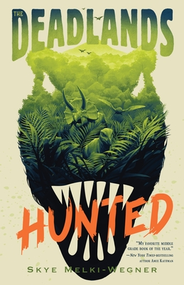Fred, a scrappy and lovable dog, gets cast as a stand-in for the lead role in Dog Squad, a show about crime-fighting dogs, and he soon finds out the action doesn't always stop on screen. Commercial audiobook. For grades 3-6. 2021.

#### DB 114252 [*Hunted*](https://kstb.klas.com/title/summary.jsf?id=298984988.6232) by Skye Melki-Wegner

"An unlikely group of dinosaur misfits discover a deadly secret and must band together to save their herbivore kingdoms from doom at the hands of ruthless carnivores." -- Provided by publisher. -- Commercial audiobook. For grades 4-7.

#### DB 51689 [*White Fang*](https://kstb.klas.com/title/summary.jsf?id=46992920.6232) by Jack London

A wolf-dog, rescued from danger and tamed by a kind master, redeems his brute nature by defending his master's family against an escaped convict. Companion to The Call of the Wild (DB 49486). For junior and senior high 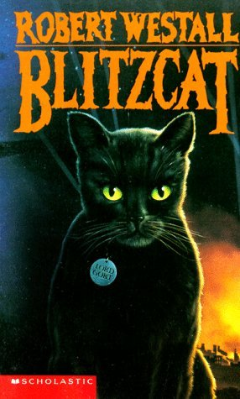and older readers. 1906.

#### DB 56052 [*Blitzcat*](https://kstb.klas.com/title/summary.jsf?id=47182033.6232) by Robert Westall

Lord Gort, a black female cat, runs away to search the countryside for her beloved master, a pilot, during World War II. She survives many dangerous adventures and is adopted by several people on her journey. Some strong language. For senior high and older readers. 1989.

#### Endangered book cover. The head of a baby ape against a black background.DB 91497 [*Endangered*](https://kstb.klas.com/title/summary.jsf?id=173727186.6232) by Eliot Schrefer

While spending the summer in the Congo, Sophie rescues an abused baby bonobo and becomes more involved in her mother's sanctuary. When fighting breaks out, it is up to Sophie to rescue the apes and somehow survive in the jungle. Unrated. Commercial audiobook. Violence. For senior high and older readers. 2016.

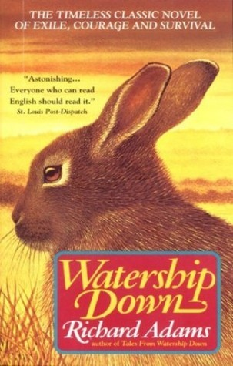Also available in braille as BR 19742.

#### DB 35730 [*Watership down*](https://kstb.klas.com/title/summary.jsf?id=54327475.6232) by Richard Adams

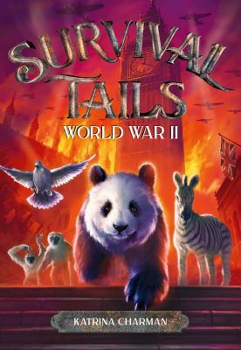A fable about a band of rabbits who set out bravely for a new home in the English countryside. They encounter many dangers and adventures along the way, and finally make it to safety after rescuing some does who become their mates. For junior and senior high and older readers.

### Braille

#### BR 23054 Survival tails: World War II, book 3 by Katrina Charman

1940. When Francis, an injured messenger pigeon, lands in Ming's enclosure, the panda bear knows she must do her part in the war effort. Ming enlists the help of other brave zoo animals to aid Francis in his mission. For grades 3-6. 2019.

#### The Golden Swift book cover. Two trains sit facing each other on railroad tracks with mountains and hills in the background under a full moon coming up over the horizon. A boy perches on the front of the golden train on the left holding onto a ladder with one hand. Two Canadian lynx crawl along the golden train. On the left, a girl hold onto the black train with one hand and a shovel in other slightly reaching out to the other train. A cassowary and a wolverine are on the train with the girl.BR 24210 *The Golden Swift* by Lev Grossman

"Kate and Tom are now full-fledged conductors of the steam-powered, animal-saving Great Secret Intercontinental Railway, but when Kate takes the Silver Arrow out on an unsanctioned mission to find Uncle Herbert she discovers a mysterious train called the Golden Swift with an agenda of its own." -- Provided by publisher. For grades 4-7. 2022.

#### Toad rage book cover. A toad perches its front legs on the title of the book with double yellow lines on the road behind it.BR 18117 *Toad rage* by Morris Gleitzman

An Australian cane toad named Limpy notices that human drivers deliberately run down and kill his relatives. Determined to figure out why humans hate toads and to change their opinion, Limpy embarks on a dangerous trek from his swamp to the Summer Olympics in Sydney. For grades 3-6. 2001.

#### Fire and ice book cover. A boy with a staff and a bid of prey face off against a giant polar bear in front of snowy buildings.BR 21142 *Fire and ice* by Shannon Hale

Conor, Abeke, Meilin, and Rollan, supported by their spirit animals, follow a lead in the cold north, only to arrive in a deceptively beautiful village where everything is not as it seems. Sequel to Blood Ties (BR 20991). Uncontracted braille. For grades 4-7. 2014.

#### BRG03318 The magnificent Moon Hare and the foul treasure by Sue Monroe

P.J. and the Moon Hare are off on a new adventure, battling pirates. Accompanied by P.J.'s dragon (who's called Sandra even though he's a boy), can P.J. and the Moon Hare stop the horrible feathered villain Foul from stealing Uncle Julian's treasure? Grades 2-4. Sequel to "The magnificent Moon Hare". 2012. Marrakesh title.

#### BR 15435 *Tough trails* by Irene Morck

Seventeen-year-old Ambrose takes tourists on trail rides while working for his uncle in Alberta's Rocky Mountains. He buys an older mare out of compassion but faces disaster when the animal can't make it up a pass. Uncontracted braille. For senior high and older readers. 2003.