Week 4: Ocean Mythology

Books for Adults

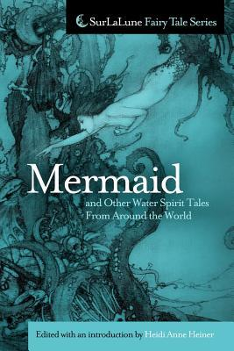
DB 81731 Mermaid and other water spirit tales from around the world: folklore about mermaids and other merfolk by Heidi Anne Heiner
Annotation: This collection gathers over 150 folktales, fairy tales, and ballads from around the world about mermaids and other water spirits, together with information on their history. Includes examples of the earliest scholarship on mermaids and similar creatures. Violence. 2011.

DB 104942 The last odyssey by James Rollins
Annotation: In the frozen tundra of Greenland, a group of climatologists and archaeologists uncover a medieval ship buried a half mile below the ice. Inside are priceless treasures, including a clockwork map that traces the path of Odysseus's ship after leaving Troy. It also reveals the entrance to Tartarus. Unrated. Commercial audiobook. 2020

DB 80796 Jason and the Argonauts by Apollonius
Annotation: Translation in verse of Ancient Greek poem detailing the voyage of the hero Jason and his crew, the Argonauts--including Heracles and Orpheus, as they search for the Golden Fleece at the directive of King Pelias. They encounter treachery of all kinds, both from mortal and immortal foes. Some violence. 2014.

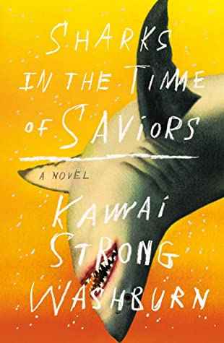
DB 98952 Sharks in the time of saviors by Kawai Strong Washburn
Annotation: In 1995, seven-year-old Hawaiian boy Nainoa Flores falls overboard on a ship. He is rescued by sharks, which his family believes marks him as favored by the gods. But as time passes, this supposed divine favor begins to drive the family apart. Unrated. Commercial audiobook. 2020.

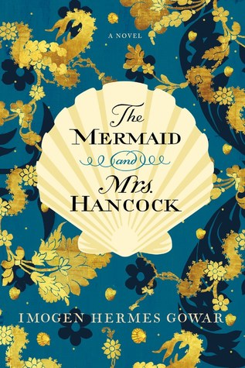
DB 93081 The mermaid and Mrs. Hancock by Imogen Hermes Gowar
Annotation: 1785. Merchant Jonah Hancock is shocked when one of his ship's captains returns home with the news that he sold the ship for the mummified remains of a mermaid. All of London wants to see the wonder, and Jonah finds himself engaged in a perilous liaison. Contains some descriptions of sex. Commercial audiobook. 2018.

DB 54582 Folklore and the sea by Mystic Seaport Museum
Annotation: A collection of maritime traditions, legends, beliefs, and superstitions about shipbuilding, weather, mermaids, sea monsters, specter ships, and related topics. Includes a selection of songs and chanteys. 1973.

Books for Youths

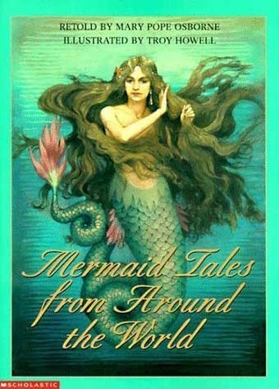
DB 38698 Mermaid tales from around the world by Mary Pope Osborne
Annotation: A collection of twelve water maid tales from a wealth of different cultures and times. The author notes that mermaids, unlike other women in folklore, are universally portrayed as fierce, strong characters. Includes the French "Mystery of Melusine," the Irish "The Enchanted Cap," the Nigerian "The Fish Husband," and Japanese, Persian, German, Greek, and Native American legends. For grades 3-6 and older readers.

DB 83297 Mocha Dick: the legend and fury by Brian J. Heinz
Annotation: The original great white whale, first spied off the coast of Chile in 1810, becomes a prime target for whalers as he thrashes about the Pacific and achieves legendary status. For grades 2-4. 2014.

DB 86573 Moana by Suzanne Francis
Annotation: In the ancient South Pacific, Moana, a born navigator, sets sail in search of a fabled island. She teams up with the legendary demi-god Maui, and they encounter enormous sea creatures and more. Adaptation of the Disney film version. For grades 2-4 and older readers. 2016.

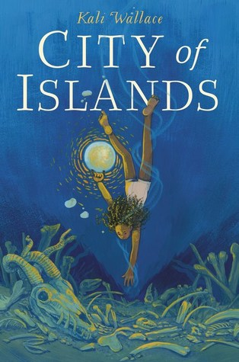
DB 92029 City of islands by Kali Wallace
Annotation: Orphaned and now a diver for the powerful Lady of the Tides, young Mara makes a startling discovery of magical bones on the ocean floor. The reward she expects doesn't materialize, and, instead, Mara is tasked with uncovering where the bones' origin. For grades 6-9. 2018.

DB 87073 Jason and the Argonauts: the first great quest in Greek mythology by Robert Byrd
Annotation: A recounting of the legend of Greek hero Jason, the gifted Argonauts, and their dangerous quest to retrieve the magical Golden Fleece--said to have been sent by the Gods of Olympus. For grades 3-6. 2016.

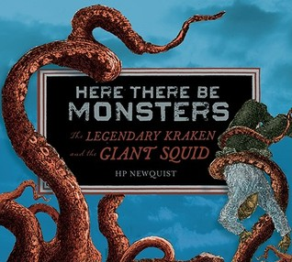
DB 72615 Here there be monsters: the legendary kraken and the giant squid by H. P. Newquist
Annotation: Traces human knowledge of enormous sea creatures from Greek myth and sailor's tales to Melville and Verne's literary works and scientific evidence slowly gathered from around the world. Describes modern technological advances that enable marine researchers to probe the ocean depths for these elusive colossal squid. For grades 5-8. 2010.

DB 55978 Water: tales of elemental spirits by Robin McKinley
Annotation: Six stories about fabulous creatures associated with water. In "Mermaid Song," by Peter Dickinson, orphan Pitiable Nasmith is beaten by her miserable grandfather, Probity Hooke, until the day she rescues an injured sea-child and thereby saves herself. For grades 6-9. 2002.

DB 100195 A song below water by Bethany C. Morrow
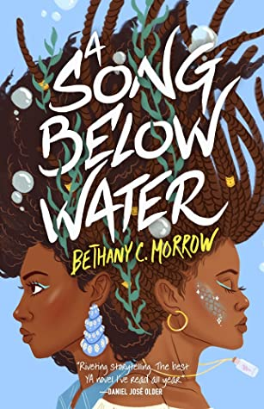
Annotation: In a society that persecutes sirens, Tavia struggles to hide her powers. Meanwhile, her best friend, Effie, is fighting against literal demons from her past. But everything changes in the aftermath of a siren murder trial that rocks the nation. Some violence. Commercial audiobook. For senior high and older readers. 2020.

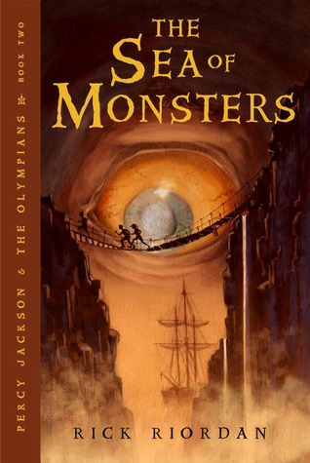
DB 64659 The sea of monsters: Percy Jackson and the Olympians, book 2 by Rick Riordan
Annotation: Upstate New York, 2006. Seventh-grader Percy, son of Poseidon and a mortal, learns that Camp Half-Blood is in danger. He and his friends undertake a perilous journey into the Sea of Monsters to save their beloved camp. Sequel to The Lightning Thief (DB 63443). For grades 5-8. 2006.

