Week 3 / 3ª semana: Into the wild alone / Solos en la naturaleza

Books for Adults / Libros para Adultos

Audio

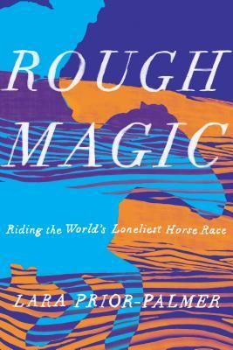
DB 95229 Rough magic: riding the world’s loneliest horse race by Lara Prior-Palmer
At nineteen, the author entered an annual endurance event where dozens of riders race wild ponies across 1,000 kilometers of the Mongolian steppes. She describes the grueling days that she rode through heat and storms in her bid to become the race's first female winner. Some strong language. Commercial audiobook. 2019.
Also available as BR 22746.

DBC13561 Old librarians never die, they jump our of airplanes adventuring through the senior years in Indiana by Marie J. Albertson
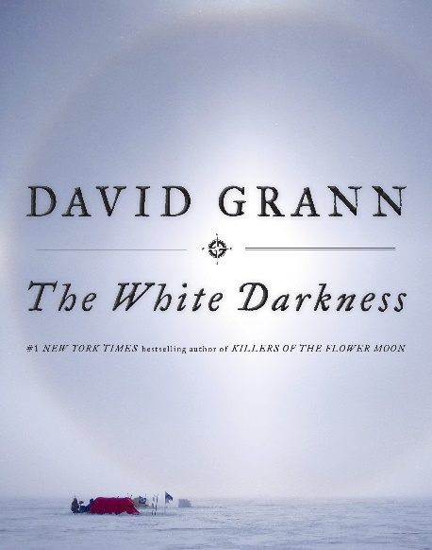
Albertson raised four children and put herself through college while doing so. After her husband's death she became a librarian at the Indiana State Library with a "rest of my life to-do list"...this book tells her personal story as she worked, then retired and began adventuring: learning to kayak, horseback-riding to see the wild mustangs, crewing on a tall ship, visiting the Great Wall of China on a budget, taking gliding lessons and reading Shakespeare.

DB 93369 The white darkness by David Grann
Profile of Lieutenant Colonel Henry Worsley, who died in 2016 while attempting to cross Antarctica on his own. Discusses Worsley's fascination with polar explorer Ernest Shackleton, his 2008 trek through the Transantarctic Mountains with two fellow descendants of Shackleton's men, and his final expedition. Commercial audiobook. 2018.

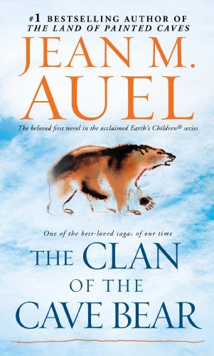
DB 52680 The clan of the cave bear by Jean Auel
After her people perish in an earthquake during the Ice Age, Cro-Magnon woman Ayla is adopted by a beetle-browed Neanderthal clan. Banished several times for flouting taboos, Ayla finally realizes that she must leave the group, doomed to extinction, and seek out her own kind. Some explicit descriptions of sex. Bestseller. 1980.
Also available as BR 16674.

DB 117446 A true account: Hannah Masury’s sojourn amongst the pyrates, written by herself by Katherine Howe
"In Boston, as the Golden Age of Piracy comes to a bloody close, Hannah Masury - bound out to service at a waterfront inn since childhood - is ready to take her life into her own hands. When a man is hanged for piracy in the town square and whispers of a treasure in the Caribbean spread, Hannah is forced to flee for her life, disguising herself as a cabin boy in the pitiless crew of the notorious pirate Edward "Ned" Low. To earn the freedom to choose a path for herself, Hannah must hunt down the treasure and change the tides. Meanwhile, professor Marian Beresford pieces Hannah's story together in 1930, seeing her own lack of freedom reflected back at her as she watches Hannah's transformation. At the center of Hannah Masury's account, however, lies a centuries-old mystery that Marian is determined to solve, just as Hannah may have been determined to take it to her grave." -- Provided by publisher. -- Unrated. Commercial audiobook.

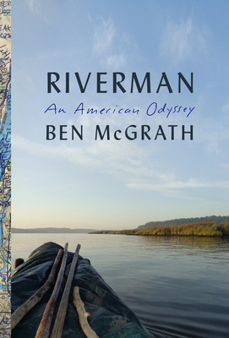
DB 110524 Riverman: an American odyssey by Ben McGrath
"For decades, Dick Conant paddled the rivers of America, covering the Mississippi, Yellowstone, Ohio, Hudson, as well as innumerable smaller tributaries. These solo excursions were epic feats of planning, perseverance, and physical courage. At the same time, Conant collected people wherever he went, creating a vast network of friends and acquaintances who would forever remember this brilliant and charming man even after a single meeting. Ben McGrath, a staff writer at The New Yorker, was one of those people. In 2014 he met Conant by chance just north of New York City as Conant paddled down the Hudson, headed for Florida. McGrath wrote a widely read article about their encounter, and when Conant's canoe washed up a few months later, without any sign of his body, McGrath set out to find the people whose lives Conant had touched-to capture a remarkable life lived far outside the staid confines of modern existence. Riverman is a moving portrait of a complex and fascinating man who was as troubled as he was charismatic, who struggled with mental illness and self-doubt, and was ultimately unable to fashion a stable life for himself; who traveled alone and yet thrived on connection and brought countless people together in his wake. It is also a portrait of an America we rarely see: a nation of unconventional characters, small river towns, and long-forgotten waterways." -- Provided by publisher. -- Unrated. Commercial audiobook.

DB 50059 Loot by Aaron J. Elkins
Austria, 1945. A lone truck carrying artworks stolen by Nazis disappears in the snow. Fifty-odd years later, one of the paintings appears in a Boston pawn shop. Art historian Ben Revere joins in an investigation that leads to Europe and the Mafia. Some violence and some strong language. 1999

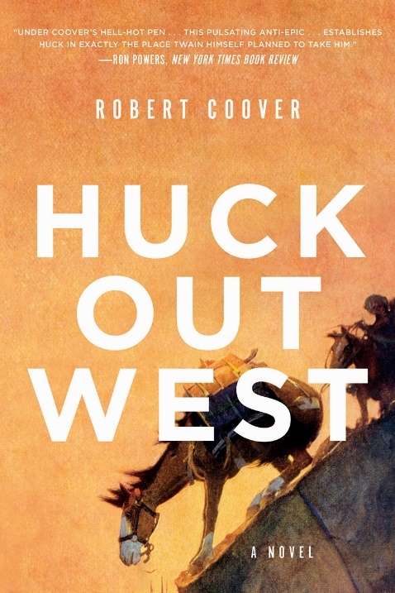
DB 108429 Huck out West by Robert Coover
"At the end of Huckleberry Finn, on the eve of the Civil War, Huck and his pal Tom Sawyer "light out for the Territory" to avoid "sivilization." In Robert Coover's vision of their Western adventures, Huck and Tom start by joining the famous but short-lived Pony Express. Tom becomes something of a hero and decides he'd rather own civilization than escape it, returning east to get a wife and a law degree. But Huck stays alone in the Territory; he guides wagon trains, scouts for both sides in the war, wrangles horses on a Chisholm Trail cattle drive, joins a bandit gang, finds an ill-fated pal in an army fort and another in a Lakota Sioux tribe, and eventually finds himself in the Black Hills just ahead of the 1876 Gold Rush. In the course of his adventures, Huck reunites with Tom, Jim, and Becky Thatcher and faces some hard truths and harder choices." -- Provided by publisher. -- Unrated. Commercial audiobook. 2017.
Also available as BR 24299.

DB 108120 In the distance by Hernán Díaz
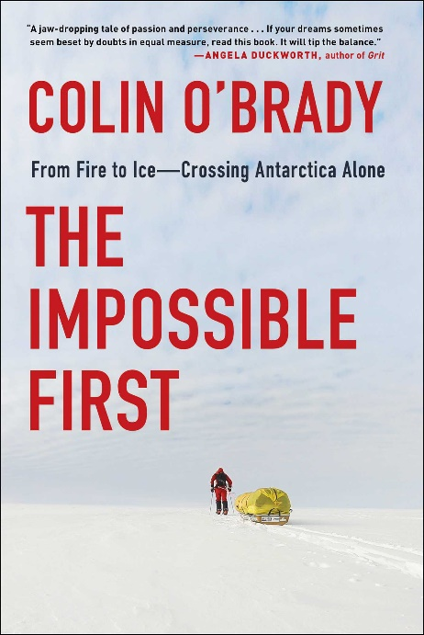
"A young Swedish immigrant finds himself penniless and alone in California. The boy travels East in search of his brother, moving on foot against the great current of emigrants pushing West. Driven back again and again, he meets naturalists, criminals, religious fanatics, swindlers, Indians, and lawmen, and his exploits turn him into a legend. Diaz defies the conventions of historical fiction and genre, offering a probing look at the stereotypes that populate our past and a portrait of radical foreignness." -- Amazon. -- Unrated. Commercial audiobook. 2017.
Also available as BR 24216.

DB 98789 The impossible first: from fire to ice—crossing Antarctica alone by Colin O’Brady
Man's chronicle of crossing the Antarctic alone ten years after being horrifically injured in an accident. Discusses his mental and physical preparations for the trip, challenges he encountered, reflections on his past including relationships that shaped him, and what it took to achieve his goal. Unrated. Commercial audiobook. 2020.

DB 118009 Un descuido cósmico by Liliana Blum
"Desde una mujer mayor que adopta a un alienígena, una esposa traicionada que recurre a la magia vudú como práctica terapéutica, una anciana solitaria que juega con la ouija, hasta una vampiresa cuyas víctimas son hombres violentos y acosadores, los ocho cuentos reunidos en este libro tienen como protagonistas a individuos comunes que se encuentran con lo fantástico, personas con pretensiones convencionales y aspiraciones legítimas que, sin embargo, las llevan a tomar caminos oscuros y desconcertantes. Plagado de humor negro, un tratamiento de la violencia sórdido y único, complementado por elementos de suspenso, de terror y hasta de ciencia ficción, Un descuido cósmico convoca a un elenco de personajes perturbadores, con sueños rotos e ilusiones perdidas, que muestran que no hay demonio más seductor y creativo que el espíritu de la venganza." -- Proporcionada por la editorial. -- Sin calificación. Audiolibro comercial.

DB 101543 La esperanza del Tíbet by José Vicente Alfaro
En el siglo dieciocho, el Tíbet se encontraba bajo el poder del Imperio mongol, como la mayoría del mundo en aquel época. Un niño budista empieza la búsqueda para la reencarnación y una familia humilde tiene que huir del ejército mongol. ¿Cuál será su destino? Sin calificación. Audiolibro comercial. NLS foreign language annotation

DB 115997 El viento conoce mi nombre by Isabel Allende
"Una historia de violencia, amor, desarraigo y esperanza Un audiolibro dramatizado en el que participan más de 20 actores y actrices de 4 países distintos, así como la propia Isabel Allende. Viena, 1938. Samuel Adler es un niño judío de seis años cuyo padre desaparece durante la Noche de los Cristales Rotos, en la que su familia lo pierde todo. Su madre, desesperada, le consigue una plaza en un tren que le llevará desde la Austria nazi hasta Inglaterra. Samuel emprende una nueva etapa con su fiel violín y con el peso de la soledad y la incertidumbre, que lo acompañarán siempre en su dilatada vida. Arizona, 2019. Ocho décadas más tarde, Anita Díaz, de siete años, sube con su madre a bordo de otro tren para escapar de un inminente peligro en El Salvador y exiliarse en Estados Unidos. Su llegada coincide con una nueva e implacable política gubernamental que la separa de su madre en la frontera. Sola y asustada, lejos de todo lo que le es familiar, Anita se refugia en Azabahar, el mundo mágico que solo existe en su imaginación. Mientras tanto, Selena Durán, una joven trabajadora social, y Frank Angileri, un exitoso abogado, luchan por reunir a la niña con su madre y por ofrecerle un futuro mejor. En El viento conoce mi nombre pasado y presente se entrelazan para relatar el drama del desarraigo y la redención de la solidaridad, la compasión y el amor. Una novela actual sobre los sacrificios que a veces los padres deben hacer por sus hijos, sobre la sorprendente capacidad de algunos niños para sobrevivir a la violencia sin dejar de soñar, y sobre la tenacidad de la esperanza, que puede brillar incluso en los momentos más oscuros." -- Proporcionada por la editorial. -- Sin calificación. Audiolibro comercial.

DB 103043 Lo que le falta al tiempo by Ángela Becerra
Una estudiante de pintura vive sola en París. En su casa encierra un valioso secreto que ha sido conservado por generaciones y que puede cambiar el rumbo del arte. Su vida se verá conmocionada por la aparición de Cádiz que despierta en ella una pasión sin límites. Sin calificación. Audiolibro comercial.

DB 80968 Misión olvido by María Dueñas
Su vida personal en ruinas, La Profesora Blanca Perea acepta un puesto acadeÌmico en una universidad en California. AlliÌ Blanca descubre el trabajo olvidado de un colega muerto y logra despertar el intereÌs romaÌntico de otro, en un campus lleno de intriga y realizacioÌn inesperada.

DB 118008 Trece latas de atún by Amandititita
"Amanda ha tenido siempre una mirada aguda e irónica acerca de sí misma y de quienes la rodean: sabe estar sola y acompañada. Sin embargo, en este libro nos revela dos aspectos de su ser menos conocido: su destreza informal para la fabulación: sabe relatar historias breves por medio de un ritmo más seductor que acosador. Y, por otra parte, abandona la guerra cotidiana que libra a cada momento de su vida como artista popular y nos propone a un ser menos glamuroso, pero más humano. Este conjunto de relatos biográficos, ficciones y trazos literarios no necesitan la definición del género: están aquí para ser leídos como quien se asoma a una ventana y se da cuenta de que la aparente sencillez de las cosas que nos rodean y de las que formamos parte, se halla contenida en la diversidad de sus dramas y de sus tribulaciones. Trece latas de atún no es un libro gratuito porque posee un valor inusual en estos tiempos de penuria y comercio salvaje: ha sido escrito con desgarbo, humor y perspicacia. No es una construcción artificial y sí la consecuencia de una pelea y destrucción constante y animada." -- Proporcionada por la editorial. -- Sin calificación. Audiolibro comercial.

DBG19184 Lo que me queda por vivir by Elvira Lindo
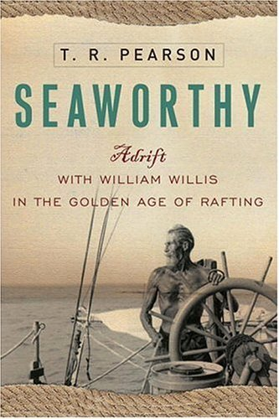
Reseña: Antonia tiene veintiséis años cuando se ve sola con un niño de cuatro en el cambiante Madrid de los ochenta. La suya es la historia de un viaje interior, el de una mujer que se enfrenta a la juventud y a la maternidad mientras intenta hacerse un lugar en la vida. Unrated. Spanish language. Marrakesh title.

Braille

BR 16854 Seaworthy: adrift with William Willis in the golden age of rafting by T. R. Pearson
Chronicles the life of German-born sailor William Willis (1893-1968), highlighting his voyages aboard small crafts of his own design and construction. Describes his 1954 115-day, trans-Pacific solo journey (with a cat and a parrot), during which he endured injuries, ailments, storms, and other calamities and survived by drinking seawater. 2006.

BR 20725 Finding zero: a mathematician’s odyssey to uncover the origins of numbers by Amir D. Aczel
"The invention of numerals is perhaps the greatest abstraction the human mind has ever created. Virtually everything in our lives is digital, numerical, or quantified. The story of how and where we got these numerals, which we so depend on, has for thousands of years been shrouded in mystery. Finding Zero is an adventure filled saga of Amir Aczel's lifelong obsession: to find the original sources of our numerals. Aczel has doggedly crisscrossed the ancient world, scouring dusty, moldy texts, cross examining so-called scholars who offered wildly differing sets of facts, and ultimately penetrating deep into a Cambodian jungle to find a definitive proof. Here, he takes the reader along for the ride. The history begins with the early Babylonian cuneiform numbers, followed by the later Greek and Roman letter numerals. Then Aczel asks the key question: where do the numbers we use today, the so-called Hindu-Arabic numerals, come from? It is this search that leads him to explore uncharted territory, to go on a grand quest into India, Thailand, Laos, Vietnam, and ultimately into the wilds of Cambodia. There he is blown away to find the earliest zero--the keystone of our entire system of numbers--on a crumbling, vine-covered wall of a seventh-century temple adorned with eaten-away erotic sculptures. While on this odyssey, Aczel meets a host of fascinating characters: academics in search of truth, jungle trekkers looking for adventure, surprisingly honest politicians, shameless smugglers, and treacherous archaeological thieves--who finally reveal where our numbers come from." – provided by publisher

BR 13430 Mr. Finchley discovers his England by Victor Canning
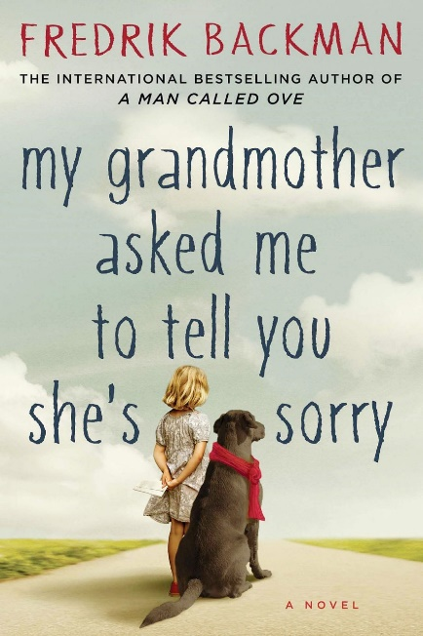
Twelve-year-old mastermind Artemis plans to restore his family fortune by obtaining some of the fairies' gold. The first step involves blackmailing an alcoholic fairy to photograph her "Book," containing her race's secrets but written in an ancient tongue. Some violence. For grades 5-8. Bestseller. 2001.

BRG03737 My grandmother sends her regards and apologizes by Fredrik Backman
Elsa is seven years old and different. Her grandmother is seventy-seven years old and crazy. Standing-on-the-balcony-firing-paintball-guns-at-men-who-want-to-talk-about-Jesus-crazy. She is also Elsa's best, and only, friend. At night Elsa runs to her grandmother's stories, to the Land of Almost-Awake and the Kingdom of Miamas. There, everybody is different and nobody needs to be normal. So when Elsa's grandmother dies and leaves behind a series of letters apologizing to people she has hurt, it marks the beginning of Elsa's greatest adventure. 2015. Unrated. Marrakesh title.

BR 13312 The water in between by Kevin Patterson
Canadian ex-army doctor Patterson recalls a sailing adventure from Vancouver Island to Tahiti with a friend in 1994 and 1995. Describes the four-day gale encountered on his solo return voyage and his fear that a journey meant to distract him from a broken heart might actually end in death. 1999.

BR 13297 Yukon alone: the world’s toughest adventure race by John Balzar
A journalist spends six months among the mushers of the far north as they prepare for the grueling Yukon Quest International Sled Dog Race--1,023 snowy miles between Whitehorse and Fairbanks, Alaska. Depicts the men and women struggling to take their dog teams through the wilderness. Some strong language. 1999.

BRG02981 Into the wild by Jon Krakauer
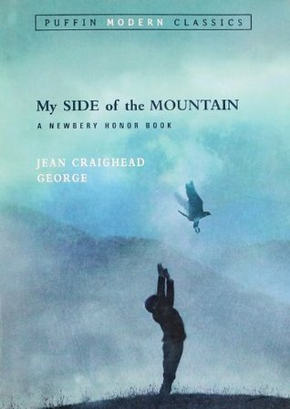
This book, which grew from an article the author wrote for Outside magazine, discusses a fatal trek by a young man named Chris McCandless. After graduating from college in 1990, McCandless abandoned his car, gave away his money, and cut off contact with his family. Exactly 112 days after he wandered into the Alaskan wild, McCandless was found dead of starvation. The author looks to himself and other adventurers for an explanation. Bestseller. 1996. Unrated. Marrakesh title.

Books for Youths / Libros Juveniles

Audio

DB 50211 My side of the mountain by Jean Craighead George
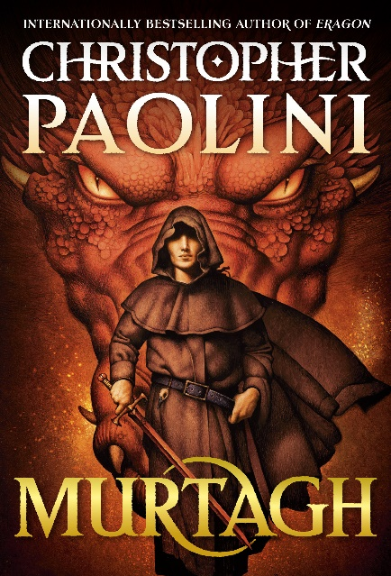
Sam Gribley relates his adventures during the year he lives alone in the Catskill Mountains. He describes his struggle for survival, his dependence on nature, his animal friends, and his ultimate realization that he needs human companionship. For grades 5-8. 1959.
Also available as BR 15070.

DB 117564 Murtagh by Christopher Paolini
"Join Dragon Rider--and fan favorite--Murtagh and his dragon as they confront a perilous new enemy! The world is no longer safe for the Dragon Rider Murtagh and his dragon, Thorn. An evil king has been toppled, and they are left to face the consequences of the reluctant role they played in his reign of terror. Now they are hated and alone, exiled to the outskirts of society." -- Provided by publisher. Unrated. Commercial audiobook. For junior and senior high readers.

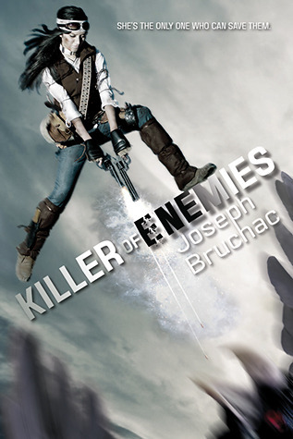
DB 78176 Killer of enemies by Joseph Bruchac
In a distant future, Native American girl Lozen hunts genetically modified monsters for the tyrants who are holding her mother, sister Ana, and little brother Victor hostage. With each kill Lozen's unique powers grow. Violence and some strong language. For senior high and older readers. 2013.
Also available as BR 20462.

DB 75721 Max Cassidy, escape from Shadow Island by Paul Adam
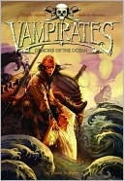
British fourteen-year-old Max Cassidy draws on his skills and training as a professional escape artist to prove his mother did not murder his father. Max's dad disappeared two years earlier in the Central American country of Santo Domingo. For grades 5-8 and older readers. 2009.

DB 112721 Demons of the ocean by Justin Somper
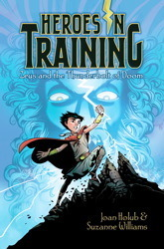
"Conor and Grace are twins, recently orphaned after their widowed father's death. Rather than being adopted by the town's busy-bodies, they decide to set sail for new pastures in their father's last single possession, his sailing boat. But a vicious storm sees their boat capsize and the twins are separated. Two mysterious ships sail to their rescue--each picking up one twin before disappearing into the mist. Conor wakes to find himself on a pirate ship and is soon being trained up with a cutlass. Meanwhile Grace finds herself locked in a darkened room, as the vampirates wait for night to fall and their feasting to begin. Determined to find each other, yet intrigued by their new shipmates, the twins are about to embark on the biggest adventure of their life." -- Provided by publisher. -- Unrated. Commercial audiobook. For grades 5-8.

DB 116747 Zeus and the thunderbolt of doom by Suzanne Williams
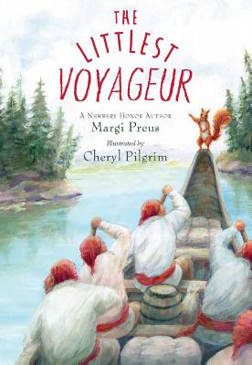
"When ten-year-old Zeus is kidnapped, he discovers he can defend himself with a magical thunderbolt." -- Provided by publisher. -- Commercial audiobook. For grades 2-4.

DB 109347 The littlest voyageur by Margi Preus
"In 1792, Jean Pierre Petit Le Rouge, a squirrel, eager for adventure, stows away in the canoe of a group of voyageurs, unaware of what they are traveling so far to trade." -- Provided by publisher. -- Commercial audiobook. For grades 2-4.

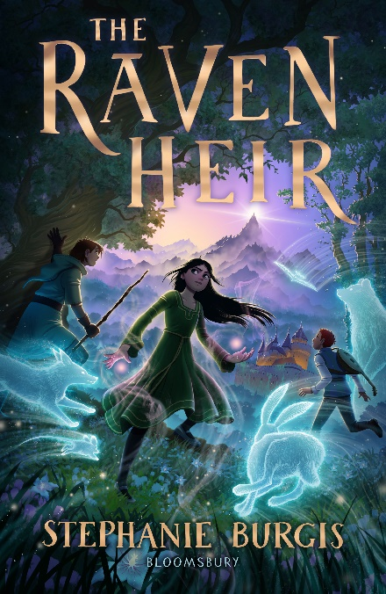
DB 115325 The Raven heir by Stephanie Burgis
"Cordelia, a young shapeshifter who has always lived in an enchanted forest with her siblings and mother, must now use her powers to discover the truth about who the Raven Heir really is." -- Provided by publisher. -- Commercial audiobook. For grades 3-6.

DB 30535 Hatchet by Gary Paulsen
Brian, thirteen and troubled by his parent's divorce, is flying in a single-engine plane to visit his father. As Brian is the only passenger, the pilot casually shows him how to fly the plane. When the pilot has a heart attack and dies, Brian must take control. After the plane crashes in the Canadian wilderness, Brian has only the hatchet attached to his belt to help him survive. For grades 6-9 and older readers.
Also available as BR 08059.

DB 100877 Beatriz decidió no casarse by María Paulina Camejo
Una escritora famosa que decidió hace mucho años enfocarse en la carrera en vez de la vida personal empieza a reflexionar sobre las noches que pasó trabajando sola cuando gana un premio importante. ¿Valió la pena? Sin calificación. Audiolibro comercial. Para los lectores de alta secundaria y mayores.

DB 107128 Agua, agüita = Water, little water by Jorge Teltl Argueta
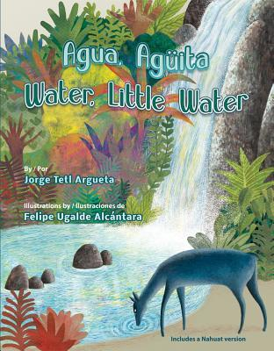
Este cuento bilingüe en verso, escrito en inglés y español, comparte el ciclo vital del agua desde la perspectiva de una sola gota. El texto completo se ofrece también en náhuat, una lengua indígena centroamericana. Para niños preescolares hasta el grado 2. This bilingual story in verse, written in English and Spanish, shares the life cycle of water from the perspective of a single droplet. Full text provided in Nahuat as well, a Central American indigenous language. For preschool-grade 2. Spanish language. 2017.

Braille

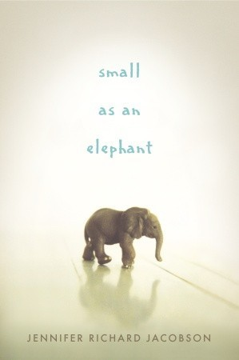
BR 11695 Black whiteness: Admiral Byrd alone in the Antarctic by Robert Burleigh
True-life adventure of Richard Byrd, who spent six months alone in the Antarctic in 1934. Includes excerpts from Byrd's diary recounting the incredible cold and discomfort he suffered. Describes how Byrd used a kite for rescue. For grades 4-7.

BR 19349 Small as an elephant by Jennifer Jacobson
Maine. On a camping trip with his mother, eleven-year-old Jack, an expert on all things elephant, wakes up alone--his mother has deserted him. Jack does not panic or ask an adult for help, but instead sets out to find her on his own. For grades 4-7 and older readers. 2011.

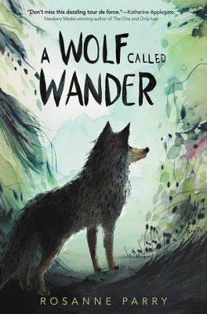
BR 24245 A wolf called Wander by Rosanne Parry
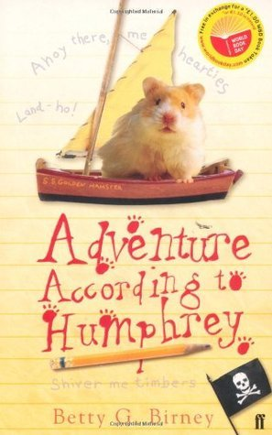
"Swift, a young wolf cub, lives with his pack in the mountains. Then a rival pack attacks, and Swift and his family scatter. Alone and scared, Swift must flee and find a new home. Inspired by the extraordinary true story of a wolf named OR-7 (or Journey), this irresistible tale of survival invites listeners to experience and imagine what it would be like to be one of the most misunderstood animals on earth." -- Provided by publisher. -- For grades 4-7. 2019.

BR 20182 Adventure according to Humphrey by Betty G. Birney
Classroom hamster Humphrey can barely contain his excitement when he, along with the kids in Room 26, starts learning about boats, the ocean, and sailing. But Humphrey's newest adventure may be his most dangerous yet. For grades 2-4. 2009.

BR 09548 Jumper by Steven Gould
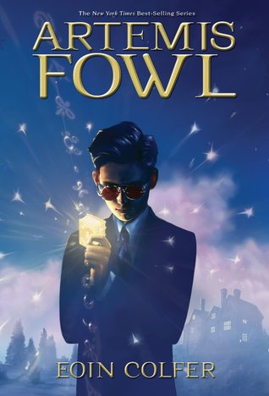
After twice ending up in his local library following threatening situations, Davy Rice, seventeen, realizes he has the ability to "jump," or teleport himself. He also believes his mother had the same power and that she used it to escape from Davy's abusive father. Soon Davy finds himself on the streets of New York where he uses teleporting for survival and to find his Mom. Strong language and some violence. For junior and senior high and older readers.

BR 13430 Artemis Fowl by Eoin Colfer
Twelve-year-old mastermind Artemis plans to restore his family fortune by obtaining some of the fairies' gold. The first step involves blackmailing an alcoholic fairy to photograph her "Book," containing her race's secrets but written in an ancient tongue. Some violence. For grades 5-8. Bestseller. 2001.

