Week 3: Exploration and Navigation

Books for Adults

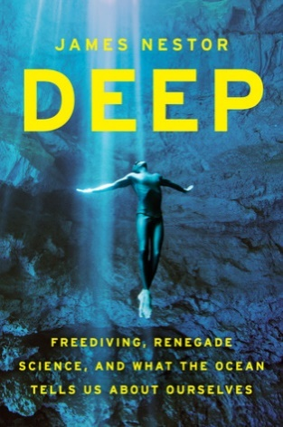
DB 105278 Deep: freediving, renegade science, and what the ocean tells us about ourselves by James Nestor
Annotation: Author of Breath (DB 99870) illuminates the culture and science of freediving, which is descending to great depths in the ocean on a single breath of air. Explores skills exhibited by marine life which humans can emulate, including echolocation and directional sense. Unrated. Commercial audiobook. 2014.

DB 79445 Sextant: a young man’s daring sea voyage and the men who mapped the world’s oceans by David Barrie
Annotation: Chronicle of the author's first transatlantic ship voyage in 1973 as a college student. Discusses his fascination with the sextant from childhood and how his trip led him to investigate the development of the instrument as well as the lives of notable mariners including Captain Cook and Captain Bligh. 2014.

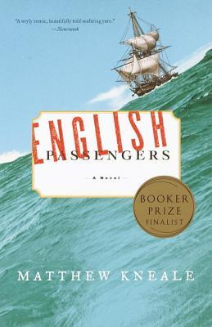
DB 92310 English passengers by Matthew Kneale
Annotation: In the 1850s, British Customs' exorbitant fines force Illiam Quillian Kewley, captain of a smuggling band, to charter his ship. His two passengers are on a quest to prove that the actual Garden of Eden was Tasmania. But they do not arrive at any paradise. Commercial audiobook. 2000.

DB 51403 Abduction by Robin Cook
Annotation: Perry Bergman's marine exploration company encounters problems drilling into a sea mountain under the Atlantic Ocean. He joins a diving team on a submersible craft, and they discover a subterranean world far beyond anything they'd imagined. Some descriptions of sex, some violence, and some strong language. Bestseller. 2000.

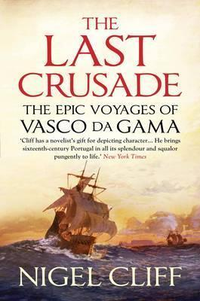
DB 83387 Last crusade: the epic voyage of Vasco da Gama by Nigel Cliff
Annotation: In 1498, Vasco da Gama sailed from Portugal, opening a sea route to the Indies. With Crusader crosses on their sails, the explorers arrived in the heart of the Muslim East during a time of high religious tension and began a six-year sea battle that altered the fates of three continents. 2011.

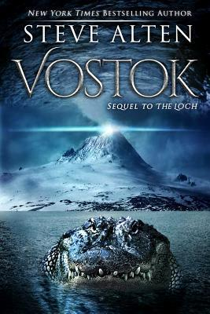
DB 84877 Vostok by Steve Alten
Annotation: After the remains of two mysterious creatures emerge on the Amery Ice Shelf in Antarctica, marine biologist Zachary Wallace is asked to embark on a dangerous underwater expedition 13,000 feet beneath the ice of Lake Vostok. Sequel to The Loch (DB 81330). Some violence and some strong language. 2015.

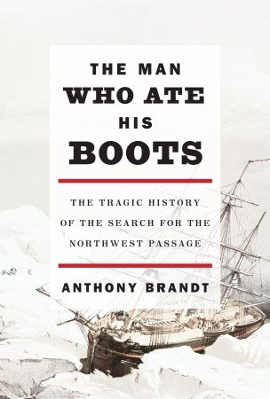
DB 73182 The man who ate his boots: the tragic history of the search for the Northwest Passage by Anthony Brandt
Annotation: Chronicles Great Britain's quest for an arctic sea route connecting the Atlantic and Pacific Oceans. Covers expeditions from an 1818 trip to the late nineteenth-century search for John Franklin, an explorer who vanished in 1845. Discusses allegations that Franklin's final journey ended in cannibalism. 2010.

Books for Youths

DB 57141 To the edge of the world by Michele Torrey
Annotation: Orphaned at fourteen in Spain, Mateo Macías is hired as cabin boy on Ferdinand Magellan's expedition launched in 1519 to search for a western route to the fabled Spice Islands. Sea disasters, attempted mutiny, and other dangers--but also friendships--abound on the two-year voyage. Some violence. For grades 6-9. 2003.

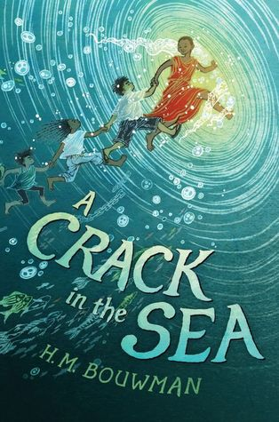
DB 86760 A crack in the sea by H. M. Bouwman
Annotation: Pip, a young boy who can speak to fish, sets off on a great adventure with his sister, Kinchen. They are joined by twins with magical powers, refugees fleeing post-war Vietnam, and some helpful sea monsters. Commercial audiobook. For grades 5-8. 2017.

DB 59709 Ferdinand Magellan and the discovery of the world ocean by Rebecca Stefoff
Annotation: Biography of the sixteenth-century Portuguese sea captain who commanded the first expedition that sailed around the world, thus proving the Earth was round. Introductory essay by astronaut Michael Collins. For grades 5-8. 1990.

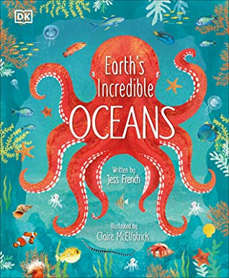
DB 104065 Earth’s incredible oceans by Jess French
Annotation: Animal expert Jess French explores the fascinating underwater world, demonstrating how amazing oceans are, what plants and animals live in them, and how we can help them. French includes amazing facts on how ocean animals have fun, care for their young, and interact with each other. For grades 3-6. 2021.

DB 69144 Jacques Cousteau: a life under the sea by Kathleen Olmstead
Annotation: Biography of Jacques Cousteau (1910-1997) explains that his love of swimming and marine life led him to become an inventor, ocean explorer, filmmaker, and environmentalist. Discusses Cousteau's adventures inventing the aqualung, exploring from his ship the Calypso, and deep-sea diving in a minisubmarine. For grades 5-8. 2008.

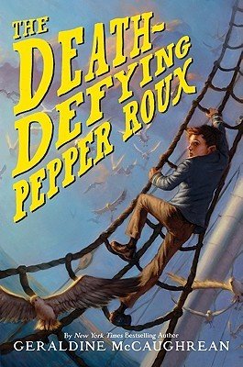
DB 70722 The death-defying Pepper Roux by Geraldine McCaughrean
Annotation: A young French boy raised to believe that he will die on his fourteenth birthday chooses instead to run away. He takes his father's place as captain of a ship and sails off to a series of adventures under various assumed identities. For grades 5-8. 2009.

DB 74256 Henry Hudson: English explorer of the Northwest Passage by Josepha Sherman
Annotation: Biography of seventeenth-century English explorer and navigator Henry Hudson, who disappeared in 1611. Includes excerpts from the ship logs he wrote while on his last voyage and provides a time line for his life and adventures. For grades 4-7. Commercial audiobook. 2002

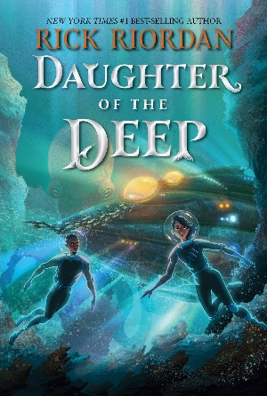
DB 105522 Daughter of the deep by Rick Riordan
Annotation: Ana Dakkar begins school at Harding-Pencroft Academy--a five-year high school that graduates the best marine scientists, naval warriors, navigators, and underwater explorers in the world. There, Ana makes astounding discoveries about her heritage and tests her leadership skills against deadly enemies from a rival school. Commercial audiobook. For grades 5-8. 2021.

