Week 2: Love without Boundaries
Note: All BR (braille) books are available from BARD.

Books for Adults

DB 96413 The warlord wants forever by Kresley Cole
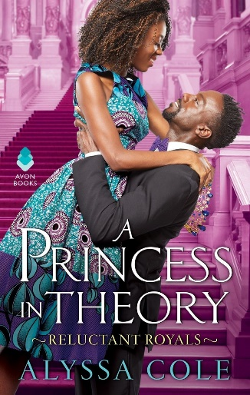
A princAnnotation: Vampire general Nikolai Wroth will stop at nothing to find the woman who will make his heart beat again and bring him power. He's stunned when it turns out to be Myst, a legendary Valkyrie who has devoted her life to fighting vampires. Unrated. Commercial audiobook. 2006.

DB 90825 A princess in theory by Alyssa Cole
Annotation: When grad student Naledi Smith gets an email claiming she is betrothed to an African prince, she assumes it is a scam. Prince Thabiso comes to America to track down Naledi, pretending to be a regular guy to secretly get to know her. Some strong language and some explicit descriptions of sex. 2018.

DB 72629 A discovery of witches by Deborah Harkness
Annotation: After scholar and witch Diana Bishop requests an alchemical manuscript from the depths of Oxford's Bodleian Library, she finds the magical power within the leather cover disturbing and hastily sends it back. But the book's reemergence causes a chain reaction through the paranormal community. Descriptions of sex. Bestseller. 2011.

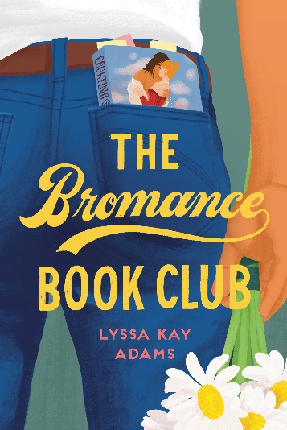
DB 97443 The bromance book club by Lyssa Kay Adams
Annotation: Baseball player Gavin Scott's marriage is in trouble, and to fix things, he's going to need some assistance. He finds a secret book club of other men who have used romance novels to fix their own relationships, and they agree to help him win back his family. Unrated. Commercial audiobook. 2019.

DB 100476 Hot and badgered by Shelly Laurenston
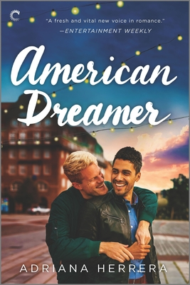
Annotation: It's not every day that a beautiful naked woman falls out of the sky and lands face-first on grizzly shifter Berg Dunn's hotel balcony. Berg is instantly smitten by Charlie MacKilligan, but by the time he figures out she's part honey badger shifter, it's too late. Explicit descriptions of sex. Strong language. Contains violence. Commercial audiobook. 2018.

DB 96150 American dreamer by Adriana Herrera
Annotation: For Nesto Vasquez, moving his Afro-Caribbean food truck from New York City to the wilds of upstate New York is a huge gamble. He doesn't need distractions. Librarian Jude Fuller has a good life, but he's lonely until he works up the nerve to flirt with Nesto. Unrated. Commercial audiobook. 2019.

DB 108020 Ice planet barbarians by Ruby Dixon
Annotation: After being abducted by aliens, Georgie and her fellow earth women crash-land on an inhospitable, icy planet. When she heads out in the snow to find help, she meets a big, blue, horned alien who is immediately sure that Georgie is his mate. Explicit descriptions of sex. Strong language. Contains violence. Commercial audiobook. 2015.

DB 111178 Mistakes were made by Meryl Wilsner
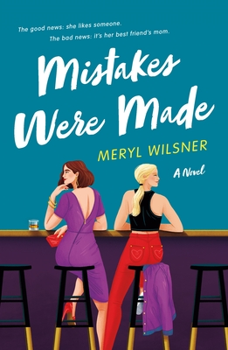
Annotation: "When Cassie Klein goes to an off-campus bar to escape her school's Family Weekend, she isn't looking for a hookup--it just happens. Buying a drink for a stranger turns into what should be an uncomplicated, amazing one-night stand. But then the next morning rolls around and her friend drags her along to meet her mom--the hot, older woman Cassie slept with. Erin Bennett came to Family Weekend to get closer to her daughter, not have a one-night stand with a college senior. In her defense, she hadn't known Cassie was a student when they'd met. To make things worse, Erin's daughter brings Cassie to breakfast the next morning. And despite Erin's better judgement--how could sleeping with your daughter's friend be anything but bad?--she and Cassie get along in the day just as well as they did last night. What should have been a one-time fling quickly proves impossible to ignore, and soon Cassie and Erin are sneaking around. Worst of all, they start to realize they have something real. But is being honest about the love between them worth the cost?" -- Provided by publisher. -- Unrated. Commercial audiobook.

DB 91202 The Pisces by Melissa Broder
Annotation: After breaking up with her boyfriend, Lucy heads to Venice Beach, California, to dog-sit for her sister. She meets Theo one night as he sits alone on the rocks and thinks her bad luck with men might have finally changed, only to discover that Theo is a merman. Explicit descriptions of sex and strong language. Commercial audiobook. 2018.

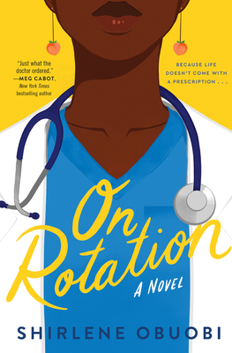
DB 109618 On rotation by Shirlene Obuobi
Annotation: "Ghanaian-American Angela Appiah has checked off all the boxes for the "Perfect Immigrant Daughter": Enroll in an elite medical school; snag a suitable lawyer/doctor/engineer boyfriend; surround self with a gaggle of successful and/or loyal friends. But then it quickly all falls apart: her boyfriend dumps her, she bombs the most important exam of her medical career, and her best friend pulls away. And her parents, whose approval seems to hinge on how closely she follows the path they chose, are a lot less proud of their daughter. It's a quarter life crisis of epic proportions. Angie, who has always faced her problems by working "twice as hard to get half as far," is at a loss. Suddenly, she begins to question everything: her career choice, her friendships, even why she's attracted to men who don't love her as much as she loves them. And just when things couldn't get more complicated, enter Ricky Gutierrez-brilliant, thoughtful, sexy, and most importantly, seems to see Angie for who she is instead of what she can represent. Unfortunately, he's also got "wasteman" practically tattooed across his forehead, and Angie's done chasing mirages of men. Or so she thinks. For someone who's always been in control, Angie realizes that there's one thing she can't plan on: matters of her heart." -- Provided by publisher. -- Unrated. Commercial audiobook.

BR24528 The garden of small beginnings by Abbi Waxman
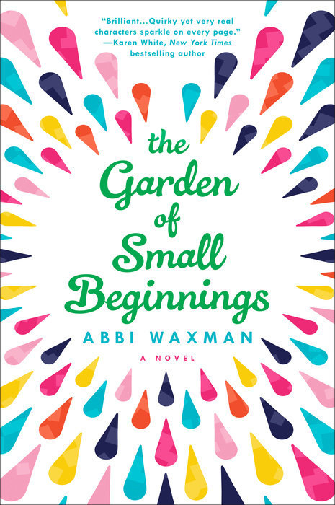
Annotation: "Lilian Girvan has been a single mother for three years--ever since her husband died in a car accident. One mental breakdown and some random suicidal thoughts later, she's just starting to get the hang of this widow thing. The only problem is she's becoming overwhelmed with being underwhelmed. At least her textbook illustrating job has some perks--like actually being called upon to draw whale genitalia. Oh, and there's that vegetable-gardening class her boss signed her up for. After recruiting her kids to join her, Lilian shows up at the Los Angeles Botanical Garden feeling out of her element. But what she'll soon discover is that into every life a little sun must shine--whether you want it to or not." -- Provided by publisher. -- Strong language.

BR23924 The flatshare by Beth O’Leary
Annotation: After a breakup, Tiffy needs to quickly find a cheap apartment in London. Leon works nights and needs money, so he offers to rent his place on an unusual basis: Tiffy can have the apartment at night, Leon during the day, and they never even need to meet. Strong language and some descriptions of sex. 2019.

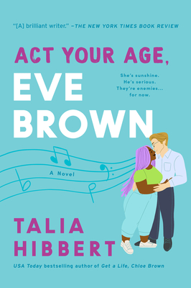
BR23740 Act your age, Eve Brown by Talia Hibbert
Annotation: Eve Brown has a hard time sticking with anything for long, and her parents have just shut off her trust fund. She applies for a job as a chef at a country bed-and-breakfast, but immediately clashes with Jacob, the owner. Strong language and some explicit descriptions of sex. 2021.

BR24265 Nora goes off script by Annabel Monaghan
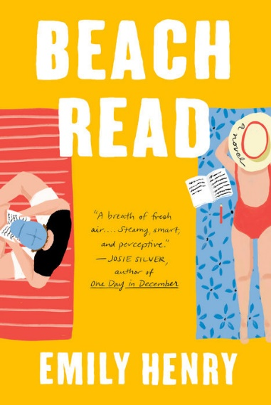
Annotation: "Nora Hamilton knows the formula for love better than anyone. As a romance channel screenwriter, it's her job. But when her too-good-to- work husband leaves her and their two kids, Nora turns her marriage's collapse into cash and writes the best script of her life. No one is more surprised than she when it's picked up for the big screen and set to film on location at her 100-year-old home. When former Sexiest Man Alive, Leo Vance, is cast as her ne'er-do-well husband, Nora's life will never be the same. The morning after shooting wraps and the crew leaves, Nora finds Leo on her porch with a half-empty bottle of tequila and a proposition. He'll pay a thousand dollars a day to stay for a week. The extra seven grand would give Nora breathing room, but it's the need in his eyes that makes her say yes. Seven days: it's the blink of an eye or an eternity depending on how you look at it. Enough time to fall in love. Enough time to break your heart." -- Provided by publisher. -- Strong language. 2022.

BR23158 Beach read by Emily Henry
Annotation: January Andrews is a romance writer who no longer believes in love. Augustus Everett is a celebrated literary writer stuck in a rut. When the two writers wind up in neighboring beach houses, they decide to try an experiment and swap genres. Strong language and some explicit descriptions of sex. 2020.

Books for Youths

DBC15721 Breakfast with Neruda by Laura Moe
Annotation: Michael is just trying to get through his community service after he made the dumb decision to try to blow up his friend's car with fireworks--the same friend who stole Michael's girl. Being expelled and losing his best buddy and his girlfriend are the least of his problems: he's living in a car, his mother is a hoarder, and his life seems to be falling apart - until he meets Shelly, that is. Unrated.

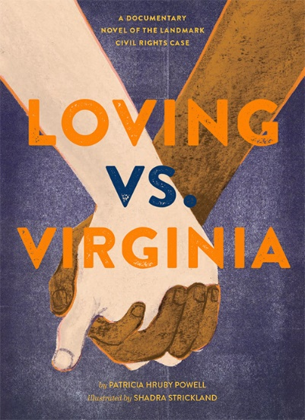
DB 88922 Loving vs Virginia: a documentary novel of the landmark civil rights case by Patricia Hruby Powell
Annotation: A novel in blank verse telling the story of Mildred Jeter, an African American woman, and Richard Loving, a Caucasian man, who marry and then challenge the Virginia law forbidding interracial marriages in the 1950s. Some strong language. For senior high and older readers. 2017.

DBC08760 XO, Ox: a love story by Adam Rex
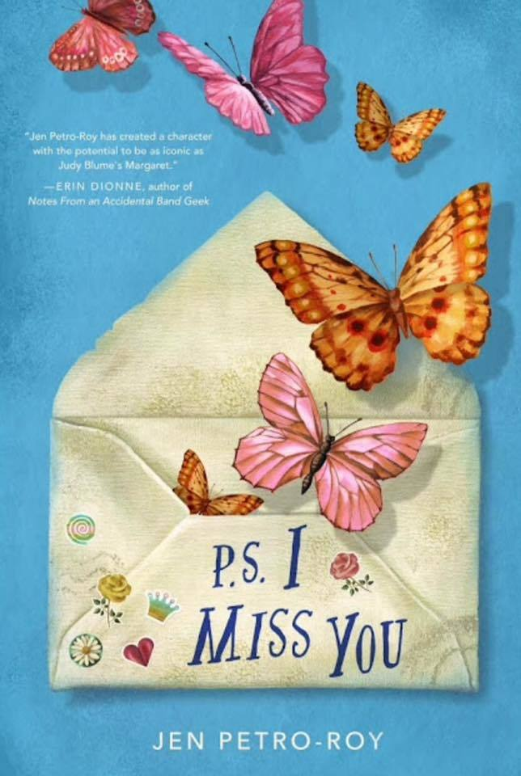
Annotation: The hilarious tale of an ox who is in love with a gazelle, told in correspondence.

DB 96297 P.S. I miss you by Jen Petro-Roy
Annotation: Evie's strict Catholic parents send her pregnant sister away to live with a great-aunt. Trying to stay in contact, Evie secretly sends her sister letters, writing about their family, her life, and the new girl in school, June--who may be more than a friend. Commercial audiobook. For grades 4-7. 2018.

DB 87836 Well, that was awkward by Rachel Vail
Annotation: There are unexpected consequences when thirteen-year-old Gracie sends texts to A. J. pretending to be her bashful best friend, Sienna. Then their friend Emmett starts texting back, pretending to be shy A. J. Commercial audiobook. For grades 5-8. 2017.

DBC08733 Odd socks by Michelle Robinson
Annotation: The love story of two socks goes awry when one of them gets a hole. For preschool-grade 2.

DB 62599 The miraculous journey of Edward Tulane by Kate DiCamillo
Annotation: A proud toy rabbit named Edward, presented to Abilene Tulane on her seventh birthday, does not appreciate Abilene's love until he is lost at sea. As he passes from one owner to the next, he begins to open his heart and learns to love. For grades 3-6. 2006.

BR24153 This is my brain in love by I. W. Gregorio
Annotation: Rising high school juniors Jocelyn Wu and Will Domenici fall in love while trying to save the Wu family restaurant, A-Plus Chinese Garden. Meanwhile, mental health issues and family prejudices threaten their budding romance. Schneider Family Book Award. Strong language and some descriptions of sex. For senior high and older readers. 2020.

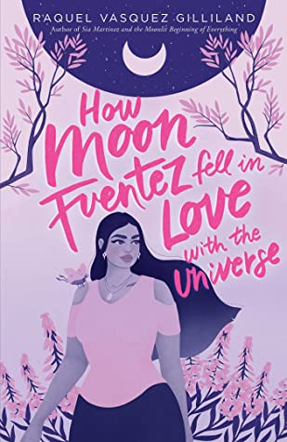
BR24132 How Moon Fuentez fell in love with the universe by Raquel Vasquez Gilliland
Annotation: When seventeen-year-old Star Fuentez reaches social media stardom, her polar-opposite twin, Moon, becomes "merch girl" on a tour bus full of beautiful influencers and the grumpy but attractive Santiago Philips. Strong language and descriptions of sex. Pura Belpré Award. For senior high and older readers. 2021.

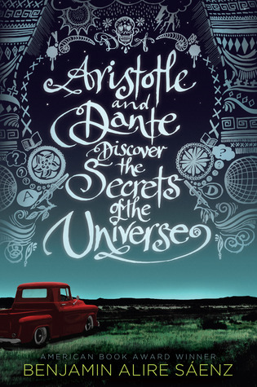
BR19825 Aristotle and Dante discover the secrets of the universe by Benjamin Alire Sáenz
Annotation: Ari Mendoza is an angry loner whose older brother is in prison. But when Ari meets Dante--his opposite--the two boys bond. Ari starts to ask questions about himself, his family, and the universe. Violence and strong language. For senior high and older readers. Stonewall, Pura Belpre Awards. 2012.

