# Week 2 / 2ª Semana: Beyond this Realm / Ma allá de esta esfera:

## Books for Adults / Libros para Adultos

### Audio

#### DB 76353 [*Inferno*](https://kstb.klas.com/title/summary.jsf?id=96645193.6232) by Dante Alighieri

A man travels to the depths of Hell with the Roman poet Virgil as his guide. This version of Dante's fourteenth-century poem incorporates references to modern cultural touchstones such as Bob Dylan, Sigmund Freud, and Eric Cartman from the television show South Park. Translated from Italian. Some strong language. 2012.

#### Book cover for 'Dying Bites' by D. D. Barant features a woman with long dark hair holding a gun in both hands and standing in front of a cemetery gate on a purple background. DB 70008 [*Dying bites*](https://kstb.klas.com/title/summary.jsf?id=56484419.6232) by D. D. Barant

David Cassius, NSA agent and vampire, transports confused FBI profiler Jace Valchek into a parallel universe where less than one percent of the population is human. David demands that, before Jace can return home, she must track down a mentally unstable killer. Some violence and some strong language. 2009.

#### DB 110256 [*Prime deceptions*](https://kstb.klas.com/title/summary.jsf?id=284451330.6232) by Valerie Valdes

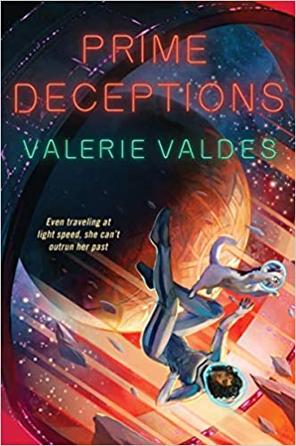"Captain Eva Innocente and the crew of La Sirena Negra find themselves once again on the fringe of populated space-and at the center of a raging covert war. When Eva's sister asks for help locating a missing scientist, promises of a big paycheck and a noble cause convince Eva to take the job despite lingering trust issues. With reluctant assistance from her estranged mother, Eva and her crew follow the missing scientist's trail across the universe, from the costume-filled halls of a never-ending convention to a dangerous bot-fighting arena. They ultimately find themselves at the last place Eva wants to see again-Garilia-where she experienced her most shameful and haunting failure. To complete her mission and get paid, Eva must navigate a paradise embroiled in a rebellion, where massive forests and pristine beaches hide psychic creatures and pervasive surveillance technology. Can she find her quarry while avoiding the oppressive local regime, or will she be doomed to repeat past mistakes when her dark deeds come to light?" -- Provided by publisher. -- Unrated. Commercial audiobook.

#### DB 81949 [*Other worlds than these: stories of parallel worlds*](https://kstb.klas.com/title/summary.jsf?id=127838149.6232) by John Joseph Adams

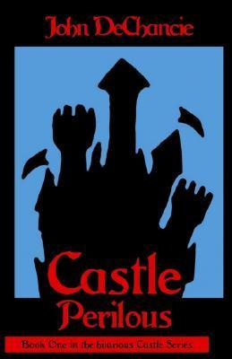This anthology collects short stories that involve parallel worlds and portal fantasies. The list of authors includes George R. R. Martin, Orson Scott Card, Stephen King, Joyce Carol Oates, Ursula K. Le Guin, Catherynne Valente, and many others. Some violence, some strong language, and some descriptions of sex. 2012.

#### DB 106267 [*Castle Perilous*](https://kstb.klas.com/title/summary.jsf?id=272866027.6232) by John DeChancie

Powerful sorcerer Incarnadine makes his home at Castle Perilous, within which lay 144,000 doors that each lead to parallel universes both magical and mundane. Those who come to the castle often stay and develop their own magical powers. Violence, strong language, and some descriptions of sex. 1988.

#### DB 107844 [*The Kaiju Preservation Society*](https://kstb.klas.com/title/summary.jsf?id=276297561.6232) by John Scalzi

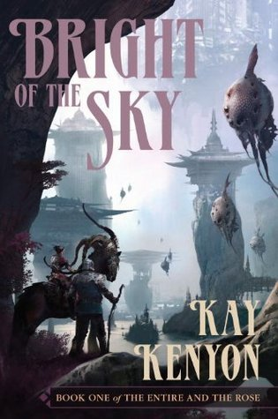Jamie Gray is contacted by an old friend who works at an "animal rights organization." His team needs a last-minute grunt to handle things on their next field visit. What he doesn't tell Jamie is that the animals his team cares for are not on Earth. In an alternate dimension, massive dinosaur-like creatures named Kaiju roam a warm and human-free world. Strong language. Commercial audiobook. 2021.

#### DB 65795 [*Bright of the sky*](https://kstb.klas.com/title/summary.jsf?id=48596178.6232) by Kay Kenyon

Seeking new methods of interstellar travel, pilot Titus Quinn's company sends him to the Entire, a parallel universe where Titus's wife and nine-year-old daughter disappeared years before. Aided by the quasi-human woman Anzi, Titus attempts to save his family without drawing the attention of cruel Tarig lords. Some violence. 2007.

#### DB 109405 [*Hominids*](https://kstb.klas.com/title/summary.jsf?id=279829134.6232) by Robert J. Sawyer

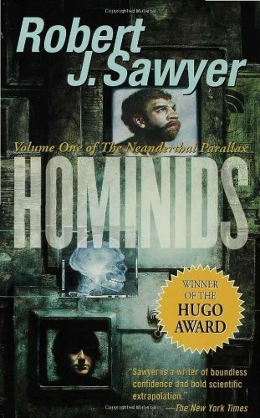"Robert Sawyer's SF novels are perennial nominees for the Hugo Award, the Nebula Award, or both. Clearly, he must be doing something right since each one has been something new and different. What they do have in common is imaginative originality, great stories, and unique scientific extrapolation. His latest is no exception. |Hominids| is a strong, stand-alone SF novel, but it's also the first book of The Neanderthal Parallax, a trilogy that will examine two unique species of people. They are alien to each other, yet bound together by the never-ending quest for knowledge and, beneath their differences, a common humanity. We are one of those species, the other is the Neanderthals of a parallel world where they, not Homo sapiens, became the dominant intelligence. In that world, Neanderthal civilization has reached heights of culture and science comparable to our own, but is very different in history, society, and philosophy. During a risky experiment deep in a mine in Canada, Ponter Boddit, a Neanderthal physicist, accidentally pierces the barrier between worlds and is transferred to our universe, where in the same mine another experiment is taking place. Hurt, but alive, he is almost immediately recognized as a Neanderthal, but only much later as a scientist. He is captured and studied, alone and bewildered, a stranger in a strange land. But Ponter is also befriended-by a doctor and a physicist who share his questing intelligence and boundless enthusiasm for the world's strangeness, and especially by geneticist Mary Vaughan, a lonely woman with whom he develops a special rapport. Meanwhile, Ponter's partner, Adikor Huld, finds himself with a messy lab, a missing body, suspicious people all around, and an explosive murder trial that he can't possibly win because he has no idea what actually happened. Talk about a scientific challenge! Contact between humans and Neanderthals creates a relationship fraught with conflict, philosophical challenge, and threat to the existence of one species or the other-or both-but equally rich in boundless possibilities for cooperation and growth on many levels, from the practical to the esthetic to the scientific to the spiritual. In short, Robert J. Sawyner has done it again." -- Provided by publisher. -- Violence and strong language.

Also available in braille and electronic braille as BRG01453.

#### DB 99243 [*Chosen ones*](https://kstb.klas.com/title/summary.jsf?id=222895937.6232) by Veronica Roth

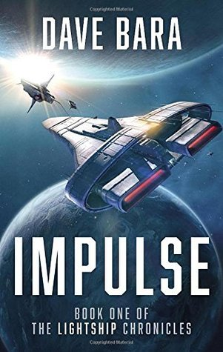Fifteen years ago, five ordinary teenagers were singled out by a prophecy to take down an impossibly powerful entity. After the Dark One fell, the world went back to normal for everyone but the Chosen Ones. After all, what do you do when your purpose in life is now fulfilled? Some strong languauge, some violence, and some explicit descriptions of sex.. Commercial audiobook. 2020.

#### DB 81145 [*Impulse*](https://kstb.klas.com/title/summary.jsf?id=124184177.6232) by Dave Bara

Lieutenant Peter Cochrane learns that his former girlfriend and her shipmates were killed in an unprovoked attack upon Lightship Impulse in a distant solar system. His plans are further ruined when he is assigned to a ship under foreign command and headed to an unexpected destination. Violence and some strong language. 2015.

#### DB 117245 [*The fragile threads of power*](https://kstb.klas.com/title/summary.jsf?id=307881681.6232) by Victoria Schwab

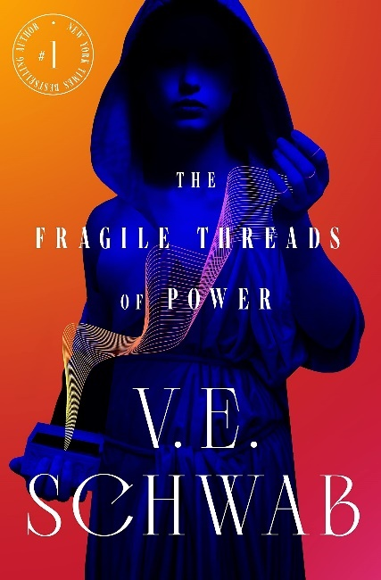"Once, there were four worlds, nestled like pages in a book, each pulsing with fantastical power and connected by a single city: London. Until the magic grew too fast and forced the worlds to seal the doors between them in a desperate gamble to protect their own. The few magicians who could still open the doors grew more rare as time passed and now, only three Antari are known in recent memory-Kell Maresh of Red London, Delilah Bard of Grey London, and Holland Vosijk, of White London. But barely a glimpse of them have been seen in the last seven years-and a new Antari named Kosika has appeared in White London, taking the throne in Holland's absence. The young queen is willing to feed her city with blood, including her own-but her growing religious fervor has the potential to drown it instead. And back in Red London, King Rhy Maresh is threatened by a rising rebellion, one determined to correct the balance of power by razing the throne entirely. These two royals from very different empires now face very similar struggles: how to keep their crowns-and their own heads. Amidst this tapestry of old friends and new enemies, a girl with an unusual magical 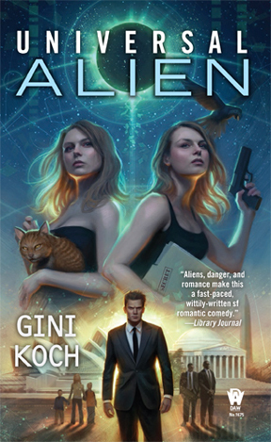ability comes into possession of a device that could change the fate of all four worlds. Her name is Tes, and she's the only one who can bring them together-or unravel it all." -- Provided by publisher. -- Unrated. Commercial audiobook.

#### DB 80950 [*Universal alien*](https://kstb.klas.com/title/summary.jsf?id=123034836.6232) by Gini Koch

Kitty accidentally offends the Australian prime minister. She and Jeff must rectify things to avoid an incident forcing Jeff to resign and the A-Cs to leave the planet. Their problems compound when someone switches Kitty with an alternate-universe Kitty. Strong language, explicit descriptions of sex, and some violence. 2014.

#### DB 104405 [*Una leyenda del futuro*](https://kstb.klas.com/title/summary.jsf?id=266130109.6232) by Agustín de Rojas

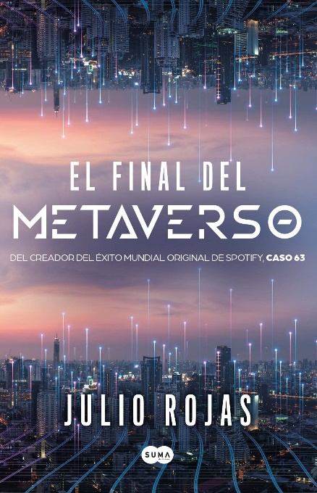Esta novela se desarrolla en una misión a Titán, una de las lunas de Saturno. Cuando un accidente condena la misión, el viaje de vuelta a la Tierra obliga a los miembros de la tripulación a enfrentarse a sus miedos más profundos mientras conviven entre ellos en un estado de desesperación. Sin calificación. Audiolibro comercial.

#### DB 118875 [*El final del metaverso*](https://kstb.klas.com/title/summary.jsf?id=311368934.6232) by Julio Rojas

"Del autor de Caso 63, el podcast de ficción más escuchado en habla hispana. En un futuro no tan lejano, un programador debe solucionar los errores que se producen en un mundo donde los humanos interactúan con entidades dotadas de inteligencia artificial, ignorando que no son reales, sino que forman parte de un juego virtual. Aunque quizás este metaverso sea algo más que un juego. ¿Qué pasa si te enamoras de un avatar que no existe en la realidad? ¿Qué pasa si rompes las reglas y le dices la verdad? Tras una larga experiencia como guionista y un libro que mezcla la historia con el thriller, Julio Rojas nos entrega su primera novela de ciencia ficción. En El final del metaverso concibe una atrapante aventura entre distintos planos de realidad que nos hace cuestionar los conceptos de tiempo y espacio." -- Proporcionada por la editorial. -- Sin calificación. Audiolibro comercial.

#### DB 109392 [*Treinta y seis metros*](https://kstb.klas.com/title/summary.jsf?id=280329077.6232) by Santiago Ambao

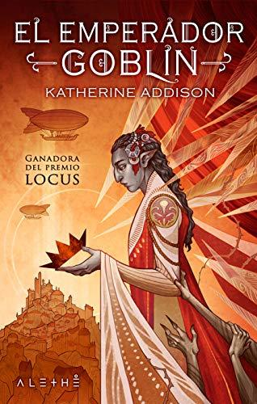"Cosas que pasan porque sí, cafés que se tiran a la pileta sin beber, tostadas que se tiran a la basura sin comer, un protagonista que trata de poner nombre a sus sentimientos pero que se obliga a no pensar en determinadas direcciones, una mujer que casi siempre está en la ducha o tras otro tipo de mamparas, otra mujer que asoma como promesa pero que apenas se roza, una chica inocente y ligeramente bizca, un funcionario que enloquece justo cuando está llegando a su jubilación, un jefe o dos que hacen y deshacen a su antojo, dos niños que se sumergen en la realidad deformada de la PlayStation, un televisor de última generación, un sillón confortable y la mejor cafetera posible, el deseo no cumplido de ir a pescar en familia, una fuga interior, una fuga futura. Santiago Ambao ha metido todos estos ingredientes en una coctelera y ha sacado de ella una historia brillante, bien batida y mezclada, aunque lo que la hace todavía más grande es unirla a otra historia paralela, subterránea, que transcurre al otro lado del mundo, una especie de trama política y económica, mezcla de realismo y ciencia ficción, o más bien fruto de un realismo inquietantemente visionario." -- Proporcionada por la editorial. -- Contiene algo de lenguaje ofensivo y descripciones de violencia.

#### DB 105034 [*El emperador Goblin*](https://kstb.klas.com/title/summary.jsf?id=267722644.6232) by Katherine Addison

Maia asciende al trono de los duendes cuando su padre, el emperador, y sus tres hermanastros mueren en un accidente de aeronave. Alejada de la corte durante toda su vida debido a su sangre mixta, Maia deberá navegar por aguas traicioneras, especialmente después de que se descubra que el accidente fue intencionado. Traducido de la edición en inglés de 2014. Contiene algunas descripciones de violencia. Premio Locus.

#### DB 108563 [*Tierra contrafuturo*](https://kstb.klas.com/title/summary.jsf?id=278027581.6232) by Luis Carlos Barragán Castro

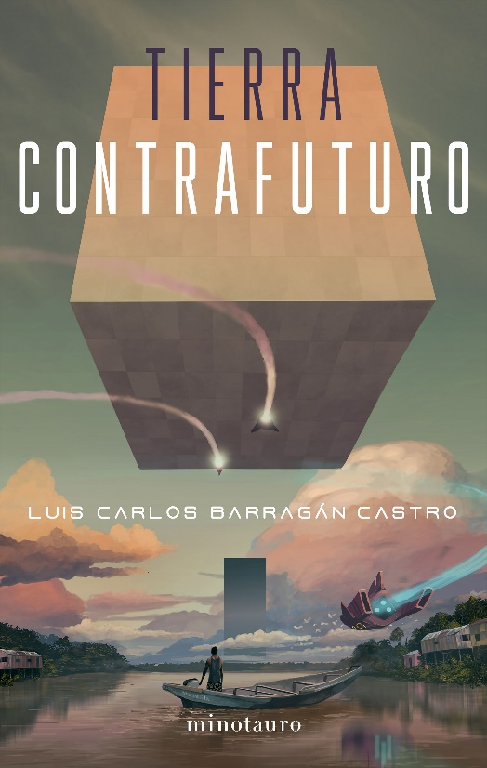"El primer contacto extraterrestre ocurre en las selvas latinoamericanas. Dos colombianos sin nada que perder huyen en una nave espacial. Un par de años después, uno de ellos regresa para fundar una embajada interplanetaria, que promete traer tecnología y mano de obra alienígena a la Tierra. Ahora la humanidad tiene la oportunidad de convertirse en una sociedad tipo I y de ser parte del Directorio Interestelar. Pero los poderes económicos y políticos de siempre tratarán de impedir ese futuro. La crisis diplomática con las potencias terrestres es grave, pero ahora hay seres superiores que intervendrán para bien o para mal." -- Goodreads. -- Contiene lenguaje ofensivo, algunas descripciones de violencia y algunas descripciones explícitas de índole sexual.

#### DB 56970 [*Los hijos del immortal*](https://kstb.klas.com/title/summary.jsf?id=47282651.6232) by Ralph Barby

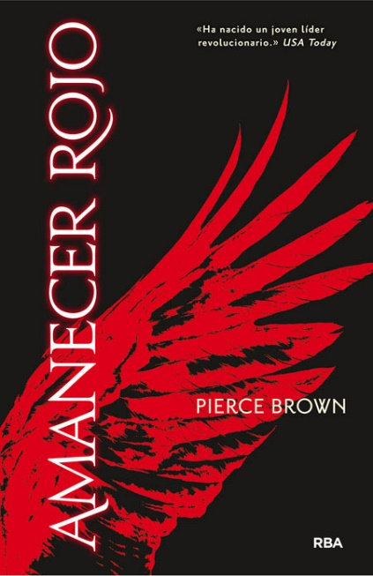Ronald Hoover, el propietario despótico de Golden Fat, el planeta mas rico de la galaxia, emplea a Joc Seny, el aventurero del espacio, para que emprenda una misión peligrosa entre las estrellas. Joc Seny y la tripulación del cosmonave Tralla Nova viajan en busca del antídoto que salvará al hijo predilecto de Ronald Hoover que sufre de la picadura envenenosa de una arana bicéfala.

#### DB 100880 [*Amanecar rojo*](https://kstb.klas.com/title/summary.jsf?id=253143339.6232) by Pierce Brown

Darrow, de 16 años, trabaja en una colonia minera en Marte. Cree que está mejorando el planeta para las futuras generaciones, pero su esposa Eo cree que son esclavos. Cuando Eo es condenado a muerte, Darrow se infiltra en la casta gobernante para fomentar la rebelión. Contiene lenguaje ofensivo, descripciones de violencia y algunas descripciones de índole sexual. Audiolibro comercial.

### Braille

#### The book of lost things book cover. Gold filigree with keys, leaves, and thorns make branches holding the author's name and title. A white silhouette of a person resting sword is at the top and a white silhouette of a person laying on a branch reading a book is on a lower branch.BRC01507 *The book of lost things* by John Connolly

England, 1930s. Young David, sad and angry over his mother's death and father's remarriage, is transported to another realm through a gap in a garden wall. To return home, David undertakes a quest to find a king and the Book of Lost Things, and grows up along the way. Some violence. 2006.

#### BR 11353 *Neverwhere* by Neil Gaiman

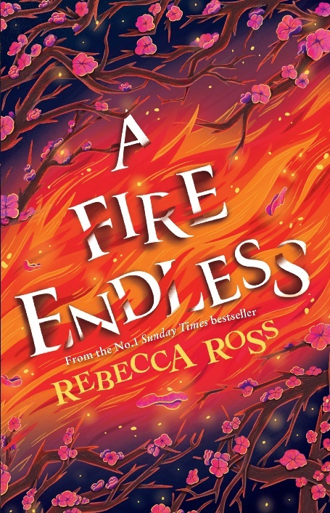En route to a formal dinner, London businessman Richard Mayhew spots a young woman lying wounded in the street. He takes the victim to his home and awakes the next day to find that he has lost his identity in the real world. Mayhew joins the now-healed woman in a perilous quest through an eerie subterranean realm. Strong language and violence.

#### BR 24827 *A fire endless* by Rebecca Ross

"East and West. Humans and Spirits. Breccans and Tamerlaines. The Isle of Cadence has always held itself and its residents in a tenuous balance. But now Bane, the spirit of the North Wind, has pushed everyone and everything in his path off-kilter in a bid to claim dominion over human and spirit alike. In the East, a sickness is spreading through the orchards, affecting the people of the Tamerlaine clan. As their healer, Sidra desperately searches for a cure while her husband Torin, the clan's new leader, attempts to draw answers from the spirits. But humans were never meant to walk for long amongst the elementals, and the deeper he strays into their realm, the further lost he and the clan become. In the West, Adaira finds it hard to adjust to the more brutal way of life that the Breccans embrace. Both the clan and the spirits suffer beneath Bane's command, whose growing power can be felt in every gust of wind. With the island falling further out of balance, Jack decides to take up his harp and cross the clan line, to not only reunite with Adaira but to unravel a sinister mystery that would grant him the knowledge to defeat Bane and restore peace to the isle. Yet no one can challenge the North Wind without paying a price, and the sacrifice required this time may just be the ultimate one. Torin, and Sidra can bear to pay." -- Provided by publisher.

#### BR 24494 Daughter of the moon goddess by Sue Lynn Tan

"Growing up on the moon, Xingyin is accustomed to solitude, unaware that she is being hidden from the feared Celestial Emperor who exiled her mother for stealing his elixir of immortality. But when Xingyin's magic flares and her existence is discovered, she is forced to flee her home, leaving her mother behind. Alone, powerless, and afraid, she makes her way to the Celestial Kingdom, a land of wonder and secrets. Disguising her identity, she seizes an opportunity to learn alongside the emperor's son, mastering archery and magic, even as passion flames between her and the prince. To save her mother, Xingyin embarks on a perilous quest, confronting legendary creatures and vicious enemies. But when treachery looms and forbidden magic threatens the kingdom, she must challenge the ruthless Celestial Emperor for her dream—striking a dangerous bargain in which she is torn between losing all she loves or plunging the realm into chaos. |Daughter of the Moon Goddess| begins an enchanting duology which weaves ancient Chinese mythology into a sweeping adventure of immortals and magic, of loss and sacrifice—where love vies with honor, dreams are fraught with betrayal, and hope emerges triumphant." -- Provided by publisher. Some violence.

#### BR 09730 *Dark mirror* by Diane Duane

When the Enterprise is drawn into a parallel universe, Captain Picard and his colleagues come face to face with an alternate Enterprise manned by persons identical to themselves. This universe turns out to be a place where humanity has gone awry, with rule by terror and brutality. And the evil counterparts of Picard and his crew are bent on capturing the Enterprise for sinister purposes. A Star Trek: The Next Generation novel. Bestseller.

#### The space between worlds book cover. On one side vertically is a person in rough, worn clothing walking near a city in desert surroundings. There is a bright, yellow-white cloud space in the middle that both landscapes share. On the other side, a person in white, flowy clothing walks on a pathway looking out at a futuristic cityscape.BR 23376 *The space between worlds* by Micaiah Johnson

Since multiverse travel is only possible to worlds where one's counterpart is not alive, Cara's many dead selves make her the perfect traveler. When one of her few remaining alternative selves dies under mysterious circumstances, Cara is plunged into a new world with an old secret. Strong language and some violence. 2020.

#### BR 06983 *A la Conquista del espacio* by Laurent Broomhead and Daniel Sassier

Short introduction to space exploration provides basic information on rockets, satellites, space flight, men in space, the moon landings, space stations, and other topics. For young adult and adult readers. Spanish language.

## Victories greater than death book cover. A woman with bright light purple hair and eyes looks out at the reader.Books for Youths / Libros Juveniles

### Audio

#### DB 102993 [*Victories greater than death*](https://kstb.klas.com/title/summary.jsf?id=261371399.6232) by Charlie Jane Anders

Tired of hiding in obscurity on Earth, Tina, the human clone of a brilliant alien tactician, pursues her destiny in space. But success is elusive until Tina and her best friend Rachael assemble a ragtag crew and set out to save all the worlds. Unrated. Commercial audiobook. For senior high and older readers. 2021.

#### DB 50842 [*Alice’s adventures in Wonderland; and, Through the looking glass, and what Alice found there*](https://kstb.klas.com/title/summary.jsf?id=82918868.6232) by Lewis Carroll

Extraordinary things happen when a little girl falls down a rabbit hole and encounters the White Rabbit, the Cheshire Cat, the Mad Hatter, and other unusual characters. Alice's second adventure takes her to a land with a peculiar back-to-front order in which everything is reversed. For grades 3-6 and older readers. 1865.

#### The wonderful Wizard of Oz book cover. A lion wearing glasses and a bow in its mane has a girl riding on its back as it walks next to a small dog, a tin man carrying an axe, and an Oz guard carring a bayonet with a long beard with a bow in it.DB 15141 [*The Wizard of Oz and The land of Oz*](https://kstb.klas.com/title/summary.jsf?id=140354358.6232) by L. Frank Baum

Blown by a cyclone from her Kansas home to the wonderful Land of Oz, Dorothy meets the Tin Woodman, the Cowardly Lion, and other fantastic creatures. In "The Land of Oz," Dorothy and a venturesome companion search for the lost heiress of the kingdom of Oz. For grades 4-7 and older readers.

#### Book cover of The graveyard book. A gravestone with the face of a person carved out to make a negative space image. A blue-white fog swirls around the gravestone. DB 68027 [*The graveyard book*](https://kstb.klas.com/title/summary.jsf?id=38672589.6232) by Neil Gaiman

A toddler enters a cemetery pursued by the knife-wielding stranger who just murdered his family. Resident ghosts Mr. and Mrs. Owens protect and adopt the child, naming him Nobody "Bod" Owens. Bod's graveyard upbringing serves him well, but why was his family targeted? For grades 5-8 and older readers. 2008.

#### DB 50083 [*The complete chronicles of Narnia*](https://kstb.klas.com/title/summary.jsf?id=42336570.6232) by C. S. Lewis

Seven complete novels presented in the chronological order in which C. S. Lewis intended them to be read, not the original publication order. The first is The Magician's Nephew (1955) telling how the journeys between the two worlds began and how the wardrobe came to be a doorway leading into Narnia. Six other books follow: The Lion, the Witch and the Wardrobe (1950) The Horse and His Boy (1954) Prince Caspian (1951) Voyage of the Dawn Treader (1952) The Silver Chair (1953) and The Last Battle (1956). For grades 4-7. 1998.

#### DBC29180 [*Rudy and the snow goblins*](https://kstb.klas.com/title/summary.jsf?id=310513332.6232) by Jeremy Paul Amick

Chandler and Joey embark upon a grand adventure outdoors and meet a magical elf named Rudy. The three quickly become involved in pursuit of the dreaded Snow Goblins, who have robbed food from the citizens of the elf kingdom. For grades 2-4.

#### DBC28997 [*Felice and the wailing woman*](https://kstb.klas.com/title/summary.jsf?id=312667745.6232) by Diana Lopez

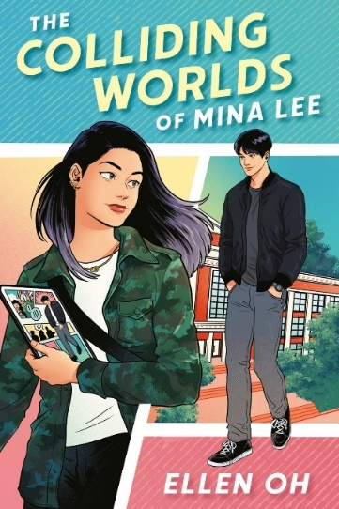"The twelve-year-old daughter of La Llorona vows to free her mother and reverse the curses that have plagued the magical town of Tres Leches"-- Provided by publisher. Commercial audiobook. For grades 5-8. Unrated.

#### DB 119182 [*The colliding worlds of Mina Lee*](https://kstb.klas.com/title/summary.jsf?id=311345186.6232) by Ellen Oh

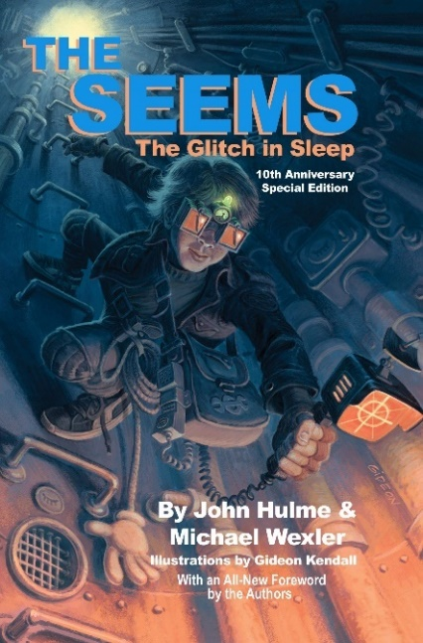"When a Korean American teenage artist gets sucked into the world of her own web comic, she must find a way out with the help of a cute boy all while facing off against a villainous corporation." -- Provided by publisher. -- Unrated. Commercial audiobook. For senior high and older readers.

#### DB 68469 [*The glitch in sleep*](https://kstb.klas.com/title/summary.jsf?id=42088312.6232) by John Hulme

Middle-schooler Becker Drane applies for work in the Seems--a parallel universe that runs everything in the World. Becker's first mission as a fixer is to repair a glitch in the Department of Sleep that threatens everyone's ability to ever fall asleep again. For grades 5-8. 2007.

#### DB 49606 [*A swiftly tilting planet*](https://kstb.klas.com/title/summary.jsf?id=46947021.6232) by Madeleine L’Engle

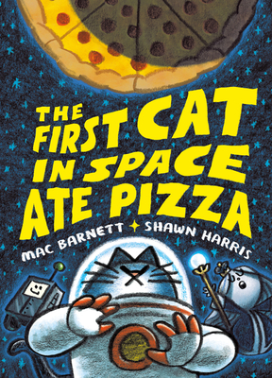Charles Wallace, the youngest of the Murry children, must travel through time and space in a battle against an evil dictator who would destroy the entire universe. Sequel to A Wind in the Door (DB 41596, BR 7884). For grades 5-8.

#### DB 118261 [*The first cat in space ate pizza*](https://kstb.klas.com/title/summary.jsf?id=310241013.6232) by Mac Barnett

"Something terrible is happening in the skies! Rats are eating the MOON! There's only ONE hero for the job, a bold and fearsome beast bioengineered in a secret lab to be the moon's savior and Earth's last hope! And that hero is.. a cat. A cat who will be blasted into space! Accompanied by the imperious Moon Queen and LOZ 4000, a toenail clipping robot, the First Cat in Space journeys across a fantastic lunar landscape in a quest to save the world. Will these unlikely heroes save the moon in time? Can a toenail-clipping robot find its purpose in the vast universe? And will the First Cat in Space ever eat some pizza?" -- Provided by publisher. -- Commercial audiobook. For grades 4-7.

#### DB 102861 [*La tienda de los sueños: un siglo de cuento fantástico mexicano*](https://kstb.klas.com/title/summary.jsf?id=261181246.6232) by Alberto Chimal

Una colección de cuentos fantásticos (escritos entre 1928-2015) de autores mexicanos, seleccionados por Alberto Chimal. Incluye contribuciones de Juan José Arrreola y Elena Garro, entre otros, que estan llenos de desapariciones inexplicables y saltos en el tiempo. Contiene algo de lenguaje ofensivo, algunas descripciones explícitas de índole sexual, y algunas descripciones de violencia. Para lectores de alta secundaria y mayores.

#### DB 54960 *El reino del dragón de oro La ciudad de las bestias* by Isabel Allende

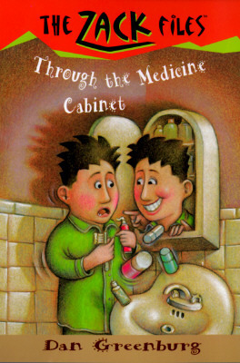Alexander Cold, joven de quince años, tiene una abuela que es reportero, y tiene la oportunidad de acompañarla en una expedición a las Amazonas en busca de la legendaria Bestia de las Amazonas. Alexander y su nueva amiga Nadia emprenden una mgica aventura en la misteriosa y impenetrable selva. Para alumnos de escuela secundaria y lectores mayores.

### Braille

#### BR 19457 Through the medicine cabinet by Dan Greenburg

Zack opens his medicine cabinet one morning and sees a boy who could be his double staring back at him. Soon Zack enters a parallel universe, where his look-alike Zeke lives. For grades 2-4. 1996.

#### BR 07160 *Dragon dance* by John Christopher

Teenage cousins Simon and Brad, whisked from England to a parallel world in "Fireball," and continuing their fireball experiences in "New Found Land," now find themselves on the coast of California. After coming upon a strange pagoda, they are captured by slavers and taken to China. There they learn at last the secret of the fireball and encounter incredible practices of mind control. Conclusion of the Fireball Trilogy. For grades 6-9 and older readers.

#### Stargazer book cover. A girl wearing a compass on a necklace stands behind a decorative barrier with ropes in front and behind. She holds the rope in one hand. Right next to her, a lizard peaks over the barrier with one clawed paw resting on it and its tail showing on the other side of the girl. In the background are large, tall stone pillars with communities on the top and fog surrounding the bases.BR 18737 *Stargazer* by Patrick Carman

After defeating Abaddon in The Tenth City (BR 17195), Alexa, Yipes, and their shipboard companions unwittingly lead Abaddon, now in the form of an enormous sea monster, to the Five Stone Pillars, a hidden realm where he again attacks, seeking control. For grades 4-7. 2008.

#### Mister Monday book cover. A young man holding a wand in one hand stands behind a clock on the floor. Silhouettes of the same person are lined up equidistance fading into the background of clouds. A building-like structure is in the background partially covered by the clouds. The tips of the hands of the clock are glowing red like hot metal.BRC00762 *Mister Monday* by Garth Nix

Seventh-grader Arthur Penhaligon is not supposed to be a hero. He is, in fact, supposed to die an early death. But then his life is saved by a key shaped like the minute hand of a clock. Arthur must venture into another realm to save humankind from a mysterious sleeping plague. For grades 5-8.

#### BRC00853 *Heartlight* by T.A. Barron

When evil powers attack the sun, Kate's astrophysicist grandfather sets off on a galaxy-spanning quest to save it from certain destruction. Refusing to be left behind, Kate sets off after her grandfather and is caught up in the struggle between the forces of light and darkness. For grades 5-8.