Week 2: Sea Creatures

Books for Adults

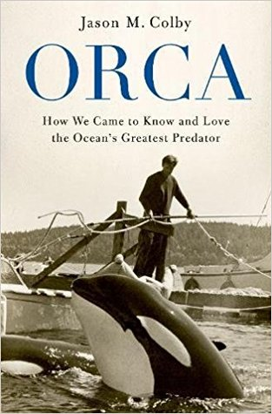
DB 91479 Orca: how we came to know and love the ocean’s greatest predator by Jason M. Colby
Annotation: Historian profiles orcas, also known as killer whales. Discusses the perception of orcas since Roman times, attempts by the fishing industry to eradicate them, the impact of public displays of captured orcas since 1965, and the success of conservation efforts. 2018.

DB 89730 Into the drowning deep by Mira Grant
Annotation: Seven years after the disappearance of an entire ship and its crew while seeking to film a "mockumentary" about legendary sea creatures, a new crew has been assembled. Among them is Victoria Stewart, who hopes to discover the fate of her sister, lost on the earlier voyage. Strong language and violence. Commercial audiobook. 2017.

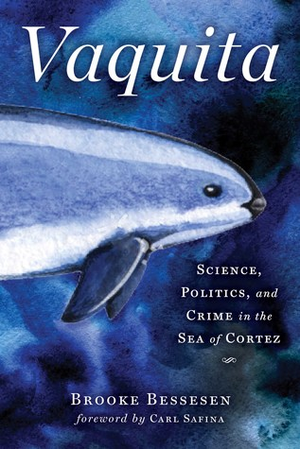
DB 92600 Vaquita: science, politics, and crime in the Sea of Cortez by Carl Safina
Annotation: Examination of the vaquita, a species of porpoise deemed the most endangered marine mammal in 2006. Discusses the fishing practices that have led to their near-extinction, diplomatic efforts between Mexico and the United States to save them, and efforts to create a breeding program. Unrated. Commercial audiobook. 2018.

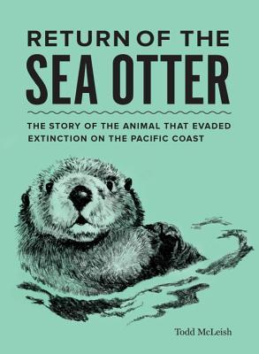
DB 91394 Return of the sea otter: the story of the animal that evaded extinction on the Pacific coast by Todd McLeish
Annotation: Journalist explores the world of the sea otter which faced extinction in the early twentieth century due to overhunting for its fur coat. Recounts the work of researchers and aquariums to regenerate the population, the impact on its marine environment, and the popularity of the species with the general public. 2018.

DB 53612 Oceanspace by Allen M. Steele
Annotation: In 2011 Joe Niedzwiecki and Peter Lipscomb are scientists aboard the first manned undersea research station, situated hundreds of feet under the Atlantic's surface. When Joe films a sea serpent Pete sends for his wife, Judith, a marine biologist, and his niece, Andie, to join them. Some violence and some strong language. 2000.

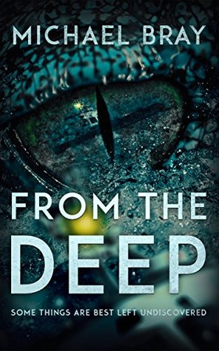
DB 102997 From the deep, books 1-3 by Michael Bray
Annotation: Trilogy written in 2014-15, featuring a sea monster that has awakened following an Antarctic ice quake. In From the Deep, a government scientist helps a survivor investigate the existence of the creature. Includes Return to the Deep and Spawn of the Deep. Violence and strong language. 2015.

DB 90694 The seabird’s cry: the lives and loves of the planet’s great ocean voyagers by Adam Nicolson
Annotation: The author of God's Secretaries (DB 56486) and Why Homer Matters (DB 81094) turns his attention to the lives of extinct and extant species of seabirds. Examines research on them, natural habitats, daily lives, and more. Commercial audiobook. 2018.

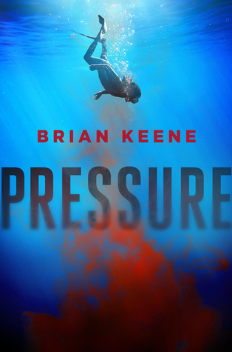
DB 86527 Pressure by Brian Keene
Annotation: When a portion of the Indian Ocean floor collapses, free diver Carrie Anderson and her partner are called in to investigate. Not only will she face corrupt officials on land, but the horrors she encounters deep in the ocean could spell extinction for humankind. Violence and some strong language. 2016.

Books for Youths

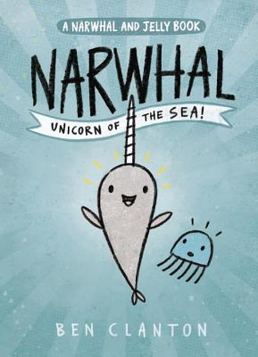
DB 100815 Narwhal, unicorn of the sea: Narwhal and Jelly by Ben Clanton
Annotation: A happy-go-lucky, waffle-loving narwhal and a cynical, no-nonsense jellyfish forge an unlikely friendship and share adventures while exploring the ocean together. Commercial audiobook. For grades K-3. 2016.

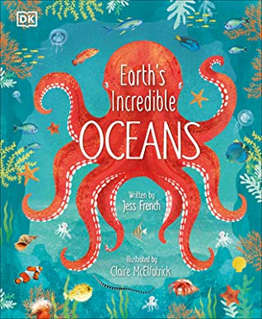
DB 104065 Earth’s incredible oceans by Jess French
Annotation: Animal expert Jess French explores the fascinating underwater world, demonstrating how amazing oceans are, what plants and animals live in them, and how we can help them. French includes amazing facts on how ocean animals have fun, care for their young, and interact with each other. For grades 3-6. 2021.

DB 88475 Sea otter heroes: the predators that saved an ecosystem by Patricia Newman
Annotation: Marine biologist investigates the mystery of how sea grasses are thriving in nutrient-polluted waters of Elkhorn Slough, an inlet of Monterey Bay in Northern California. His studies provide evidence that sea otters play an essential part in maintaining a healthy balance in this particular ecosystem. For grades 4-7. 2017.

DB 92202 The magic school bus on the ocean floor by Joanna Cole
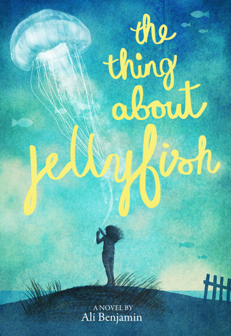
Annotation: After assigning ocean projects in school, Ms. Frizzle takes the class to the beach on a special field trip to learn about the different creatures that live there. Commercial audiobook. For grades K-3. 1992.

DB 82842 The thing about jellyfish by Ali Benjamin
Annotation: When twelve-year-old Suzy's best friend drowns, she believes a rare jellyfish was responsible for her death. Suzy will do everything possible to prove her theory is correct. Commercial audiobook. For grades 5-8. 2015.

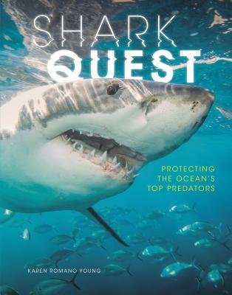
DB 92640 Shark quest: protecting the ocean’s top predators by Karen Romano Young
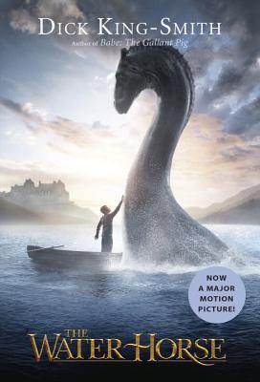
Annotation: Overview of sharks, from their intelligence and feeding habits to how researchers study sharks at sea. Discusses the human impact on their populations, and what we can do to save these incredible predators. For grades 6-9 and older readers. 2018.

DB 48417 The water horse by Dick King-Smith
Annotation: Scotland, 1930. Kirstie and her little brother Angus bring an odd fish egg home from the beach. When a strange creature with a long neck and a horse-like head hatches in their bathtub, their grandfather helps the children care for the baby sea monster. For grades 3-6.

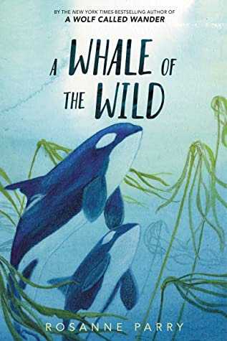
DB 101457 A whale of the wild by Rosanne Parry
Annotation: Vega, a young Orca, is learning to be a salmon finder and the family's future matriarch. When a devastating earthquake and tsunami render the seascape unrecognizable, Vega must use all her skills to lead her little brother back to their pod. Commercial audiobook. For grades 3-6. 2020.

DBC08690 Here come the humpbacks! by April Pulley Sayre
Annotation: A mother humpback whale and her calf participate in the great migration and face dangers along the way that reveal to young children some of the hazards confronting our environment and the animals that depend upon it. For grades K-3.

DB 87387 Giant squid by Candace Fleming
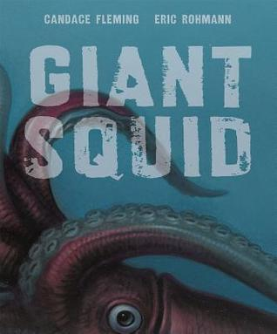
Annotation: Explores the mysterious life and anatomy of the elusive giant squid. Provides details on the creature's cunning defense mechanisms as it roams for prey in the ocean's deep. For grades 2-4. 2016.

