# Week 1 / 1ª Semana: Quests for Fortune / Búsqueda de Fortuna:

## Books for Adults / Libros para Adultos

### Audio

#### DB 50122 [*Ronicky Doone’s treasure*](https://kstb.klas.com/title/summary.jsf?id=46958896.6232)by Max Brand

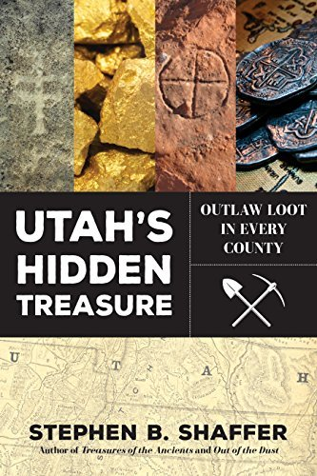"Horse-breaker, mischief-maker, adventurer by instinct," Ronicky Doone loves a good fight, especially for an underdog. As a reward for helping Hugh Dawn and his daughter escape the savage revenge of gang leader Jack Moon, Doone is invited to share in the search for the gold Dawn is hunting. Some violence. 1922.

#### DBC20254 [*Utah’s hidden treasure: outlaw loot in every county*](https://kstb.klas.com/title/summary.jsf?id=294308735.6232) by Stephen B. Shaffer

Strike it rich in your own backyard! This comprehensive guide to uncovering the lost loot in Utah will inspire you to go out and explore with your family. Covering every county in Utah, the book makes treasure-hunting accessible for everyone. Avid adventurer Stephen Shaffer will show you a side of Utah you've never seen before. Adult.

#### DB 09810 [*Lost treasures of the West*](https://kstb.klas.com/title/summary.jsf?id=143343181.6232) by Brad Williams

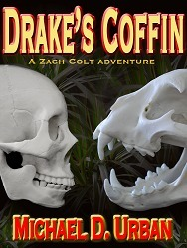Little-known stories of missing, stolen, or buried wealth, based on actual events. Lost treasures include a 500-pound silver ingot "lost" in the Mojave Desert, a gold mine sunk in Los Angeles Harbor, and $1,000,000 in gold bullion buried in San Francisco's North Beach.

#### DBC03871 [*Drake’s coffin*](https://kstb.klas.com/title/summary.jsf?id=259319748.9032) by Michael D. Urban

This thrilling adventure tells the story of a group of men who reunite to find Sir Francis Drake's lost treasure, which they had stumbled upon many years before as teenagers with tragic circumstances. Explicit descriptions of sex, strong language and violence.

#### The curse of Oak Island book cover. A skull mostly underwater with dome of the head above water growing trees and plants.DB 95448 [*The curse of Oak Island: the story of the world’s longest treasure hunt*](https://kstb.klas.com/title/summary.jsf?id=188869766.6232) by Randall Sullivan

Journalist chronicles more than two hundred years of treasure hunting on a small island off the coast of Nova Scotia. Discusses his history with the legend, the television show featuring modern-day treasure hunters on the History Channel, and the many people the "Money Pit" has lured to the island. 2018.

#### DBC06418 [*The gold of Cape Girardeau*](https://kstb.klas.com/title/summary.jsf?id=168016469.6232) by Morley Swingle

A treasure trove of gold is found buried next to a skeleton with a bullet hole in its skull. The secrets of the gold are revealed in a story that takes the reader from a modern courtroom to the glory days of steamboating on the Mississippi; from young love on the river to the perils of living in a town of split loyalties during the Civil War. Winner of the 2005 Governor's Book Award.

#### DB 96655 [*The eye of the tiger*](https://kstb.klas.com/title/summary.jsf?id=192119729.6232) by Wilbur A. Smith

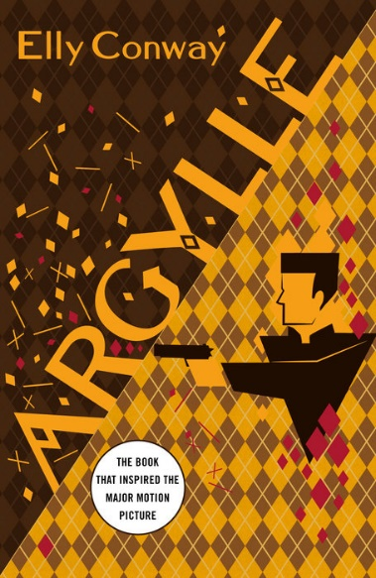Reformed thief Harry is now skipper of a charter boat in the Indian Ocean. When his latest clients go after a treasure under the sea, Harry is soon dealing with bloodthirsty villains, scuba diving, coral poisoning, fights with sharks, and hand-to-hand encounters with human monsters. Some strong language. 1974.

#### DB 12999 [*Apache gold and Yaqui silver*](https://kstb.klas.com/title/summary.jsf?id=142062467.6232) by J. Frank Dobie

True, colorful adventures about buried treasure and lost mines of the Southwest. Dobie made numerous pack trips across trails and mountains to authenticate his stories, and he supplies many details of personal experiences.

#### DB 118427 [*Argylle*](https://kstb.klas.com/title/summary.jsf?id=310259827.6232)by Elly Conway

"A luxury train speeding towards Moscow and a date with destiny. A CIA plane downed in the jungles of the Golden Triangle. A Nazi hoard entombed in the remote mountains of South-West Poland. A missing treasure, the eighth wonder of the world, lost for seven decades. One Russian magnate's dream of restoring a nation to greatness has set in motion a chain of events which will take the world to the brink of chaos. Only Frances Coffey, the CIA's most legendary spymaster, can prevent it. But to do so, she needs someone special. Enter Argylle, a troubled agent with a tarnished past who may just have the skills to take on one of the most powerful men in the world. If only he can save himself first..." -- Provided by publisher. -- Unrated. Commercial audiobook.

#### Within these gilded halls book cover. A woman in a long blue dress standing in a large two story hall with windows and an arched ceiling.DB 113973 [*Within these gilded halls*](https://kstb.klas.com/title/summary.jsf?id=298516691.6232) by Abigail Wilson

"Hidden treasure and betrayal mingle with unexpected love within the walls of Avonthorpe Hall. After studying art under Miss Drake, a renowned painter, Phoebe Radcliff is certain she can finally move beyond the childish mistake that's kept her away from home. She is thrilled when Miss Drake employs her to complete a complicated ballroom renovation. Everything changes, however, the moment Miss Drake is murdered. With her last breath she imparts the location of a clue to Phoebe. Can the biggest secret of Avonthorpe Hall be true-the rumored treasure real? Phoebe is tasked to finish her work in the ballroom by Miss Drake's infuriatingly regimented yet all-too-handsome nephew, Lt. Graham Burke. Determined to fulfill the promise she made to her beloved teacher to find the treasure, Phoebe also works to uncover the truth about Miss Drake's death-and she must do so before Lt. Burke leases the house. But dark shadows line the gilded halls of Avonthorpe, and soon enough Phoebe realizes she's not the only person who knows about the clues. What's worse, she needs Lt. Burke's help to stay ahead of whoever is hard on her heels. If only she weren't so attracted to him. Caught up in a deadly race for answers, Phoebe must find a way to breach the shroud of lies that surrounds every last resident in the house and, more importantly, face a past she's been running away from for far too long." -- Provided by publisher. -- Unrated. Commercial audiobook.

#### DB 108471 [*Something Wilder*](https://kstb.klas.com/title/summary.jsf?id=277446434.6232) by Christina Lauren

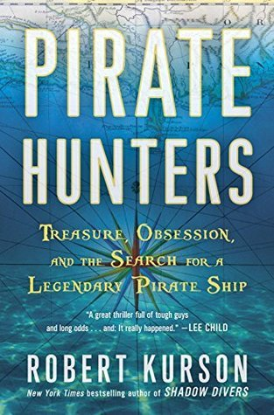"Growing up the daughter of notorious treasure hunter and absentee father Duke Wilder left Lily without much patience for the profession... or much money in the bank. But Lily is nothing if not resourceful, and now uses Duke's coveted hand-drawn maps to guide tourists on fake treasure hunts through the red rock canyons of Utah. It pays the bills but doesn't leave enough to fulfill her dream of buying back the beloved ranch her father sold years ago, and definitely not enough to deal with the sight of the man she once loved walking back into her life with a motley crew of friends ready to hit the trails. Frankly, Lily would like to take him out into the wilderness--and leave him there. Leo Grady knew mirages were a thing in the desert, but they'd barely left civilization when the silhouette of his greatest regret comes into focus in the flickering light of the campfire. Ready to leave the past behind him, Leo wants nothing more than to reconnect with his first and only love. Unfortunately, Lily Wilder is all business, drawing a clear line in the sand: it's never going to happen. But when the trip goes horribly and hilariously wrong, the group wonders if maybe the legend of the hidden treasure wasn't a gimmick after all. There's a chance to right the wrongs--of Duke's past and their own--but only if Leo and Lily can confront their history and work together. Alone under the stars in the isolated and dangerous mazes of the Canyonlands, Leo and Lily must decide whether they'll risk their lives and hearts on the adventure of a lifetime." -- Provided by publisher. -- Unrated. Commercial audiobook. 2022.

#### DB 81865 [*Pirate hunters: treasure, obsession, and the search for a legendary pirate ship*](https://kstb.klas.com/title/summary.jsf?id=127828364.6232)by Robert Kurson

Author of Shadow Divers (DB 58650) chronicles the story of John Chatterton (born 1951) and John Mattera (born 1962) and their search for the Golden Fleece, a pirate ship sunk off the coast of the Dominican Republic in the 1680s. Discusses challenges faced until the ship's 2008 discovery. Commercial audiobook. 2015.

Also available in braille as BR 21111.

#### DBG05328 [*Treasure Island revisited*](https://kstb.klas.com/title/summary.jsf?id=296201173.6232) by Jack Fitzgerald

The story of Captain Keating and the Cocos Island treasure, also known as "The lost treasure of Lima", was the inspiration for Robert Louis Stevenson's novel "Treasure Island". Hundreds of adventurers from all over the world, including President Franklin D. Roosevelt, sought Keating's treasure, estimated to be worth three hundred million dollars. An examination of the tale of Captain Keating, and of the connections between his story and Stevenson's classic. 2005. Unrated. Marrakesh title.

#### DB 17963 [*Leyendas de Guatemala*](https://kstb.klas.com/title/summary.jsf?id=136393456.6232) by Miguel Angel Asturias

The Nobel prize-winning author translates Guatemalan Indian legends and myths. Includes "Legend of the Tangle," "Legend of the Volcano," "Legend of the Devil's Hat," "Legend of the Flowers," "Warlocks of the Spring Storm," and "Cuculcan." Spanish language.

#### DB 62994 [*Oro y la paz*](https://kstb.klas.com/title/summary.jsf?id=48186996.6232) by Juan Bosch

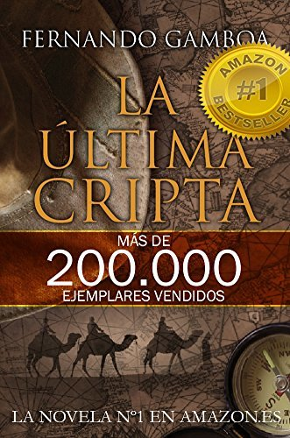Pedro Yasic has come to the Amazon jungle of Bolivia to find peace, but he meets others who come in search of riches. The interplay of the different characters against the exotic background forms the action of this novel by the acclaimed Dominican writer. Spanish language. 1976. Pedro Yasic ha venido a la selva amazónica de Bolivia para encontrar la paz, pero conoce a muchas personas que vienen en busca de tesoro. Los caracteres de esos personajes y el efecto que tienen sus pasiones entre sí, así como los obstáculos y las durezas de la selva que se les presentan forman la acción de esta novela del más leído de los escritores dominicanos.

#### DB 95525 [*La* ú*ltima cripta*](https://kstb.klas.com/title/summary.jsf?id=188828208.6232) by Fernando Gamboa

Diver Ulysses Vidal finds a 14th-century bronze bell of Templar origin and--together with a medieval history professor and a Mexican archeologist--begins a global search for the legendary treasure of the Order of the Temple. Spanish language. 2013. El submarinista Ulises Vidal encuentra una campana de bronce del siglo decimocuarto de origen templario y--junto con un profesor de historia medieval y un arqueólogo mexicano--comienza una búsqueda global para el legendario tesoro de la Orden del Templo.

#### DB 100294 [*Carta esférica*](https://kstb.klas.com/title/summary.jsf?id=243002402.6232) by Arturo Perez-Reverte

España, los 90. Una carta náutica antigua presenta dos improbables socios, Manuel Coy de la Marina Mercante y Tanger Soto de el Museo Naval de Madrid. Ellos usan el mapa para buscar un barco jesuita hundido del siglo XVII y su presunto tesoro. Contiene lenguaje ofensivo y algunas descripciones de violencia y índole sexual. Spain, 1990s. An antique nautical chart introduces two unlikely partners, Manuel Coy of the Merchant Marine and Tanger Soto of the Madrid Naval Museum. They use the map to search for a sunken, seventeenth-century Jesuit ship and its presumed treasure. Strong language, some violence, and some descriptions of sex. Spanish language. 2000.

#### DB 112783 [*Revolución: una novela*](https://kstb.klas.com/title/summary.jsf?id=294621470.6232)by Arturo Perrez-Reverte

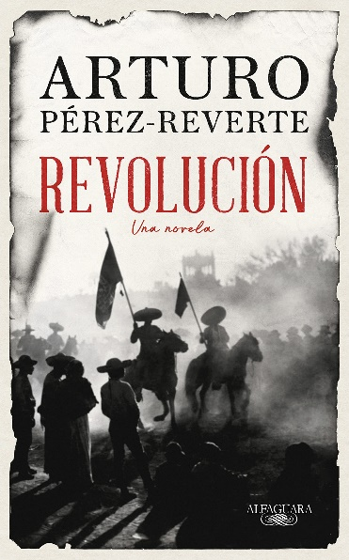"This is the story of a man, three women, a revolution, and a treasure. The revolution was that of Mexico in the time of Emiliano Zapata and Francisco Villa. The treasure was fifteen thousand and twenty pesos in the form of Maximilian gold coins, stolen from a bank in Ciudad Juarez on May 8, 1911. The man's name was Martín Garret Ortiz and he was a young Spanish mining engineer. It all began for him that day, when he heard the first distant gunshot from his hotel. He went out into the street to see what was happening and from that moment on his life changed forever...." -- Translation provided by NLS. -- Unrated. Commercial audiobook. Spanish language. "Ésta es la historia de un hombre, tres mujeres, una revolución y un tesoro. La revolución fue la de México en tiempos de Emiliano Zapata y Francisco Villa. El tesoro fueron quince mil monedas de oro de a veinte pesos de las denominadas maximilianos, robadas en un banco de Ciudad Juárez el 8 de mayo de 1911. El hombre se llamaba Martín Garret Ortiz y era un joven ingeniero de minas español. Todo empezó para él ese mismo día, cuando desde su hotel oyó un primer disparo lejano. Salió a la calle para ver qué ocurría y a partir de ese momento su vida cambió para siempre...." -- Goodreads. -- Sin calificación. Audiolibro comercial.

#### DB 119521 [*Argylle*](https://kstb.klas.com/title/summary.jsf?id=312017081.6232) by Elle Conway

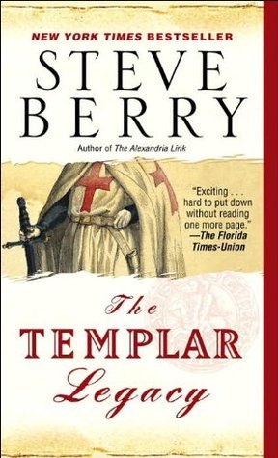Unrated. Commercial audiobook. Spanish language. "Christopher Clay tuvo una infancia difícil. Nacido en Rusia y abandonado por sus padres, fue adoptado por una familia americana con la que se crió en los Estados Unidos. Pero nunca olvidó sus orígenes y regresó a su país convertido en Vasily Federov, un hombre de negocios inmensamente rico, decidido a recolocar a su país en el centro del poder mundial. Frente a él, Frances Coffey, legendaria agente de la CIA y su equipo de agentes especiales. Entre ellos, Aubrey Argylle, cuyo oscuro pasado familiar le capacita para una misión tan peligrosa como sofisticada: localizar, antes que los hombres de Federov, el escondite de un tesoro napoleónico, arrebatado por los nazis y trasladado en secreto a uno de los lugares más recónditos de Europa. Las cartas están echadas, que gane el mejor." -- Proporcionada por la editorial. -- Traducido de la edición en inglés de 2023. Sin calificación. Audiolibro comercial.

### Braille

#### BRG01895 *The Templar legacy* by Steve Berry

Cotton Malone, retired top operative of the U.S. Justice Department, comes to the aid of his former supervisor Stephanie Nelle, who is pursuing the legendary treasure of the Knights Templar. Violence, strong language, and some descriptions of sex. 2006. Marrakesh title.

#### Something more book cover. Two people sit on horses next to a stream with trees, bushes, and rocks around them.BR 17600 *Something more* by Janet Dailey

Wyoming. Rancher Luke McCallister unearths human remains purported to be those of treasure hunter Henry James Wilson, grandfather of history teacher Angie Sommers. Angie arrives to claim the body and, more important, locate long-lost outlaw gold. Angie enlists Luke's help, but they aren't the only ones seeking the fortune. 2007.

#### BR 15599 *Plum Island* by Nelson DeMille

When two research biologists are found shot on Plum Island, NYPD detective John Corey, recuperating from wounds sustained on a previous job, joins the case. He finds himself in a perilous world of germ warfare, buried treasure, avarice, and murder. Descriptions of sex, violence, and strong language. 1997.

#### BR 13146 *Three miles down* by James Hamilton-Paterson

The author's account of his 1995 participation in Project Orca--the hunt for a Japanese submarine sunk during World War II and believed to be carrying several tons of gold. He portrays the anticipation of finding treasure and a primordial watery world full of unexpected beauty. Some strong language. 1999.

## Books for Youths / Libros Juveniles

### Treasure Island book cover. A young boy holds the wheel of the ship as a man with a gun his belt and a parrot on his shoulder stands behind him.Audio

#### DB 82593 [*Treasure hunters*](https://kstb.klas.com/title/summary.jsf?id=131466648.6232) by James Patterson

Following clues left by their missing father, twelve-year-old twins Bickford and Rebecca Kidd sail from the Caribbean to New York City with their siblings to finish the dangerous quest of their world-famous treasure-hunting parents. Commercial audiobook. For grades 4-7 and older readers. 2013.

#### DB 29508 [*Mummies, tombs, and treasure: secretes of ancient Egypt*](https://kstb.klas.com/title/summary.jsf?id=155832615.6232) by Lila Perl

The ancient Egyptians believed that the spirit of a dead person could live forever if that person's body was preserved. So, they began to mummify their dead and to bury them in tombs equipped for the afterlife with food, drink, household items, and riches. The author discusses the Egyptians' views of death and afterlife, mummification, tombs, and tomb robbers. For grades 6-9 and older readers.

#### DB 52436 [*Treasure Island*](https://kstb.klas.com/title/summary.jsf?id=155832615.6232)by Robert Louis Stevenson

The ancient Egyptians believed that the spirit of a dead person could live forever if that person's body was preserved. So they began to mummify their dead and to bury them in tombs equipped for the afterlife with food, drink, household items, and riches. The author discusses the Egyptians' views of death and afterlife, mummification, tombs, and tomb robbers. For grades 6-9 and older readers.

#### Windcatcher book cover. A young person works on fixing the sail of their small sailboat while guiding it through rough waters to an island in the distance.DBC27910 [*Windcatcher*](https://kstb.klas.com/title/summary.jsf?id=299355991.6232) by Avi

This tale offers a potent brew of mystery and adventure in this tale of an 11-year-old boy involved in a search for a centuries old shipwreck. The setting is among the Thimble Islands located off the coast of Connecticut thought to be the hiding spot of Captain Kidd's treasure. For grades 2-4.

#### DB 12810 [*The treasure of Alpheus Winterborn*](https://kstb.klas.com/title/summary.jsf?id=131701381.6232) by John Bellairs

After stumbling upon a well-hidden clue in the public library, Anthony Monday sets out on a wild and dangerous hunt for a treasure rumored to have been hidden long ago by the town's eccentric millionaire and practical joker. A mystery for grades 5-8.

#### Tangled up in luck book cover. A girl kneels down on one knee on the sidewalk of a town. Above her is a square frame. The girl looks up as she shines a flashlight at another girl wearing all black with a mask and holding a magnifying glass who is balanced on the frame. Beneath her side of the frame is a graveyard. DBC24412[*Tangled up in luck*](https://kstb.klas.com/title/summary.jsf?id=301322857.6232) by Merrill Wyatt

Seventh graders Sloane and Amelia are devastated to be paired for a research project about long-lost jewels, but soon they are finding clues hidden for nearly a century and realize they are being used. For grades 3-6.

#### DBC11610 [*The tale of the Scituate lightkeeper’s daughter*](https://kstb.klas.com/title/summary.jsf?id=469849225.9032) by Richard M. Wainwright

Set in an historic seaside town south of Boston, this is the story of a mysterious stranger who leads a lighthouse keeper's daughter to a long hidden treasure. For grades K-3.

#### DB 32612 [*Sunken treasure*](https://kstb.klas.com/title/summary.jsf?id=155923498.6232) by Gail Gibbons

In 1622 the "Atocha"--a Spanish treasure ship laden with gold, jewels, silver bars, and thousands of coins--sank in a hurricane off the coast of Florida. This book describes the many-years-long search for the ship and its artifacts. For grades 2-4 and older readers.

#### DB 81055 [*At home in her tomb: Lady Dai and the Ancient Chinese treasures of Mawangdui*](https://kstb.klas.com/title/summary.jsf?id=123041266.6232) by Christine Liu-Perkins

Explores the mysteries of the Mawangdui (mah-wahng-dway) tombs, one of China's top archaeological finds, and sheds light on what life was like during the Han dynasty (202 B.C.-220 A.D.). Details the burial and condition of Lady Dai's body and cause of death. For grades 6-9 and older readers. 2014.

#### DB 107122 [*Manual de piratas*](https://kstb.klas.com/title/summary.jsf?id=274483618.6232) by Monica Carretero

This guide to becoming a pirate includes fun interactive games that test children to see if they have what it takes to be a pirate. Can they find the buried treasure while flying the skull and crossbones flag? Only one way to find out! For grades K-3. Spanish language. 2007. Esta guía para convertirse en pirata incluye divertidos juegos interactivos que ponen a prueba a los niños para ver si tienen lo que se requiere para ser un pirata. ¿Podrán encontrar el tesoro enterrado mientras enarbolan la bandera del cráneo y huesos cruzados? ¡Sólo hay una forma de averiguarlo! Para grados K-3

#### DB 17755 [*The treasure of Guatavita = El Tesoro de Guatavita*](https://kstb.klas.com/title/summary.jsf?id=130843035.6232) adapted by Harriet Rohmer & Jesus Guerrero Rea

A short folk tale, based on a legend of the Chibcha Indians of Columbia, telling of a priceless treasure protected by the goddess Bachue at the bottom of the lake. In English and Spanish language. For children and adult readers.

#### DB 106725 [*De como Tia Lola salvo el verano*](https://kstb.klas.com/title/summary.jsf?id=273630258.6232) by Julia Alvarez: traducción de Mercedes Guhl

Tía Lola's friend Víctor brings his three daughters to Vermont for a visit, surrounding Miguel with girls. But Tía Lola creates a fun summer camp where Miguel, his sister Juanita, and the other girls enjoy adventures. Sequel to How Tía Lola Learned to Teach (DB 73105). For grades 3-6. Spanish language. 2012. El amigo de Tía Lola, Víctor, trae de visita a sus tres hijas a Vermont, rodeando a Miguel de niñas. Pero Tía Lola crea un divertido campamento de verano en el que Miguel, su hermana Juanita y las demás niñas disfrutan de aventuras. Traducido de la edición en inglés del 2011. Secuela a "De Cómo Tía Lola Aprendió a Enseñar (DB 106983)". Para grados 3-6.

### Braille

#### Breathing underwater book cover. A young woman with a camera strapped to her shoulder leans on the back of a young man holding an iPod. Each person has one of the earbuds in their ear as they listen with their eyes closed. Water with a school of fish and a turtle swirl around them.BR 24073 *Breathing underwater* by Sara Elisabeth Allen

During a road trip, thirteen-year-old Olivia, a budding photographer, tries to recreate a Treasure Hunt she once shared with her sixteen-year-old sister, Ruth, while watching for signs that Ruth's depression is back. For grades 5-8. 2021.

#### BR 07989 Gold & silver, silver & gold by Alvin Schwartz

A collection of twenty-five brief pieces--legends, true stories, fiction, and tall tales--about buried treasures. For junior and senior high and older readers.

#### Skybreaker book cover. Four people ride in an open top plane away from a zeppelin folding in half all surrounded by clouds.BRG01085 *Skybreaker* by Kenneth Oppel

16-year-old Matt Cruse is the only person who knows the coordinates of The Hyperion, a legendary ghost ship rumoured to be full of riches. Soon Matt and his sweetheart Kate are on a dangerous treasure hunt, along with pilot Hal and Nadira, a gypsy girl who claims to have the key to the Hyperion's booby-trapped booty. Sequel to "Airborn." Descriptions of violence. For Junior high readers. Winner of the 2006 Red Maple Award. 2005. Marrakesh title.

#### BR 07736 *Pearl’s pirates* by Frank Asch

When their owner is thrown off his bike and taken to the hospital, Pearl and Wilbur (two mice) are left on their own. It's not long before they're in trouble and find themselves trapped in a crate on an ocean liner headed for France. After jumping ship with their new friend Bill, the mouse sailor, they go off on a treasure hunt. Sequel to "Pearl's Promise." For grades 3-6.

#### The curse of the mummy book cover. A sarcophagus of a pharaoh with shining gold eyes and streams of golden light curling out and around the sarcophagus.BR 23998 The curse of the mummy: uncovering Tutankhamun’s tomb by Candace Fleming

During the reign of the New Kingdom of Egypt, the boy pharaoh Tutankhamun ruled and died tragically young. An award-winning author recounts the true story of the search for Tutankhamun's tomb, the Western public's belief that the dig was cursed, and the battle for ownership of the treasures within. For grades 4-7. 2021.