Week 1: Love Yourself…Because Kindness Starts from Within

Books for Adults

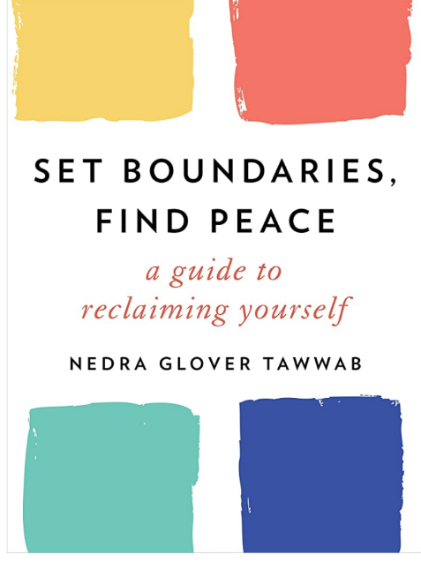
DB 102769 Set boundaries, find peace: a guide to reclaiming yourself by Nedra Glover Tawwab
Annotation: A counselor and relationship expert discusses the importance of setting healthy personal boundaries. Referencing the latest research in cognitive behavioral therapy (CBT), she identifies techniques that help identify and express needs clearly to unravel a root problem behind codependency, power struggles, anxiety, depression, and more. Unrated. Commercial audiobook. 2021.
Also available as BR24417 from BARD

DB 112025 Vibrant: a groundbreaking program to get energized, own your health, and glow by Stacie Stephenson
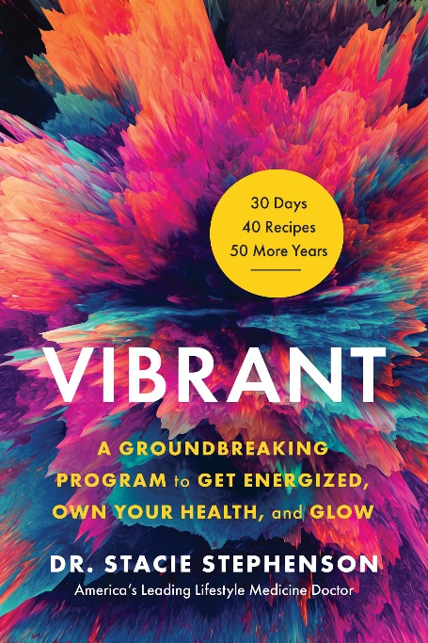
Annotation: "Today's view of wellness is far too often fragmented, focusing on specific symptoms rather than the whole person. In Vibrant, Dr. Stacie Stephenson introduces listeners to a new and empowering way of looking at health. By the end of this life-changing book, listeners will have the tools to transform their energy, weight, fitness, and general wellness, tackling everything from enhancing sleep quality to building an iron-clad immune system. Beginning with basics such as the truth about the best diet, the critical role of exercise in vitality and longevity, and the importance of human connection, Vibrant also dives deeper to give a holistic picture of health and how to achieve it. With helpful breakdowns on supplements, detoxification, and how to think about disease, this is much more than just another wellness book. With Stephenson's candid and conversational voice, Vibrant is like having a friend who also happens to be a leading health authority take you under her wing. Along with practical advice, she shares powerful insights that will change the way you think about everything from exercise to relationships, and sends listeners off with an inspirational chapter on how health has a ripple effect that can change your family, your community, and help to create a more vibrant world." -- Provided by publisher. -- Unrated. Commercial audiobook.

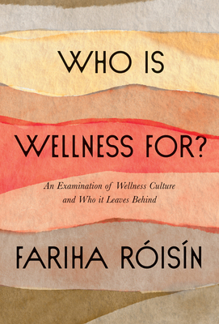
DB 110142 Who is wellness for? an examination of wellness culture and who it leaves behind by Fariha Róisín
Annotation: "The multi-disciplinary artist and author of Like a Bird and How to Cure a Ghost explores the commodification and appropriation of wellness through the lens of social justice, providing resources to help anyone participate in self-care, regardless of race, identity, socioeconomic status or able-bodiedness. Growing up in Australia, Fariha Róisín, a Bangladeshi Muslim, struggled to fit in. In attempts to assimilate, she distanced herself from her South Asian heritage and identity. Years later, living in the United States, she realized that the customs, practices, and even food of her native culture that had once made her different-everything from ashwagandha to prayer-were now being homogenized and marketed for good health, often at a premium by white people to white people. In this thought-provoking book, part memoir, part journalistic investigation, the acclaimed writer and poet explores the way in which the progressive health industry has appropriated and commodified global healing traditions. She reveals how wellness culture has become a luxury good built on the wisdom of Black, brown, and Indigenous people-while ignoring and excluding them. |Who Is Wellness For?| is divided into four sections, beginning with The Mind, in which Fariha examines the art of meditation and the importance of intuition. In part two, The Body, she investigates the physiology of trauma, detailing her own journey with fatphobia and gender dysmorphia, as well as her own chronic illness. In part three, Self-Care, she argues against the self-care industrial complex but cautions us against abandoning care completely and offers practical advice. She ends with Justice, arguing that if we truly want to be well, we must be invested in everyone's well being and shift toward nurturance culture. Deeply intimate and revelatory, |Who Is Wellness For?| forces us to confront the imbalance in health and healing and carves a path towards self-care that is inclusionary for all." -- Provided by publisher. -- Unrated. Commercial audiobook.

DB 80435 Success through stillness: meditation made simple by Russell Simmons
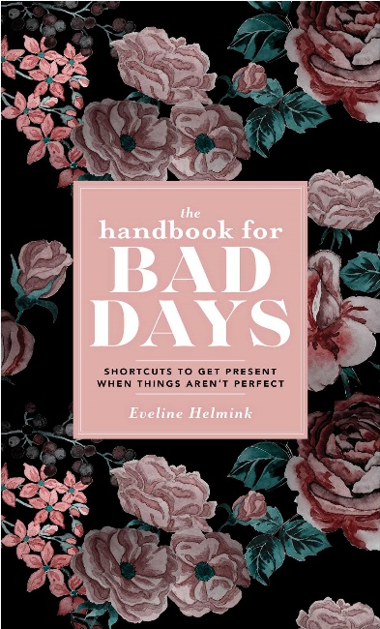
Annotation: Entrepreneur and author of Do You! (DB 65065), who believes the most fundamental key to success is meditation, explains how to use stillness as a powerful tool to access potential. Illustrates the connection between inner peace and outward success through interviews with successful leaders in various industries. 2014

DBC24674 The handbook for bad days: shortcuts to get present when things aren’t perfect by Eveline Helmink
Annotation: Keep your head held high even on the bad days with 70 mindful self-care strategies to find happiness. The Handbook for Bad Days is the ultimate guide for anyone who strives to be present, not perfect. The Handbook for Bad Days is a call to face our worst days with courage and intentionality.

DB 106333 Feeding the soul (because it’s my business): finding our way to joy, love, and freedom by Tabitha Brown
Annotation: An actress discusses her personal struggles with chronic autoimmune pain, her personal journey of growth and health, and how she learned to listen to what her soul and body needed. She shares lessons and stories from her own life, career, faith, and family. Unrated. Commercial audiobook. Bestseller. 2021.

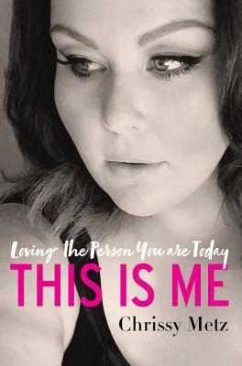
DB 90995 This is me: loving the person you are today by Chrissy Metz
Annotation: Memoir of actress famous for her role on the TV show This Is Us. She discusses her difficult youth, her career, and the challenges she faced being a plus-sized woman--especially in Hollywood. She shares lessons she learned about self-acceptance, empowerment, and gratitude. Some strong language. Bestseller. 2018.
Also available as BRG04265 from BARD.

BR12253 The healer within: the four essential self-care methods for creating optimal health by Roger Jahnke
Annotation: A doctor of acupuncture and Chinese medicine explains how to achieve long-term wellness in a few minutes a day using four tools--gentle movement, self-applied massage, breathing exercises, and relaxation or meditation.

BR20490 10% happier: how I tamed the voice in my head, reduced stress without losing my edge, and found self-help that actually works—a true story by Dan Harris
Annotation: Coanchor of Nightline and Good Morning America recounts his recreational drug use and 2004 nationally televised panic attack that--coupled with overextension at work and his stint covering religion--prompted him to practice meditation, which he asserts led to increased calm, focus, and happiness in his life. 2014.

Books for Youth

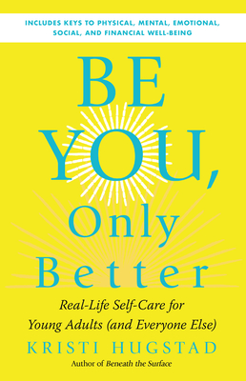
DB 111716 Be you, only better: real life self-care for young adults (and everyone else) by Kristi Hugstad
Annotation: "Outlines daily practices that promote physical, mental, and emotional health for young people making the transition to adulthood. The author covers practices such as journaling, exercise, healthy sleep habits, time management, and mindfulness, with brief discussions of scientific research showing the proven benefits of each practice." -- Provided by publisher. Unrated. Commercial audiobook. For senior high and older readers.

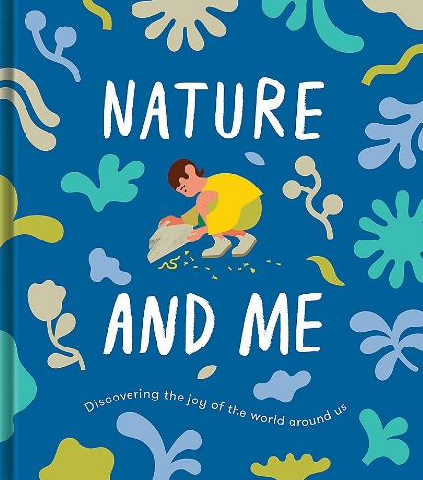
DB 110178 Nature and me: a guide to the joys and excitements of the outdoors by School of Life
Annotation: "Children are used to hearing about how important it is to protect nature, but they may not fully understand how the natural world can positively impact their emotional wellbeing. With that in mind, this book looks to show children how nature can be fun, uplifting, consoling and even offer companionship." -- Provided by publisher. -- For grades 3-6.

DB 111618 Just be you: ask questions, set intentions, be your special self, and more by Mallika Chopra
Annotation: "Just Be You will help kids become focused on growth mindset by self-reflection, setting intentions for their lives, and being of service to themselves, their families, and the global community. Designed specifically with kids ages 8-12 in mind and with full-color illustrations throughout, Mallika's book offers mindful exercises to help young people explore and find their voice. Mallika believes that if children learn early on to reflect, to be comfortable with uncertainty, to contribute in a way that's unique to them, and to feel good about the journey, they will lead healthier, more adjusted, and happier lives." -- Provided by publisher. -- Commercial audiobook. For grades 4-7.

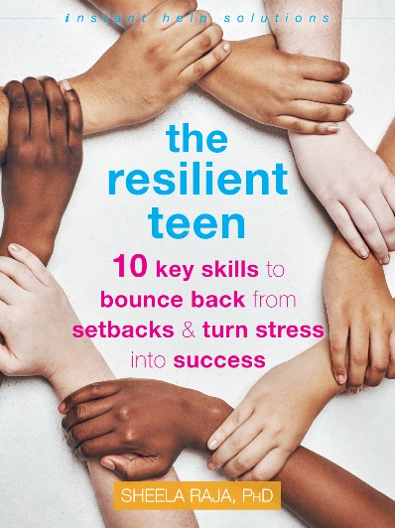
DB 104450 The resilient teen: 10 key skills to bounce back from setbacks & turn stress into success by Sheela Raja
Annotation: Raja, a clinical psychologist, provides tools and critical skills to help teens bounce back from challenging situations, deal with difficult emotions, care for their physical and mental health, and cultivate a sense of joy, even in the face of modern-day stressors. For senior high and older readers. 2021.
Also available as BR23761 from BARD

DB 104691 Positively teen: a practical guide to a more positive, more confident you by Nicola Morgan
Annotation: Award-winning author provides strategies to cope with change during adolescence. Emphasis on the importance of doing things you enjoy, understanding your personality type, how exercise and healthy eating can fuel mental and physical health, and more. For senior high and older readers. 2018.

