Week 1: All about the Ocean

Books for Adults

DB 72681 Atlantic: great sea battles, heroic discoveries, titanic storms, and a vast ocean of a million stories by Simon Winchester
Annotation: Author of Krakatoa (DB 55879) traces the history of the Atlantic Ocean from its formation 370 million years ago to its predicted obliteration in about 170 million years. Includes geographical descriptions and accounts of explorers and maritime battles. 2010.

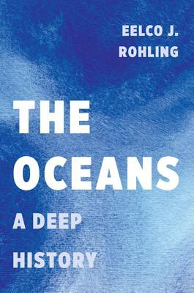
DB 94383 The oceans: a deep history by Eelco J. Rohling
Annotation: Oceanographer provides a history of the world's oceans and their role in Earth's climate systems over the past 4. 4 billion years. Discusses the oceans' origins, change agents, climate swings, the impacts of life on Earth, acidification, and prospects for the future. 2017.

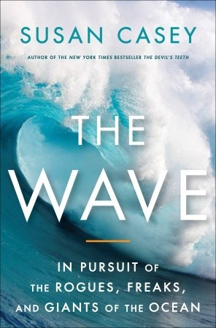
DB 71995 The wave: in pursuit of the rogues, freaks, and giants of the ocean by Susan Casey
Annotation: Explores the science, evidence, and legend behind rare one-hundred-foot-and-bigger behemoth waves. Chronicles the experiences of scientists and a tribe of surfers in their continual and dangerous search for the mammoth wave. Includes historical reconstructions of events that devastated ships and oil rigs. Some strong language. Bestseller. 2010.

DB 84250 Pacific: silicon chips and surfboards, coral reefs and atom bombs, brutal dictators, fading empires, and coming collision of the world’s superpowers by Simon Winchester
Annotation: Bestselling historian and author of Atlantic (DB 72681) looks at how the planet's largest ocean is at the center of the new world stage. Focuses on both the cultural and the political history of the region since 1950, showing the shifts in world influence. Bestseller. 2015.

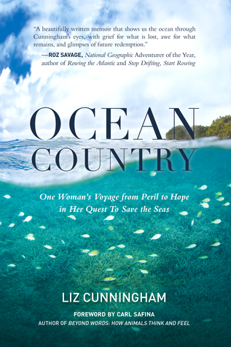
DB 94069 Ocean country: one woman’s voyage from peril to hope in her quest to save the seas by Liz Cunningham
Annotation: After a near-drowning that left her temporarily paralyzed, the author traveled the globe to understand the threats to the world's oceans. Stops along the way included the Turks and Caicos Islands, the California coast, the Coral Triangle, the Mediterranean, and the Silver Bank. Unrated. Commercial audiobook. 2015.

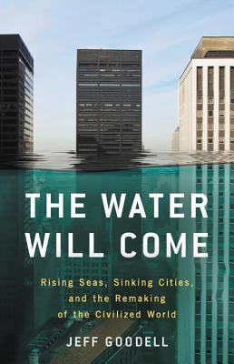
DB 89944 The Water will come: rising seas, sinking cities, and the remaking of the civilized world by Jeff Goodell
Annotation: The author of Big Coal (DB 63733) examines the impact of rising sea levels on coastal settlements and systems. Discusses climate change, melting ice caps, higher tides, economic disruption, seacoast infrastructure, housing, and more. Commercial audiobook. 2017.

DB 87117 The tide: the science and stories behind the greatest force on Earth by Hugh Aldersey-Williams
Annotation: Author of Anatomies (DB 77022) provides an episodic history of scientific research into the tides. Also discusses literary portrayals of tidal phenomena and their effects on communities, from the times of the Ancient Greeks to the modern period. 2016.

DB 18521 The sea around us by Rachel Carson
Annotation: A revised edition of an award-winning classic. An eminent marine biologist reveals the science and poetry of the sea from its primeval beginnings billions of years ago to scientific probings of its tantalizing mysteries. The most important new findings since the first edition (1950) are appended in notes.

Books for Youth

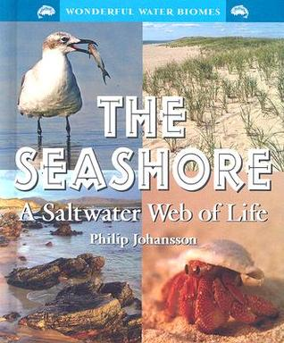
DB 68529 The seashore: a saltwater web of life by Philip Johansson
Annotation: A naturalist defines a seashore biome by discussing some of the plants and animals that live and interact on sandy beaches by the ocean. For grades 3-6. 2008.

DB 62626 On the coral reefs by Sneed B. Collard
Annotation: Describes the research of Dr. Alexandra Grutter and other marine biologists on coral reef relationships. Discusses Grutter's work with cleaner fish, who remove parasites from client fish. Explains how coral reefs benefit people and why reefs need protection. For grades 4-7. 2006.

DB 55174 What makes an ocean wave? Questions and answers about oceans and ocean life by Melvin Berger
Annotation: Short answers about sea water--waves, tides, salt; about life in the ocean--plankton, fish, mammals, and the food chain; and about the coast--beaches, wetlands, and reefs. For grades 3-6. 2000.

DB 26816 The continental shelf: an underwater frontier by Alice Thompson Gilbreath
Annotation: Describes the shelves under the oceans that begin at the shorelines and extend out from each of the world's continents. Discusses the plants and animals that live there, the fuel and minerals the shelves provide, the dangers of pollution, and the shelves' possible future use. For grades 4-7.

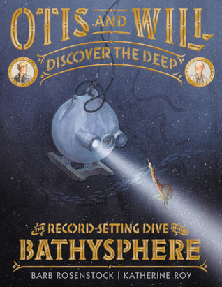
DB 93180 Otis and Will discover the deep: the record-setting dive of the Bathysphere by Barb Rosenstock
Annotation: Biographical account of engineer Otis Barton and naturalist Will Beebe's record-setting descent into the deep ocean in their Bathysphere craft. The scientists were the first humans to witness deep-sea creatures in their natural habitat. For grades K-3. 2018.

