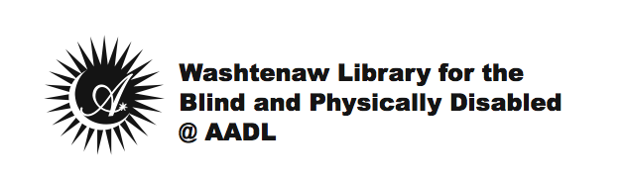

Date

Dear Patron,

In order to maintain an “Active” status as a member of the WLBPD@AADL, it is required that you check out materials at least one time during the previous twelve-month period.

You’re receiving this letter today because our records indicate you have not checked out any materials, downloaded any items from BARD or subscribed to a magazine in at least the last six months; and unfortunately, all attempts to reach you by phone or email to find out how we may better serve you have also been unsuccessful.

Please know that WLBPD staff is available during the following days and times to assist you in-person, over the phone, or by email:

Mondays: 10am-9pm
Tuesdays-Fridays: 9am-9pm
Saturdays: 9am-6pm
Sundays: 12pm-6pm

It is our goal that you receive the services you want and at the frequency that you want them. Or, if you no longer wish to receive services through the WLBPD@AADL, we would like to assist you with closing out your account. In either case, please do not hesitate to contact us so we may better serve you! You may reach us by phone at (734) 327-4209, or by email at wlbpd@aadl.org, and we look forward to hearing from you.

Sincerely,

Washtenaw Library for the Blind & Physically Disabled @
Ann Arbor District Library

