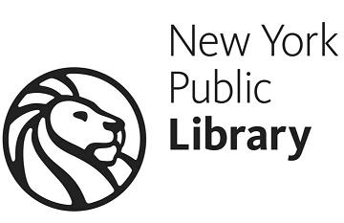
Trouble reading text?
Trouble holding books?
Contact us. You may be eligible for a free talking-book library service from NYPL and the Library of Congress.
If you have a physical impairment affecting your ability to read print books, you can get FREE access to:
- Digital talking book players mailed to your house
- Over 30,000 titles of audiobooks, read by narrators, which can be mailed to your house
- An online database where you can download unlimited titles with no wait
- A free app for iPhone/iPad to download and listen to those titles on the go
- Accessible programs and social groups ...and more.
Please contact us:
Andrew Heiskell Braille and Talking Book Library
talkingbooks@nypl.org 212-206-5400

