Accessibility and Inclusion at NYPL

Introduction
11.2% of people in New York City have a disability; Over half a million New Yorkers have 2 or more disabilities. 1 in 4 people will have a disability before they retire; some of these individuals are our colleagues. Three library staff members, Ronni Krasnow, Senior Librarian, Ellen MacInnis, Children’s Librarian, and Nefertiti Matos, Assistant Trainer for Assistive Technology give their thoughts on accessibility.

(Transcript of Employees Thoughts)
[Ellen MacInnis]
I can’t stress how we are everywhere, whether or not the disability is visible or invisible; But you’re in New York City, and it’s 2018 and what do you mean you don’t know that there are disabled people literally all over?

What’s Helpful?
[Nefertiti Guzman]
Don’t just assume that you know, even if you think you know, you probably don’t know, and that’s ok;
[Ellen MacInnis]
the most important thing about accessibility issues is that you cannot assume anything; that’s both for what you can see, and for invisible disabilities like ones that I have; I never think it’s a bad thing to ask what accommodations can I get for you, or do you need anything; I think it’s always a good place to start, and to mean it;
[Ronni Krasnow]
don’t help without asking, if I need help;
[Nefertiti Guzman]
if we need help or we need an accommodation, trust us to let you know what that is, trust us to know ourselves and speak up for ourselves;
[Ellen MacInnis]
the questions that you’re asking disabled people are the questions you should be asking everybody. What do you need? Do you need help? If you see someone struggling, how can I be of assistance? There’s nothing specifically that disabled people as a whole need, that able bodied people don’t; and we all need help from time to time;
[Nefertiti Guzman]
Don’t talk at us, talk to us; especially if we happened to be accompanied by a friend or a relative or even a caregiver; you’re speaking to us, because we are there for ourselves;
[Ronni Krasnow]
if I go to the theater for example, and I’m with a friend; the usher will always say, “if she needs the bathroom, it’s …” they assume, they sort of assume that if you have a physical impairment, that a mental impairment accompanies that.”

Final thoughts?
[Nefertiti Guzman]
Just treat us like you would any other colleague, speak to us the same; include us;
[Ellen MacInnis]
if you’ve met one disabled person, you have met one disabled person, and you’ve only met them on one day; and it’s just important to meet them as individuals;
[Ronni Krasnow]
I would say just treat a colleague with a disability the way you would treat any other colleague, we all have senses of humor, we want to interact, and not to be afraid, because we wouldn’t be here, if we couldn’t do the job.

Thank you, Ronni, Ellen, and Nefertiti.
----------------------
Overview
Ensuring the Library is accessible, inclusive and welcoming to everyone is the responsibility of every staff member.

Almost 1 million people in New York City have a disability. It is likely that you have worked with someone, who has a disability, and not even realized. This could be a member of the public, a vendor, a contractor, a volunteer, or a fellow staff member.

Everyone with physical, sensory, cognitive, and developmental disabilities should feel welcome at the New York Public Library.

This module will provide you with best practices, guidelines, and resources to help you do your part in making the Library’s commitment to accessibility and inclusion a reality.
-------------------------------------------------
Best Practices for Working with People with Disabilities
Disability Sensitivity Training Video from the District of Columbia Office of Disability Rights
------------------------------------------
Person First Language
A good practice is to use Person First Language, which emphasizes the person, not a disability.
"People with Disabilities", instead of "Disabled People", for example.

Find more examples in the NYPL Accessibility Handbook.

*People with disabilities are as diverse as any other community and there are people who do not like person first language. If an individual corrects you, don't feel discouraged - just use the language he or she requests.
------------------------------------------------------------
Hidden Disabilities
Not every disability is something you can observe. Many are considered Hidden Disabilities.
You won't always know if someone has a disability or not - and it doesn't matter. If you are regularly using best practices around etiquette and language, you should feel confident and comfortable in all interactions.
--------------------------------------------
Equality vs. Equity
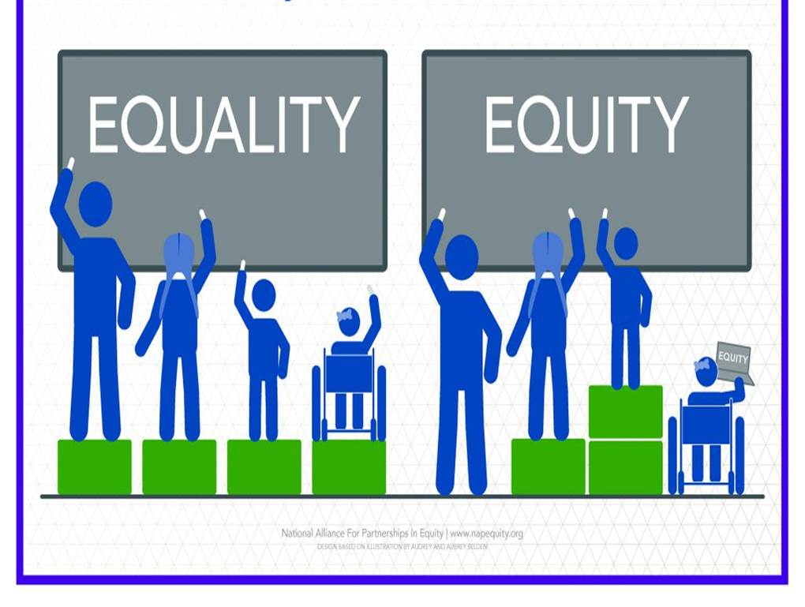
One way you can support people with disabilities is to create an equitable experience.

This illustration shows the difference between equality and equity. The left side represents Equality. Four people of varying heights, including a person in a wheelchair, are at a chalkboard using identical boxes to elevate them, and increase their reach. The tallest person doesn’t need the box to reach the board; it does allow the medium height person to reach the board, but does not help the shortest person, or the person in the wheelchair. It’s equal, because everyone has the same box - but not helpful for everyone. The right side of the picture shows an example of equity; everyone has what they need to participate in a way that is meaningful for them. The tallest person doesn’t need a box, the medium height person uses one box to reach the board; the shorter person uses two boxes to reach, and the person using a wheelchair has been provided a laptop in order to participate. When working with someone, who has a disability, be flexible and open to ways that you can provide an equitable experience.
-----------------------------------
Equitable Experiences
Standing for long periods of time can be difficult for people with certain disabilities; having chairs available for standing meetings or for patrons waiting in line will allow these individuals to participate comfortably; when materials are shared electronically in advance, it allows people to access them in the way that is best for them, by increasing the font or having it read through a screen reader for example. When planning events, whether for staff or the public, be mindful of the location and its level of accessibility.
---------------------------------------------

Library Resources
The Library provides many resources about accessibility for both staff and the public.
accessibility@nypl.org is a point of contact for both staff and patrons with questions around accessibility.
The following resources can be found on LAIR.
- The Accessibility Services page provides basic information, and links to resources
- The NYPL Accessibility Handbook has tips for communication, and etiquette, as well as best practices for customer service, program design, and Library resources.
- BLM #5 is the Library's policy and guidelines for accessibility

nypl.org/accessibility provides information for the public on the range of services and technologies available at the Library.
The Andrew Heiskell Braille and Talking Book Library provides materials for people, who are blind, visually impaired, or are otherwise physically unable to read standard print. The Andrew Heiskell Library can be contacted at talkingbooks@nypl.org.
-------------------------------------------------
Accessibility & Inclusion: Serving the Public
------------------------------------------------
Introduction
The New York Public Library is a place where people of all abilities feel welcome and can fully access the information, services and programs available.

Providing excellent customer service requires a welcoming environment, and staff, who are knowledgeable on Library resources and services.

To create a welcoming environment - think about everything discussed in the previous module. Remember not to make assumptions, and ask how you can help.

What information do you need to be knowledgeable about Library services and resources? The LAIR Accessibility Services Page; the NYPL Accessibility & Inclusion Handbook; and the public website all provide resources for making our services accessible.
----------------------------------------------
Personal Reading Machines
Personal Reading Machines are available at several NYPL locations.
Check nypl.org or LAIR for a current list, before making a referral.
Patrons use the Reading Machines to read everything from personal mail to ingredients labels.
-----------------------------------------------
Assistive Technologies
Jaws is a screen reader, which reads aloud what’s on the PC screen. Magic is a screen magnification software that allows users to customize the monitor for ease of viewing. Both are available on all Library PCs. You can find them in the Accessibility Software Folder.

If your location has Apple computers, they are equipped with accessibility features, including VoiceOver, and Zoom. These can be found in the settings, under accessibility.

Other Assistive technologies are available throughout the Library. You can find what’s available, and at what locations on the nypl.org accessibility page, and the Accessibility Services page on LAIR. This is list may change overtime, so it is important to check these pages, when making referrals. If you have any of these devices at your location, it is important that you know how to help patrons use them.
---------------------------------------
Bookshare
Bookshare has over 600,000 titles available from academic books to career manuals to popular items. Patrons of the Andrew Heiskell Library can use Bookshare for free.
----------------------------------------------------
Serve the Person, Not the Disability
Make sure to "serve the person, not the disability." What does this mean? Remember that your location will have many services for patrons regardless of ability. It's great to mention Andrew Heiskell services to your patrons, who might want them, but remember to also offer the services available locally - Jaws and MAGic, Audio Books, Large Print, DVDs with captions or descriptive audio for example.

Ebooks allow patrons to enlarge the type to a font that is accessible for them. They also work with iphone's voiceover technology or Android's TalkBack.

Many DVDs in our collection have captions for people, who are deaf or hard of hearing, and with audio descriptive tracks for patrons with visual impairments.

You can do a keyword search in the catalog for "Video recordings for the hearing impaired" for movies with captions, and on "Video recordings for people with visual disabilities" for movies with descriptive audio tracks.
-----------------------------------------------------------
Programs
Accessibility factors should be included, when programs are being designed. The Accessibility & Inclusion Handbook provides a checklist of things to consider to make your programs accessible. This includes room setup, information to include on promotional materials, and basics for different types of programs. No patron should be excluded from a program, because of a disability.
-----------------------
Accommodations
Some patrons may require an accommodation access Library services.

An accommodation request is made, when a person with a disability requests a particular service or assistance to enable them to participate in an activity or access a service. Some accommodations can be incorporated into you planning, so that a patron doesn’t need to request them. Arranging furniture, so wheelchairs can fit, or creating materials in large print for example.

How to accommodate a patron request may not always be clear. Your goal should be to find a solution, and not turn the patron down, while at the same time maintaining Library guidelines, and not compromising safety concerns. The solution you come up with may vary depending on your location, and the options available to you.
-----------------------------------
Quiet Spaces
Quiet spaces can be essential to patrons with sensory disorders or autism spectrum disorders to avoid being overwhelmed by bright lights, loud noises, and other stimuli in the Library. This is something you can think about in advance. Look at your space and think about your building - what spaces can you offer the patron without compromising safety? Are there days of the week or certain times of day you can designate an area as “Quiet Space”? Also, find out what libraries near your location have quiet spaces for referrals, if your location does not have a space available.
------------------------------------------------------
Core Values
Scenario
A patron enters the branch with a shopping cart. The patron appears to be using the cart as a walker. Can you accommodate the patron bringing the cart into the branch?

Answer
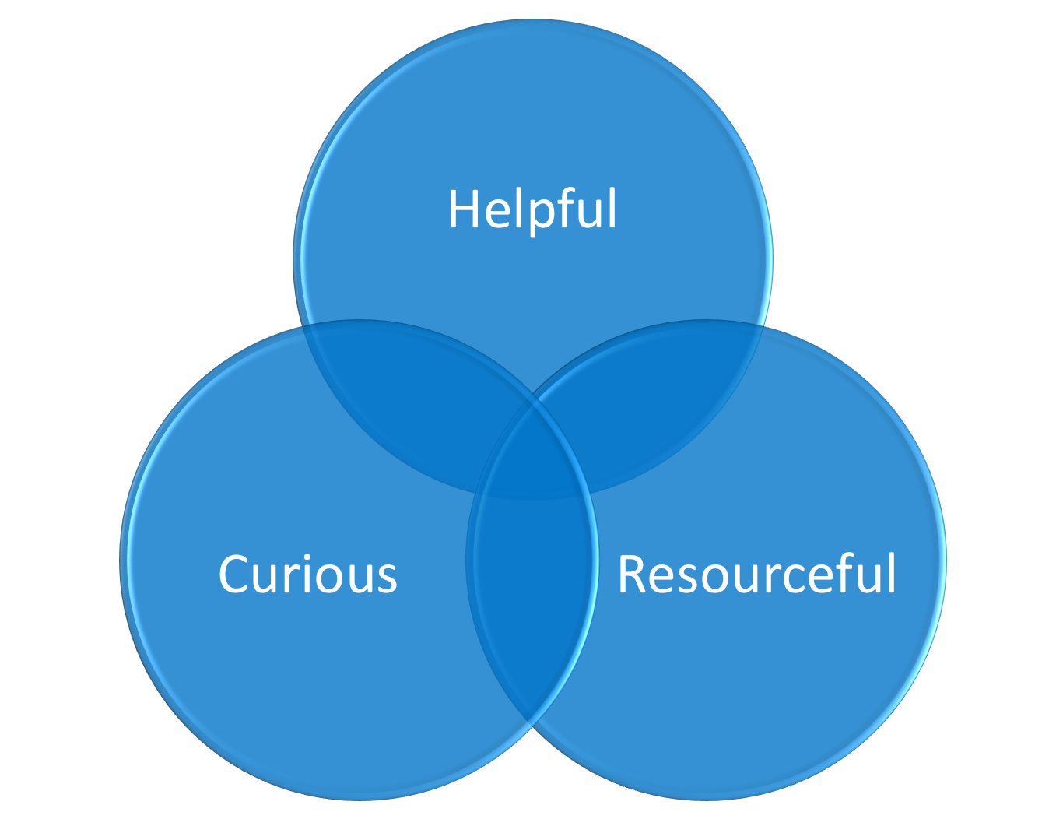
Yes. While shopping carts aren't designed to be mobility devices, it is common for people to use them for support.

The shopping cart example is a time when the Library's core values can help you make decisions. Think about what’s helpful in this circumstance. How can you provide an equitable experience for the patron without compromising the safety of all Library users?

--------------------------------------
Wheelchair Lifts
Because of safety concerns, maintenance and general wear and tear on the lifts, they should be reserved for patrons with disabilities or physical conditions that make it difficult for them to use stairs.
-----------------------------------------
Service Animals
Service animals can provide assistance for many disabilities, even those that are not visible. If you have concerns about animal, you may ask “What work or task has the animal been trained to do?”, but not about the disability. Emotional support animals are companion animals that a medical professional has determined provides benefit for an individual with a disability. Emotional support animals may be used by people with a range of physical, psychiatric, or intellectual disabilities. An animal does not need specific training to become an emotional support animal. If a patron tells you that her animal is an emotional support animal, or comfort animal you should allow the animal in the Library. Service animals and emotional support animals are not required to wear licenses or other items such as vests.

If you ask about the animal’s training, and the person has no answer - what do you do? If she says, something like, he’s for comfort and I can’t leave the house without him - consider it to be an emotional support animal. If she says something like, well he’s really well behaved, and I’m only going to be a minute … explain that because of safety and hygiene concerns, the Library cannot allow pets.
------------------------------------------
Buildings
Our buildings have different levels of accessibility, and it is important to remember this when referring patrons to other locations. Pay special attention to any location identified as “partially accessible.” This means different things in different locations.

In addition to www.nypl.org, information about the accessibility of our buildings can be found in the Atlas Database through ServiceNow
------------------------------
accessibility@nypl.org is one of the most important resources available to you.
Reach out whenever your have questions, whether about programs, collections, assistive technologies, or accommodations
---------------------------------------------
Additional Content for Managers
Below is the facilitators guide for the in person follow-up session. Accessibility & Inclusion @ NYPL Facilitator's Guide
In order to make sure all session leaders have access to the facilitator's guide, please let us know, how you plan to roll out the in person session in your department by completing this form.

