Results of the Duplication on Demand Network Survey 2021-04
These responses are listed in order of response to the survey.

KS1A – Michael Lang - michael.lang@ks.gov – 620-341-6287
- If you are using Gutenberg, why did you decide to use this system?
The printed list of books that is included with each cartridge.
- If you are using Scribe for KLAS libraries, why did you decide to use this system?
Null
- What are the benefits of DOD? (i.e. what can you do now that you were not able to do before?)
null
- What challenges did DOD present, if any? (i.e. what can't you do now that you were able to do before?)
Access ALL the books. Fill patron requests/reserves in a quicker time.
- FOR GUTENBERG LIBRARIES: How has NLS continued to provide support after moving your library to DOD? (i.e. ordering DOD supplies, cartridge allotments, etc.)
We're still trying to figure out how to easily circulate our local magazines
- How do library patrons that visit the library browse for titles now?
Very supportive of set up and troubleshooting. Getting answers about supply shipments has been lackluster.
- How do library patrons that visit the library now check out audio books?
Do not have a browsing collection
- Who manages the DOD process and system?
We're still in the learning phase, but it will hopefully soon be our two circulation staff.
- How long does it take to do the daily DODs? Before DOD and after DOD?
Less than 30 minutes, but we only have about 5% of our people rolled over.
- How did you inform your patrons about the change in service and would you do it that way again?
Webinar, newsletter, blog posts, and a "warning" postcard that their service is about to change. Still too early to decide if it's worked well. I like the postcard because it will give us people who have bad addresses on file.
- Do you have a need for more than the one DOD workstation supplied by NLS? If so, why?
No

- How do you assure quality when processing DOD? (For example: ensuring there aren't any audio errors on the cartridge you just duplicated? That KLAS is putting the correct book on the correct cartridge and mailing label?)
Just hope that it’s working. We ran tests first and they seemed accurate
- In what specific ways do circulation staff ensure quality control in workloads? (i.e. How do you make sure you aren't mixing up a mailing label and cartridge?)
Go one at a time.
- Braille circulation: Are you running separate circulation models between audio and hard copy or electronic braille?
null
- Can you create pre-bundles of books or series that can then be downloaded to a cartridge on demand?
null

- What are the specific ways that workloads/tasks have shifted for Circulation staff?
Still aren't far enough into it to know. COVID quarantine has been more of a shift than DoD so far.
- Did you see a reduction in need for staff and if so, how did you accommodate that shift?
Probably. We've already moved one of our full-time circ positions to half time. And I assume we'll probably phase out that half time position entirely.
- What best practices do you use for migrating staff incorporating DOD into their work routines?
We will update our job descriptions.
- Are you updating your job descriptions, and union workers and fair compensation with the addition of DOD work?
We will update our job descriptions.
- What are the positive and negative effects of DOD on staffing?
General unease that the machine is going to "take their job." But reiterating the stats and the number of books that they are getting into the hands of readers helps.

North Carolina – Craig Hayward - craig.hayward@ncdcr.gov – 919-538-5747
- If you are using Gutenberg, why did you decide to use this system?
Null
- If you are using Scribe for KLAS libraries, why did you decide to use this system?
We are using Scribe because at the time we wanted to initiate DOD, it was the only system available to us. We were offered LSTA grant money to fund development and implementation of a new duplication system. That said, because of this we were able to help develop the system and build in lots of capabilities. We were able to better dictate the workflow based on what we knew.
- What are the benefits of DOD? (i.e. what can you do now that you were not able to do before?)
Duplication on Demand allows us to serve more patrons, with more available titles. We were able to mostly stop having to Interlibrary Loan talking books and cleanup our reserve lists. We also can mix in locally recorded materials that aren't going to be put onto BARD, like our descriptive video catalog and issues of Tar Heel Talk. This has allow us to repurpose those cartridges used for our local magazines and allow us to distribute local magazines in with books.
- What challenges did DOD present, if any? (i.e. what can't you do now that you were able to do before?)
The only real challenges have included getting cartridges setup for use. We had to borrow the unlocking device from NLS twice to recycle cartridges to use and then label them. We discover some issues with local network bandwidth that had to be addressed along the way as things change and develop. Other than this, we have been pleased with things and don't see many things we can't do that we could before.
- FOR GUTENBERG LIBRARIES: How has NLS continued to provide support after moving your library to DOD? (i.e. ordering DOD supplies, cartridge allotments, etc.)

- How do library patrons that visit the library browse for titles now?
We are primarily a closed-stacks system. We don't have many walk ins, but there are a few. However, patrons can use our online catalog to search and find materials which we can serve using a walk-in mode on our Scribes. We have one Scribe at the front desk of the library for this purpose. Patrons can call in orders or choose to have the next order they wish automatically pulled and duplicated on their own cartridge that they bring to the library to refill.
- How do library patrons that visit the library now check out audio books?
We have a walk in Scribe unit that will either pull a prebuilt order and duplicate on to a carried in cartridge or a Reader Advisor can take a phoned in order or work with a patron who comes into the library and create a new order for them in a couple of minutes. Then staff or the patron can run the order on the Scribe.
- Who manages the DOD process and system?
The DOD process is managed by the Collections Librarian and Systems and Digital Services Librarian working in conjunction with the Books On Demand advisory team. Once processes and standards are in place from this team, the Systems and Digital Services Librarian monitors how the system is working and makes adjustments, can resubmit orders, as needed and offer advise to Readers Advisors on how to tune patron accounts. The Collections Librarian offers insight on how to tune the collection of titles for the system.
- How long does it take to do the daily DODs? Before DOD and after DOD?
Before Duplication on Demand the library would have somewhere around 2000 items in all formats per day to checkout and a similar amount to check in each day. It took roughly 3 hours in the morning to check things out and 2 to 3 hours in the afternoon to check things in. To run orders for DOD it takes around 2.5 hours to run an average or 600 orders per day. These are mixed in with checking out 100 other items in various other formats. It requires around 1.5 to 2 hours to check in the around 700 cartridges that get returned daily, plus checking in the other items each day. What this has also meant is that what was once 1200-1500 talking books a day, is now on average 5400 talking books a day checked out, based on our standard starting setup of 8 books per cartridge.
- How did you inform your patrons about the change in service and would you do it that way again?
Direct phone calls, an article in our newsletter and letters mailed to patrons to inform them of the changes. Overall, this worked mostly. Initially it did probably mean some cartridges that were either kept by patrons too long or were lost. But lessons were learned about communicating with patrons about this kind of a switch.
- Do you have a need for more than the one DOD workstation supplied by NLS? If so, why?
I can't speak for the need for more NLS, if we did have Gutenberg we may benefit from more than one station. But we currently run 3 Scribes in Circulation and 1 at the Front desk. This amount seems to work well for us in terms of our work processes. We have the units spread out into zones also, based on demand.
- How do you assure quality when processing DOD? (For example: ensuring there aren't any audio errors on the cartridge you just duplicated? That KLAS is putting the correct book on the correct cartridge and mailing label?)
At the beginning, we used a dtb player to spot check things to see and make sure things were working. For the most part we never really had any issue this way. What we do use now is what's called the Scribe Monitor to aid us in seeing if the order is running, any errors are present and such. With some of the network issues we have had we have used this to help monitor the situation and to rerun errant orders as needed. This has also helped Keystone see where there are issues and put in more failsafe measures to help ensure the right books are going to the right patrons.
- In what specific ways do circulation staff ensure quality control in workloads? (i.e. How do you make sure you aren't mixing up a mailing label and cartridge?)
Circulation staff has had in place a process to ensure this does have mixups. We also have the Scribe organizer to keep the cartridge and the mailing container together. Another failsafe built in, and used on a rare occasion, is a file that is added to each cartridge as its run that has the order ID, the patron ID and a small manifest that goes with the order. This is in the event the mailing card falls out and such you can reprint things and put things back together.
- Braille circulation: Are you running separate circulation models between audio and hard copy or electronic braille?
Kind of. For both we run separate mailing card batches. We distribute the duplication orders to the assigned for the day duplication person or persons, and we have other staff pulling braille and other materials from the shelves and checking them out. So these are kind of separate circulation models. They all go together out with the daily truck run to the post office and all come back together from the post office on this run.
- Can you create pre-bundles of books or series that can then be downloaded to a cartridge on demand?
Yes we can. This is a feature we are exploring potentially for foreign language materials, book clubs and seasonal reading programs.
- What are the specific ways that workloads/tasks have shifted for Circulation staff?
The shift has been in daily responsibilities assigned. Now at least one staff member is designated daily to run mailing cards and to run duplication orders. This has split the load. Many tasks are similar, but some have been added. One area of change is inventory of older cartridges and organization by cartridge size and for NLS recycling. There is now no more shelving of talking books other than any items that get returned for recycling. The turnaround area gets more use for braille and large type now. There are cleaning and maintenance tasks with the duplication equipment. Staff now does relabeling and labeling of cartridges. The coming of duplication on demand also meant that staff in circulation took more control of task and out of that we gained a duplication champion who knows the process in and out and is a big help for all other related processes.
- Did you see a reduction in need for staff and if so, how did you accommodate that shift?
Part of the way we have designed the workflow and process is to accommodate staff remaining the same and or a potential reduction. People see automation of some tasks as allowing for this to happen, but where one area may shrink, another one may grow. Currently we operate 3 days a week with 2 less staff. This is at least temporary for health reasons and for safety concerns during the pandemic. There are no plans for this to remain, but we are getting to see some things in action utilizing less staff.
- What best practices do you use for migrating staff incorporating DOD into their work routines?
Upfront discussions and allowing them to help shape the process. Rip the band aid off at the beginning. Let them know you will involve them in decisions and keep your promises. We include those staff mainly impacted circulation staff, readers advisors and public service staff, particularly, on the books on demand committee. We make what they do a part of the process by giving them say in how we do it and testing out what works based on their recommendations. We also put all of staff on the system and see how things works. We did this by setting each up with a service queue, letting some staff change the address on file to home addresses and then running orders for them. We mailed them out and let them come back. We then ran some more orders for them. We also wrote up detailed processes for each unit based on feedback from the committee. All of this helped make the process work for the staff doing the jobs.
- Are you updating your job descriptions, and union workers and fair compensation with the addition of DOD work?
At this time, we are not. If new staff get hired we will probably make adjustments to accommodate.
- What are the positive and negative effects of DOD on staffing?
On the positive side, staff get more variety in what they do and learn more. In the process, we have a saying that the cartridge represents the patron more now than it did before. It also helps control some things, in terms of circulation to them. As long as you return a cartridge you get a new one. On the negative side, some staff can see that what they do now has changed as a result. Not all change is viewed positively. In some cases, it can be frightening if staff considers the amount of work the duplication machines can do in the time compared to how many books can be pulled and scanned out.
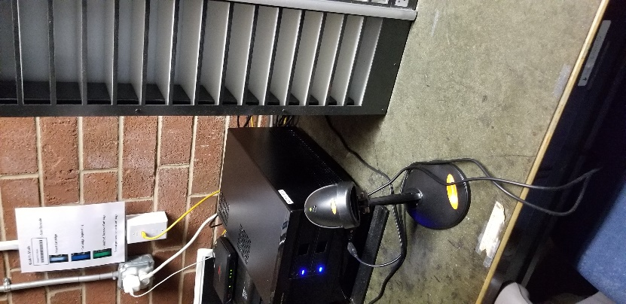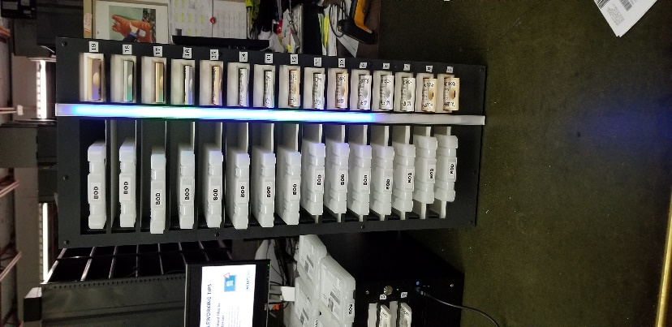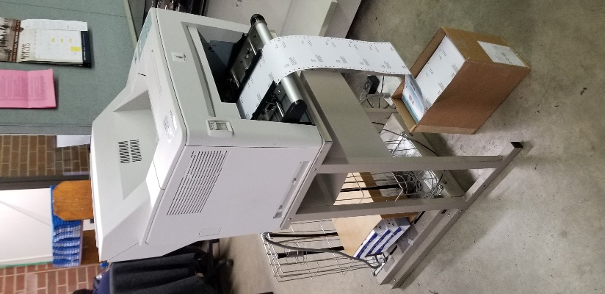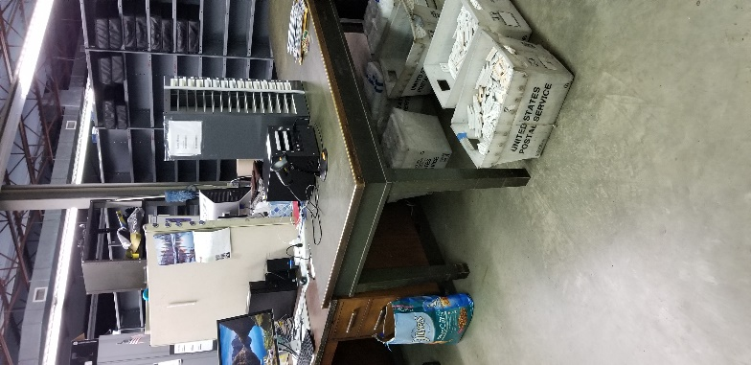
Overview, our setup involves 4 Scribe units. They are called Thing 1, Thing 2, Thing 3, and Thing 5. Thing 5 replaced Thing 4. Thing 1, 2 and 5 do the heavy lifting in the circulation area back in the warehouse. Thing 3 is our walk-in station at the front desk.

Kentucky – KY1A – Barbara Penegor - barbara.penegor@ky.gov – 502-564-1738
- If you are using Gutenberg, why did you decide to use this system?
It was the only system available at the time and is the only system available for use with WebReads.
- If you are using Scribe for KLAS libraries, why did you decide to use this system?
Null
- What are the benefits of DOD? (i.e. what can you do now that you were not able to do before?)
Less staff and time needed for circ, less space--no physical DB collection needed, every title available all the time, eliminates mismatched cartridges/containers, eliminates copy allotment and book delivery verification for DB, can load an entire series onto 1 cartridge for patrons, very easy to learn--anyone can take over circ during absences.
- What challenges did DOD present, if any? (i.e. what can't you do now that you were able to do before?)
none
- FOR GUTENBERG LIBRARIES: How has NLS continued to provide support after moving your library to DOD? (i.e. ordering DOD supplies, cartridge allotments, etc.)
We still have peach cartridges left from initial supply but have the ability to reuse NLS white cartridges when needed. We purchase our own mail cards and toner cartridges. NLS provides tech support when needed. NLS monitors the system and replaced it when it was running out of storage room after 3 years. WebReads has had several upgrades to incorporate and enhance DoD.
- How do library patrons that visit the library browse for titles now?
We seldom have walk-in patrons and have never had a browsable collection. Librarians will help walk-ins select titles if they do not come with a list.
- How do library patrons that visit the library now check out audio books?
Librarians create an ad hoc order that is ready in minutes.
- Who manages the DOD process and system?
1 administrative assistant
- How long does it take to do the daily DODs? Before DOD and after DOD?
with DoD--maybe a couple of hours. Before--most of the day
- How did you inform your patrons about the change in service, and would you do it that way again?
We explained to patrons as they called. Posted in newsletter before switch and upon startup. Also, social media.
- Do you have a need for more than the one DOD workstation supplied by NLS? If so, why?
No
- How do you assure quality when processing DOD? (For example: ensuring there aren't any audio errors on the cartridge you just duplicated? That KLAS is putting the correct book on the correct cartridge and mailing label?)
We do not check for audio errors--too rare to warrant time. We scan 1 cartridge at a time and insert mail card, but sometimes there are technical errors that cause mismatched card and cartridges. There is no way to verify match of cartridge and mail card.
- In what specific ways do circulation staff ensure quality control in workloads? (i.e. How do you make sure you aren't mixing up a mailing label and cartridge?)
There is no way to visually match cartridge and mail card. You must scan cartridges 1 at a time and insert the mail card. before scanning the next cartridge.
- Braille circulation: Are you running separate circulation models between audio and hard copy or electronic braille?
yes. Nothing has changed for patrons receiving embossed braille. Patrons using ebraille are set up differently from those receiving hard copy braille. For patrons who receive both audio and ebraille you have the choice of keeping them separate or putting both on the same cartridge. WE are keeping separate. From a circulation standpoint you cannot tell which cartridges contain audio and which contain braille--it is all the same.
- Can you create pre-bundles of books or series that can then be downloaded to a cartridge on demand?
Not that I know of, but there is really no need. We simply run an autoselect by author, add the series to the patron's request list, then create an ad hoc order.
- What are the specific ways that workloads/tasks have shifted for Circulation staff?
We did have 2 full-time and 1 part-time temp working in circ. One fullt-time person left shortly before we switched to DoD, so we did not fill his position. We let the temp go after most patrons were switched to DoD. Once the daily DoDcirc is done, the circ person can work on braille circ, new braille, and shipping XESS braille overseas.
- Did you see a reduction in need for staff and if so, how did you accommodate that shift?
Yes, one took another job before DoD, and we let the temp go. If we still had the second full-time person, he would have been assigned to State Library circulation duties--similar duties in another part of the agency.
- What best practices do you use for migrating staff incorporating DOD into their work routines?
It was very simple to learn for both circ staff and librarians. Several employees easily learned to perform circ when the regular employee is absent. Librarians really only had to learn how to create ad hoc orders.
- Are you updating your job descriptions, and union workers and fair compensation with the addition of DOD work?
No, job descriptions remain the same--it is still circulation--but the annual performance plan has been updated to match new procedures. we do not have unions.
- What are the positive and negative effects of DOD on staffing?
All positive, no negative. Circulation is so much faster and easier.
Photos of physical set up
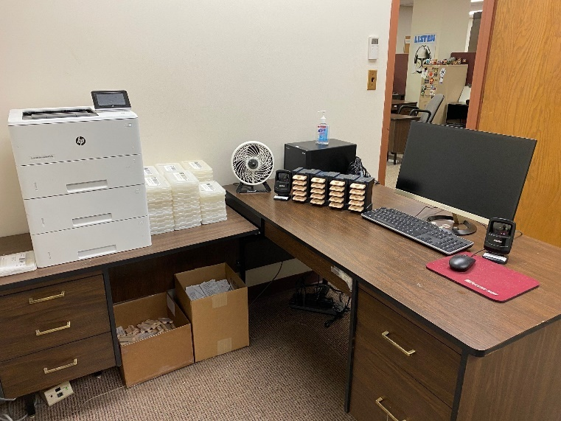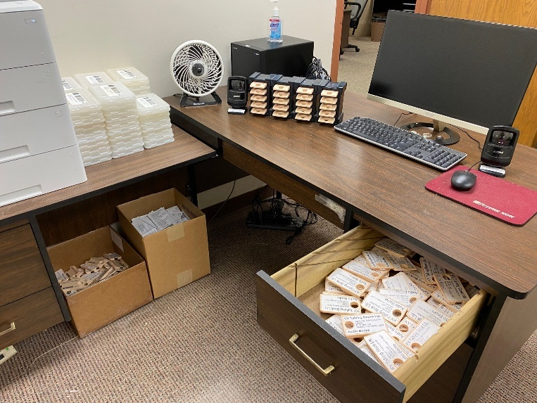
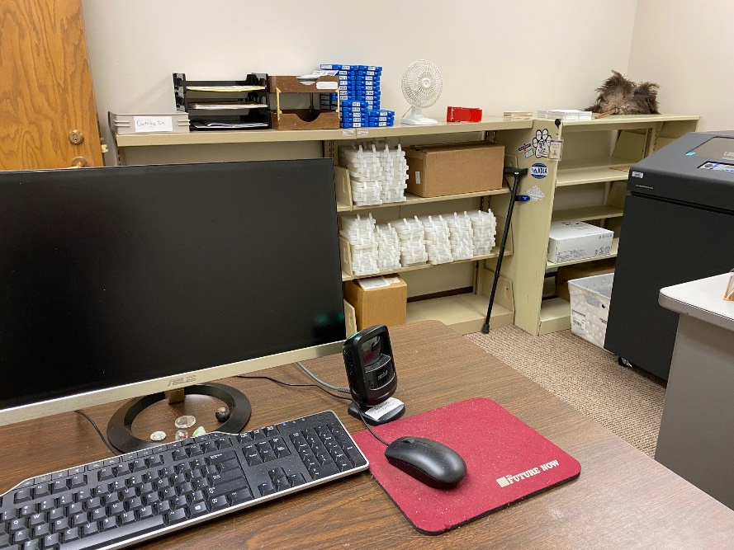
Barbara’s explanation - Attached are photos of our DoD workstation. It is in an office with another desk with the employee’s computer workstation. He does braille circ, too, so there is a large Printronix printer in there, as well shelves for supplies. This office is right off of our main Talking Book office, so we can easily run a quick ad hoc order or substitute during absences. Incoming/outgoing cartridges are transported to/from shipping on a single book cart.
VT1A – no contact given
- If you are using Gutenberg, why did you decide to use this system?
null
- If you are using Scribe for KLAS libraries, why did you decide to use this system?
The support seemed better
- What are the benefits of DOD? (i.e. what can you do now that you were not able to do before?)
Cuts down on incoming and outgoing mail; no longer have to ILL from Multistate Center; no longer have to wait for the return of our copies; no longer have to do copy allotment.
- What challenges did DOD present, if any? (i.e. what can't you do now that you were able to do before?)
Learning to use the new system and assist patrons with the change. Had difficulty with the leaflet.
- FOR GUTENBERG LIBRARIES: How has NLS continued to provide support after moving your library to DOD? (i.e. ordering DOD supplies, cartridge allotments, etc.)
Null
- How do library patrons that visit the library browse for titles now?
Same way
- How do library patrons that visit the library now check out audio books?
Similar to previous
- Who manages the DOD process and system?
ABLE Library staff
- How long does it take to do the daily DODs? Before DOD and after DOD?
1-3 hours. Depends on load.
- How did you inform your patrons about the change in service and would you do it that way again?
Tried the leaflet, newsletter and inserts with the cartridge. If the leaflet application was easier to use, I'd definitely do it again.
- Do you have a need for more than the one DOD workstation supplied by NLS? If so, why?
No
- How do you assure quality when processing DOD? (For example: ensuring there aren't any audio errors on the cartridge you just duplicated? That KLAS is putting the correct book on the correct cartridge and mailing label?)
Do a quick check before sending them out
- In what specific ways do circulation staff ensure quality control in workloads? (i.e. How do you make sure you aren't mixing up a mailing label and cartridge?)
All the information is on the mailing card.
- Braille circulation: Are you running separate circulation models between audio and hard copy or electronic braille?
null
- Can you create pre-bundles of books or series that can then be downloaded to a cartridge on demand?
Not sure.
- What are the specific ways that workloads/tasks have shifted for Circulation staff?
Hasn't really changed with the exception of less mail.
- Did you see a reduction in need for staff and if so, how did you accommodate that shift?
No
- What best practices do you use for migrating staff incorporating DOD into their work routines?
Just two of us and we communicate regularly.
- Are you updating your job descriptions, and union workers and fair compensation with the addition of DOD work?
No
- What are the positive and negative effects of DOD on staffing?
Stressful while making the migration but all around a better system.
UT1A – no contact given
- If you are using Gutenberg, why did you decide to use this system?
Equipment was free from NLS
- If you are using Scribe for KLAS libraries, why did you decide to use this system?
null
- What are the benefits of DOD? (i.e. what can you do now that you were not able to do before?)
We are able to add the UT produced books onto cartridges along with nationally produced books. We had an aging, expensive system for sorting and shelving our materials. It is no longer necessary to use this with DoD.
- What challenges did DOD present, if any? (i.e. what can't you do now that you were able to do before?)
Getting patrons migrated has been time intensive. There have been some challenges with training staff/patrons to the new method.
- FOR GUTENBERG LIBRARIES: How has NLS continued to provide support after moving your library to DOD? (i.e. ordering DOD supplies, cartridge allotments, etc.)
We have not yet called upon NLS for support. We have not required supplies yet.
- How do library patrons that visit the library browse for titles now?
NA
- How do library patrons that visit the library now check out audio books?
KLAS has a walk-in option for creating DoD cartridges. It is quick and easy to use. It is a great option.
- Who manages the DOD process and system?
The warehouse staff
- How long does it take to do the daily DODs? Before DOD and after DOD?
15-45 minutes outgoing, and less time for check in. Adding property stickers to the cartridges and containers is time intensive. 15-45 minutes in the morning and the same for the afternoon. Depends on the number of orders/incoming mail to process.
- How did you inform your patrons about the change in service and would you do it that way again?
Half sheet mailing was sent to Utah, Alaska, Wyoming patrons informing them of the changes. yes, I would do this again.
- Do you have a need for more than the one DOD workstation supplied by NLS? If so, why?
We have two workstations, due to serving three libraries.
- How do you assure quality when processing DOD? (For example: ensuring there aren't any audio errors on the cartridge you just duplicated? That KLAS is putting the correct book on the correct cartridge and mailing label?)
Yes, staff do QC
- In what specific ways do circulation staff ensure quality control in workloads? (i.e. How do you make sure you aren't mixing up a mailing label and cartridge?)
The mailing cards are printed once the barcode on the cartridge is scanned. The mailing card is inserted into the slot of the container, and the cartridge is put into the container at this time.
- Braille circulation: Are you running separate circulation models between audio and hard copy or electronic braille?
No, but we are waiting for Keystone to make braille DoD available to us.
- Can you create pre-bundles of books or series that can then be downloaded to a cartridge on demand?
Yes, via the service queue option in KLAS. Anything available on BARD that the patron wants to read can be added to the service queue. KLAS has the capabilities of manipulating the queue so books can be put into a specific order.
- What are the specific ways that workloads/tasks have shifted for Circulation staff?
Less labor required for DoD, vs pulling and shelving dbs.
- Did you see a reduction in need for staff and if so, how did you accommodate that shift?
No, we still circulate braille and large print collections.
- What best practices do you use for migrating staff incorporating DOD into their work routines?
NA
- Are you updating your job descriptions, and union workers and fair compensation with the addition of DOD work?
NA
- What are the positive and negative effects of DOD on staffing?
Staff have time for other projects, such as collection maintenance. Also, it is time consuming to add property labels to both cartridges and containers used for DoD.
SD1A – no contact info
- If you are using Gutenberg, why did you decide to use this system?
Null
- If you are using Scribe for KLAS libraries, why did you decide to use this system?
The customer support we get with Keystone Library Automated Systems (KLAS) - Only having to deal with KLAS and not having to deal with Gutenberg support and KLAS support and if they would have to wait on each other for functionality fixes. Having one place to deal with and they can work with their techs in-house. We have immediate access to KLAS staff by phone and email. - How the Scribe works. The functionality and the workflow associated with Scribe. We consulted information and videos from different states and companies. (We also got a chance to visit a neighboring library that uses Gutenberg and saw the good and the flaws with that system and hearing the difference in support -though they were a READS library so there were also system features they didn't have that we do with KLAS). Scribe works with our current mailing cards and Zebra printers and we can do an entire mail card run at once as well as push individual. (also the update to have a second mail card print with book titles on the cartridge). We only have to scan a mail card once and then stick a cartridge in and it does the rest-you just keep the card on the shelf next to the cartridge on the tower and when the green light on the tower lets you know the order successfully completed you can put the cartridge and the card in a DB mail container and it's ready to go. You also don't have to check-in returned cartridges separately before reusing, but you can.
- What are the benefits of DOD? (i.e. what can you do now that you were not able to do before?)
Multiple titles on one cartridge. Books and magazines both can go on one cartridge. - You don't have to spend hours to go search for titles on a physical shelf. - Less physical cartridges to inspect. Fewer issues with matching up cartridges and cases. - More titles are available - all BARD books - Patrons don't have to wait for a book title to have available copies - No waiting lists! This is great for popular book titles, book clubs, etc. - Heavy readers can have 20 titles on one cartridge - Greater ability to add multiple serial titles and more easily send previous issues to patrons - Ability of Scribe to have the latest DTBM firmware software update on the cartridge to keep patrons' machines on the latest upgrade.
- What challenges did DOD present, if any? (i.e. what can't you do now that you were able to do before?)
Reeducating patrons to changes. Some immediately love it, some greatly dislike it, and some just need time to adjust. Thankful for the ability to adjust for individual patron how many titles are on a cartridge so if you have someone who isn't able to use the bookshelf function you could send them one title per cartridge. - Complaints from patrons who want Braille list of what titles are on a cartridge. Explain the bookshelf function to hear all the titles on the cartridge.
- FOR GUTENBERG LIBRARIES: How has NLS continued to provide support after moving your library to DOD? (i.e. ordering DOD supplies, cartridge allotments, etc.)
N/A except NLS is planning to send cartridges and cases and labeling supplies still to us even though we are a Scribe library - I don't know when.
- How do library patrons that visit the library browse for titles now?
They don't browse in the library and they never did previous to DOD. they go visit with their reader advisor and the reader advisor can help them search for what they might be interested in. Walk-ins or in person. If they want to browse we give them Talking Book Topics catalogs to browse. Or of course our WebOPAC catalog or BARD.
- How do library patrons that visit the library now check out audio books?
The reader advisor can print an immediate walk-in order to Scribe that can be duplicated by the circulation technician, RA, or other staff.
- Who manages the DOD process and system?
The circulation technician who uses it daily and the Equipment and Audio Production Manager who troubleshoots and also contacts KLAS customer support for assistance.
- How long does it take to do the daily DODs? Before DOD and after DOD?
Before DOD outgoing depending on the card run it typically took half a day for the circulation technician to pull and check out all the physical DBs, etc. Plus inspecting returns and check-in and reshelving process that took more time. After DOD a couple of hours more or less depending on the card run. Checkin and inspection are greatly reduced as the circulation technician is able to use the days returned cartridges to duplicate and send out new orders.
- How did you inform your patrons about the change in service and would you do it that way again?
Initial ones in the trial were contacted by phone. Later letters were sent to patrons and then all switched over and actually got patrons that you maybe haven't been able to get ahold of to contact us. Facilities were more slowly switched over as the Reader Advisor for facilities - nursing homes, libraries, etc. worked with them.
- Do you have a need for more than the one DOD workstation supplied by NLS? If so, why?
We have two Scribe towers from KLAS. Efficiency and backup for if something goes wrong.
- How do you assure quality when processing DOD? (For example: ensuring there aren't any audio errors on the cartridge you just duplicated? That KLAS is putting the correct book on the correct cartridge and mailing label?)
Scribe and the FTP site it uses for locally recorded materials works well. - If Reader Advisors notice something like a magazine request stuck in the request list and not going into the reader service queue the Equipment and Audio Production Manager looks into it and troubleshoot either himself or with the assistance of Keystone KLAS staff. - Scribe lights up red if there is an error in downloading. - Patrons help us by reporting if they have any issues in the audio of a certain title and we look into it.
- In what specific ways do circulation staff ensure quality control in workloads? (i.e. How do you make sure you aren't mixing up a mailing label and cartridge?)
As long as you keep the correct card with the cartridge there aren't issues. That is why to avoid human error you need to decide your individual process in DOD circulation - the order that you do things. Processes and procedures are important. Example: Rip the mail card with the patron's address and the card with book titles still attached. Scan the order barcode on the mail card with the Scribe scanner. The Scribe tower will light up blue with where to insert the cartridge (if completely empty it goes in order from the top of the tower to the bottom). Insert the cartridge into that slot and put the mail card on the adjacent parallel shelf. Scan cards and insert cartridges until the tower is full. When the light next to the slot of a cartridge lights red we know it is an error to troubleshoot. If it turns green we remove the cartridge and grab the adjacent card and put them both in the plastic DB mailing case and put them in the pile or mailing tub ready to be mailed. Continue the process.
- Braille circulation: Are you running separate circulation models between audio and hard copy or electronic braille?
No
- Can you create pre-bundles of books or series that can then be downloaded to a cartridge on demand?
KLAS allows you to add whatever you want to a patron reader service queue and reorder them and then send that order to the Scribe.
- What are the specific ways that workloads/tasks have shifted for Circulation staff?
Null
- Did you see a reduction in need for staff and if so, how did you accommodate that shift?
Null
- What best practices do you use for migrating staff incorporating DOD into their work routines?
Null
- Are you updating your job descriptions, and union workers and fair compensation with the addition of DOD work?
Null
- What are the positive and negative effects of DOD on staffing?
Null
OR1A – Elke Brunton - elke.bruton@slo.oregon.gov – 971-375-3509
- If you are using Gutenberg, why did you decide to use this system?
We had attempted to use PCC with Keystone but the support was nonexistent and that system was never able to get off the ground.
- If you are using Scribe for KLAS libraries, why did you decide to use this system?
Null
- What are the benefits of DOD? (i.e. what can you do now that you were not able to do before?)
decreased staff time, increased circulation ability for other staff to work remotely, customization of selections all titles available, the ability to "switch gears" quickly when staff is unavailable or the building is unreachable (storm damage, etc)
- What challenges did DOD present, if any? (i.e. what can't you do now that you were able to do before?)
labeling training logistics However, these were all planning issues and expected...we had stopped circ for 6 weeks at the beginning of COVID which allowed us to deal with these "offline" and did not impact our service.
- FOR GUTENBERG LIBRARIES: How has NLS continued to provide support after moving your library to DOD? (i.e. ordering DOD supplies, cartridge allotments, etc.)
NLS monitors the system and has alerted us to issues quickly. We have not needed additional supplies or cartridges yet.
- How do library patrons that visit the library browse for titles now?
Our building has been closed to the public since March 2020 and will remain closed through September 2020. Even then, our library was not a browsing library.
- How do library patrons that visit the library now check out audio books?
See # 6
- Who manages the DOD process and system?
Our KLAS administrator with support from our ONE circulation technician.
- How long does it take to do the daily DODs? Before DOD and after DOD?
Our KLAS administrator with support from our ONE circulation technician.
- How did you inform your patrons about the change in service and would you do it that way again?
Circulation had been halted for 6 weeks due to covid. Our patrons were basically desperate for any service. Returning to service of any kind made them happy. When we first started, we brought patrons online to DOD at the rate of 40 per day. We called all 40 each day to alert them. After 2 weeks we found that, largely, they were disinterested with those details/call so we stopped. We answered questions that were brought to us instead of preemptively giving information. We found this to be a better use of staff time on phones and email.
- Do you have a need for more than the one DOD workstation supplied by NLS? If so, why?
One is plenty for our library. We serve 5000 patrons. We average 170 cartridges out per day and around the same number returned/checked in.
- How do you assure quality when processing DOD? (For example: ensuring there aren't any audio errors on the cartridge you just duplicated? That KLAS is putting the correct book on the correct cartridge and mailing label?)
It's literally not an issue. There is no need or excusable reason to create a step for this during circulation.
- In what specific ways do circulation staff ensure quality control in workloads? (i.e. How do you make sure you aren't mixing up a mailing label and cartridge?)
One staff processes our circulation. We average 170 cartridges out per day. She is able to "stuff" as she goes...or, on a big day, has room to lay out the cartridges in order. If you "relax" and go with the flow of DOD instead of trying to "process" it to death, it's very easy.
- Braille circulation: Are you running separate circulation models between audio and hard copy or electronic braille?
NA
- Can you create pre-bundles of books or series that can then be downloaded to a cartridge on demand?
Yes, there are several methods for achieving this within the KLAS service queue function.
- What are the specific ways that workloads/tasks have shifted for Circulation staff?
We used to have two full time circulation techs. They spent a total of 8 hours per day on circulation. Circulation is now completed by one circulation tech in 2 hours. We eliminated one of our circulation technician positions.
- Did you see a reduction in need for staff and if so, how did you accommodate that shift?
We had a circulation technician resign in October 2019 and decided NOT to fill the vacancy. We knew DOD was coming in early 2020 so we did without until that time. Other support staff pitched in with tasks, etc.
- What best practices do you use for migrating staff incorporating DOD into their work routines?
If COVID had not happened, my original plan for integrating the new service model was this (reader's digest version): 1. Let circulation staff do their normal work. 2. KLAS administrator (me) would switch patrons over to DOD at the rate of 100 per day. 3. KLAS admin would "run" DOD circ every day which would take about an hour to process. 4. Raise number to switch as normal circulation begins to drop, incorporating circ staff in DOD process and removing them from old circ process. 5. repeat until all patrons are switched to DOD. 6. The questions on the phone really don't change so other staff are not much impacted by migration to DOD.
- Are you updating your job descriptions, and union workers and fair compensation with the addition of DOD work?
Yes, in October 2019 we planned out how job descriptions would change. We communicated with to our staff and prepared them for the change of duties beginning by March 2020. They were in cross training processes during January and February 2020. We ran all changes through HR and I was actually the local president at the time, so this whole process was completed with the full input of staff, union, and HR.
- What are the positive and negative effects of DOD on staffing?
Everything is easier. EVERYTHING. There has literally been NO negative effects on staffing. Anyone who tells you there is, isn't managing expectations, steps, and processes very well. You are either trying too hard, or you're not trying hard enough. Communicate with staff...check in regularly. Make sure they understand that failure is always an option and that anything that you break...can be fixed...don't worry so much. Take risks.
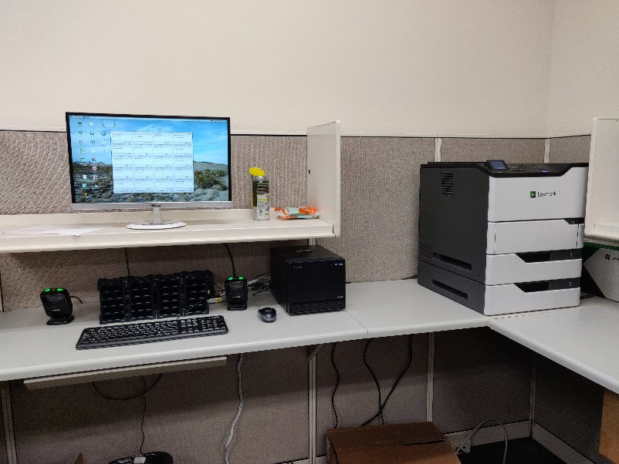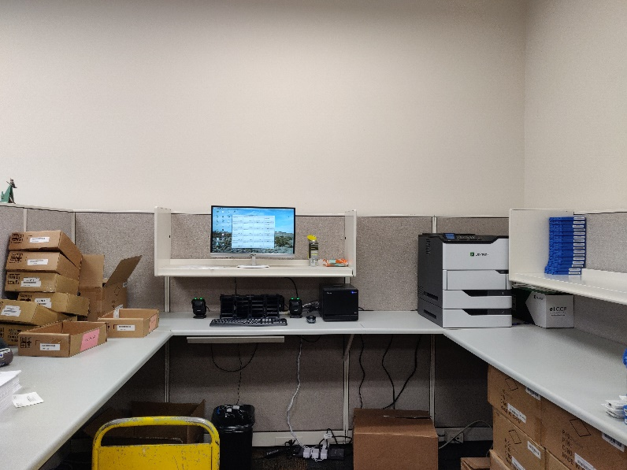
Here are two pictures of our setup. One is nice and “clean” and the other is a wide shot showing things as they “work.” On the left are our boxes of blank cartridges and/or cartridges that were returned and just need to be checked in. On the right is the printer, and down below, boxes of blue mailing containers ready to be used. This is what we decided to start with…with the thought being that, after a year, we would move it and design something “better.” We didn’t know what “better” would be…we just didn’t want to spend a bunch of money in labor and parts when we didn’t even know how DOD would change us yet. Since we started DOD in COVID and only have one staff member physically present in our whole operation, we will likely need an additional year (after staff returns) to decide what we really need for workflow. This set up has met all of our needs for processing daily circulation so we know that it will just come down to “where” we really want it to live, and what other features that area should include. For instance, we have our “old” circulation desk and computer still setup and used for checking in machines, DVDs, random stuff…and we still have a “machine” room that houses another desk for checking machines into or our of various stages of circulation or repair. We used to have two circulation techs so having more than one spot for circulation was key. In DOD land…not needed…at least, with only one staff member present, not needed.

Nevada TBS – Hope Williams - hwilliams@admin.nv.gov – 775.684.3381
- If you are using Gutenberg, why did you decide to use this system?
For access to all titles available on BARD and to reduce our space needs.
- If you are using Scribe for KLAS libraries, why did you decide to use this system?
Null
- What are the benefits of DOD? (i.e. what can you do now that you were not able to do before?)
Send multiple books in a series at once. Extend or eliminate due dates. No need to ILL. Circulation duties greatly reduced: reduced number of cartridges to check in, no need to shelve, no copy allotment (and everything that entails.).
- What challenges did DOD present, if any? (i.e. what can't you do now that you were able to do before?)
Nothing that I can think of.
- FOR GUTENBERG LIBRARIES: How has NLS continued to provide support after moving your library to DOD? (i.e. ordering DOD supplies, cartridge allotments, etc.)
They also provide tech support.
- How do library patrons that visit the library browse for titles now?
We were not a browsing collection before, so this is not a change.
- How do library patrons that visit the library now check out audio books?
We do this for them.
- Who manages the DOD process and system?
We do not have in-house IT. The librarian communicates with NLS and KLAS regarding issues. A circulation staff person does all of the circulation functions.
- How long does it take to do the daily DODs? Before DOD and after DOD?
It depends on the day. Check outs are still triggered by a check in the previous day, but with multiple titles per cartridge, the handling of items is equal to 1: number of titles on a cartridge. In the past, we may check out 10 titles to a patron, and now we check out and check in 1. There is no need for repairs or replacement of missing titles. No need to weed or shift. We are done one staff person since July and are doing fine.
- How did you inform your patrons about the change in service, and would you do it that way again?
We included a notice with their first cartridge. It worked well. We also explained it thoroughly in our newsletter.
- Do you have a need for more than the one DOD workstation supplied by NLS? If so, why?
No
- How do you assure quality when processing DOD? (For example: ensuring there aren't any audio errors on the cartridge you just duplicated? That KLAS is putting the correct book on the correct cartridge and mailing label?)
Gutenberg will tell us if there is a problem with the duplication. KLAS has an option under Tool\select titles for cartridge\duplication orders to view errors. We check this daily after check outs are completed.
- In what specific ways do circulation staff ensure quality control in workloads? (i.e. How do you make sure you aren't mixing up a mailing label and cartridge?)
Print one mail card at a time. place the cartridge with the mail card. If these is any question, scan the cartridge again to reprint the mail card.
- Braille circulation: Are you running separate circulation models between audio and hard copy or electronic braille?
No
- Can you create pre-bundles of books or series that can then be downloaded to a cartridge on demand?
Possibly, by putting them in the queue. I don't know of an automated way as the settings in KLAS for the number of series added to the queue are global.
- What are the specific ways that workloads/tasks have shifted for Circulation staff?
Less staff time required.
- Did you see a reduction in need for staff and if so, how did you accommodate that shift?
We have one less staff person now as one retired. We had 5 before and now do fine with 4. This staff person also did subject and series coding which is automatic now in KLAS.
- What best practices do you use for migrating staff incorporating DOD into their work routines?
null
- Are you updating your job descriptions, and union workers and fair compensation with the addition of DOD work?
null
- What are the positive and negative effects of DOD on staffing?
I have not heard of any negatives. Positives were mentioned in an earlier answer.
NE1A - Gabe Karmer - gabe.kramer@nebraska.gov – 402.471.6242
- If you are using Gutenberg, why did you decide to use this system?
That's kind of a funny question in a broader context, because the simple answer is that it was the only thing being engineered to work with READS. I think sometimes the bigger libraries forget about the smaller states that have been using READS long-term, rather than exploring it as a "new" option because of DOD.
- If you are using Scribe for KLAS libraries, why did you decide to use this system?
Null
- What are the benefits of DOD? (i.e. what can you do now that you were not able to do before?)
The obvious answer is that we can put multiple books on a cartridge.
- What challenges did DOD present, if any? (i.e. what can't you do now that you were able to do before?)
We weren't sure if there was anything that we could previously do that we can't anymore.
- FOR GUTENBERG LIBRARIES: How has NLS continued to provide support after moving your library to DOD? (i.e. ordering DOD supplies, cartridge allotments, etc.)
After the initial supply of cartridges and supplies (i.e. toner, mailing cards, etc.) the only support that NLS has continued to provide is technical. We just received a new 16TB hard drive, if we have any software or hardware issues NLS is available to help.
- How do library patrons that visit the library browse for titles now?
In Nebraska, we have always had closed stacks so our patrons have never been able to browse for titles in person.
- How do library patrons that visit the library now check out audio books?
The same way they always had in the past. They talk to their reader advisor and the reader advisor calls our circulation coordinator to let them know that a new order in the queue to be processed.
- Who manages the DOD process and system?
I (the director) oversee it, but we have a circulation coordinator who manages the day-to-day aspects of DOD.
- How long does it take to do the daily DODs? Before DOD and after DOD?
that depends on the day, but the actual process of creating, duplicating, and boxing the DOD cartridges takes about an hour. But that does not include the hour prior for sorting the incoming mail (i.e. separating the carts from the boxes, cleaning, etc.).
- How did you inform your patrons about the change in service and would you do it that way again?
The short answer is, we didn't. We just switched a few over at a time. We planned on 3 months to switch all of our roughly 3,000 patrons over, we ended up switching them all in about 6 weeks. The long answer is, when they would call in and request books, we would tell them that they would be receiving carts and boxes that were a different color and would contain multiple titles on the cartridge. Most of our patrons did not have an issue with the change. Those that did are just receiving a cartridge with one title on it. We also have some patrons that want the cartridge completely full. We currently average about 3 titles per cart.
- Do you have a need for more than the one DOD workstation supplied by NLS? If so, why?
No
- How do you assure quality when processing DOD? (For example: ensuring there aren't any audio errors on the cartridge you just duplicated? That KLAS is putting the correct book on the correct cartridge and mailing label?)
You can't unless you are willing to listen to each and every cartridge. When an error happens during the duplication process Gutenberg will alert you to the error. Errors are rare and most of the time, the error on the patron side, such as not being able to navigate multiple books on cartridge.
- In what specific ways do circulation staff ensure quality control in workloads? (i.e. How do you make sure you aren't mixing up a mailing label and cartridge?)
Just take the time to process one at a time.
- Braille circulation: Are you running separate circulation models between audio and hard copy or electronic braille?
null
- Can you create pre-bundles of books or series that can then be downloaded to a cartridge on demand?
null
- What are the specific ways that workloads/tasks have shifted for Circulation staff?
This has been the biggest change since switching to DOD. Prior to DOD, circulation staff would spend most of the morning pulling books to put in the mail. We now have empty stacks and no longer pull books. There is also less mail to sort. You can figure that if you are averaging three books per cart, then your mail is going to be only a third of what is was prior to DOD. Lastly, there is no longer any books to shelve.
- Did you see a reduction in need for staff and if so, how did you accommodate that shift?
Yes. We were lucky and most of our staff retired prior to the DOD switch and we just did not fill those positions. To fill time, we then had to assign different tasks such as reviewing our in-home recorded books for accuracy and our circulation staff is also repairing and processing machines.
- What best practices do you use for migrating staff incorporating DOD into their work routines?
Proper training. All staff should have proper training with their ILS software and at least know the basics of processing cartridges.
- Are you updating your job descriptions, and union workers and fair compensation with the addition of DOD work?
No, not solely because of the switch to DOD. They are still circulating books.
- What are the positive and negative effects of DOD on staffing?
I have seen zero negatives.

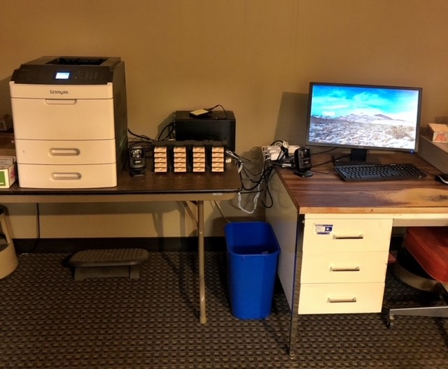
CT1A – Gordon Reddick - gordon.reddick@ct.gov – soon to retire
- If you are using Gutenberg, why did you decide to use this system?
Gutenberg is used with WebREADS at no cost
- If you are using Scribe for KLAS libraries, why did you decide to use this system?
Null
- What are the benefits of DOD? (i.e. what can you do now that you were not able to do before?)
Significant time and labor savings in circulating books. Very easy to use. Elimination of copy allotment and new book processing and shelving. Empty shelves and recycle all DB books. Updated daily. Contains all titles.
- What challenges did DOD present, if any? (i.e. what can't you do now that you were able to do before?)
Initial setup difficult and labor intensive to repurpose and format 20,000 cartridges and apply container labels - used volunteers. Otherwise no challenges.
- FOR GUTENBERG LIBRARIES: How has NLS continued to provide support after moving your library to DOD? (i.e. ordering DOD supplies, cartridge allotments, etc.)
Excellent support. Very fast response to problems. We're responsible for recurring supplies as we were before. After initial cartridge allotment, we're responsible for making our own (repurpose existing DB's).
- How do library patrons that visit the library browse for titles now?
No visits, no browsing.
- How do library patrons that visit the library now check out audio books?
Gutenberg/WebREADS has a patron walk-in selection that'll duplicate book request immediately. RA checks it out.
- Who manages the DOD process and system?
Director manages. Staff create the cartridges.
- How long does it take to do the daily DODs? Before DOD and after DOD?
Not even remotely comparable. Now there's one workstation and one staff member to do all check-in's, duplication, and check-outs, with just one scan and while sitting down. No inspections. Can reasonably process 200 cartridges in 3 hrs. Previously took volunteers to inspect books, staff member to scan in the incoming and shelve them, another staff to run mailcard program and print labels, another or more to walk all over pulling books from shelves and inserting mail card and doing two scans of each book - and only one title per cartridge. Surviving the pandemic would have been impossible without Gutenberg.
- How did you inform your patrons about the change in service and would you do it that way again?
Newsletter, web site, informed patrons as they called in, mostly relied on comments on every cartridge. Would do it again though having Facebook would be helpful.
- Do you have a need for more than the one DOD workstation supplied by NLS? If so, why?
No. Volume of 200-300 cartridges per day readily handled. Have capacity to do a lot more. But 300 cartridges is roughly 1800 titles (we average about 6 titles per cartridge) -- that much volume was impossible in old system.
- How do you assure quality when processing DOD? (For example: ensuring there aren't any audio errors on the cartridge you just duplicated? That KLAS is putting the correct book on the correct cartridge and mailing label?)
Trust the system. Quality control is built into the duplication process. Do one cartridge at a time so easy to be sure the mailing label is for the cartridge just scanned.
- In what specific ways do circulation staff ensure quality control in workloads? (i.e. How do you make sure you aren't mixing up a mailing label and cartridge?)
Do one cartridge at a time. Very good work flow. Pull cartridge from toaster, scan it, mail card automatically printed, insert cartridge and mail card into container. Then repeat. Don't do multiple cartridges.
- Braille circulation: Are you running separate circulation models between audio and hard copy or electronic braille?
NA
- Can you create pre-bundles of books or series that can then be downloaded to a cartridge on demand?
Don't know but I don't think so. All duplication is automatic so any bundles would have to be created at the time of adding books to the book cart and submitting the order.
- What are the specific ways that workloads/tasks have shifted for Circulation staff?
No longer inspect incoming books or matching cartridges to correct container. No more using a turnaround shelf. No more reshelving or books lost on shelves. No more picking books from shelves. No more walking all over. No more adding new books to inventory. No more reserves or waiting for a title to come back. No more copy allotment and processes. No more downloading books from BARD and making a copy if title not in inventory. No more ILL's. No more handling of hundreds of containers - much less volume now.
- Did you see a reduction in need for staff and if so, how did you accommodate that shift?
In theory can reduce staff. In reality, already short staffed so less time and effort is diverted to processing books thus allowing other work to get done more efficiently and effectively.
- What best practices do you use for migrating staff incorporating DOD into their work routines?
One staff assigned as duplicator and related tasks.
- Are you updating your job descriptions, and union workers and fair compensation with the addition of DOD work?
Not relevant. Just a change in procedures. Job descriptions are in general terms anyway such as circulating books and do not specify exact procedures. Thus no change to union stuff. Would need to change standard operating procedures (SOP's).
- What are the positive and negative effects of DOD on staffing?
All positive!
Indiana TBS – Laura Williams - lawilliams1@library.in.gov - 317-232-0609
- If you are using Gutenberg, why did you decide to use this system?
We are a KLAS library, but we felt that Gutenberg was the more developed system at the time we needed to make our decision.
- If you are using Scribe for KLAS libraries, why did you decide to use this system?
Null
- What are the benefits of DOD? (i.e. what can you do now that you were not able to do before?)
It cuts down on supplies and manpower, we no longer have to order older titles and locally produced titles through ILL, there are no wait times for popular titles, new titles are available more quickly, series titles can be bundled on one cartridge.
- What challenges did DOD present, if any? (i.e. what can't you do now that you were able to do before?)
Some patrons cannot use either bookshelf mode or sequential play and so we have had to go back to one book per cartridge. This has only happened in a few instances though. Some patrons, especially those who were getting many books at a time, have trouble getting used to only being allowed 4 cartridges, even if each of those cartridges have up to 10 books. There has also been some confusion about the mail cards, and many patrons mail the card back in the container. Finally, the content of the cartridges is no longer printed in braille.
- FOR GUTENBERG LIBRARIES: How has NLS continued to provide support after moving your library to DOD? (i.e. ordering DOD supplies, cartridge allotments, etc.)
NLS has provided support in ordering supplies. We did have an issue with our cartridges, which the shipping company misplaced for 4 months, but NLS sent us replacements until the originals finally arrived, and then picked up the originals since we no longer needed them. NLS has also provided technical support for issues that have arisen.
- How do library patrons that visit the library browse for titles now?
Our collection has never been browsable.
- How do library patrons that visit the library now check out audio books?
Walk-in patrons usually call ahead so we have cartridges already prepared for them. We would be able to serve any surprise walk-ins within 10 minutes.
- Who manages the DOD process and system?
The acting director manages the system, and one circulation staff member manages the process.
- How long does it take to do the daily DODs? Before DOD and after DOD?
It takes about an hour for one person to do 100 DoDs, so depending on the day it can take anywhere from 2-4 hours. This is about as long as it took before DoD, but with three people working instead of one.
- How did you inform your patrons about the change in service and would you do it that way again?
We informed our patrons through our newsletter. We gradually changed patrons over in a process that took about 5 months, so if a patron called to order books and was not switched over, we would do so while they were on the phone and explain DoD to them.
- Do you have a need for more than the one DOD workstation supplied by NLS? If so, why?
Not currently, although we might need to get one in the future if there is an increase in circulation.
- How do you assure quality when processing DOD? (For example: ensuring there aren't any audio errors on the cartridge you just duplicated? That KLAS is putting the correct book on the correct cartridge and mailing label?)
We don't have the staffing required to do that level of quality control.
- In what specific ways do circulation staff ensure quality control in workloads? (i.e. How do you make sure you aren't mixing up a mailing label and cartridge?)
The circulation staff member in charge of duplication switched a setting in Gutenberg that prints the card as soon as the cartridge is removed from the toaster. That helped immensely in making sure address cards/cartridges matched up, since they print in order and it makes sure all cards get printed, versus when she was solely using the barcode scanner for address labels. She stacks the address cards, cartridges, and cases together in the order that they are pulled/printed and makes sure everything lines up before she assembles them. If something does go askew, she will double-check cards/cartridges by either using the address card barcode scanner or as a last resort putting the cartridge in a player to find out which books are on it.
- Braille circulation: Are you running separate circulation models between audio and hard copy or electronic braille?
No
- Can you create pre-bundles of books or series that can then be downloaded to a cartridge on demand?
Yes
- What are the specific ways that workloads/tasks have shifted for Circulation staff?
We have one circulation staff member that has taken over the primary workload for duplication: Duplicating cartridges, checking in cartridges, and monitoring supplies. Another staff member was in charge of examining the old-style cartridges for size, keeping the ones with more storage space, and xcessing the ones with less. This staff member is on an indefinite medical leave and so this task is being done by the acting director, the readers' advisors, and the other circulation staff member.
- Did you see a reduction in need for staff and if so, how did you accommodate that shift?
As mentioned above, we have a staff member who is on indefinite medical leave. We have not had to hire a temporary worker.
- What best practices do you use for migrating staff incorporating DOD into their work routines?
Because our transition to DoD happened over many months, during which we also had staffing changes, we've had to be very flexible. Currently we have one person doing the actual duplication, other staff members are working on the task of identifying cartridges for repurposing and shipping out the rest of our digital collection. That project will be done by the end of the year, then we will have to make adjustments. When we don't have to worry about Covid protocols, we will probably have 2 staff members doing duplication, for example.
- Are you updating your job descriptions, and union workers and fair compensation with the addition of DOD work?
Yes
- What are the positive and negative effects of DOD on staffing?
DoD has been crucial in allowing us to continue operating at our usual level even with staffing shortages. With the changes in staffing duties, we've had to work on maintaining communication to make sure everyone clearly understands what they need to do.
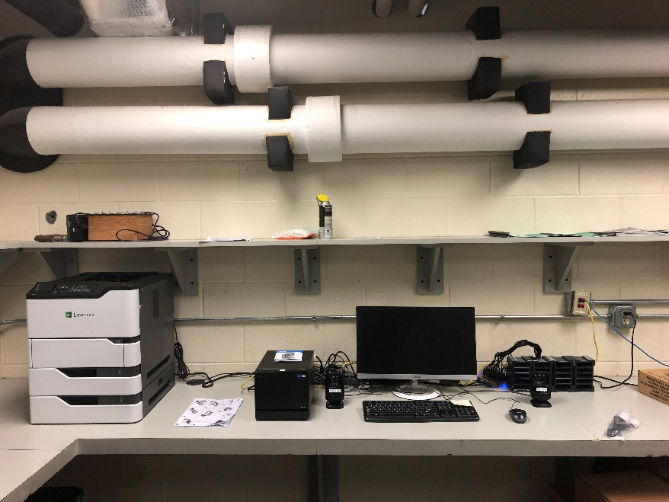
GA1A – Keith Haun - khaun@georgialibraries.org - 470-512-1391
- If you are using Gutenberg, why did you decide to use this system?
At the time we began to pursue conversion to DoD (early-mid 2019) Scribe was still in a prototype phase, not ready for deployment. Gutenberg was already in use at a number of WebREADS libraries, and we were willing to serve as the test case / guinea pig. NLS offered to provide all of the computer and printer hardware for free, and half of the projected cartridges and cases that we would need (i.e. cost).
- If you are using Scribe for KLAS libraries, why did you decide to use this system?
Null
- What are the benefits of DOD? (i.e. what can you do now that you were not able to do before?)
Reduced demand on staff time: We were able to eliminate 6 part-time seasonal positions (student workers) and are now running with 1 supervisor and 2 full-time library assistants. Decreased volume allows increased attention to detail, better inventory tracking, time for "work adjacent" activities such as continuing education, etc. - Massively reduced physical footprint and relocation: We were able to vacate a 111,000-square foot warehouse, and consolidate operations into existing office space at a parent organization. This also eliminated $111,000 per year for the lease, which absorbed a large portion of the budget cuts necessitated by COVID in mid-late 2020. (Those figures are accurate and similar, not a typo). We now operate out of ~2,500 square feet in office space already leased by our parent organization. - Catalog access: Patrons can listen to any book in our catalog. There are no longer waiting times for limited copy allotment cartridges, or older titles that are unavailable due to cartridge attrition.
- What challenges did DOD present, if any? (i.e. what can't you do now that you were able to do before?)
Disposal of the Copy Allotment collection: GLASS had upwards of 150,000 DB copy allotment books. This began with shipping multiple tractor-trailer loads of "Beyond boxes" to Multi-State East on shrink-wrapped pallets. Our total volume would have overwhelmed their capacity to store and process, so we then gained authorization from NLS to contract a secure-document disposal company to destroy the rest. - Patron confusion: While most of our patrons have adjusted, in the beginning our Reader Advisors fielded a large number of questions from patrons who were surprised by the new format.
- FOR GUTENBERG LIBRARIES: How has NLS continued to provide support after moving your library to DOD? (i.e. ordering DOD supplies, cartridge allotments, etc.)
Supplied new labels for our cartridges and containers after our move. - Strong and consistent technical support for software, network, and hardware issues. (For example, we had an incident where one morning the check-in and check-out barcode scanners suddenly ceased to function. NLS sent replacements that day, overnight through FedEx.)
- How do library patrons that visit the library browse for titles now?
None, however, GLASS has never maintained a walk-in browsing collection.
- How do library patrons that visit the library now check out audio books?
None, however GLASS has never maintained a walk-in browsing collection.
- Who manages the DOD process and system?
We have a Distribution Center Supervisor who oversees daily operations, and reports to a Manager of Technology and Access.
- How long does it take to do the daily DODs? Before DOD and after DOD?
Before DoD: Daily check-outs were done by three full-time staff and 2-4 part-time staff over the course of 4-5 hours. Check-ins were handled by a similar number of staff, generally 1-2 hours. Volume could adjust the time significantly. - After DoD, daily check-outs can be handled by two staff in 2 to 3 hours. Check-ins are handled by 1 staff and generally does not take more than an hour.
- How did you inform your patrons about the change in service and would you do it that way again?
Patrons that were involved in the initial pilot phase and testing portion of DoD spread news through word of mouth, and an announcement was made in our monthly newsletter the month that we went live. By and large we did not pre-announce the change based on reports from WebREADs libraries that had gone before us. The easiest way to 'explain' DoD is to simply get a DoD cartridge in the hands of a patron, and announcements with long lead times only generate concern and anxiety among patrons.
- Do you have a need for more than the one DOD workstation supplied by NLS? If so, why?
Yes. We have two due to sheer circulation volume. Since GLASS was also the first KLAS library to adopt Gutenberg, this also allowed them to test and pilot a two-workstation configuration.
- How do you assure quality when processing DOD? (For example: ensuring there aren't any audio errors on the cartridge you just duplicated? That KLAS is putting the correct book on the correct cartridge and mailing label?)
We do not do on-site testing of cartridges as they are generated and checked out. If a patron reports an issue with a cartridge, an RA can send the same books out on a new cartridge. Part of the check-in process is to look for notes from patrons that indicate there may be a flaw on the cartridge.
- In what specific ways do circulation staff ensure quality control in workloads? (i.e. How do you make sure you aren't mixing up a mailing label and cartridge?)
Careful planning and a "lining up" correlation process. It is similar to how, before DoD, returns were checked-in on the "bookshelf" style, where books were checked into KLAS onto a specific shelf and kept in that order.
- Braille circulation: Are you running separate circulation models between audio and hard copy or electronic braille?
We do not currently circulate electronic Braille, and hard copy Braille is handled individually in KLAS.
- Can you create pre-bundles of books or series that can then be downloaded to a cartridge on demand?
I am not sure if that is an option in KLAS with Gutenberg at this time; if it is, I do not think we are currently using it.
- What are the specific ways that workloads/tasks have shifted for Circulation staff?
There is much less of it. There are a number of one-time "investment" work projects that had to be dealt with along with adoption to DoD, incorporated into daily workflow routines (primarily labelling DoD cartridges and containers and preparing the copy allotment collection for disposal).
- Did you see a reduction in need for staff and if so, how did you accommodate that shift?
Yes. We released six part-time temporary student employee positions and are expanding the responsibilities of former GLASS circulation staff to assist with circulation activities in another agency-sponsored book collection, our State Professional Collection.
- What best practices do you use for migrating staff incorporating DOD into their work routines?
Not sure "migrating" means in this context. In the sense of "adjusting to the new workflow", it was a 100% hands-on day by day approach with the project lead on site to adjust to every situation as necessary.
- Are you updating your job descriptions, and union workers and fair compensation with the addition of DOD work?
There is basically no union presence in Georgia, but we have updated job descriptions. We are expanding the responsibilities of former GLASS circulation staff to assist with circulation activities in another agency-sponsored book collection, our State Professional Collection
- What are the positive and negative effects of DOD on staffing?
Positive: Less physically demanding. Takes less time (so more time can be devoted to other duties). Negative: Difficulty adjusting to new routines (which is temporary). Some staff are "antsy" with reduced workload demand.
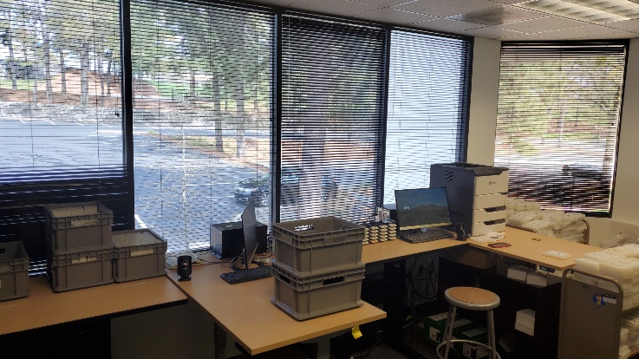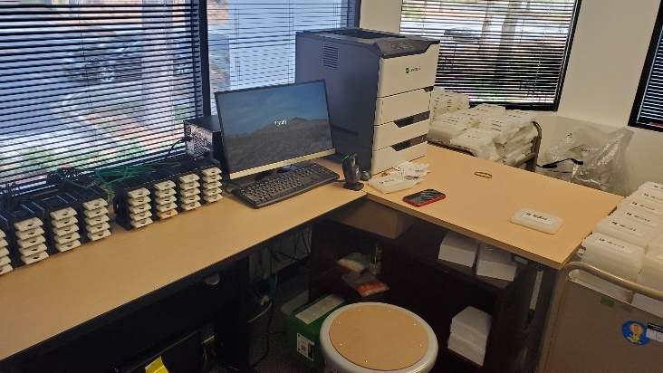

WA1A – Danielle Miller - danielle.miller@sos.wa.gov - 206-615-1588
- If you are using Gutenberg, why did you decide to use this system?
To align with NLS and because there was no cost associated.
- If you are using Scribe for KLAS libraries, why did you decide to use this system?
Null
- What are the benefits of DOD? (i.e. what can you do now that you were not able to do before?)
We are able to offer our full collection at all times, better meet patron requests, provide series in order or completely. Less work for Shipping staff and staff in general, less mail delivery for Post Office. More efficient.
- What challenges did DOD present, if any? (i.e. what can't you do now that you were able to do before?)
It is harder to work with physical cartridges like flagging a specific cartridge. A lot of the reporting in KLAS is set up for copy allotment not DoD.
- FOR GUTENBERG LIBRARIES: How has NLS continued to provide support after moving your library to DOD? (i.e. ordering DOD supplies, cartridge allotments, etc.)
NLS has provided some technical support and we have not needed their assistance in ordering supplies at this point. They have not done a general overview on how to use DoD which has been requested of them.
- How do library patrons that visit the library browse for titles now?
NLS has provided some technical support and we have not needed their assistance in ordering supplies at this point. They have not done a general overview on how to use DoD which has been requested of them.
- How do library patrons that visit the library now check out audio books?
When patrons can come in, they will work with readers' advisors and cartridges will be created and be checked out and paged from our Shipping Department and brought to the front of the library for the patron.
- Who manages the DOD process and system?
Our KLAS Administrator manages it.
- How long does it take to do the daily DODs? Before DOD and after DOD?
DoD takes 1.5-2 hours and copy allotment took about 4 hours.
- How did you inform your patrons about the change in service and would you do it that way again?
We announced it in advance in our newsletter and then we sent every patron a postcard two weeks in advance of them being switched over. We also had information on our website. We also did phone calls. Yes, we would do it that way again.
- Do you have a need for more than the one DOD workstation supplied by NLS? If so, why?
NLS supplied two workstations and that is sufficient.
- How do you assure quality when processing DOD? (For example: ensuring there aren't any audio errors on the cartridge you just duplicated? That KLAS is putting the correct book on the correct cartridge and mailing label?)
Software provides information on errors and staff test random cartridges.
- In what specific ways do circulation staff ensure quality control in workloads? (i.e. How do you make sure you aren't mixing up a mailing label and cartridge?)
We follow NLS recommendation on processing and we have a system for placing the mailing cards in order next to a row of duplicated cartridges using trays. We randomly sample that the titles on the mailing card match the books playing on the cartridges.
- Braille circulation: Are you running separate circulation models between audio and hard copy or electronic braille?
Yes
- Can you create pre-bundles of books or series that can then be downloaded to a cartridge on demand?
We don't know how to do that....
- What are the specific ways that workloads/tasks have shifted for Circulation staff?
There is less to do and more focus on recycling and beyond recall of copy allotment DBs.
- Did you see a reduction in need for staff and if so, how did you accommodate that shift?
We aren't quite there yet because there is still a lot to do with recall and labeling and we aren't able to have volunteers in the library yet.
- What best practices do you use for migrating staff incorporating DOD into their work routines?
Director, KLAS Admin, and Shipping staff all work together and watched NLS videos and practiced together in Gutenberg sandbox. We did trainings with KLAS for service queue, etc. KLAS Admin works with staff.
- Are you updating your job descriptions, and union workers and fair compensation with the addition of DOD work?
The DoD work isn't an addition, it is change in process, but positions will be updated to reflect some of the changes in tasks.
- What are the positive and negative effects of DOD on staffing?
For the readers' advisors they can almost always say "yes" to patrons which is very positive. DoD is faster for Shipping to get circulation out which is positive, but also has the negative of reduced staffing needs. There are lots of pros but not a lot of cons. Librarians can meet the needs of problem patrons better. Better overall service for patrons.
CO1A – Teresa Kalber - kalber_t@cde.state.co.us – 303-727-9277
- If you are using Gutenberg, why did you decide to use this system?
Our Director decided she wanted to use Gutenberg and duplication on demand during an NLS national conference where Michael Katzmann demonstrated Gutenberg with the "robot" to make multiple cartridges. She felt it would provide better, more efficient service to our patrons.
- If you are using Scribe for KLAS libraries, why did you decide to use this system?

- What are the benefits of DOD? (i.e. what can you do now that you were not able to do before?)
We can offer our patrons more book choices since we have access to all the titles on BARD, which is great for patrons who like older titles. Patrons are able to have a greater selection since we place 10 books on each cartridge as our default. It was really helpful when COVID started to be able to ensure our patrons would have plenty of reading material. Privacy is also a benefit – no one can see what book you are reading.
- What challenges did DOD present, if any? (i.e. what can't you do now that you were able to do before?)
We had difficulties at first getting locally recorded material to patrons. But since we've figured that out, we can do everything now that we did before.
- FOR GUTENBERG LIBRARIES: How has NLS continued to provide support after moving your library to DOD? (i.e. ordering DOD supplies, cartridge allotments, etc.)
They are always available for a consult on any issue that arises.
- How do library patrons that visit the library browse for titles now?
We have never really had a browsing collection. Before COVID, our patrons had to meet with a Reader Advisor to get audio books and that will still be the case when we open to the public again.
- How do library patrons that visit the library now check out audio books?
As mentioned above, all our walk-in patrons go through a Reader Advisor to get their books.
- Who manages the DOD process and system?
Our circulation/mail operations staff.
- How long does it take to do the daily DODs? Before DOD and after DOD?
It takes our circulation staff about 2 hours to complete they daily run of new cartridges and about 1 1/2 hours to inspect and check-in the returned cartridges. Before DOD it took 3 - 3 1/2 hours to pull books each morning and 4 - 5 hours to inspect, check-in and shelve the returned books. The biggest difference is in resources. With DOD, we have 1 staff person doing both check-in and check-out. Whereas before DOD, we'd have all 3 staff, plus several volunteers doing the work.
- How did you inform your patrons about the change in service and would you do it that way again?
We put a short article in our newsletter before we started. But we did not inform patrons individually beforehand. We just made the change and started sending out the new cartridges. Then we put a longer article in our next newsletter. Yes - I would do it the same way again.
- Do you have a need for more than the one DOD workstation supplied by NLS? If so, why?
We were supplied with 2 DOD workstation and that seems to work fine for us. We did purchase a second printer. While useful when doing the migration, it is now a back up printer if we need it.
- How do you assure quality when processing DOD? (For example: ensuring there aren't any audio errors on the cartridge you just duplicated? That KLAS is putting the correct book on the correct cartridge and mailing label?)
We don't do any quality assurance. We don't know if there's a problem unless a patron calls. I'm not sure how you would do a quality check, unless you popped each cartridge into a player to check them.
- In what specific ways do circulation staff ensure quality control in workloads? (i.e. How do you make sure you aren't mixing up a mailing label and cartridge?)
We only scan one cartridge at a time to ensure that the label that is printing goes to that cartridge. When that label is done, we scan the next cartridge so the label can print while the previous label and cartridge are put in a mailing container.
- Braille circulation: Are you running separate circulation models between audio and hard copy or electronic braille?
Yes. Our audio had gone completely to DOD, whereas our Braille collection is only hard copy. For Braille, we still need to print the cards, pull the items from the shelf and package them to mail. We don't distribute electronic Braille.
- Can you create pre-bundles of books or series that can then be downloaded to a cartridge on demand?
We can't create bundles of books, but we can assign an entire series to a patron individually and have those books downloaded to a DOD cartridge.
- What are the specific ways that workloads/tasks have shifted for Circulation staff?
With DOD we have shifted some responsibilities. We have one staff member handle the audio books and another the large print and Braille books. This worked well for us since we were unable to have volunteers help with the workload for almost a year.
- Did you see a reduction in need for staff and if so, how did you accommodate that shift?
We had a staff member retire at the end of June 2019. Since we knew we were making the move to DOD, we didn't re-hire the position. Another staff person will retire at the end of July and that position will be reconfigured and shifted to patron services as opposed to mail operations.
- What best practices do you use for migrating staff incorporating DOD into their work routines?
I don't know that we followed any best practices. We just started using DOD. As more patrons were shifted to DOD, that naturally led to less books needing to be pulled from the stacks. We began with DOD in October 2019 and did a fast conversion so that all patrons were switched over by mid-December. On January 1, 2020, we stopped all non-DOD circulation of audio books.
- Are you updating your job descriptions, and union workers and fair compensation with the addition of DOD work?
As appropriate
- What are the positive and negative effects of DOD on staffing?
Positive - one staff member can complete the entire days work of DOD, freeing up remaining staff to work on other projects if needed. Negative - can't think of anything.

