Talking Book Summer Reading Program

Oceans of Possibilities

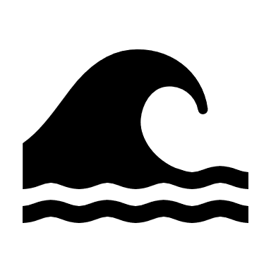

Join the summer fun with the annual

Talking Book & Large Print summer reading program!
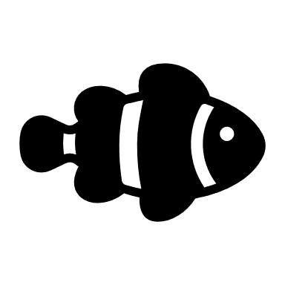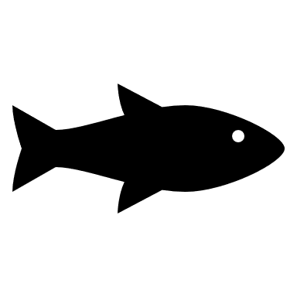
Who’s eligible: Kids from birth through high school
When: Monday, July 11th – Saturday, August 20th
How to join: Call or email Sarah at the Maine State Library: (207) 287-1957 or sarah.d.duggan@maine.gov
Where: Wherever you are! Just pick a reading goal (minimum of three books) to receive crafts, prizes, and more!
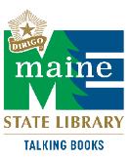
Talking Books: Special format library materials for people who are blind, visually impaired, or print disabled.

These programs are supported by federal LSTA funds through grants from the Institute of Museum and Library Services, administered by the Maine State Library.
Oceans of Possibilities – Suggested Reading List
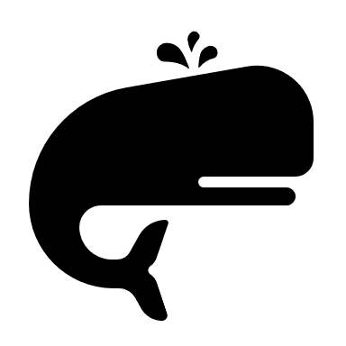
EARLY READERS

(DB 91498) Shark Lady: The True Story of How Eugenie Clark Became the Ocean’s Most Fearless Scientist by Jess Keating and Marta Alvarez Miguens, Non-fiction
(DB 93180) Otis and Will Discover the Deep by Barb Rosenstock and Katherine Roy, Non-fiction
(DB 85250) Solving the Puzzle Under the Sea: Marie Tharp Maps the Ocean Floor by Robert Burleigh and Raul Colon, Non Fiction
(DB 34063) The Little Red Lighthouse and the Great Gray Bridge by Hildegarde Swift and Lynd Ward, Fiction
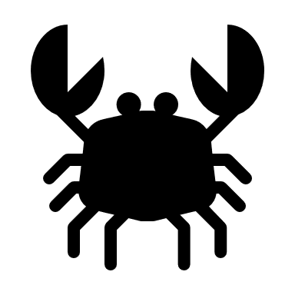
JUVENILE READERS

(DB 95958) What a Waste: Trash, Recycling, and Protecting our Planet by Jess French, Non-fiction
(DB 70483) Odd and the Frost Giants by Neil Gaiman, Fiction
(DB 51900, DB 56068, DB 64187) The Castaways of the Flying Dutchman series by Brian Jacques, Fiction
(DB 63443, DB 64659, 65245, DB 67158, DB 69015) Percy Jackson and the Olympians series by Rick Riordan, Fiction
YOUNG ADULT READERS

(DB 18521) The Sea Around Us by Rachel Carson, Non-fiction
(DB 102634) How to Change Everything: The Young Human’s Guide to Protecting the Planet and Each Other by Naomi Klein and Rebecca Stefoff, Non-fiction
(DB 96100) The Last Voyage of Poe Blythe by Ally Condie, Fiction
(DB 100195) A Song Below Water by Bethany Morrow, Fiction

