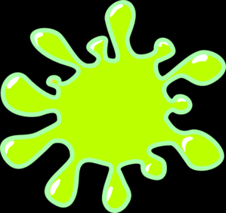
MY SLIME JOURNAL

Welcome to the 2021 Teen STEM Summer Reading Program!

Includes:

- Welcome
- Important Safety Information
- Safety Procedures for Making Slime
- Definitions
- The Science of Slime
- Equipment Needed
- Slime Recipes
- Oobleck Slime Recipes
- You Can Eat This!
- Clean Up
- My Slime Journal Experiments
- STEM Recommends

State Library of Louisiana
Talking Books and Braille Library
701 North 4th Street
Baton Rouge, LA 70802

tbblkids@state.lib.la.us
1.800.543.4702 or 225.342.9563

WELCOME!

This year we are looking at the science of slime. Slime is ooey, gooey, stretchy, and oh so interesting to make! It is inexpensive to make, using ingredients from around your own home. It’s a fun chemistry science activity that promotes STEM awareness.

Participants may earn a forest green “Tails & Tales” T-shirt featuring the Tortoise and the Hare reading books and other items just by reading a STEM book from the recommended list and trying 2 STEM experiments. Activity log should be returned by August 31.
Important! Read this First

Due to concerns about the use of pure Borax in slime experiments causing skin irritations, the following recipes will recommend only the safest EPA Grade 4 Borax products.

Please, be aware that all science experiments, science activities, STEM activities, and slime recipes have the potential for safety risks. Slime is not considered a toy, and is not a food item, even if it is identified or described as edible. Chemical products used in the making of slime can cause severe allergic reactions and rashes on the skin. Eating or ingesting slime and products for making slime can cause severe diarrhea, vomiting, stomach cramps, and possible hospitalization.

The State Library of Louisiana, its officers and employees, are not in any way responsible for the risks assumed in making homemade slime or in using slime toys.

It is very important to understand and follow all safety instructions under adult supervision, during the making, experimenting, and playing of slime products and recipes.

What is Borax?

The primary ingredients in most slime recipes are glue and Borax. Borax is a salt of the natural element boron. All products that are used for making slime activator contain some form of borax. These includes borax, liquid laundry starch, contact lens solution, and magical slime activating solutions.

The recipes and experiments in this booklet have been tested multiple times, and only the safest measures for handling slime products will be listed. There are enough recipe choices listed, that everyone can choose an experiment according to their ability and comfort level. Choosing the right slime recipe for your situation, adult supervision and moderation are the keys to safe “slime-time.”

Safety Procedures for Making Slime

- Adult supervision is necessary for children playing with or making slimes, so that these products are not eaten, tasted, or ingested in anyway. It is a chemical and needs to be treated as such.
- ABSOLUTELY there should be no eating or drinking or food preparation while making or playing with borax-slime. Since small amounts of material can get into the mouth from the fingers, why take the chance of any amount being eaten?
- Gloves must be worn when mixing Borax products, to avoid skin contact and potential allergic reaction.
- After all the mixing is done, take off the gloves and wash hands and arms thoroughly, but gently with soap and water.
- Masks can be worn if there is a risk of breathing in product.
- It is recommended to use disposable containers and equipment when preparing slime, rather than every-day kitchen dishes that normally hold food or beverages.
- Thoroughly wash any non-disposable containers after slime preparation, and do not use for future food use if a Borax product was stored in the container.
- Keep the container of Borax solution closed and out of reach of small children, even when it is out of the cabinet during “slime-time.”
- Scooping the Borax product from the container should be done carefully to prevent spilling. If it does spill, clean up by wiping down the spill area with a wet paper towel to pick up the remaining product. Sweepings and paper towels can go in the household trash.
- Be aware that the Borax solution in water is a drinking accident waiting to happen. Don’t leave the solution in a container that someone could mistake for a beverage. Pour unused or leftover solution into the sink drain immediately.
- Keep in mind that once the slime appears during the mixing, the glue and the Borax are largely gone, wrapped up in making something new. Skin contact with slime itself is not the same thing as skin contact with Borax. On the other hand, handling it hours upon hours at a time, all the time, is probably not a good idea.
- Consider limiting the amount of time your child plays with the Borax-slime. There is no hard and fast rule, but thirty minutes to an hour a day seems reasonable.
- After handling slime with bare hands, thoroughly wash and rinse it away from skin.
- Slimes can wreak havoc with plumbing, so don't throw it down the drain.
- Keep slimes away from anything they could damage. They can dry into fabric, and any dyes they may have can stain. All slimes can potentially harm surfaces, especially wood.
- Slimes using Borax solutions work best if you pour the Borax solution into the other solution, rather than the other way around. Coloring should be added before the Borax.
- Young children or others who may put the slime in their mouth should play only with edible slime made with food.
- Non-borax recipes that use starch are safer overall.
- Pregnant women should avoid Borax-slime recipes.
- Be safe, and have fun.

Definitions

Elasticity – The ability of a material to resist a distorting influence or force, and return to its original size and shape when the force is removed.

Maxwell Fluid – Viscoelastic fluid having the properties of both elasticity and viscosity.

Non-Newtonian fluid - A fluid whose apparent viscosity changes with applied shear force (Newtonian fluids have constant viscosity)

Oobleck – A substance that viscosity increases with the rate of sheer force. It becomes a solid under stress.

Rheopectic - Apparent viscosity increases with duration of stress

Sheer force – The amount of stress or pressure applied.

Viscosity - Resistance of fluid to a flow.

Thixotropic - Apparent viscosity decreases with duration of stress

The Science of Slime

Welcome to the fascinating world of non-Newtonian fluids! They get their name from the fact that they do not fit Newton's laws of how true liquids behave (specifically, in how they react to shearing forces).

Quicksand, butter, ice cream, glues, gelatin, and ketchup are all non-Newtonian fluids. There are two main types of non-Newtonian fluids, rheopectic and thixotropic. Slimes are rheopectic, which means they show an increase in apparent viscosity (resistance to flow) with time under a constantly applied stress (they do not have a well-defined viscosity). They resist flow dependent on the velocity of flow. If something acts on them with a small amount of force (if you stir them slowly, or let you fingers slowly sink into them) they won't offer as much resistance as they would if a greater force acted on them. If you punch a good stout oobleck, it should resist about as much as a brick wall. They fight back.

Thixotropic fluids, on the other hand, tend to have more apparent viscosity under low shear stress and less under higher shear stress. Paints typically are thixotropic fluids; they flow easily when being brushed on, and stay put once applied. If you are ever so inclined to study fluids a bit more seriously, you will soon realize that these are very simplified definitions, and that there are many more types of fluids. But these are a good start.

Slime is a unique play material composed of a cross-linked polymer. It is classified as a non-Newtonian Maxwell fluid. These are thick liquids that have a variable viscosity and elasticity. Slime is typically made by combining a polymer like polyvinyl alcohol solutions found in Elmer’s glue with borate ions in a large mixing container.

The molecular structure of slime is the factor responsible for its interesting behavior. Toy slime is typically composed of tangled, long-chain polymer molecules. These polymer molecules can be thought of as spaghetti strands. When put together on a plate, the strands are mixed together making a tangled mess. If the strands are rubbed together, they line up and become smoother. This motion gives the mass its slimy, slippery feel.

While the intermixing of the polymer strands will give some built-in viscosity, a cross-linking agent containing Borax is also present in slime to give it the non-Newtonian fluid behavior. Cross-linking agents are ions that help temporarily connect polymer strands with relatively weak ionic bonds. These bonds are strong enough to hold the polymer strands together but not strong enough to make the mass a solid. Borax products contain the element Boron, which has unique cross-linking properties not shared by other elements. This is why Borax products are the only slime activators that will effectively work.
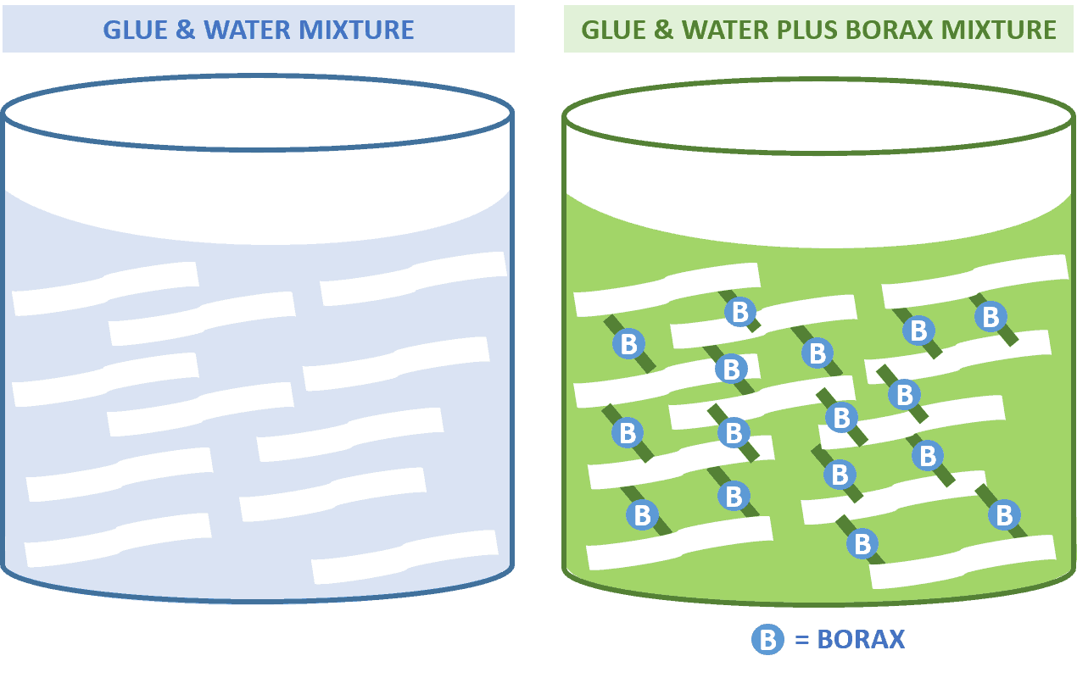
General Equipment You Will Need

The following items are recommended to have on hand for proper slime making.

- A safe dry surface. Keep slimes away from anything they could damage. They can dry into fabric, and any dyes they may have can stain. All slimes can potentially harm surfaces, especially wood.
- Safety gloves to be worn when making slime.
- Stir sticks or spoons
- Measures for
- Tablespoon
- Teaspoon
- ½ Tablespoon
- ½ Teaspoon
- ¼ Teaspoon
- ¼ Cup
- 1/8 Cup
- Mixing Bowl
- Ziplock Bags or containers to store Slime
- Paper towels
- Kitchen or bath towel
- Oven mitt
- Microwave safe dish
- Coconut oil
- Vinegar and baking soda

Slime Recipes

Many people keep the common materials named in the following slime recipes in their kitchens. However, most materials for slime making can be purchased from the local dollar store or the local grocery store in your area for under $10.00.

I recommend using Elmer’s Glue Slime Magical Liquid Activator, or a similar pre-mixed solution. The cost is generally around $5.00 for an 8 ounce bottle, and should be enough to conduct all experiments in this booklet. Each recipe also shows a substitute alternate measurement for contact saline solution and baking soda.

In the case that you only have access to Borax, make a solution of 1 teaspoon laundry powder dissolved into about 1 cup of warmed water. Keep this in a secured container plainly labeled Borax Solution. This can be substituted in place of the contact lens solution measurements in the following recipes. Liquid starch can also be substituted, adding and mixing 1 teaspoon at a time until the slime reaction occurs.

Warning: Always wear Gloves when handling Borax products. Pure Borax is not recommended for making slime.

Remember that Borax is a skin irritant. Contact lens solution and Magic Slime Activator are less likely to cause an allergic reaction. But, reasonable care must be taken when using any Borax products and always under adult supervision.

Warning: Please Heed!

Do not use eye drop solutions such as Visine or artificial tears. These have a different chemical than Borax, and will not work. They pose a serious health risk if ingested.

Baseline Slime Recipe
Materials you will need:

2 oz of clear or school glue (4 tablespoons or ¼ cup measurement)
1 oz of water (2 tablespoons or 1/8 cup measurement)
3-4 teaspoons of Magic Slime Solution (recommended)
¼ tablespoon baking soda (Alternate)
½-1 tablespoon contact lens solution (Alternate)
Food coloring of your choice
Coconut oil

Directions:
- Pour 2 oz of glue into a mixing bowl.
- Add 1 oz of water to glue and mix well.
- Add a drop of desired food coloring and mix well.
- Add ½ teaspoon of Magic Slime activator at a time, mixing after each time, until slime reaction begins to occur. (Usually about 3-4 teaspoons).

(Alternately)
Mix ¼ tablespoon baking soda with 1 teaspoon of warm water. (Set aside).
Add dissolved baking soda to water and glue mixture.
Stir in saline solution a little at a time, stirring each time until reaction occurs.

- When the reaction starts to occur, glue mixture will start to separate from sides of the mixing bowl.
- Stir until mixture is completely separated from sides of mixing bowl.
- You can add a couple of drops of magic slime activator or saline solution during stirring, if the reaction needs it. But, be careful as too much solution can make the slime become putty, and lose its elasticity.
- After the mixture reaction has occurred and the mixture is separated from the bowl sides, take the mixture up and start to knead it, this will complete the reaction.
- Remember not to remove your gloves until the slime has fully formed.
- A few drops of coconut oil on your fingers before handling slime will reduce stickiness.

Epsom Salt Slime Recipe
Materials you will need:

2 oz of clear glue (4 tablespoons or ¼ cup measurement)
3 tablespoons of water
2 tablespoons of Epsom salts
Food coloring of your choice

Directions:
- You will need to heat the water in the microwave using the beverage setting in a microwave safe container. This is about 1 - 1½ minutes.
- Use oven mitts or a clean dish towel to remove from microwave.
- Dissolve the Epsom salts into the hot water.
Caution: Do not heat the water with the Epsom salts in it. Add the Epsom salts after you heat the water, as the salts can cause the water to boil over.
Do not overheat the water as this can lead to skin burns.
Extra caution is needed when taking heated items out of the microwave. Use a towel or potholder to handle heated containers.

- Pour 2 oz of clear glue into mixing bowl. (Clear glue works better than white school glue with Epsom salts).
- Add coloring and mix well.
- Begin adding Epsom salt mixture 1 teaspoons at a time, mixing each time.
- The reaction will occur when the glue mixture begins to clump and separate from the sides of the bowl. (starts after about 3 or 4 teaspoons of solution)
- Once the reaction begins, stir for a couple of minutes to see if you need to add a little more Epsom salt solution.
- Too much Epsom salt solution and the mixture will become a putty.
- Once reaction occurs, pick up mixture and start to knead. This will help complete the reaction.
- Remember not to remove your gloves until the slime has fully formed.
- If the slime feels too putty like, add some coconut oil to soften it.

Guar Gum Slime Recipe
Materials you will need:

¼ teaspoon Guar Gum
About ½ cup warm water (3 oz or 6 tablespoons)
3-5 teaspoons of Magic Slime Solution (recommended)
¼ tablespoon baking soda (Alternate)
½-1 tablespoon contact lens solution (Alternate)
Food coloring of your choice

Directions:
- Pour ½ cup warmed water into mixing bowl. (Tap water will work)
- Add a drop or two of coloring and mix into the water.
- Sprinkle ¼ teaspoon of Guar Gum over surface of water, and start to mix into the water. The water will become cloudy and small clumps of the powder may form and have to be stirred until dissolved.
- When Guar Gum has dissolved or mostly dissolved,
- Add ½ teaspoon of Magic Slime activator at a time, mixing after each time, until slime reaction begins to occur. (Usually about 3-4 teaspoons).

(Alternately)
Mix ¼ tablespoon baking soda with 1 teaspoon of warm water. (Set aside).
Add dissolved baking soda to guar gum mixture.
Stir in saline solution a little at a time, stirring each time until reaction occurs.

- Stir all ingredients together.
- Reaction starts when mixture separates from sides of mixing bowl.
- Continue to stir for a couple of minutes until reaction has occurred.
- Once mixture has separated from the sides of the bowl, it can be picked up and kneaded. This will help complete the reaction.
- Remember not to remove your gloves until the slime has fully formed.
- If slime is too sticky, add a little more solution.

Xanthan Gum Slime Recipe
Materials you will need:

1 oz of clear glue (2 tablespoons or 1/8 cup measurement)
2 oz of water (4 tablespoons or ¼ cup measurement)
½ tablespoon baking soda
¼ teaspoon of xanthan gum
3-5 teaspoons of Magic Slime Solution (recommended)
½-1 tablespoon contact lens solution (Alternate)
Food coloring of your choice
Coconut oil

Directions:
- Mix ½ tablespoon baking soda with ½ tablespoon of warm water. (Set aside).
- Pour 2 oz of water into mixing bowl.
- Add a drop of desired food coloring and mix well.
- Sprinkle xanthan gum on mixture and stir in thoroughly.
- Pour 1 oz of glue into the mixing bowl. Mix well.
- Add dissolved baking soda. Mix well.
- Add magic slime activator ½ teaspoon at a time, stirring each time until reaction begins to occur. (Between 3-5 teaspoons).

(Alternately)
Stir in saline solution a little at a time, stirring each time until reaction occurs.

- When the reaction starts to occur, glue mixture will start to separate from sides of the mixing bowl.
- Stir until mixture is completely separated from sides of mixing bowl.
- You can add a couple of drops of solution during stirring, if the reaction needs it. But, be careful as too much solution can make the slime become putty, and lose its elasticity.
- After the mixture reaction has occurred and the mixture is separated from the bowl sides, take the mixture up and start to knead it, this will complete the reaction.
- Remember not to remove your gloves until the slime has fully formed.

Making Fluffy Slime

Try adding one of these to change the texture of your baseline slime recipe.
- 2 cups Shaving Cream (Stir in before adding activator).
- ½ cup Vaseline (Stir in before adding activator).
- Replace water with Shampoo, dish soap, or hand soap (Adding water will cause the experiment to fail).
- ½ cup Hand Lotion (Stir in before adding activator).
- Substitute 1 oz of glue with glitter glue.
- Add ½ tablespoon glow powder or glow-in-the-dark paint.
- Add mini-foam balls.
- Substitute soda for water.
Oobleck Slimes and Food based Slimes

These slime recipes are considered taste safe

Basic Oobleck Slime Recipe

Materials you will need:

5 parts Cornstarch to 3 parts water

You can measure your portions out in tablespoons, ounces, or cups. It depends on how much oobleck you want to make. This recipe will use tablespoon measurements.
Food coloring of your choice

Directions:
- Pour 5 tablespoons of cornstarch into a mixing bowl.
- Add food coloring to 3 tablespoons of water. Mix well.
- Start mixing in 3 tablespoons of water. (Many recipes call for stirring in water, but if this is too messy, I find kneading in the water works best.)
- Add a little more water (1/2 teaspoon at a time) if need to fully mix.
- The reaction has occurred when the mixture can be picked up and quickly kneaded into a ball, but immediately melts when kneading stops.
- This will be a messy recipe, so be sure to prepare and mix on an easily cleaned surface.

Yogurt Slime

Materials you will need:

2 oz of yogurt (one tube of yogurt, 4 tablespoons, or 1/8 cup)
1 cup of cornstarch (8 oz)

Directions:
- Pour 2 oz of yogurt into a mixing bowl.
- Put a little coconut oil or lotion on your hands to cut down on stickiness.
- Start adding cornstarch in by one tablespoon at a time, stirring or kneading into the yogurt until it reaches the consistency of cake batter.
- Continue adding cornstarch 1 teaspoon at a time and kneading until mixture becomes like soft playdough, and is no longer sticky.
- You should be able to pick up and knead and play with the slime.

Chia Seed Slime
Materials you will need:

1/8 cup chia seeds (1 oz or 2 tablespoons) or ¼ cup flax seeds (2 oz or 4 tablespoons)
1 cup of water (8 oz)
1 teaspoon of xanthan gum
1 cup of cornstarch (8 oz)
Food coloring of your choice
A sealable container

Directions:
- Add desired food coloring to water.
- Mix 1/8 cup chia seeds with 1 cup of water into a sealable container and store overnight in the fridge (12-24 hrs).
- Check and try to stir mix at least once to reduce clumping.
- The next day, mixture should be gelatinous.
- Remove from fridge.
- Stir to break up clumps.
- Add by sprinkling the 1 teaspoon of xanthan gum. Whisk or stir well.
- Start to add in the cornstarch 2 tablespoons at a time.
- Stir into mixture until it thickens.
- Then start to knead into mixture.
- Knead and add cornstarch until mixture is no longer sticky.
- If it is crumbly and not stretchy, add a teaspoon of water to correct and continue to knead.
- Slime is ready when it can be moved as a heap.
- It can be stored in a sealed container in the fridge for up to 5 days.
- If it hardens, it can be softened by adding some water and kneading it.

You Can Eat This!

These 2 recipes are made with food, and are safe to eat.

How to Make Homemade Butter

Materials you will need:

1 sealable container
½ cup heavy whipping cream

Directions:
- Pour heavy cream into sealable container. (Can use a ziplock bag)
- Seal container.
- Start shaking container for about 20 minutes.
- Periodically take lid off and check to see if butter has formed.
- Once butter has formed, you can remove the left over liquid. This is buttermilk and is drinkable, or can be used in biscuit recipes to replace some of the water.
- The butter is edible and can be spread on toast and eaten.

Ice Cream in a Bag
Materials you will need:

1 quart sized ziplock bag
1 gallon sized ziplock bag
1 cup of heavy whipping cream
1 tablespoon of sugar
Enough ice to cover quart bag
¼ cup salt (Rock salt is recommended, but table salt will do)
1 teaspoon vanilla extract
1 kitchen or bath towel

Directions:
- Pour 1 cup heavy whipping cream into quart ziplock bag.
- Add sugar and vanilla extract
- Seal the bag, and let excess air out.
- Fill the gallon bag halfway with ice.
- Pour salt into gallon bag.
- Place quart bag into gallon bag.
- Add some more ice.
- Seal the gallon bag.
- Wrap the gallon bag in a towel to protect hands from cold ice.
- Shake this bag for 7 minutes.
- Take the quart bag out, and wipe or rinse top of bag to remove salt.
- Open bag and see ice cream.
- Stir and eat with a spoon.

Clean up

Sometimes, Slime Happens

How to Get Slime Out of Carpet
- Scrape up what you can: First, remove as much excess slime as you can. A spoon works well
- Make your cleaning solution: Mix warm water and vinegar in a ratio of about one-third water to about two-thirds vinegar.
- Apply the solution: Use a soft brush to apply the solution and brush gently to loosen it.
- Blot: Blot the area with a clean, white rag and repeat the process as necessary until the slime is gone.
- Vacuum: Vacuum to pick up loosened slime bits and to restore fluff to your carpet.
Note: You can also perform the same steps using rubbing alcohol (instead of vinegar), which will also help remove any food coloring that might be staining your carpet. Don’t use WD-40, as it can leave an oily residue that will attract dirt over time.

How to Get Slime Out of Clothing
- Scrape up what you can: First, remove as much excess slime as you can. A spoon works well.
- Get the slime nice and hard: Next, use ice cubes to freeze the slime residue that remains on the clothing and, once it’s hard, scrape away at it again.
- Treat the stain: Pre-treat the affected area with liquid laundry detergent, rubbing it gently into the fiber of the fabric.
- Set a timer: Allow the liquid detergent to sit but don’t let it sit for more than 10 minutes.
- Rinse: Rinse the detergent out of the garment.
- Soak: Soak the clothing in warm water for about half an hour.
- Wash: Launder as usual.

How to Get Slime Out of Hair
- Pull back the unaffected hair: If possible, clip back the hair that doesn’t have slime in it.
- Add oil: Rub olive oil, coconut oil, or vegetable oil into the area affected by the slime.
- Comb it out: Work the oil around and comb out the slime with fingers or a comb.
- Add dish soap: Work some Dawn dish soap into the oily portion of hair to cut the grease.
- Wash: Wash the hair as usual.

How to Get Slime off the Wall
- Scrape up what you can: Use a spoon to gently scrape what you can off of the wall. Be careful to not scrape off the paint.
- Make a paste: Make a paste of baking soda and water with a little bit of vinegar and apply it to the stain. (Around one tablespoon of baking soda, 1/4 tablespoon of water and a splash of vinegar, but you don’t have to be that precious about it.)
- Let the paste sit: Let the paste dry and wipe off the wall with a paper towel or rag.

My Slime Journal

Experiment One: Substituting Slime Ingredients

Make Baseline Slime, Epsom Salt Slime without Borax Solution, and Guar Gum Slime without glue.

Compare the differences between the three slimes.

 | Most Stretchy | Easiest Pour | Least  Sticky | Last  3 Days
Baseline
Epsom
Guar Gum

Observations:

Observe which slime is least stretchy. This is because it is an oobleck slime.

Observe which slime only last about a day.

Do any of the slimes pounce?

Which slime do you like the most?

Which slime do you like the least?

My Slime Journal

Experiment Two: Make Oobleck Slimes

Make Yogurt Slime, Cornstarch and water, and Epsom Salt Slime.

Compare the differences between the three slimes.

 | Forms a solid ball in hand | Melts out of hand fastest | Least  Sticky | Last  3 Days
Cornstarch
Yogurt
Epsom Salt

Observations:

Observe which slime melts quickest after forming a hard ball

Observe which slime only last about a day.

Observe which slime holds its shape the longest.

Observe which slime is the most moldable.

Whicjh slime do you like the most?

Which slime do you like the least?

Create Your Own Slime Experiments

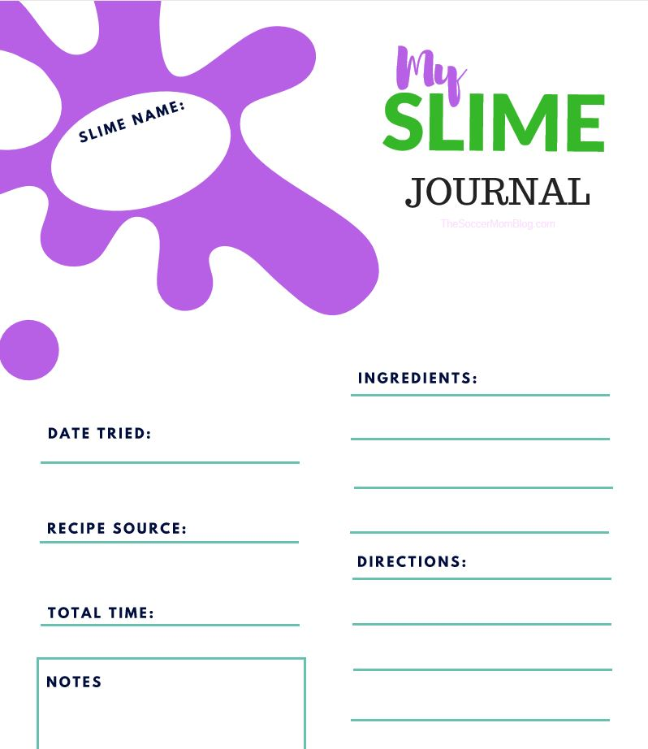

Remember to be cautious with chemicals, but also
TO HAVE FUN!
STEM RECOMMENDS
Aquarium beautiful by A. van den Nieuwenhuizen
DB51646
Read by Gary Tipton.
Explains how to set up, select fish and arrange plants in a Dutch planted aquarium. Gr 6-9. 1997.

Astrophysics for young people in a hurry
by Neil deGrasse Tyson
DB94258, LP26268
Read by LeVar Burton. Time: 3 hrs, 35 min.
Tyson invites young readers to explore the mysteries of the universe. Gr 4-7. 2019.

Back from the Brink by Nancy F. Castaldo
BR23068, DB99361
Read by Mark Ashby. Time: 3 hrs, 51 min.
Notable nature author explores the threats to seven animal species and discusses the scientific and political efforts to coax the endangered animals back from the brink of extinction. Gr 5-8. 2018.

Fighting for the forest by P. O’Connell Pearson
BR22977, DB98293
Read by Kerry Dukin. Time: 5 hrs, 43 min.
Recounts the history behind President Franklin Delano Roosevelt's Civilian Conservation Corps, and how it improved hundreds of state and national parks. Gr 6-9. 2019.

Grow it, Cook it by Jill Bloomfield
DB67838
Read by Carol Dines.
Reading time: 2 hrs, 11 min.
Explains gardening basics and step-by-step recipes feature these fresh ingredients. Parent participation necessary. Gr 5-8. 2008.

The Lion in the Living Room by Abigail Tucker
DB87000
Read by Laura Adducci. Time: 8 hrs, 5 min.
Chronicles the history and evolution of cats. Some violence. YAI. 2016.

Loos, Poos, and Number Twos by Petr Hepplewhite
DB84205
Read by Mike Stefanelli. Time: 52 minutes.
Overview of the history of excrement, from prehistoric times to how human waste could fertilize our crops in the future. Gr 6-9. 2016.

Rachel Carson: Fighting pesticides by Patricia Lantier
DB70197, LP24172
Read by Patrick Downer.
Biography of marine biologist Rachel Carson (1907-1964), author of Silent Spring (BR11887, BRC00870, DB20184). Gr 4-7. 2009.

Sniffer Dogs by Nancy F. Castaldo
BR20711, DB80913
Read by Patrick Downer. Time: 3 hrs, 28 min.
Describes how detection dogs are able to use their noses to find everything from lost people and explosives to orca whale poop. Gr 4-7. 2014.

Steve & Me by Terri Irwin
DB66251, LP21292
Read by Martha Harmon Pardee. Time: 7 hrs, 28 min.
Memoir about Steve Irwin's work rescuing crocodiles and other endangered animals. Discusses family life, before and after Steve's 2006 death from a stingray barb. YAI.

Tapas: A taste of Spain in America by José Carlos Andrés
DB62462
Read by Frank Coffee. Reading time: 6 hrs, 55 min.
Dozens of recipes for a traditional cuisine characterized by small portions that can serve either as appetizers or entrees. YAI. 2005.

Wild Horse Scientists by Kay Frydenborg
BR19866, DB76337
Read by Bill Hensel. Reading time: 2 hrs, 26 min.
Discusses wild horses that reside on Assateague Island National Seashore.
Gr 5-8. 2012.

Resources
Reproducible materials are from:
Carusella, Brian. "The Page that Dripped Slime." Bizarre Labs. January 01, 2021. https://bizarrelabs.com/slime.htm (accessed June 03, 2021).
Citro, Asia. "No-cook Edible Chia, Flax, and Seedless Slime recipes." Fun at Home with Kids. June 15, 2014. https://www.funathomewithkids.com/2014/06/no-cook-edible-chia-flax-and-seedless.html?m=1 (accessed June 03, 2021).
Collaborative Summer Library Program. Tails and Tales: 2021 Collaborative Summer Library Program Manual. Collaborative Summer Library Program, 2021.
Edwards, Deborah. "Report of the Food Quality Protection Act (FQPA) Tolerance Reassessment Eligibility Decision (TRED) for Boric Acid/Sodium Borate Salts." Environmental Protection Agency. July 6, 2012. https://www3.epa.gov/pesticides/chem_search/reg_actions/reregistration/tred_PC-011001_1-Jul-06.pdf (accessed June 03, 2021).
Fun with Mama. "How to Make Xanthum Gum Slime Recipe." Fun with Mama. March 19, 2018. https://www.funwithmama.com/xanthum-gum-slime-recipe/ (accessed June 03, 2021).
McLeod, Kimberly. "Butter Slime." The Best Ideas for Kids. 06 18, 2018. https://www.thebestideasforkids.com/butter-slime/ (accessed 06 03, 2021).
Rodriguez, Stacey Garska. "Edible Slime Recipes Made with Simple Kitchen Ingredients." The Soccer Mom Blog. August 05, 2020. https://thesoccermomblog.com/edible-slime/ (accessed June 03, 2021).
Science Explorers. "Complete Guide to Making Slime." Science Explorers. February 07, 2019. https://scienceexplorers.com/complete-guide-to-making-slime/ (accessed June 03, 2021).
Simple Everyday Mom, LLC. "Easy Slime Recipes for Kids." Simple Everyday Mom. June 03, 2021. https://www.simpleeverydaymom.com/easy-slime-recipes-for-kids/ (accessed June 03, 2021).
STEAMsational. "The Best Slime recipes with Step-by-Step Directions." STEAMsational STEAM activities for kids. June 03, 2021. https://www.steamsational.com/slime-recipes/ (accessed June 03, 2021).

CONTACT INFORMATION
TELEPHONE In-state toll-free 1.800.543.4702
Baton Rouge 225.342.9563
Utah (Braille) 1.800.453.4293
EMAIL TBBL tbblkids@state.lib.la.us
Utah blind@utah.gov
FAX 225.342.6817
ADDRESS State Library of Louisiana
Talking Books and Braille Library
P.O. Box 131
Baton Rouge, LA 70821
WEB ADDRESSES
TBBL http://www.state.lib.la.us/
Utah http://blindlibrary.utah.gov/
NLS http://www.loc.gov/nls/

