Crafts
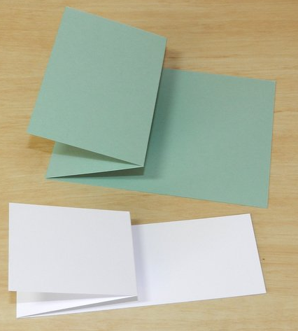
SPINNING CARD INSTRUCTIONS 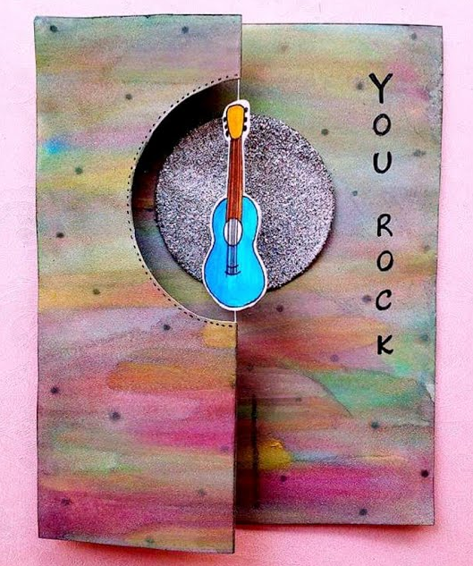 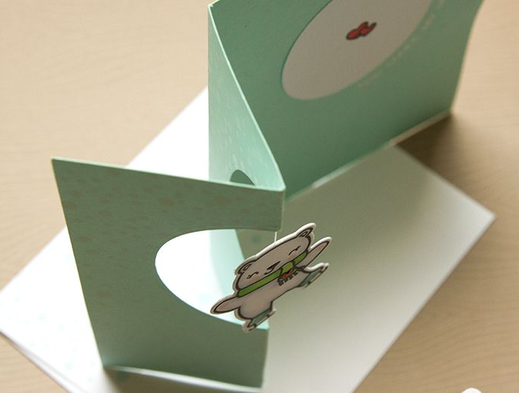
Materials Provided:
1 6 ¾” by 9 ½” piece of cardstock or construction paper (Pre-cut)
1 piece of thread, twine, or string about 6” long
2 stickers or pictures that can be glued back to back and can be placed in a 2 ½ diameter circle or square cut area
Some stickers and decorations
Additional Materials:
Glue
Tape
Additional stickers and decorations
Writing pen, colors, markers, and/or colored pencils
Note: Materials in your packet are pre-cut and scored.
Directions:
- Cut a letter sized piece of cardstock or construction paper to 6 ¾” by 9 ½” dimensions.
- Fold paper in half, so that the folded paper is 4 ¾” by 6 ¾” dimensions, and giving two pages or flaps.
- Lay folded paper flat.
- Make a Z fold by folding top flap in half for dimensions 2 ½” by 6 ¾”.
- Use either a die cut or something to make a pattern approximately 2” diameter, to cut a circle or a square in center upper part of the folded top flap. Make it at least 1” from the top of the paper.
- Now measure out the desired piece of thread.
- Take the two matching images for your spinner and glue them together, with the thread in between.
- Fold the paper flat out with the cut out area to the left hand side or at the top of the page (depending how you want the card to open; laying the image in the center of the circle cut area to make sure it fits, allowing space around it.
- Put the image to the side.
- Lay the card flat making the Z fold out and cut out to the left hand side. This should show the inside of your card.
- Decide how you will decorate the inside of the card, and the outside top Z flap on top.
- It is recommended to decorate first, before trying to attach the image.
- Now that the card is decorated the way you want, unfold the Z flap so that the back or hidden side of the Z flap is facing flat up.
- Now use tape or adhesive to attach the thread on the backside of the Z flap, such that the image is centered in the circle-cut. The thread will be hidden in the flap crease when folded.
- Cut excess thread.
- Fold the top of the card back into a Z fold, showing the decorated picture on the card.
- Carefully, wind the image attached to the thread a few times.
- Lay the smaller folded edge of the card along with the image against the back flap to close the card.
- You can now slip the card into an envelope.
- Make sure that the card is placed into the envelope with the double fold and spinner portion facing the envelope opening, and the back part tucked into the envelope.
- When the card is removed from the envelope, the wound image will twirl or spin on the thread when the Z fold is opened.
Source: Jennifer McGuire Ink on Youtube

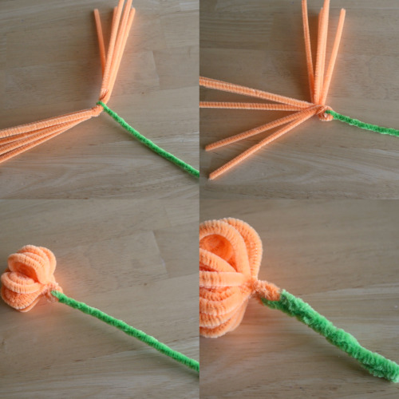
Pipe Cleaner Flowers and Basket
Materials Provided:
Colored Pipe Cleaners
Ribbon
Cardstock basket template
Additional Materials:
Glue dots
Instructions:
For the flowers:
- Wrap a long green pipe cleaner around the 6 bundled pipe cleaners.
- Bend and twist it to make the stem.
- Spread out your now 12 strands, and curl them up into each other to make the flower.
- For a sturdier stem, fold the green pipe cleaner in half again.
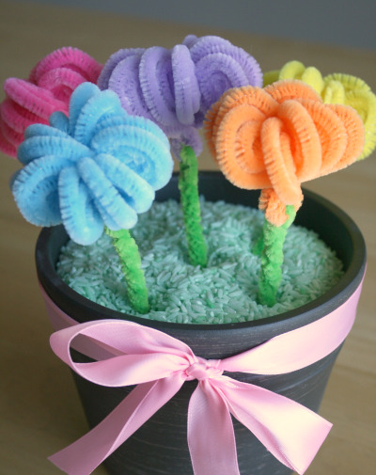
For the flower pot:
- Assemble the basket.
- Cut a colored ribbon to length.
- Attach it to the rim of the pot using glue dots.
- Tie it off in a bow. I also attached the bow in place with a glue dot.
- Then add green colored rice, (or similar filler) to fill the pot.
- Place flowers in the pot.
- You can group them all together and tie it with another pipe cleaner, to make a bouquet.
Source: makeandtakes.com
Tangram Puzzle

Use the provided shapes to make tangram pictures.
Source: CSLP 2022 SRP manual

Pine Cone Bird Feeder [Source: Melissa Mayntz]
This is a great activity for anyone of any age.

Version 1

Materials
Pinecone: Natural pinecones are the best, especially ones that have fallen to the ground during the fall. You can also buy pinecones online or at the dollar stores. Just make sure to get ones that haven’t been painted or glittered or that are scented, as the chemicals can be harmful to birds.
String or Twine: Cut a piece about 8 to 10 inches long, but can be longer if needed in order to hang. Other good options are ribbon or yarn. Do not use very thin thread, such as floss, fishing line, etc., as birds might get tangled in it.
Peanut butter: Any brand or type can be used. You can also use lard, vegetable shortening, sunflower butter or other nut butters (but avoid sugar-free versions).
Birdseed: A mixed birdseed is great, but you can use any available. Birdseed can be found at almost any grocery store.

Instructions
- Remove any dirt or debris from the pinecone by shaking, tapping, or brushing it gently.
- Tie a piece of your string or twine to the top of your pinecone, two or three rows down.
- Pour birdseed onto a plate or into a shallow dish.
- Tie the ends of the string together to hang the pinecone from. Make sure to do this BEFORE adding peanut butter to the pinecone.
- Spread peanut butter onto the pinecone. Use as little or as much as you like.
- Once the pinecone is coated in peanut butter, roll it in the birdseed, pressing lightly to adhere the seed to the pinecone.
- Go hang them somewhere outside. NOTE: Preferably somewhere in the shade as high heat can cause peanut butter to go rancid or grow soft or melt.

Version 2
This version is slightly different. Instead of using a pinecone, you can use an empty toilet paper roll.

Instructions
- Clean any excess paper off the cardboard toilet paper roll.
- Spread peanut butter all over the outside of the toilet paper roll. Use as little or as much as you like.
- Roll it in the birdseed, pressing lightly to adhere the seed to the roll.
- Cut string, twine, yarn, or ribbon into 12-24 inch lengths and thread through the roll.
- Tie the two ends together. Hang outside.

