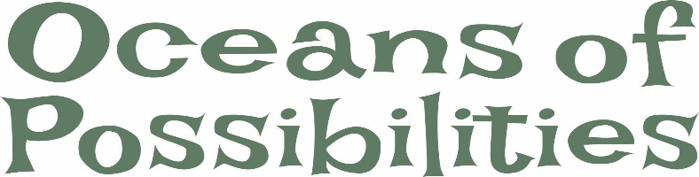

TBBL Summer Reading Program Survey 2022 Year

- My child and I learned something new by participating in the Summer Reading Program.

Strongly agree
Agree
Neither agree nor disagree
Disagree
Strongly disagree

- Participation in the Summer Reading Program made my child more confident with his/her reading skills.

Strongly agree
Agree
Neither agree nor disagree
Disagree
Strongly disagree

- My child and I can apply the reading skills that we have developed by participating in the Summer Reading Program to help achieve personal reading goals.
Strongly agree
Agree
Neither agree nor disagree
Disagree
Strongly disagree

- My child and I are more likely to participate in future Library Summer Reading Programs.

Strongly agree
Agree
Neither agree nor disagree
Disagree
Strongly disagree

- I am more likely to use other library services and resources that the Talking Books and Braille Library has to offer.

Strongly agree
Agree
Neither agree nor disagree
Disagree
Strongly disagree

- Overall, were you satisfied or dissatisfied with the TBBL Summer Reading Program event?

Strongly agree
Agree
Neither agree nor disagree
Disagree
Strongly disagree

- Comments:

Thank you for taking time to fill out our survey. Please, return your responses in the provided envelope.

