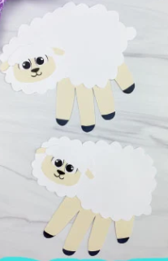
Crafts

Handcraft Sheep Ornament

Materials Provided:
Black foam for sheep body
White felt pieces for sheep wool, tail, and head
Piece of pink foam for sheep nose
2 black foam pieces for sheep ears
1 piece of string to hang ornament
1 bowtie
2 wiggle eyes

Additional Materials:
Pencil
Scissors
Glue

Directions:
- Lay your hand on the black foam sheet and trace around it with a pencil.
- Cut out the handprint.
- Turn the handprint so that the fingers are facing down. The fingers will be the sheep’s legs.
- Glue the big white felt piece to the palm of the hand to make the body.
- Glue the pink foam nose to the end of the thumb.
- Glue the wiggle eyes above the nose.
- Glue the medium felt piece above the wiggle eyes.
- Glue the black foam ears to the medium felt.
- Glue the small felt to the body for a tail.
- Glue the bowtie to the front of the sheep.
- Glue the string to the backside of the sheep for a hanger.
- Allow time for your craft to dry.

Warning: Please, be aware of small pieces that could present a choking hazard to people under 3 years of age.

Simple Everyday Mom
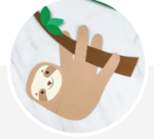
Sloth Handprint Craft

Materials Provided:
Colored foam piece for sloth body
1 foam for head
1 foam face
2 small foam for eyes
Colored cardstock or construction paper for tree limb
1 piece of string to hang ornament
Sloth template

Additional Materials:
- Scissors
- Glue
- Black marker
- Pencil

Directions
- Lay your hand on the body foam sheet and trace around it with a pencil.
- Cut out the handprint.
- Turn the handprint so that the fingers are facing up. The fingers will be the sloth’s legs.
- Take the sloth's head and line it up with the thumb side of the handprint. Glue it in place. You may need to trim off some excess paper to make it look seamless.
- Glue the sloth's face to the middle of the head, then use the black marker to draw in the eyes. Use the brown marker to draw on the sloth's nose.
- Make the branch by gluing the three leaves on the skinny end of the branch.
- Interlace the sloth's arms and legs (the fingers) around the thicker portion of the branch and then glue it in place.
- Glue the string to the backside of the sloth for a hanger.
- Allow time to dry.

Warning: Please, be aware of small pieces that could present a choking hazard to people under 3 years of age.

Simple Everyday Mom

Shark Father’s Day Card

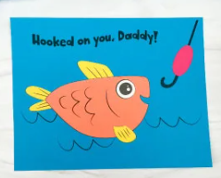
Materials Provided:
- Colored cardstock or construction paper
- Fish template

Additional Materials:
- Scissors
- Glue

Directions:
- Download the fish template, print, and cut out the pieces you need.
- Begin to create the fish by gluing the eye just to the left of the mouth.
- Take the top fin and glue it to the top and back of the fish.
- Next, take the side fin and glue it to the front and bottom of the fish, below the gills.
- Glue the tail fin to the end and back of the fish's body.
- Position the completed fish on the water background and glue it in place.
- Finish off by gluing the bobber between the hook and line of the fishing pole.

Warning: Please, be aware of small pieces that could present a choking hazard to people under 3 years of age.

Simple Everyday Mom

The Mermaid Puzzle/ Fish Puzzle
Cut out the picture circles and glue them to fill in the mermaid picture.
Source: CSLP 2022 SRP Manual
Tangram Pattern Block Sheets
Directions:
Attach shapes to the matching cut out on the paper.
Source: CSLP 2022 SRP Manual
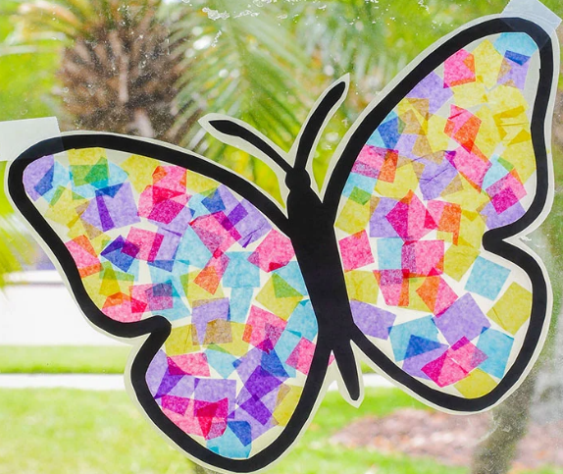
Butterfly Craft
Materials Provided:
Cutout of a butterfly body
Cut up tissue paper
Contact paper

Additional Materials:
Scissors
Washi Tape
Directions:
- Print out the butterfly outline or draw a butterfly outline on a piece of paper. Cut out the center of the butterfly outline.
- Cut a piece of contact paper a little larger than the butterfly and peel the backing off the sheet. Carefully press the butterfly paper to the contact paper and tape to a window or wall with the sticky side facing out.
- Cut tissue paper into small squares and decorate the sticky butterfly wings, overlapping each square to completely cover.
- Cut a second piece of contact paper, peel off the back and place on top of the butterfly, sticky side down. Cut around the butterfly and hang in the window.
Source: The Suburban Mom

Penguin Craft
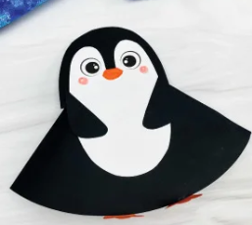
Materials Provided:
- Colored cardstock
- Penguin template
Additional Materials:
- Scissors
- Glue stick
- Markers

Directions:
- Download the penguin template, print, and cut out the pieces you need.
- Take the half circle penguin body and fold it in half. Line the open half with a thin strip of glue and glue the sides together. (Can use a stapler or tape.)
- Next, place the penguin's head at the top point of the body and glue it in place.
- Place the belly in the middle of the head and glue it to the head and the body.
- Use the markers to draw on the penguin's beak and cheeks.
- Position the flippers on either side of the belly, with the flippers pointing inward. Glue them in place.
- Take the feet and fold about 1/3 of the feet up. This little flap is where you will place the glue. Once the glue is on the small flap, open the bottom of the penguin and glue the flap to the inside portion of the front of the body.
- Now open up the base of the penguin so it stands on its own.

Source: Simple Everyday Mom

