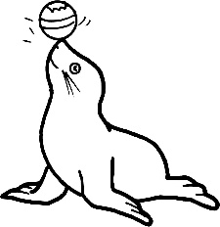
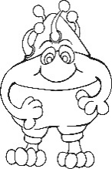
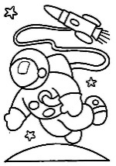
SRP Activity Log
Mark off up to 3 activities with
stickers, markers, pencil, or pen. Turn in your
Activity Log at the end of summer program.

NAME: __________________________________________________________________________

STEM Book I chose: _______________________________________________________________

Second Book I chose: ______________________________________________________________
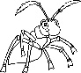  Read a Science, Technology, Engineering, Arts, and Math book. | Read a 2nd book.  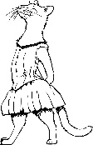  Make it fiction. | Read about Slime Science,  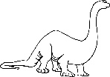  And make one slime experiment. | 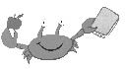  Attend a summer reading program at your local library. Online or in person.
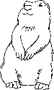  Make another Slime Science experiment. | Go glamping in your backyard or living room. Or have a family BBQ/ picnic. | Try growing a small herb, flower, or rock garden.  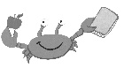 | Visit a museum, zoo, or planetarium. Online or in person.
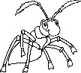  Choose your own animal-themed word, and write an acrostic poem. | 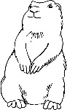  Read a 2nd book. Pick a biography about a Biologist or scientist. | 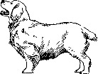  Take a nature walk. Make notes on what you experience around you. | Watch a science documentary about the animals.

