TEEN’S
2022 SUMMER READING PROGRAM

Includes:
Welcome to the Summer Reading Program, Suggested Reading List, and Program Instructions

State Library of Louisiana
Talking Books and Braille Library
701 North 4th Street
Baton Rouge, LA 70802

tbblkids@state.lib.la.us
1.800.543.4702 or 225.342.9563
WELCOME TO THE 2022
TBBL SUMMER READING PROGRAM

Welcome to the 2022 Summer Reading Program – Oceans of Possibilities. The items in this folder are yours to keep.

What do I need to do?
Read! Read! Read!
You should keep track of the titles of all the books and magazines you read beginning May 30, when the program officially starts. You can use the provided reading logs or any piece of paper to do this. The program ends August 30. This is the last day to turn in your reading log. You may always email your list of books to tbblkids@state.lib.la.us, fax your list to 225.342.6817, or call the library toll-free at 800.543.4702 or call 225. 342.9563.

What do I earn?!
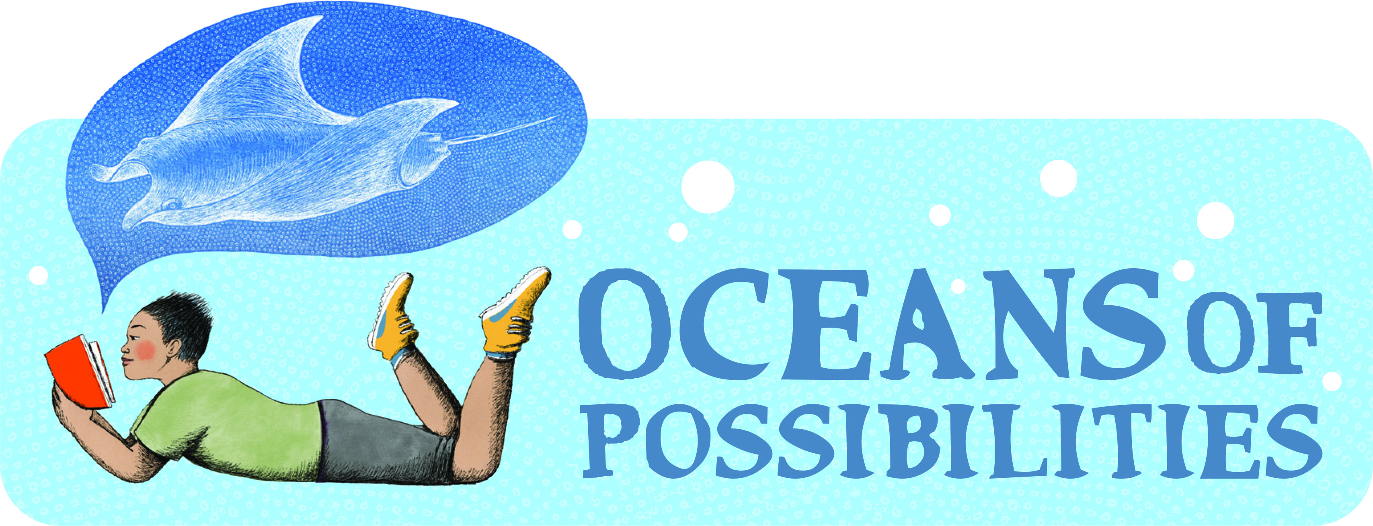
Participants may earn a sky blue “Oceans of Possibilities” T-shirt and other items just by reading books and returning your reading log by August 30.

How many books do I have to read?
For readers participating in the Teen’s Program (for readers in middle or high school), we have set the minimum goal at two books.

Do I have to read books from this reading list?
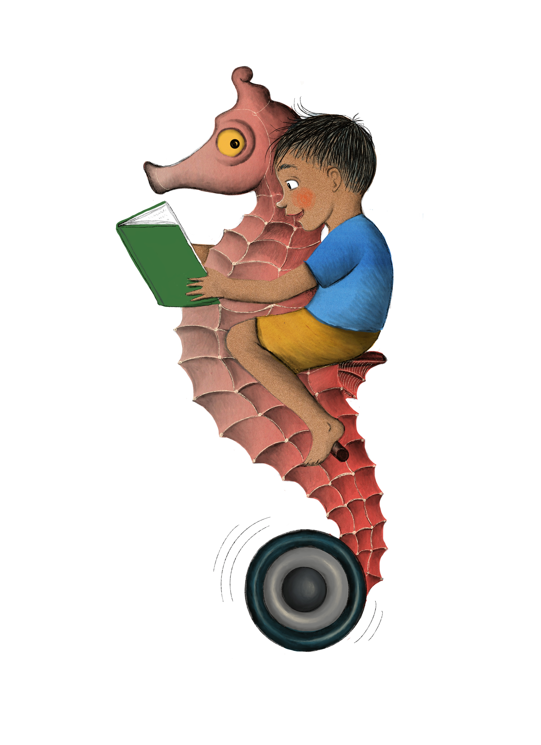
No, this is only a suggested list to give you ideas. You may read anything you want from our library, your public library, or from home. This includes audiobooks, Braille, print books, magazines, and newspapers. Also, if you have a required reading list for school this summer, please let us know so we can send you what you need. Your required summer reading books can count toward your reading goals. Contact the TBBL if you would like more reading ideas. We would be happy to help you.
Do I have to write a book report?
No, just make sure to fill out your Reading Log, and

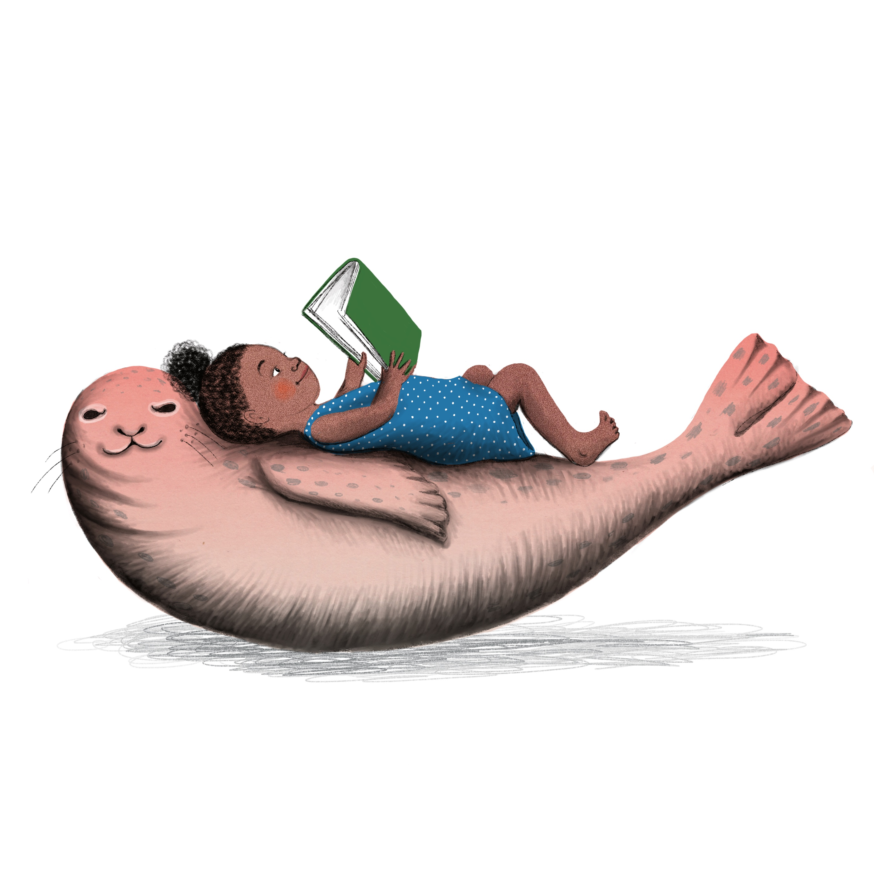
Have Fun!!

If you have any questions about Library services, downloading, or playing digital books, contact TBBL at 800.543.4702.

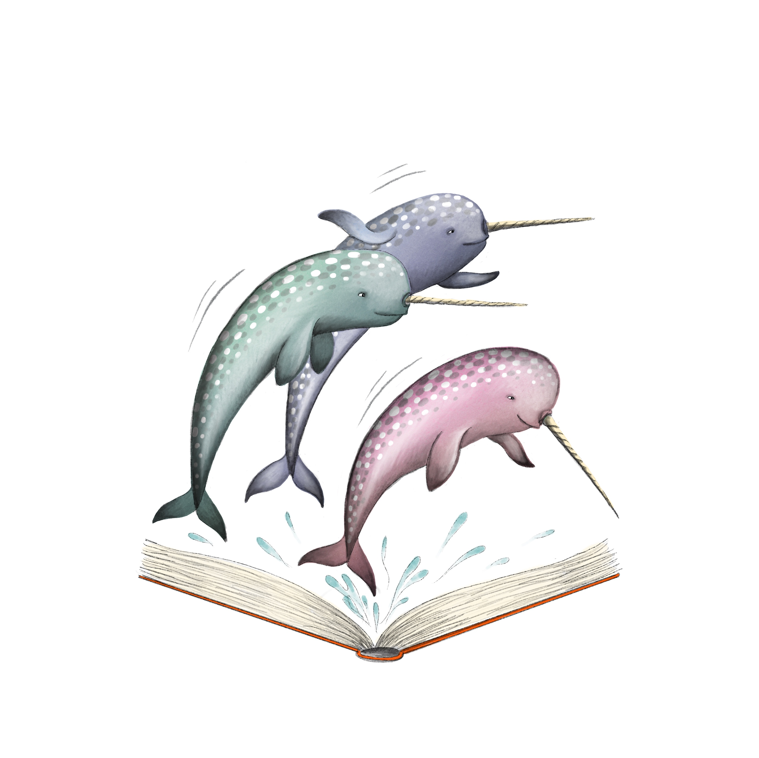
SUGGESTED READING

Format notes:
DB & DBC = Digital Audio Book
BR & BRA = Braille Book
LP = Large Print Book
BARD = All Audiobooks are available for Digital Audio Download.

Shark Week!!

Water wonders of the world by Janet Nuzum Myers
BRC01013
Discusses topics that grab our attention, including the killer waves of tsunamis, great white sharks, blood-sucking leeches, sunken treasure ships, mermaids, the Loch Ness Monster, and giant squids. Some wonders we know are real, and others debated, but all are fascinating. 2006. Gr. 4-7.

Swimming with sharks by Twig C. George
DB51538
Read by Nancy German. Time: 1 hrs, 57 min.
Ten-year-old Sarah thinks she will be incredibly bored spending the summer at her grandparents' Florida Keys home--until she discovers a baby shark. Sarah turns to her grandfather, a recently retired marine biologist, for help. 1999. Gr. 4-7.

The great white shark scientist by Sy Montgomery
DB85863
Read by Marsha Rehns. Reading time: 2 hrs, 18 min.
Follows Dr. Greg Skomal as he studies the habits and habitats of great whites in order to save this amazing and misunderstood creature. 2016. Gr. 5-8.

Shark life by Karen Wojtyla and Peter Benchley
DB60894
Read by Erik Synnestvedt. Time: 4 hrs, 42 min.
Author of Jaws relates his sea diving adventures and close encounters with sharks. Companion book to Shark trouble (LP15447). 2005. Gr. 5-8.

Here there be monsters by H.P. Newquist
DB72615
Read by L.J. Ganser. Time: 2 hrs, 15 min.
Traces human knowledge of enormous squids from Greek myth and sailor's tales to Melville and Verne's literary works and scientific evidence slowly gathered from around the world. 2010. Gr. 5-8.

Soul Surfer by Bethany Hamilton
BR19783, DB59485,
Read by Michele Schaeffer. Reading time: 3 hours, 1 minute.
Autobiography of a Hawaiian junior-champion surfer who lost an arm in a shark attack when she was thirteen. Gr. 6-9.

The Devil’s teeth by Susan Casey
BR17567, DB67002
Read by Martha Harmon Pardee. Time: 11 hrs, 6 min.
Account of the author's journey to the Farallon Islands, twenty-seven miles from San Francisco, a renowned refuge of great white sharks. Casey relates joining scientists as they studied the predators in their natural habitat. Some strong language. 2005. Gr. 6-9.

The soul of an octopus by Sy Montgomery
BR21140, DB82438
Read by Kimberly Schraf. Time: 10 hrs, 38 min.
Naturalist explores the world, intelligence, and consciousness of octopuses. Describes her interactions with captive giant Pacific octopuses at the New England Aquarium in Boston, and her field investigations. 2015. YAI.

Monsters of the sea by Richard Ellis
DB42471
Read by Gary Telles. Time: 18 hrs, 46 min.
A cryptozoologist, who studies the reported existence of unknown creatures, provides an analysis of some of the terrifying "monsters" people throughout history have believed to live in the sea. Ellis also discusses the need to protect and preserve the creatures of the sea. 1994. YAI.
Our Blue Planet- Oceanography and Conservation
Diving to a deep-sea volcano by Kenneth Mallory.
DB63835
Read by Alexander Strain. Reading time: 1 hr, 48 min.
Discusses the first discoveries of prolific life-forms surrounding hydrothermal vents and the scientists who made the dives one and one-half miles below the surface of the Pacific Ocean. 2006. Gr. 4-7.

Where am I? by AG Smith
BR11859, DB47623
Read by Norm Thibeault. Time: 1 hrs, 28 min.
A history of how people learned to identify their physical location in the world. Traces the development of maps and navigational skills, the discovery of the compass, and the use of satellites. 1997. Gr. 5-8.

Back from the Brink by Nancy F. Castaldo
BR23068, DB99361
Read by Mark Ashby. Reading time: 3 hrs, 51 min.
Notable nature author explores the scientific and political efforts to coax seven endangered animal species back from the brink of extinction. 2018. Gr. 5-8.

Frozen secrets: Antarctica revealed by Sally M. Walker
DB72915
Read by Nona Pipes. Time: 4 hrs, 15 min.
Describes exploration of the icy South Pole continent. Discusses researchers' methods of mapping the terrain, scuba diving, using underwater robots, retrieving fossils, and collecting ice core samples to analyze data about the Antarctic Ice Sheet. 2010. Gr. 5-8.

Rising water by Marc Aronson
DB94347
Read by Vikas Adam. Time: 2 hrs, 55 min.
Recounts the incredible true story of twelve boys trapped with their soccer coach in a flooded cave in Thailand and their inspiring rescue. 2019. Gr. 6-9.

Plasticus maritimus: An invasive species by Ana Pego
DB103937
Read by Margaret Strom. Time: 3hrs, 16 min.
A marine biologist explains how plastic is made, offers a field guide to help young people identify the Plasticus maritimus species, and takes a critical look at our current "solutions" to plastic contamination in the oceans. 2020. Gr. 6-9.

The sea around us by Rachel Carson
BR15487, DB18521, LP0191
Read by Phil Regensdorf. Time: 10 hrs, 21 min.
Eminent marine biologist, writer, and ecologist reveals the science and poetry of the world's oceans from their primeval beginnings billions of years ago to humankind's modern explorations. 1961. YAI.

Generation Green by Linda and Tosh Sivertsen
DB69820
Read by Margaret Strom. Time: 8 hrs, 8 min.
Authors provide examples for others wanting to adopt an eco-friendly lifestyle. They suggest using the five Rs--reduce, reuse, recycle, rethink, and refuse. Also include tips on greener pet care, beauty products, and school supplies. 2008. YAI.

Take the Mic by Jason Reynolds and Samira Ahmed
DB104677
Read by Colleen Delaney. Time: 5 hrs, 17 min.
Collection of stories, poems, and a comic strip featuring youth resistance and empowerment. Includes works by Jason Reynolds, Samira Ahmed, Laura Silverman, Sofia Quintero, and more. Some strong language. 2019. YAI.

Discover Treasure- Pirates, Vikings, and Treasure
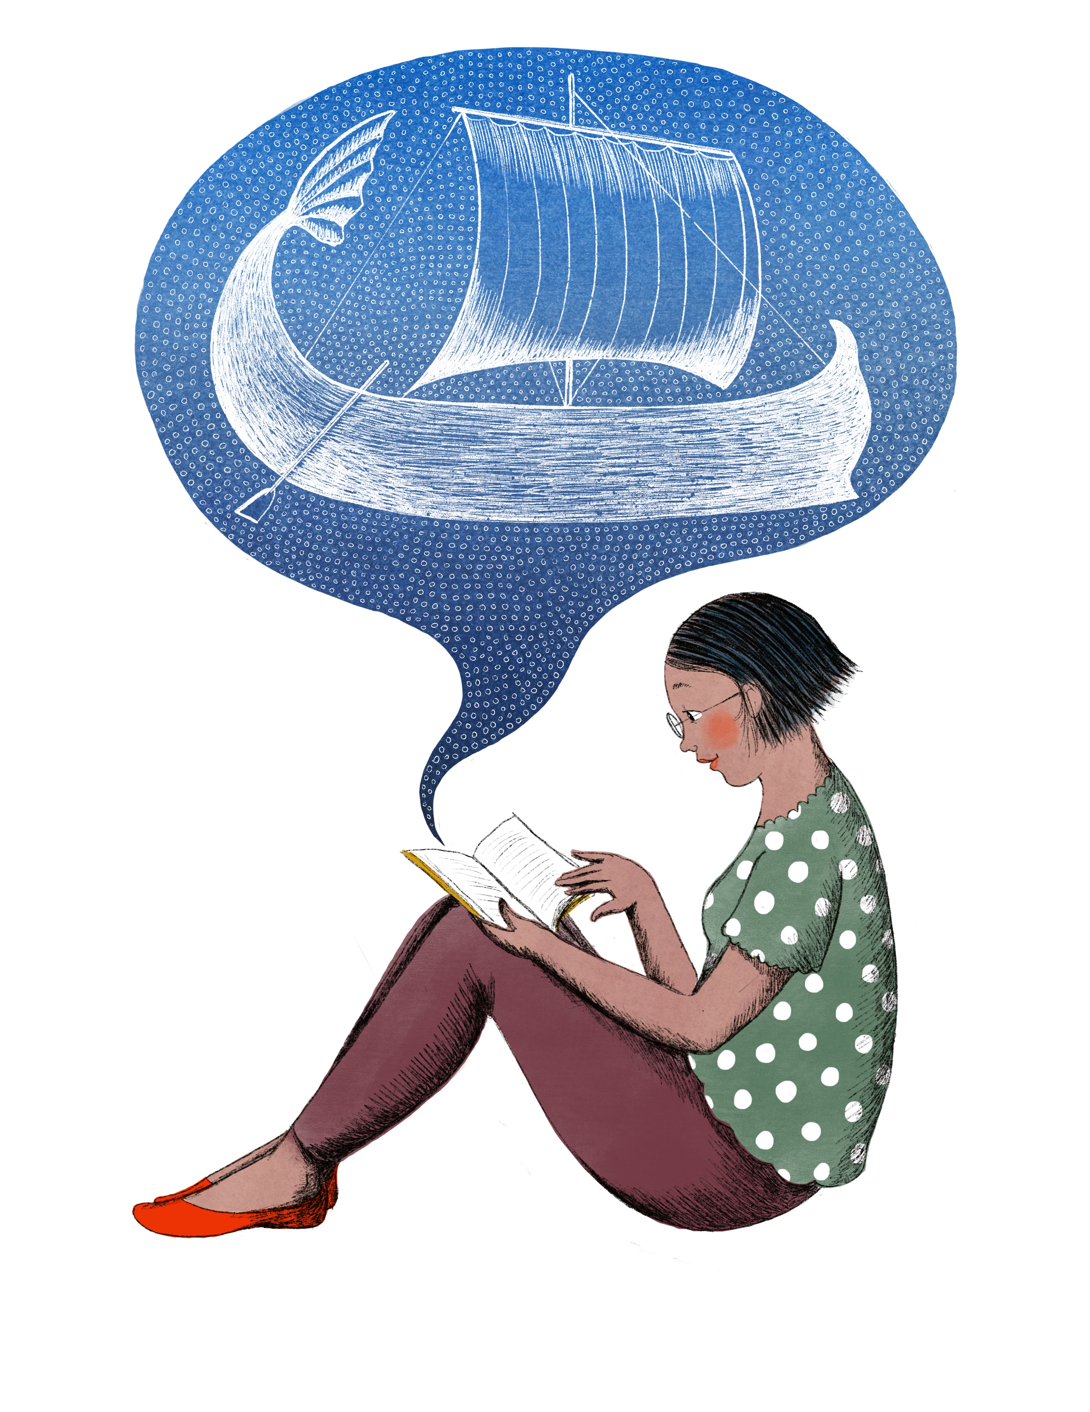

Peter Pan by JM Barrie
BR15663, DB59430, LP17514
Read by Conrad Feininger. Time: 4 hrs, 15 min.
Classic about the Neverland adventures of Wendy, John, and Michael Darling with Peter, the boy who refuses to grow up. 1911. Gr. 4-7.

The Whydah: A pirate ship feared, wrecked, and found by Martin W. Sandler
BR21982, DB88088
Read by Bob Moore. Time: 3 hrs, 37 min.
In 1984, the pirate ship the Whydah was discovered nearly three hundred years after it sank in a storm off the coast of Cape Cod in 1717. 2017. Gr. 5-8.

Treasure Island by Robert Louis Stevenson
BR13682, LP02575, DB52436
Read by Erik Sandvold. Time: 7 hrs, 38 min.
Young Jim Hawkins finds a map in a dead seaman's possessions. His friends realize it's a treasure map. They hire a ship, unaware that the crew includes the pirate Long John Silver. 1881. Gr. 5-8.

Flush by Carl Hiaasen
BR17107, DB60792, LP19177
Read by Erik Sandvold. Time: 7 hrs, 23 min.
When their father is jailed for sinking a gambling boat, Noah Underwood and his sister Abbey gather evidence that casino owner Dusty Muleman is illegally emptying sewage tanks into the coastal waters off the Florida Keys. They receive help from a former card dealer, a pirate, and Dusty's ex-girlfriend. 2005. GR. 5-8.

Pirates!: The true and remarkable adventures of Minerva Sharpe and Nancy Kington, female pirates by Celia Rees
BR15430, LP16666
In 1722 sixteen-year-old Nancy Kington arrives at her family's Jamaican plantation to be married off to Bartholome. To escape her fate she runs away with her slave friend, Minerva Sharpe, and together they become pirates. 2003. Gr. 6-9.

Percy Jackson and the Olympians series by Rick Riordan
Read by Erik Sandvold. Series read time: 52 hrs, 7 min.
Written between 2005-2009. Middle school student, Percy Jackson discovers his father is the Greek god Poseidon. He attends Camp Half-blood and makes friends with other demi-gods, but soon Percy and his friends are called on to fulfill a dangerous prophecy and protect New York from the evil Kronos. Grades 6-9.
BR20213, DB63443, LP19310 #1: The Lightning Thief; BR20243, DB64659, LP19877 #2: The Sea of Monsters; BR20285, DB65245, LP20848 #3: The Titan’s Curse; BR21573, DB67158, LP22160 #4: The Battle of the Labyrinth; BR21612, DB69015, LP23231 #5: The Last Olympian

Pirate hunters by Robert Kurson
BR21111, DB81865
Read by Ray Porter. Time: 8 hrs, 26 min.
Chronicles the story of John Chatterton (born 1951) and John Mattera (born 1962) and their search for the Golden Fleece, a pirate ship sunk off the coast of the Dominican Republic in the 1680s. Strong language. 2015. Gr. 6-9.

Stardust by Neil Gaiman
BR20931, DB49777, LP12913
Read by George Holmes. Time: 6 hrs, 45 min.
Tristran Thorn promises to retrieve a fallen star and embarks on an arduous quest in an enchanted forest inhabited by faeries. Some violence. 1999. YAI.

Survive the savage sea by Dougal Robertson
DB58667, LP01200
Read by Jack Fox. Time: 7 hrs, 33 min.
Author relates his family's nightmare of trying to survive after killer whales attacked and sank their forty-three-foot schooner in the Pacific Ocean. 1973. YAI.

An Ocean of Wonder- Animals Living in the Ocean

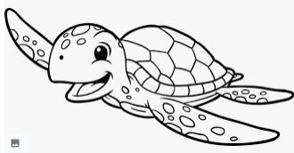
Song for a whale by Lynne Kelly
BR22668, DB94077, LP26836
Read by author. Time: 6 hrs, 37 min.
Twelve-year-old Iris and her grandmother, who are both deaf, drive from Texas to Alaska armed with Iris's plan to help Blue 55, a whale unable to communicate with other whales. 2019. Gr. 4-7.

Under the sea wind by Rachel Carson
BRJ01641, DB35033
Read by Miriam Wagner. Time: 7 hrs, 6 min.
This classic describes a portion of North Carolina's coast through the life history and adventures of Scomber, a mackerel; and Anguilla, an eel. 1941. Gr. 5-8.

Spindlefish and stars by Christiane M. Andrews
DB101054, LP26821
Read by Vanessa Johansson. Time: 9 hrs, 35 min.
Clo ends up stranded on a strange island and must learn to spin fish into yarn to unravel the secret of her missing father. 2020. Gr. 5-8.

Journey of the pink dolphins by Sy Montgomery
DB51514
Read by Ray Childs. Time: 10 hrs, 6 min.
Naturalist recounts searching the confluence of rivers near Manaus, Brazil, for pink dolphin--an elusive freshwater species. 2000. Gr. 6-9.

Coral reefs by Charles Sheppard
DB85698
Read by Stephen Van Doren. Time: 4 hrs, 37 min.
Explains the complex biology and geology of corals and reefs. 2014. Gr. 6-9.

Mystery of the Mammoth Bones & How it was Solved by James Giblin
DB49234
Read by Anne Hancock. Reading time: 2 hrs, 2 min.
An account of the discovery of the first mastodon skeletons and their exhibit in Philadelphia in 1801. 1999. Gr. 6-9.

Voices in the ocean: A journey into the wild and haunting world of dolphins by Susan Casey
DB82327
Read by Cassandra Campbell. Time: 11 hrs, 29 min.
Recounts author's two-year global adventure exploring the nature of dolphins and their interactions with humans. Unrated. 2010. YAI.

The old man and the sea by Ernest Hemingway
BR10599, DB53792, LP8365
Read by Rick Wiseman. Time: 2 hrs, 36 min.
Pulitzer Prize winning classic tale of the old Cuban fisherman Santiago and his days-long struggle with a magnificent marlin on open water in a frail skiff. 1952. YAI.

The Meg by Steve Alten and Jon Huffman
DB44838
Read by Ray Foushee. Time: 8 hrs, 7 min.
Professor Jonas Taylor theorizes that the Carcharodon megalodon, a great white shark that thrived seventy million years ago and could devour a Tyrannosaurus rex, may still exist beneath the sea. Some violence and some strong language. 1997. YAI.

Uncharted- Sea Monsters and Undersea Mysteries

Tales of the cryptids by Kelly Milner Halls
DBC17061
Read by Danielle king. Time: 2 hrs, 49 min.
The author reveals various legends about mysterious creatures from all over the world, and reports any evidence found to support their actual existence. 2006. Gr. 4-7.

Monsters of Pennsylvania by Patty A. Wilson
DBC08550
Read by Alan James. Time: 3 hrs, 50 min.
Pennsylvania is home to an assortment of odd creatures, including Lake Erie's resident monster. 2010. Gr. 5-8.

Theseus by Geraldine McCaughrean
DB63328
Read by Peter Lavezzoli. Time: 2 hrs, 46 min.
Seventeen-year-old Theseus discovers that his father is a mighty king and sets out to meet him. On the way to Athens, Theseus angers the sea god Poseidon and faces the Minotaur. 2005. Gr. 5-8.

The Seven Wonders series by Peter Lerangis
Read by Alec Volz. Series read time: 42 hrs, 30 min.
Written between 2013-2016. Jack, Marco, Aly, and Cass have genetic abnormalities that give them special abilities--and will kill them unless treated. To create the cure, the teens must retrieve seven artifacts that hold the power of ancient Atlantis. Gr. 5-8.
DB76155 The Colossus rises; DB78035 Lost in Babylon; DB81562 The tomb of shadows; DB81562 The curse of the king; DB84121 The legend of the rift

Norse Mythology by Neil Gaiman
BR21814, DB87395
Read by George Holmes. Time: 6 hrs, 35 min.
Stories from Norse mythology. 2018. Gr. 6-9.

Mermaid and other water spirit tales from around the world by Heidi Anne Heiner
DB81731
Read by Catherine Byers. Time: 41 hrs, 11 min.
Collection of 150 folktales, fairy tales, and ballads from around the world about mermaids and other water spirits. Violence. 2011. Gr. 6-9.

Lake monsters of Wisconsin by Chad Lewis
DBC08237
Read by Ceri Hartnett. Time: 4 hrs, 35 min.
Author claims that Wisconsin is the Lake Monster Capital of the Americas and provides documentation on the many "sea serpent" sightings in Wisconsin. 2016. Gr. 6-9.

The shape of water by Guillermo del Toro
DB90389
Read by Jenna Lamia. Time: 13 hrs, 30 min.
A mute young woman with a mysterious past befriends an amphibious man held captive at the Baltimore research facility where she works as a janitor. Unrated. 2018. YAI.

Monsters of Wisconsin by Linda S. Godfrey
DBC08307
Read by Barbara Nevers. Time: 5 hrs, 25 min.
The Wisconsin author chronicles the most daunting and bizarre sighting reports like the flying lizard men, the Rock River monster, and other lesser-known beasts in the Badger State. 2011. YAI.

Explore New Depths

The lighthouse mystery by Gertrude Chandler Warner and David Cunningham
BRC01133, DB17038
Read by Elaine Hoffman. Time 1 hrs, 47 min.
The Alden children are delighted when their grandfather agrees to rent a lighthouse for the summer. Night visits by an intruder and an unfriendly neighbor add unexpected danger to the holiday. 1963. Gr. 4-7.

Secrets of a Civil War Submarine by Sally M. Walker
DB61080
Read by Ted Stoddard. Time: 2 hrs, 58 min.
Recounts the history of the Confederate submarine, H.L. Hunley. In 1864, it became the first submarine to sink a ship but then seemingly vanished. Chronicles the search for the wreckage, its 1995 discovery, and efforts to determine the wreck's cause and the crew's fate. 2005. Gr. 5-8.

The voyage of the Dawn Treader by C.S. Lewis
BR13948, DB16985, LP11987, LP04678
Read by Milton Metz. Reading time: 4 hrs, 34 min.
The adventure of two boys and their sister aboard a magic ship with Prince Caspian, Fifth title in "The Chronicles of Narnia" (DB050083). 1952. Gr. 5-8.

Dive! By Deborah Hopkinson
DB86181
Read by Richard Davidson. Reading time: 9 hrs, 22 min.
Recounts the story and events of America's little-known submarine warfare, also known as "silent service," in the Pacific during World War II. 2016. Gr. 6-9.

20,000 Leagues under the Sea by Jules Verne
BR09469, BRA09257, DB13748, DB57020, LP09446
Read by Hal Tenny, Fred Major. Reading time: 15 hours, 42 minutes.
Written in 1869, this science fiction novel is almost prophetic in its account of the first submarine, "Nautilus," whose skipper, Captain Nemo, is a mad genius. 1962. Gr. 6-9.

Jason and the Argonauts by Apollonius.
BR020691, DB080796.
Read by Mark Ashby. Time: 8 hrs, 2 min.
Translation in verse of Ancient Greek poem detailing the voyage of the hero Jason and his crew, the Argonauts--including Heracles and Orpheus, as they search for the Golden Fleece at the directive of King Pelias. They encounter treachery of all kinds, both from mortal and immortal foes. Some violence. Gr. 6-9.

In the waves: My quest to solve the mystery of a civil war submarine by Rachel Lance
DB99877
Read by Rebecca Lowman. Time: 10 hrs, 1 min.
The author recounts her investigation of the mysterious wreck of Confederate submarine HL Hunley. Thought to have been sunk by an explosion, the raised vessel revealed no sign of the blast. She presents her theory on the true cause of the submarine's demise. Unrated. 2020. YAI.

The bravest man by William Tuohy
DB65132
Read by Margaret Strom. Time: 17 hrs, 31 min.
Recounts the sinking of the submarine Tang after a defective torpedo hits it. Focuses on the experience of the ship’s skipper Richard O'Kane and the surviving crew after the accident. 2001. YAI.

The mysterious island by Jules Verne
BR12761, BR10097, DB56680
Read by Geoffrey Centi Centlivre. Time: 28 hrs, 20 min.
During the Civil War, engineer Cyrus Smith escapes a prison by hot-air balloon with four other prisoners, and a dog. A storm blows them to an island, where mysterious events and resourcefulness help them survive the next four years. Sequel to Twenty Thousand Leagues under the Sea (BR09469, DB57020, LP09446). 1874. YAI.

Seven Seas, Infinite Stories
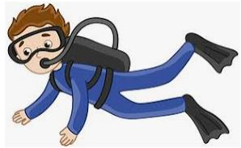

Call it courage by Armstrong Sperry.
BR009146, DB022825, LP010748.
Read by Harold Parker. Time: 2 hrs, 19 min.
Relates how Mafatu, a young Polynesian boy whose name means Stout Heart, overcomes his terrible fear of the sea and proves his courage. 1968. Gr 4-7.

Hide and seek by Katy Grant
BR19621, DBC05781
Read by Dwight Brahs. Time: 6 hrs, 25 min.
While geocaching in the mountains of Greer, Arizona for a hidden container, fourteen-year-old Chase finds a mysterious note from people claiming they are in danger and need help. 2010. Gr. 5-8.

Aquarium beautiful by A. van den Nieuwenhuizen
DB51646
Read by Gary Tipton.
Discusses creating Dutch aquariums, which emphasize plants more than fish. Discusses various types of aquariums, necessary equipment and proper locations for each. Also explains how to select plants and types of fish. 1997. Gr. 6-9.

Dungeons and Dragons player’s handbook, 5th edition by Greg Bilsland
DB91838
Read by Mark Ashby. Time: 27 hrs, 34 min.
Essential reference guide for fans of Dungeons and Dragons role-playing games. Contains rules for creating and equipping characters, exploration, combat, spellcasting, and more. 2014. Gr. 6-9.

Soul lanterns by Shaw Kuzki and Emily Balistrieri
BR24125, DB107621
Twelve-year-old Nozomi’s understanding of the bombing of Hiroshima in 1945 is transformed when she learns how those she knows and loves were affected by the event. Translated from the 2013 Japanese edition. 2021. Gr. 6-9.

Loos, Poos, and Number Twos: A Disgusting Journey through the Bowels of History! By Petr Hepplewhite
DB84205
Read by Mike Stefanelli. Reading time: 52 minutes.
Overview of the history of excrement, from prehistoric times to how human waste could fertilize our crops in the future. 2016. Gr. 6-9.

The worst-case scenario survival handbook by Joshua Piven
DB50515
Read by Barry Bernson. Time: 2 hrs, 26 min.
Techniques and planning for survival in emergencies. Basic rules include being mentally and physically prepared, having access to proper equipment, and refusing to panic. Covers medical crises, natural disasters, attacks by wild animals, and dangers that require fast escapes. 1999. YAI.

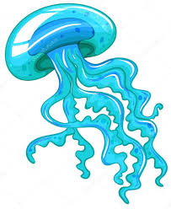

CONTACT INFORMATION
TELEPHONE
In-state toll-free 1.800.543.4702
Baton Rouge 225.342.9563
Utah (Braille) 1.800.453.4293
EMAIL TBBL tbblkids@state.lib.la.us
Utah blind@utah.gov
FAX 225.342.6817
ADDRESS State Library of Louisiana
Talking Books and Braille Library
P.O. Box 131
Baton Rouge, LA 70821
WEB ADDRESSES
TBBL http://www.state.lib.la.us/
Utah http://blindlibrary.utah.gov/
NLS http://www.loc.gov/nls/

