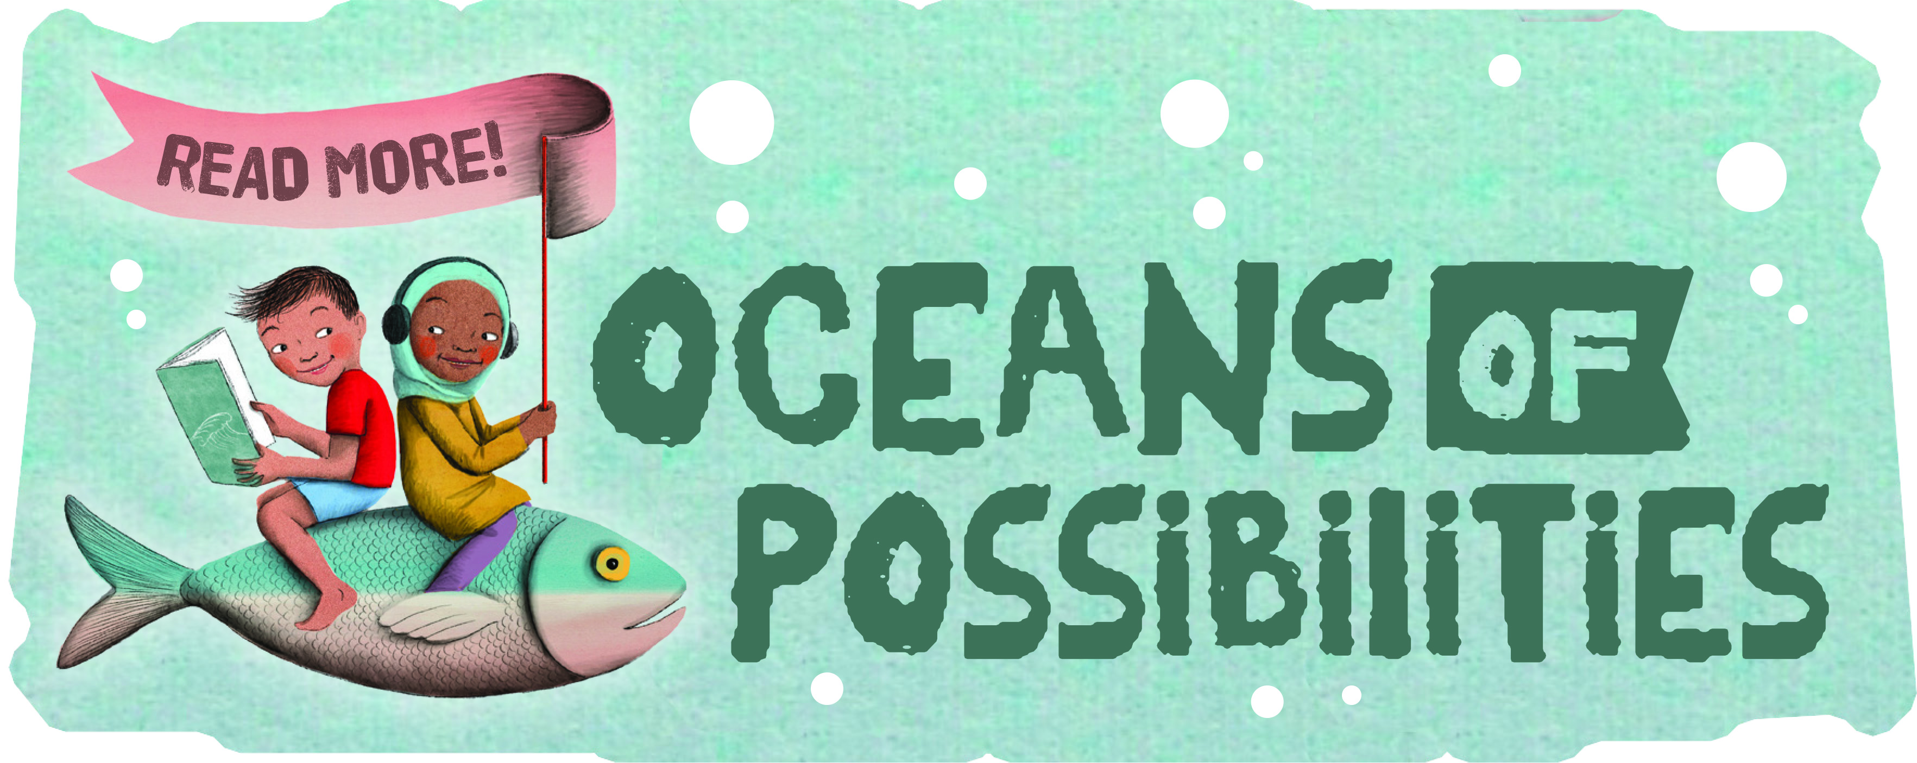
CHILDREN’S
2022 SUMMER READING PROGRAM

Includes:
Welcome to the Summer Reading Program, Suggested Reading List, and Program Instructions

State Library of Louisiana
Talking Books and Braille Library
701 North 4th Street
Baton Rouge, LA 70802

tbblkids@state.lib.la.us
1.800.543.4702 or 225.342.9563
WELCOME TO THE 2022
TBBL SUMMER READING PROGRAM

Welcome to the 2022 Summer Reading Program – Oceans of Possibilities. The items in this folder are yours to keep.

What do I need to do?
Read! Read! Read!
You should keep track of the titles of all the books and magazines you read beginning May 30, when the program officially starts. You can use the provided reading logs or any piece of paper to do this. The program ends August 30. This is the last day to turn in your reading log. You may always email your list of books to tbblkids@state.lib.la.us, fax your list to 225.342.6817, or call the library toll-free at 800.543.4702 or call 225. 342.9563.

What do I earn?!
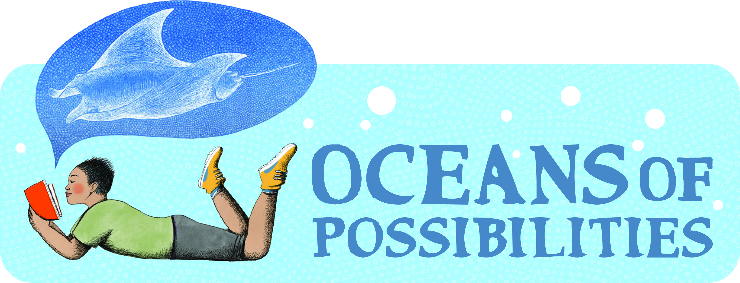
Participants may earn a sky blue “Oceans of Possibilities” T-shirt and other items just by reading books and returning your reading log by August 30.
How many books do I have to read?
For readers participating in the Children’s Program (for readers in elementary or middle school), we have set the minimum goal at six books.

Do I have to read books from this reading list?
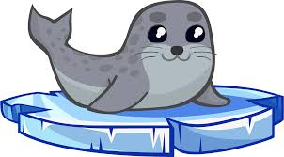
No, this is only a suggested list to give you ideas. You may read anything you want from our library, your public library, or from home. This includes audiobooks, Braille, print books, magazines, and newspapers. Also, if you have a required reading list for school this summer, please let us know so we can send you what you need. Your required summer reading books can count toward your reading goals. Contact the TBBL if you would like more reading ideas. We would be happy to help you.
Do I have to write a book report?
No, just make sure to fill out your Reading Log, and

Have Fun!!

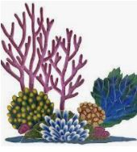
If you have any questions about Library services, downloading, or playing digital books, contact TBBL at 800.543.4702.

SUGGESTED READING

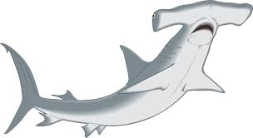
Format notes:
DB & DBC = Digital Audio Book
BR & BRA = Braille Book
LP = Large Print Book
BARD = All Audiobooks are available for Digital Audio Download.

Shark Week!!

Are you smarter than a shark? by David George Gordon
DB107557
Sharks have their own way of thinking and it makes them one of the top predators in the ocean. Five “test Your Shark Smarts” activities let you test your senses against a shark’s. 2021. Gr. 2-4.

Neighborhood sharks by Katherine Roy
DB80358
Read by Gregory Maupin. Time: 28 min.
Discusses the ocean's most fearsome and famous predator, the great white shark, and the scientists who study them. 2014. Gr. 3-6.

The great shark mystery by Gertrude Chandler Warner
DB59688
Read by Miriam Wagner. Time: 2 hrs, 1 min.
The Alden children travel to Ocean Adventure Park in Florida to swim with the dolphins, see sharks, and solve a mystery. 2003. Gr. 3-6.

Giant squid by Candace Fleming and Eric Rohmann
DB87387
Read by Jeremy Gage. Time: 22 min.
Explores the mysterious life and anatomy of the elusive giant squid. 2016. Gr. 3-6.

Water wonders of the world by Janet Nuzum Myers
BRC01013
Discusses topics that grab our attention, including the killer waves of tsunamis, great white sharks, blood-sucking leeches, sunken treasure ships, mermaids, the Loch Ness Monster, and giant squids. 2006. Gr. 4-7.

Swimming with sharks by Twig C. George
DB51538
Read by Nancy German. Time: 1 hrs, 57 min.
Ten-year-old Sarah thinks she will be incredibly bored spending the summer at her grandparents' Florida Keys home--until she discovers a baby shark. Sarah turns to her grandfather, a recently retired marine biologist, for help. 1999. Gr. 4-7.

Fossil fish alive by Sally M. Walker
DB56423
Read by Gary Telles. Time: 2 hrs, 47 min.
Describes excitement when a specimen of fish thought to be extinct was discovered off the South African coast in 1938. 2002. Gr. 4-7.

The great white shark scientist by Sy Montgomery
DB85863
Read by Marsha Rehns. Reading time: 2 hrs, 18 min.
Follows Dr. Greg Skomal, great white shark biologist as he studies the habits and habitats of great whites. 2016. Gr. 5-8.

Shark life by Karen Wojtyla and Peter Benchley
DB60894
Read by Erik Synnestvedt. Time: 4 hrs, 42 min.
Author of Jaws relates his sea diving adventures and close encounters with sharks. Companion book to Shark trouble (LP15447). 2005. Gr. 5-8.

Soul Surfer by Bethany Hamilton
BR19783, DB59485,
Read by Michele Schaeffer. Reading time: 3 hours, 1 minute.
Autobiography of a Hawaiian junior-champion surfer who lost an arm in a shark attack when she was thirteen. 2004. Gr. 6-9.

Our Blue Planet- Oceanography and Conservation

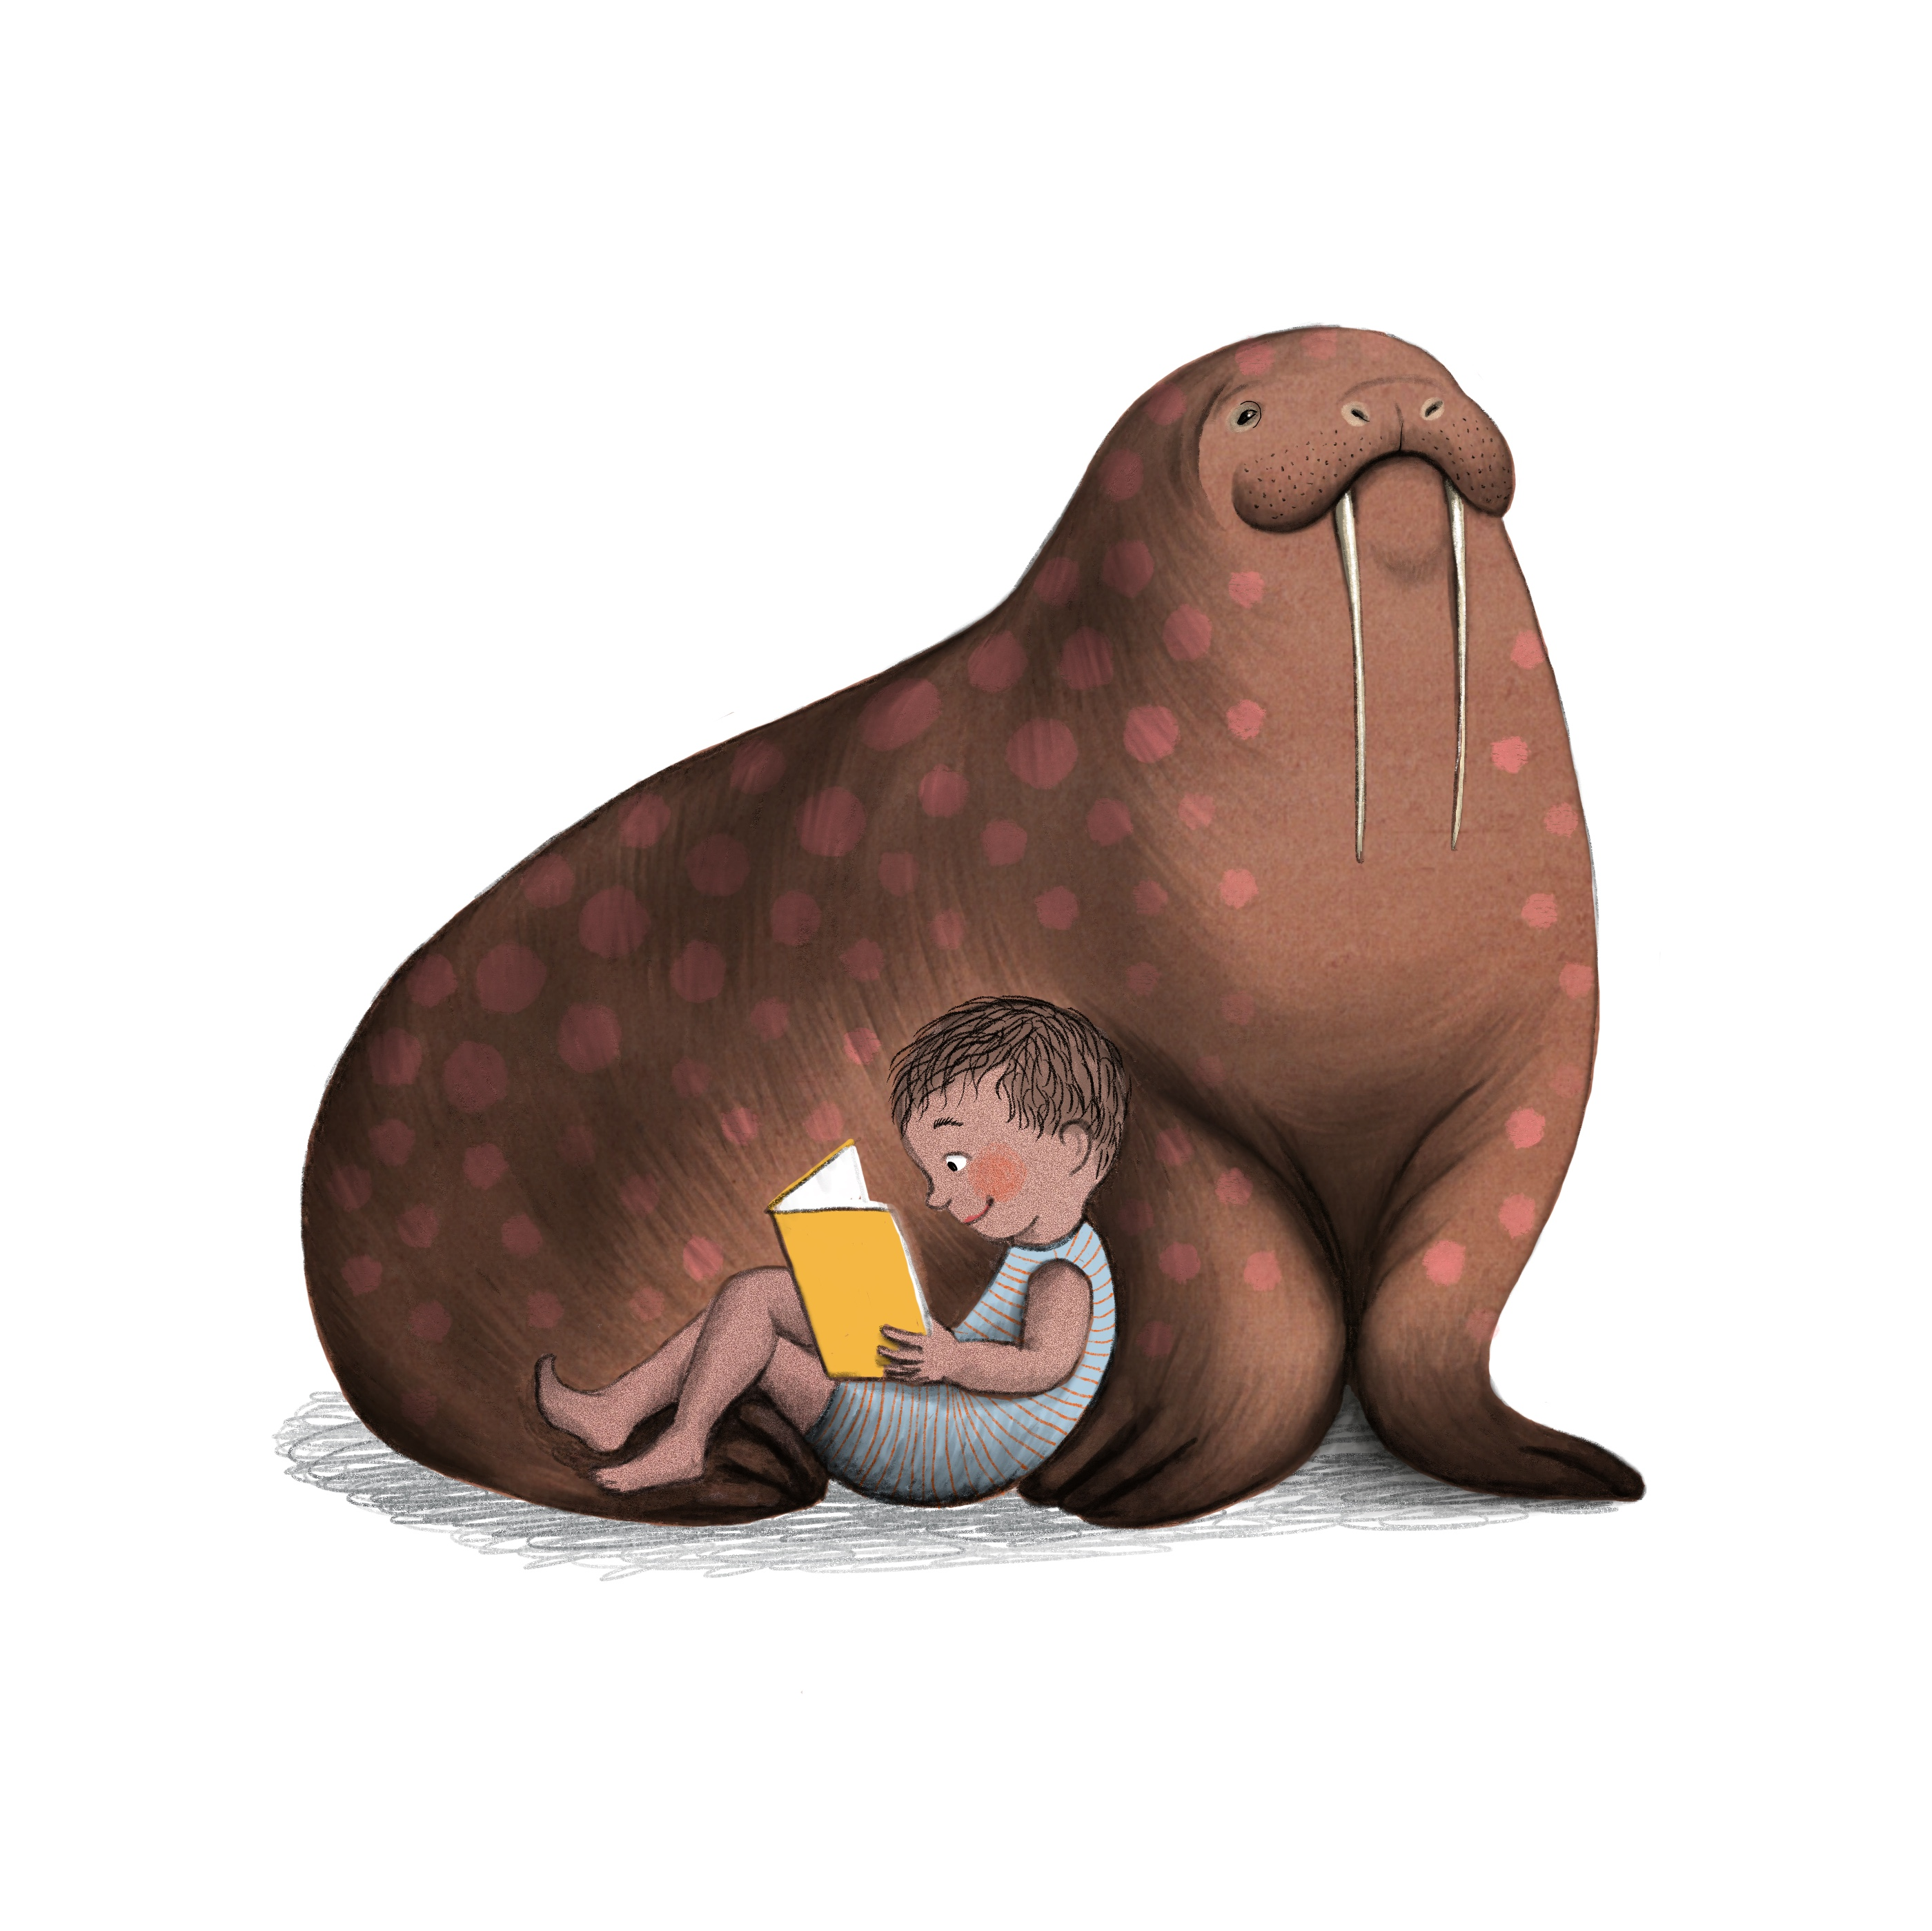
Otis and Will discover the deep by Barb Rosenstock
DB93180
Read by Jeff Allin. Time: 28 min.
Relates engineer Otis Barton and naturalist Will Beebe's record-setting descent into the deep ocean in their Bathysphere craft. The scientists were the first humans to witness deep-sea creatures in their natural habitat. 2018. Gr. 2-4.

Island: A story of the Galápagos by Jason Chin
DB79701
Read by Mary Kane. Time: 21 minutes.
Biography of a Galápagos island--from birth, through adolescence, to adulthood and beyond. Discusses how the island is a home to plants and animals that exist nowhere else on Earth. 2012. Gr. 3-6.

Olivia’s birds: Saving the Gulf by Olivia Bouler
DB75436
Read by Faith Potts. Time: 25 min.
Eleven-year-old author, who sold her bird paintings to raise money for the Audubon Society's Gulf Coast oil spill recovery efforts, offers a guide to backyard and endangered fowl. Covers fierce, weird, and wacky birds. Includes tips on saving birds and the environment. 2011. Gr. 3-6.

Diving to a deep-sea volcano by Kenneth Mallory.
DB63835
Read by Alexander Strain. Reading time: 1 hr, 48 min.
Discusses the first discoveries of prolific life forms surrounding hydrothermal vents and the scientists who made dives in the Alvin miniature submarine one and one-half miles below the surface of the Pacific Ocean. Describes large tubeworms, giant clams and other organisms. 2006. Gr. 4-7.

This book is not garbage by Isabel Thomas
BR23771, DB103573
Read by Margaret Strom. Time: 2 hrs, 41 min.
A guide for kids to make more eco-friendly decisions in their everyday lives. From creating an eco-squad at school to clothes-swapping parties to cultivating a wild section of your yard, each idea contains easy instructions. 2018. Gr. 4-7.

Where am I? by AG Smith
BR11859, DB47623
Read by Norm Thibeault. Time: 1 hrs, 28 min.
A history of how people learned to identify their physical location in the world. Traces the history of making maps originally traced on birch bark to the modern techniques of aerial photography. Follows the development of navigational skills, discovery of the compass, and modern satellites. 1997. Gr. 5-8.
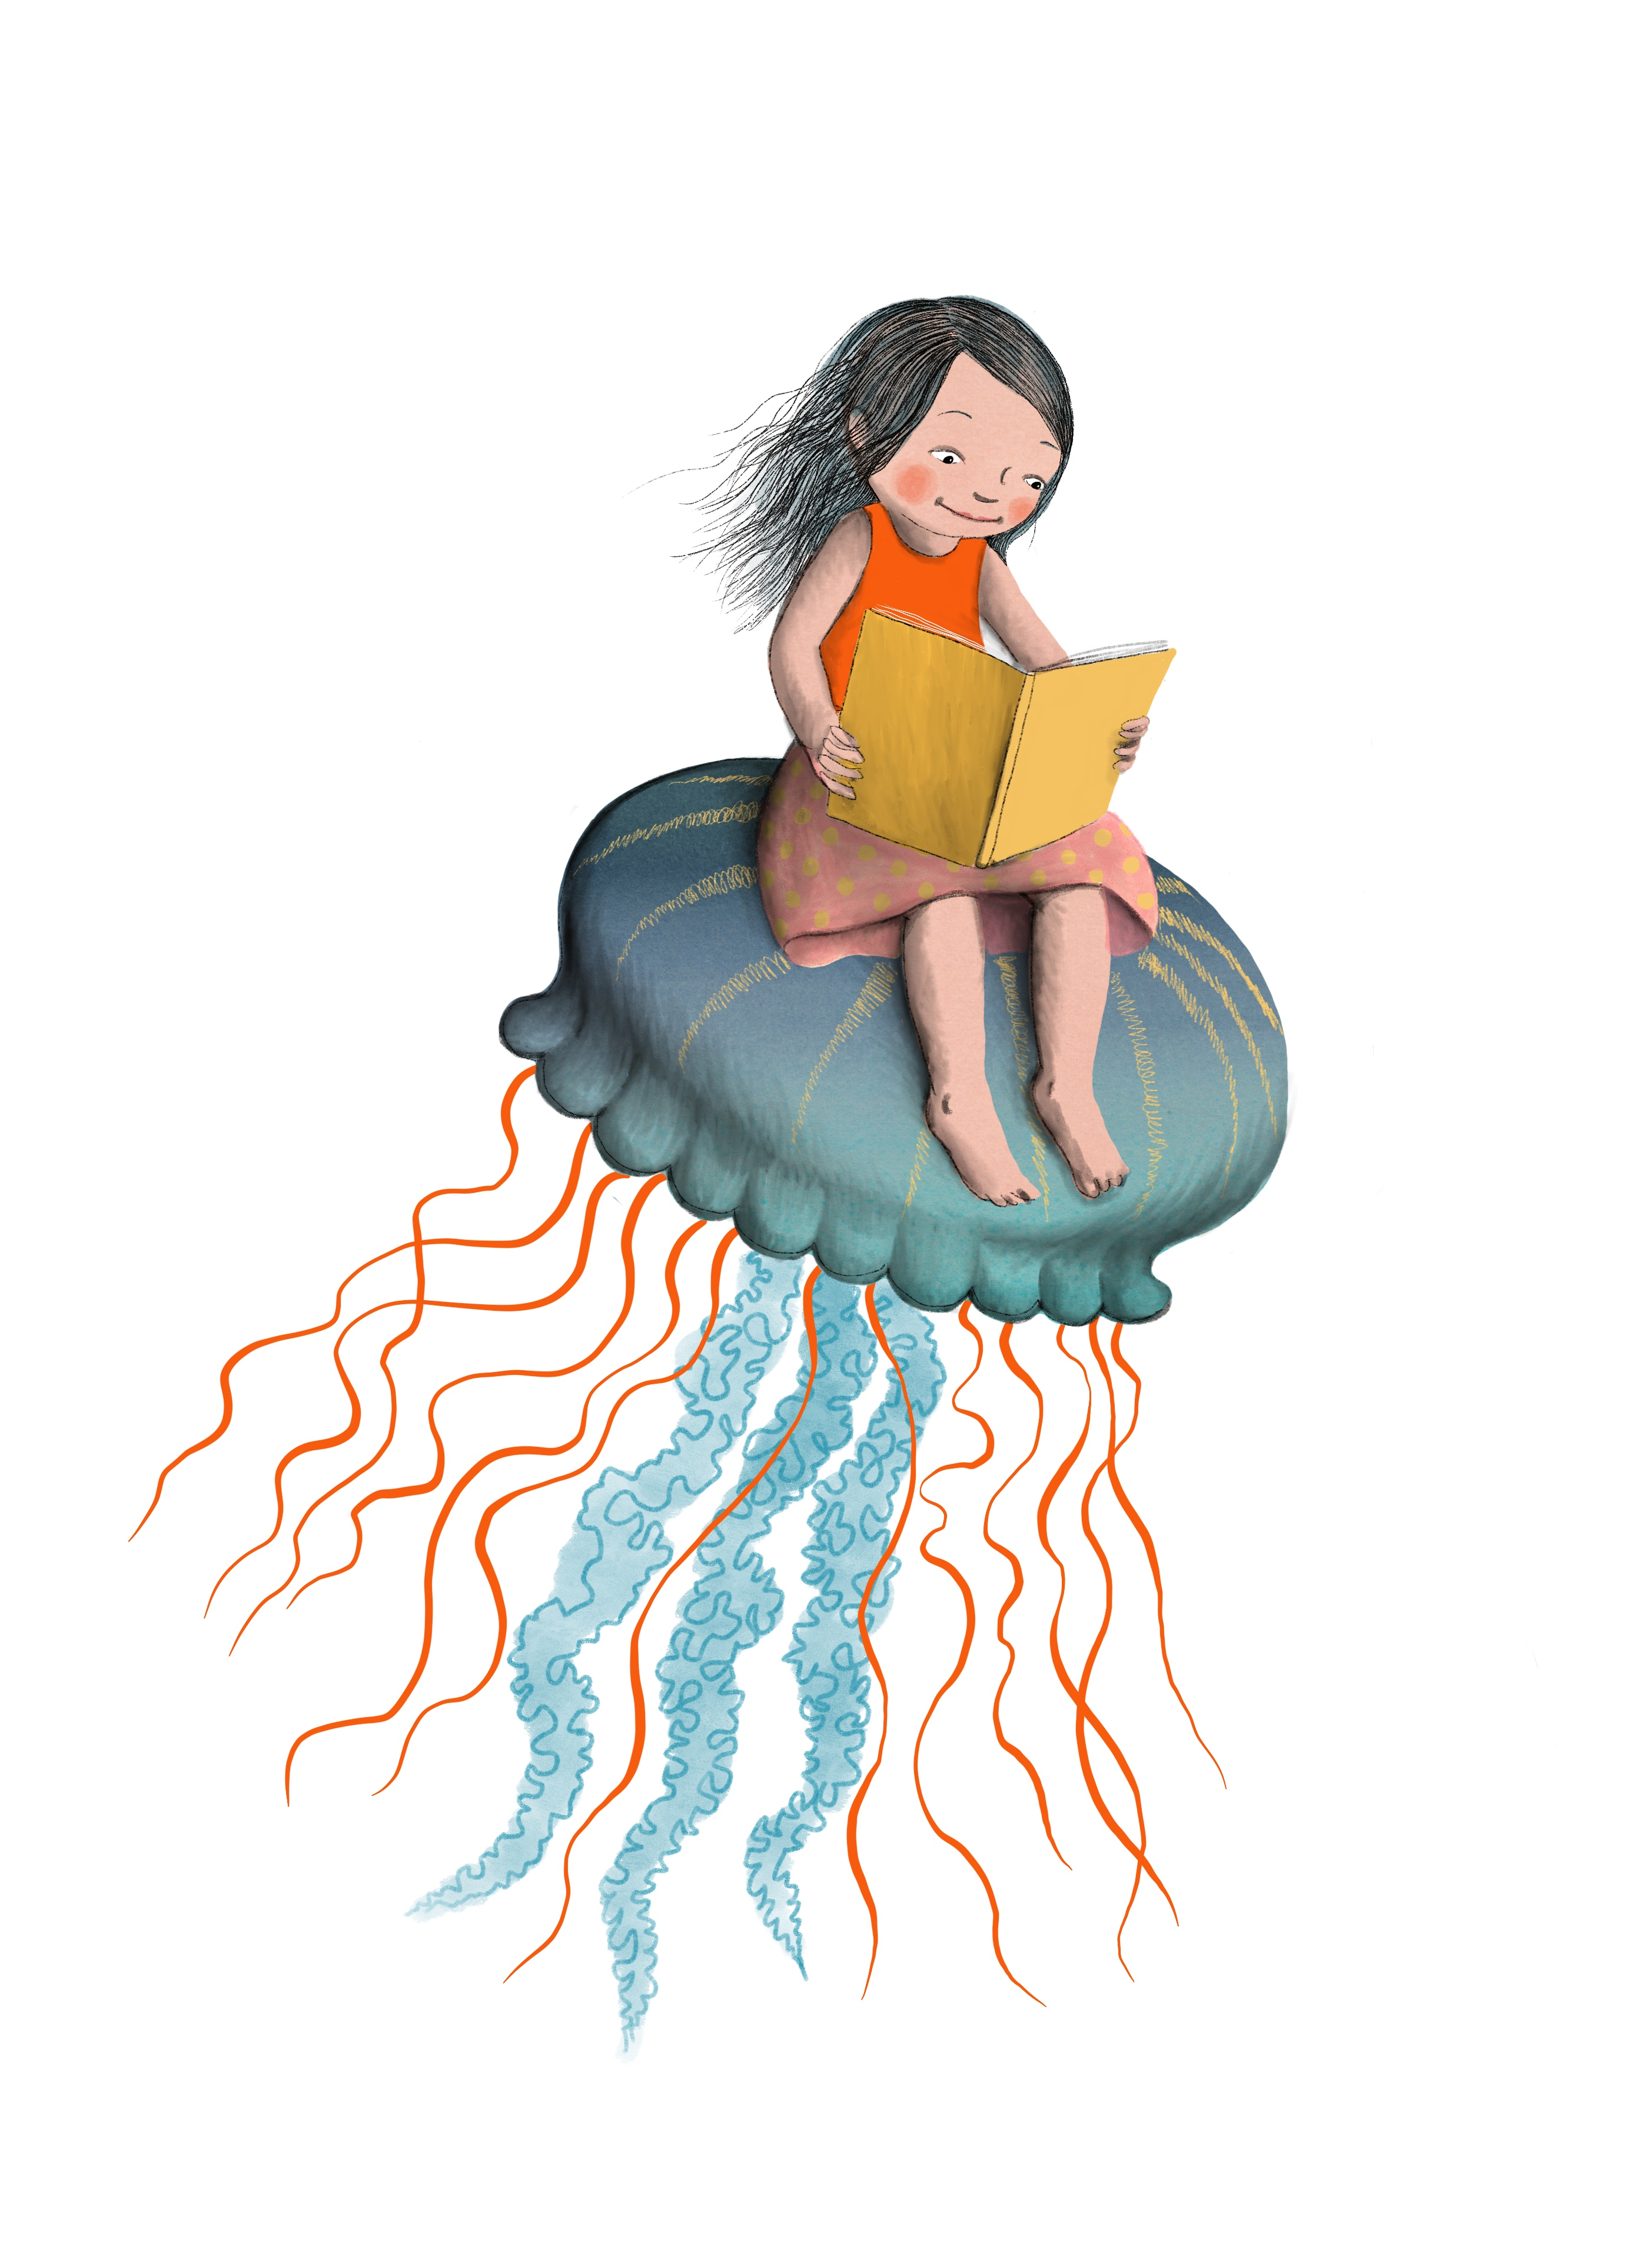
Back from the Brink by Nancy F. Castaldo
BR23068, DB99361
Read by Mark Ashby. Reading time: 3 hrs, 51 min.
Notable nature author discusses the scientific and political efforts to coax seven endangered animal species back from the brink of extinction. 2018. Gr. 5-8.

Rising water by Marc Aronson
DB94347
Read by Vikas Adam. Time: 2 hrs, 55 min.
Recounts the incredible true story of twelve boys trapped with their soccer coach in a flooded cave in Thailand and their inspiring rescue. 2019. Gr. 6-9.

Discover Treasure- Pirates, Vikings, and Treasure

Viking ships at sunrise by Mary Pope Osborne
BR14202, DB54425
Read by Gillian Green. Time: 56 min.
Jack and Annie travel back more than a thousand years to ancient Ireland, where their search for a lost book takes them to a monastery threatened by Vikings. 1998. Gr. 2-4.

Magic marks the spot: The Very Near Honorable League of Pirates by Caroline Carlson
DB 82482
Read by Jill Fox. Reading time: 8 hours, 26 minutes.
Much to the dismay of her proper parents, young Hilary Westfield escapes Miss Pimm's Finishing School for Delicate Ladies to join a misfit pirate crew. She and her house gargoyle embark on an unexpectedly magical, swashbuckling, plank-walking, seafaring journey of epic proportions. 2013. Gr. 3-6.

How to train your dragon series (2010) by Cressida Cowell
Read by David Tenant. Series read time: 45 hrs, 41 min.
Written between 2010-2016. Follows the adventures and misadventures of Hiccup Horrendous Haddock the Third on his rise to fame in his Viking clan, the Tribe of the Hairy Hooligans, and his desperate dragon-training exploits. Gr. 3-6.
DB78725 How to train your dragon; DB78726 How to be a pirate; DB78727 How to speak dragonese; DB78728 How to cheat a dragon’s curse; DB79022 How to twist a dragon’s tale; DB79023 A hero’s guide to deadly dragons; DB79024 How to ride a dragon’s storm; DB79025 How to break a dragon’s heart; DB79026 How to steal a dragon’s sword; DB79168 How to seize a dragon’s jewel; DB82771 How to betray a dragon’s hero; DB88380 How to fight a dragon’s fury; DB72291 How to train your dragon: Basis for movie

Headless Pirate/ El Pirata sin Cabeza by Harriet Rohmer
BR04469, DB17753
A short Costa Rican folk tale about a greedy pirate and the price he pays for his treachery. In English and Spanish language. 1976. Gr. 4-7.

Peter Pan by JM Barrie
BR15663, DB59430, LP17514
Read by Conrad Feininger.
Time: 4 hrs, 15 min.
Classic about the Neverland adventures of Wendy, John, and Michael Darling with Peter, the boy who refuses to grow up. 1911. Gr. 4-7.

The Whydah: A pirate ship feared, wrecked, and found by Martin W. Sandler
BR21982, DB88088
Read by Bob Moore. Time: 3 hrs, 37 min.
In 1984, the pirate ship the Whydah was discovered nearly three hundred years after it sank in a storm off the coast of Cape Cod in 1717. 2017. Gr. 5-8.

Treasure Island by Robert Louis Stevenson
BR13682, LP02575, DB52436
Read by Erik Sandvold. Time: 7 hrs, 38 min.
Young Jim Hawkins finds a map in a dead seaman's possessions. His friends realize it's a treasure map. They hire a ship, unaware that the crew includes the pirate Long John Silver. 1881. Gr. 5-8.

Pirates!: The true and remarkable adventures of Minerva Sharpe and Nancy Kington, female pirates by Celia Rees
BR15430, LP16666
In 1722, sixteen-year-old Nancy Kington arrives at her family's Jamaican plantation to be married off to Bartholome. To escape her fate she runs away with her slave friend, Minerva Sharpe, and together they become pirates searching for adventure and true love. 2003. Gr. 6-9.

An Ocean of Wonder- Animals Living in the Ocean
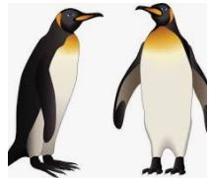

Inky’s amazing escape by Sy Montgomery
DBC12558
Read by Taryn Tranby. Time: 13 min.
Inky the Octopus lived at the New Zealand Aquarium. Then one night in 2016, Inky escaped his enclosure, slithered eight feet across the floor and down a drainpipe more than 160 feet long to his home in the sea. 2018. Gr. 2-4.

Earth’s incredible oceans by Jess French
DB104065
Read by Margaret Strom. Time: 1 hrs, 51 min.
Animal expert explores the fascinating underwater world, demonstrating how amazing oceans are, what plants and animals live in them, and how we can help them. French includes amazing facts on how ocean animals have fun, care for their young, and interact with each other. 2021. Gr. 3-6.

Interrupted Journey by Kathryn Lasky.
DB63200
Read by Dan Bloom. Reading time: 33 minutes.
Describes efforts to protect sea turtles, particularly Kemp’s ridley turtles, and help them reproduce and replenish their once-dwindling numbers. 2001. Gr. 3-6.

Song for a whale by Lynne Kelly
BR22668, DB94077, LP26836
Read by author. Time: 6 hrs, 37 min.
Twelve-year-old Iris and her grandmother, who are both deaf, drive from Texas to Alaska armed with Iris's plan to help Blue 55, a whale unable to communicate with other whales. 2019. Gr. 4-7.

Sea otter heroes by Patricia Newman
DB88475
Read by Nanette Savard. Time: 1 hrs, 32 min.
Marine biologist investigates the mystery of how sea grasses are thriving in nutrient-polluted waters of Elkhorn Slough, an inlet of Monterey Bay in Northern California. His studies provide evidence that sea otters play an essential part in maintaining a healthy balance in this particular ecosystem. 2017. Gr. 4-7.

Under the sea wind by Rachel Carson
BRJ01641, DB35033
Read by Miriam Wagner. Time: 7 hrs, 6 min.
This classic describes a portion of North Carolina's coast through the life history and adventures of Scomber, a mackerel; and Anguilla, an eel. 1941. GR. 5-8.

Spindlefish and stars by Christiane M. Andrews
DB101054, LP26821
Read by Vanessa Johansson. Time: 9 hrs, 35 min.
Clo ends up stranded on a strange island and must learn to spin fish into yarn to unravel the secret of her missing father. 2020. Gr. 5-8.

Journey of the pink dolphins by Sy Montgomery
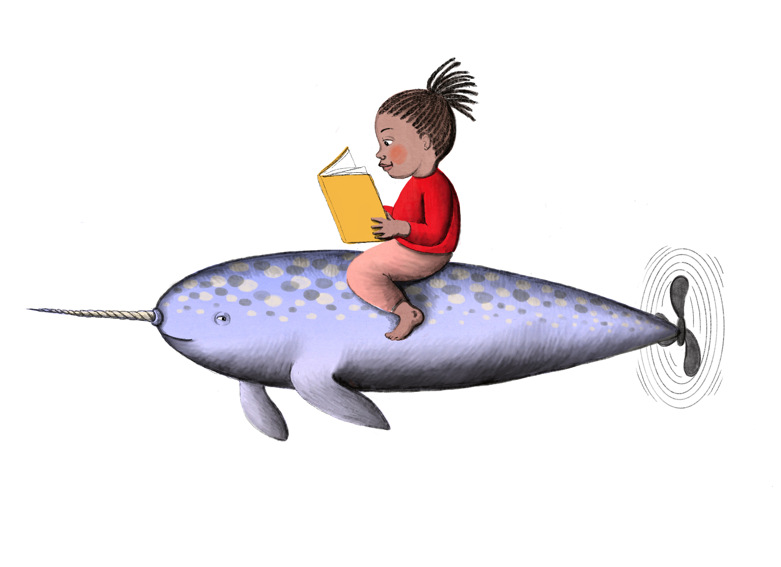
DB51514
Read by Ray Childs. Time: 10 hrs, 6 min.
Naturalist recounts searching the confluence of rivers near Manaus, Brazil, for pink dolphin--an elusive freshwater species. Includes anecdotes and legends about their behavior, and facts on native habitat. 2000. Gr. 6-9.

Uncharted- Sea Monsters and Undersea Mysteries

Pokko and the drum by Matthew Forsythe
BR23185, DBC16437, LP26386
Read by Leslie Bowman. Time: 7 min.
Pokko, a little frog, takes a magical drum deep into the quiet forest, where her playing draws the attention of musical animal friends. 2019. Gr. 2-4.

Odd and the Frost Giants by Neil Gaiman
DB70483
Read by Julie-Ann Elliott. Time: 1 hrs, 57 min.
An unlucky twelve-year-old Norwegian boy named Odd leads the Norse gods Loki, Thor, and Odin in an attempt to outwit evil Frost Giants who have taken over Asgard. 2009. Gr. 3-6.

Monsters and water beasts by Karen Miller
DB65611
Read by Gary Roan. Time: 1 hrs, 27 min.
Presents firsthand accounts and scientists' opinions about extraordinary creatures of land and sea. Discusses whether these folkloric beasts have a factual basis. 2007. Gr. 3-6.

Tales of the cryptids by Kelly Milner Halls
DBC17061
Read by Danielle king. Time: 2 hrs, 49 min.
The author reveals various legends about mysterious creatures from all over the world, and reports any evidence found to support their actual existence. 2006. Gr. 4-7.

A treasury of mermaids by Shirley Climo
DB46050
Read by Laura Giannarelli. Time: 1 hrs, 42 min.
Eight folktales from eight different countries about mermaids or mermen. 1997. Gr. 4-7.

Monsters of Pennsylvania by Patty A. Wilson
DBC08550
Read by Alan James. Time: 3 hrs, 50 min.
Pennsylvania is home to an assortment of odd creatures, including Lake Erie's resident monster. 2010. Gr. 5-8.

Theseus by Geraldine McCaughrean
DB63328
Read by Peter Lavezzoli. Time: 2 hrs, 46 min.
Seventeen-year-old Theseus discovers that his father is a mighty king and sets out to meet him. On the way to Athens, Theseus angers the sea god Poseidon and faces the Minotaur. 2005. Gr. 5-8.

Norse Mythology by Neil Gaiman
BR21814, DB87395
Read by George Holmes. Time: 6 hrs, 35 min.
Stories from Norse mythology, starting with the beginning of the nine worlds and ending with Ragnorak. 2018. Gr. 6-9.

Explore New Depths

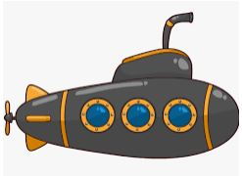
Papa’s Mechanical Fish by Candace Fleming
DB80588
Read by Abigail Maupin. Time: 17 min.
Fictional story about Lodner Phillips and the submarine he invented in 1851. 2013. Gr. 2-4.

The story of the HL Hunley and Queenie’s Coin by Fran Hawk
DBC05235
Read by Gus Bergess. Time: 16 min.
Relates the story of the very first submarine, the man who invented it, and the attempts to find it again more than 100 years after it sank off the coast of Charleston. Gr. 3-6.

Submarines by Lynn M. Stone
LP20189
Describes early submarines, their missions, and how technology has changed for these underwater giants. 2006. Gr. 3-6.

The lighthouse mystery by Gertrude Chandler
Warner and David Cunningham
BRC01133, DB17038
Read by Elaine Hoffman. Time 1 hrs, 47 min.
The Alden children are delighted when their grandfather agrees to rent a lighthouse for the summer. Night visits by an intruder and the unfriendly behavior of a neighboring boy add unexpected danger to the holiday. 1963. Gr. 4-7.

The Storm Keeper’s Island
by Catherine Doyle
DB93891
Read by Jon Pinnow. Time: 6 hrs, 48 min.
Fionn Boyle, terrified of the sea, must spend the summer with his older sister, Tara, and their grandfather on Arranmore, an island that has been known to make people disappear--and seems to be restless again. 2019. Gr. 4-7.

Coral reefs by Laurence Pringle
DB44008
Read by Miriam Wagner. Time: 1 hrs, 16 min.
Explores the exotic and important life-giving world of the coral reef. 1995. Gr. 4-7.

Secrets of a Civil War Submarine by Sally M. Walker
DB61080
Read by Ted Stoddard. Time: 2 hrs, 58 min.
Recounts the history of the Confederate submarine, H.L. Hunley. In 1864, it became the first submarine to sink a ship but then seemingly vanished. Chronicles the search for the wreckage, its 1995 discovery, and efforts to determine the wreck's cause and the crew's fate. 2005. Gr. 5-8.

The voyage of the Dawn Treader by C.S. Lewis
BR13948, DB16985, LP11987, LP04678
Read by Milton Metz. Reading time: 4 hrs, 34 min.
The adventure of two boys and their sister aboard a magic ship with Prince Caspian, Fifth title in "The Chronicles of Narnia" (DB050083). 1952. Gr. 5-8.

Dive! By Deborah Hopkinson
DB86181
Read by Richard Davidson. Reading time: 9 hrs, 22 min.
Relates the historic events of America's little-known submarine warfare, also known as "silent service," in the Pacific during World War II. 2016. Gr. 6-9.

Seven Seas, Infinite Stories

The raft by Jim LaMarche
DBC08700
Read by Wendy Devilbiss. Time: 17 minutes.
Reluctant Nicky spends a wonderful summer with Grandma who introduces him to the joy of rafting down the river near her home and watching the animals along the banks. 2000. Gr. 2-4.

Super simple hanging gardens: A kid’s guide to gardening by Alex Kuskowski
DB 81571
Read by Mike Stefanelli. Reading time: 19 minutes.
Provides techniques for growing plants in hanging containers and explains how to choose the right tools, soil, plants, and pots. 2015. Gr. 3-6.

Ship of dolls by Shirley Parenteau
DB80324
Read by Julie-Ann Elliott. Time: 5 hrs, 51 min.
Portland, Oregon, 1926. Eleven-year-old Lexie longs to rejoin her mother in San Francisco, but she is stuck with her strict grandparents. Then Lexie's class plans a contest around the shipment of friendship dolls to Japan, offering her a chance to win a trip to San Francisco. 2014. Gr. 3-6.

Rickshaw girl by Mitali Perkins
BR17581, DB86837
Read by Catherine Byers. Time: 1 hrs, 15 min.
In her Bangladesh village, ten-year-old artist Naima must disguise herself as a boy and financially help her impoverished family. 2007. Gr. 3-6.

Call it courage by Armstrong Sperry.
BR009146, DB022825, LP010748.
Read by Harold Parker. Time: 2 hrs, 19 min.
Relates how Mafatu, a young Polynesian boy whose name means Stout Heart, overcomes his terrible fear of the sea and proves his courage to himself and his people. 1968. Gr 4-7.

All thirteen by Christina Soontornvat
BR23532, DB101818
Read by Eva Wilhelm. Reading time: 5 hrs, 23 min.
The author chronicles the rescue events of June 23, 2018, when twelve young soccer players and their coach were trapped for days in a flooded cave in northern Thailand. 2020. Gr. 4-7.

White water by PJ Petersen
DB45782
Read by Gregory Gorton. Time: 2 hrs, 3 min.
A family’s white-water rafting trip turns deadly, when a rattlesnake bites the father. The two boys must navigate the rough rapids in a race against time to get medical care. 1997. Gr. 4-7.

Hide and seek by Katy Grant
BR19621, DBC05781
Read by Dwight Brahs. Time: 6 hrs, 25 min.
While geocaching in the mountains of Greer, Arizona for a hidden container, fourteen-year-old Chase finds a mysterious note from people claiming they are in danger and need help. 2010. Gr. 5-8.

First flight around the world: The adventures of the American Fliers who won the race by Tim Grove
DB 82610
Read by Patrick Downer. Reading time: 3 hours, 8 minutes.
An account of the 1924 race among six nations--Argentina, France, Great Britain, Italy, Portugal, and the United States--to be the first to circumnavigate the globe by airplane. 2015. Gr. 5-8.
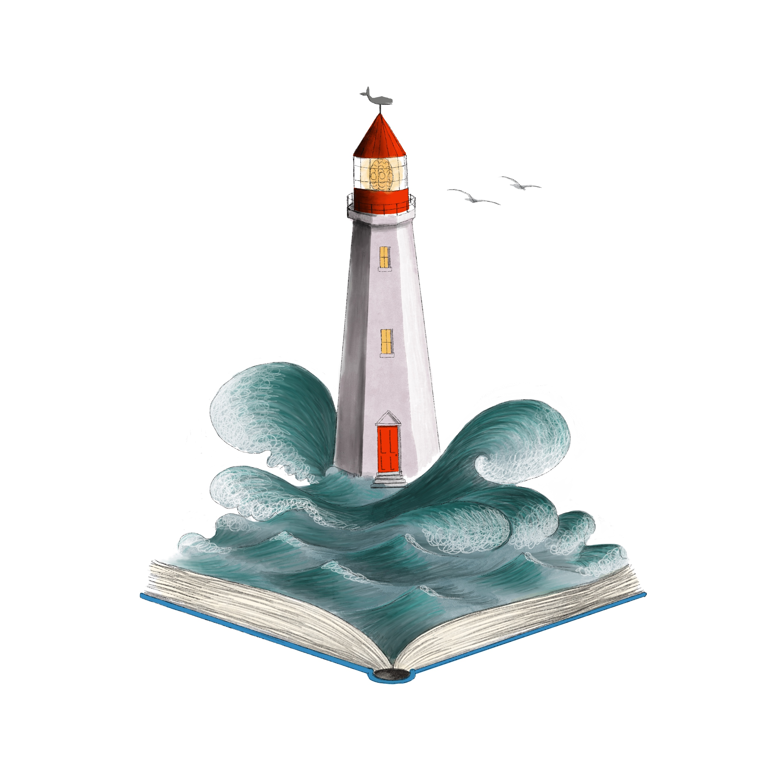
Aquarium beautiful by A. van den Nieuwenhuizen
DB51646
Read by Gary Tipton.
Discusses creating Dutch aquariums, which emphasize plants more than fish. Presents various types of these aquariums and the necessary equipment and proper locations for each. Also explains how to select and arrange plants and recommended fish. 1997. Gr. 6-9.

CONTACT INFORMATION
TELEPHONE
In-state toll-free 1.800.543.4702
Baton Rouge 225.342.9563
Utah (Braille) 1.800.453.4293
EMAIL TBBL tbblkids@state.lib.la.us
Utah blind@utah.gov
FAX 225.342.6817
ADDRESS State Library of Louisiana
Talking Books and Braille Library
P.O. Box 131
Baton Rouge, LA 70821
WEB ADDRESSES
TBBL http://www.state.lib.la.us/
Utah http://blindlibrary.utah.gov/
NLS http://www.loc.gov/nls/

