Adult
2022 SUMMER READING PROGRAM

Includes:
Welcome to the Summer Reading Program, Suggested Reading List, and Program Instructions

State Library of Louisiana
Talking Books and Braille Library
701 North 4th Street
Baton Rouge, LA 70802

tbblkids@state.lib.la.us
1.800.543.4702 or 225.342.9563
WELCOME TO THE 2022
TBBL SUMMER READING PROGRAM

Welcome to the 2022 Summer Reading Program – Oceans of Possibilities. The program starts May 1, and ends August 31.

What do I need to do?
Read! Read! Read!
If you participated last year, then you will automatically be signed up for this year's program. If you are not already signed up, please contact your reader advisor! All you have to do to complete the program is to read 20 books. Audio books, Braille books, large print books and audio magazines all count. We will keep track of your reading history. You can also request a reading log to track your progress. You may always email your list of books to tbbl@state.lib.la.us, fax your list to 225.342.6817, or call the library toll-free at 800.543.4702 or call 225. 342.9563.

What do I earn?!
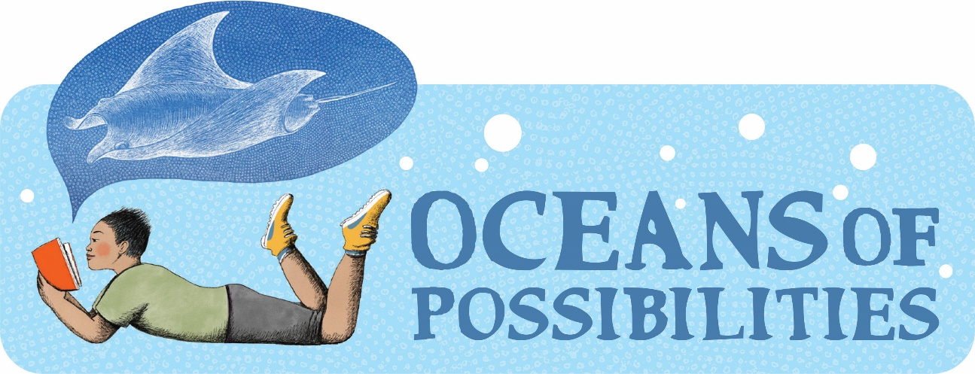
Participants who complete the program by reading 20 books or more will be entered into a drawing to win a Handheld 10X Magnifying Glass (about 4 inches wide) with a non-slip handle. We will choose 25 lucky winners. One entry per person.
How many books do I have to read?
For entry into the drawing, a participant must read 20 books, or magazines.

Do I have to read books from this reading list?
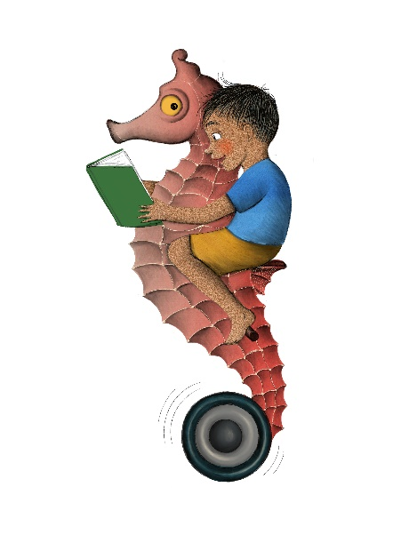
No, this is only a suggested list to give you ideas. You may read anything you want from our library, your public library, or from home. This includes audiobooks, Braille, print books, magazines, and newspapers. Contact the TBBL if you would like more reading ideas. We would be happy to help you.
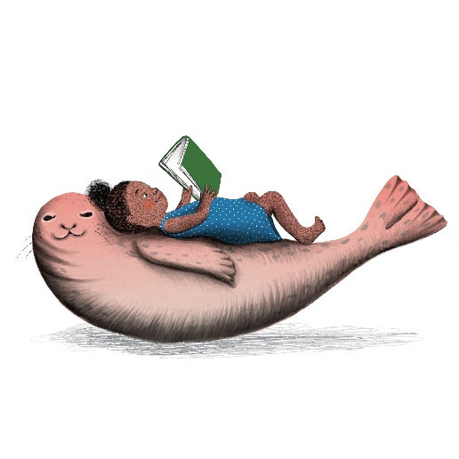
Have Fun!!

If you have any questions about Library services, downloading, or playing digital books, contact TBBL at 800.543.4702.
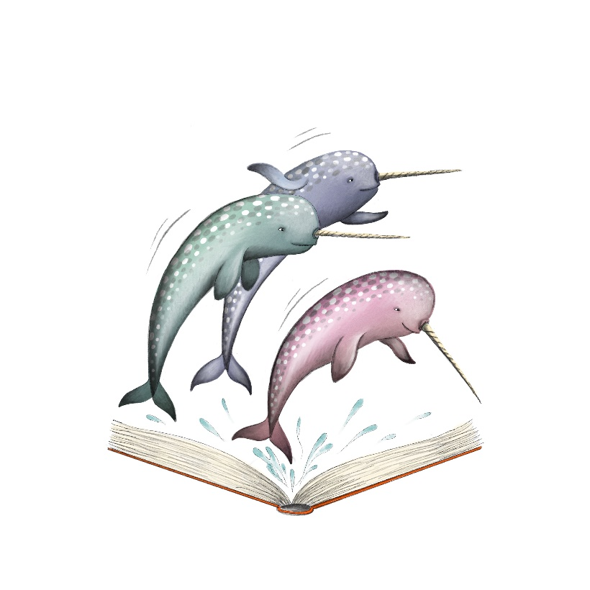
SUGGESTED READING

Format notes:
DB & DBC = Digital Audio Book
BR & BRA = Braille Book
LP = Large Print Book
BARD = All Audiobooks are available for Digital Audio Download.

Our Blue Planet- Oceanography and Conservation

The sea around us by Rachel Carson
BR15487, DB18521, LP0191
Read by Phil Regensdorf. Time: 10 hrs, 21 min.
Eminent marine biologist, writer, and ecologist reveals the science and poetry of the world's oceans from their primeval beginnings billions of years ago to humankind's modern explorations. 1961.

Cold adventures in the world’s frozen places by Bill Streever
BR19276
Scientist living in Alaska offers a year's worth of observations on the properties of cold and its physical and mental effects. Covers topics from geography and weather to biology and folklore. Includes specific discussion of hibernation, Arctic explorers, absolute zero, wind chill, blizzards, and human survival in extreme cold. 2009.

A furious sky by Eric Jay Dolin
DB100663
Read by Bob Souer. Time: 10 hrs, 54 min.
Presents a history of hurricanes and response to them in North America and the Caribbean since European colonization. Highlights the work of Jesuit priest Benito Vines and the 1900 Galveston hurricane. Unrated. 2020.

The Gulf: The making of an American sea by Jack E. Davis
DB88197
Read by JP Linton. Time: 26 hrs, 13 min.
A history of the Gulf of Mexico, extending from the Pleistocene age until the twenty-first century. Discusses the marine environment, its role in human society, and many of the individuals whose lives are intertwined with the Gulf. 2017.

Climate change by Mark Maslin
BR14775, DB85559
Read by Mark Ashby. Time: 6 hrs, 38 min.
Geography professor explains how climate changes and how changes have been measured. Presents evidence of the global pollution problem: ocean warming, sea level rise, Arctic sea ice decline, and increase in extreme weather events. Discusses impacts on water and food security and public health, and potential political and technological solutions. 2014.

Discover Treasure
Pirates, Vikings, Sea adventure

Stardust by Neil Gaiman
BR20931, DB49777, LP12913
Read by George Holmes. Time: 6 hrs, 45 min.
Tristran Thorn promises his intended to retrieve a fallen star and embarks on an arduous quest in an enchanted forest inhabited by faeries. Some violence. YAI. 1999.

Pirates of the Levant by Arturo Pérez-Reverte
DB73356
Read by Ray Childs. Time: 11 hrs, 3 min.
Captain Diego Alatriste and seventeen-year-old Íñigo Balboa join the crew of a Spanish galleon in 1627. They skirmish with Barbary pirates along the Levant and survive a fierce battle in Malta. Strong language and some violence. 2010.

Given to the sea by Mindy McGinnis
DB89120
Read by Robbie Daymond. Time: 11 hrs, 40 min.
Khosa is destined to be sacrificed to the sea to keep her kingdom safe from a destructive tidal wave. She struggles to understand her destiny as the kingdom comes under attack, and the ocean threatens to destroy them all. Unrated. 2017. YAI.

Pirate hunters: Treasure, obsession, and the search for a legendary pirate ship by Robert Kurson
BR21111, DB81865
Read by Ray Porter. Time: 8 hrs, 26 min.
Chronicles the story of John Chatterton (born 1951) and John Mattera (born 1962) and their search for the Golden Fleece, a pirate ship sunk off the coast of the Dominican Republic in the 1680s. Strong language. 2015.

Survive the savage sea by Dougal Robertson
DB58667, LP01200
Read by Jack Fox. Time: 7 hrs, 33 min.
Author relates his family's nightmare of trying to survive after killer whales attacked and sank their forty-three-foot schooner in the Pacific Ocean. Robertson's daily account describes their thirty-eight-day struggle against thirst, starvation, and exhaustion before being rescued by Japanese fishermen. 1973.

An Ocean of Wonders

Marine Animals NF

Lake monsters of Wisconsin by Chad Lewis
DBC08237
Read by Ceri Hartnett. Time: 4 hrs, 35 min.
Author claims that Wisconsin is the Lake Monster Capital of the Americas and provides documentation on the many "sea serpent" sightings in Wisconsin. 2016.

Oceana: Our endangered oceans and what we can do to save them by Ted Danson
DB73912
Read by Andy Pyle. Time: 7 hrs, 53 min.
Environmental activist discusses threats to the world's oceans, including pollution, overfishing, offshore drilling, and acidification. Suggests ways that readers can support conservation and explains the work of Oceana, an international organization dedicated to saving the seas. 2011.

The Bermuda Triangle by Valentine J. Manson
LP0091
Explore an area of the Western Atlantic between Bermuda and Florida where, since 1945, over 100 ships and planes and 1,000 people have vanished - without a trace. 1975.

Marine Animals Fiction

Under the sea wind by Rachel Carson
BRJ01641, DB35033
Read by Miriam Wagner. Time: 7 hrs, 6 min.
First published in 1941, this classic describes a portion of North Carolina's coast through the life history and adventures of Scomber, a mackerel; and Anguilla, an eel. Includes a glossary. 1941.

The old man and the sea by Ernest Hemingway
BR10599, DB53792, LP8365
Read by Rick Wiseman. Time: 2 hrs, 36 min.
Pulitzer Prize winning classic tale of the old Cuban fisherman Santiago and his days-long struggle with a magnificent marlin on open water in a frail skiff. 1952.

The Meg by Steve Alten and Jon Huffman
DB44838
Read by Ray Foushee. Time: 8 hrs, 7 min.
Professor Jonas Taylor theorizes that the Carcharodon megalodon, a great white shark that thrived seventy million years ago and could devour a Tyrannosaurus rex, may exist beneath the sea. When his research causes the Meg to emerge, Taylor is unprepared to handle her or her young. Some violence and some strong language. 1997.

Uncharted
Mythology, Sea monsters, Undersea mysteries,

Monsters of Pennsylvania by Patty A. Wilson
DBC08550
Read by Alan James. Time: 3 hrs, 50 min.
Pennsylvania is home to an assortment of odd creatures, including Lake Erie's resident monster. 2010. YAI.

Norse Mythology by Neil Gaiman
BR21814, DB87395
Read by George Holmes. Time: 6 hrs, 35 min.
Stories from Norse mythology, starting with the beginning of the nine worlds and ending with Ragnorak. 2018.

Mermaid and other water spirit tales from around the world by Heidi Anne Heiner
DB81731
Read by Catherine Byers. Time: 41 hrs, 11 min.
Collection of 150 folktales, fairy tales, and ballads from around the world about mermaids and other water spirits, together with information on their history. Includes examples of the earliest scholarship on mermaids and similar creatures. Violence. 2011.

Mysterious New Mexico by Benjamin Radford
DBC03321
Read by Jo Chapman. Time: 11 hrs, 36 min.
Radford uses folklore, sociology, history, psychology, and forensic science to reveal the truths and myths behind New Mexico's greatest mysteries. 2014.

Monsters of Wisconsin by Linda S. Godfrey
DBC08307
Read by Barbara Nevers. Time: 5 hrs, 25 min.
The Wisconsin author chronicles the most daunting and bizarre sighting reports like the flying lizard men, the Rock River monster, and other lesser-known beasts in the Badger State. 2011.

Shark Week, Giant Squids, Whales, Dolphins

Soul Surfer: A true story of faith, family, and fighting to get back on the board by Bethany Hamilton
BR19783, DB59485,
Read by Michele Schaeffer. Reading time: 3 hours, 1 minute.
Autobiography of a Hawaiian junior-champion surfer who lost an arm in a shark attack when she was thirteen. YAI.

The Devil’s teeth by Susan Casey
BR17567, DB67002
Read by Martha Harmon Pardee. Time: 11 hrs, 6 min.
Account of the author's journey to the Farallon Islands, twenty-seven miles from San Francisco, a renowned refuge of great white sharks. Casey relates joining scientists as they studied the predators in their natural habitat. Some strong language. 2005.

Moby Dick by Herman Melville
BR14641, DB34184, LP00709
Read by Gordon Gould. Time: 25 hrs, 36 min.
Sailor Ishmael signs on as a harpooner with Captain Ahab's whaling ship. Once at sea, the crew discovers that, despite dire warnings from other ships and a prophet, Captain Ahab is obsessed with killing Moby Dick, the white whale responsible for his missing leg. Violence. 1851.

Herman Melville by Rebecca Stefoff
BR10112
Biography of the author of Moby Dick (BRC01166, DB47779, LP06573) and his real-life exciting adventures. Gives brief descriptions of all Melville's novels. 1994. YAI.

The soul of an octopus by Sy Montgomery
BR21140, DB82438
Read by Kimberly Schraf. Time: 10 hrs, 38 min.
Naturalist explores the world, intelligence, and consciousness of octopuses. Describes her interactions with captive giant Pacific octopuses at the New England Aquarium in Boston, and her field investigations in French Polynesia and the Gulf of Mexico. 2015.

Explore New Depths
History of Submarines, Ships, and Naval adventures

20,000 Leagues under the Sea by Jules Verne
BR09469, BRA09257, DB13748, DB57020, LP09446
Read by Hal Tenny, Fred Major. Reading time: 15 hours, 42 minutes.
Written in 1869, this science fiction novel is almost prophetic in its account of the first submarine, "Nautilus," whose skipper, Captain Nemo, is a mad genius. 1962.

Jason and the Argonauts by Apollonius.
BR020691, DB080796.
Read by Mark Ashby. Time: 8 hrs, 2 min.
Translation in verse of Ancient Greek poem detailing the voyage of the hero Jason and his crew, the Argonauts--including Heracles and Orpheus, as they search for the Golden Fleece at the directive of King Pelias. They encounter treachery of all kinds, both from mortal and immortal foes. Some violence.

In the waves: My quest to solve the mystery of a civil war submarine by Rachel Lance
DB99877
Read by Rebecca Lowman. Time: 10 hrs, 1 min.
The author recounts her investigation of the mysterious wreck of Confederate submarine HL Hunley. Thought to have been sunk by an explosion, the raised vessel revealed no sign of the blast. She presents her theory on the true cause of the submarine's demise. Unrated. 2020.

The bravest man by William Tuohy
DB65132
Read by Margaret Strom. Time: 17 hrs, 31 min.
Recounts the sinking of the submarine Tang after a defective torpedo hits it. Focuses on the experience of the ship’s skipper Richard O'Kane and the surviving crew after the accident. 2001.

The mysterious island by Jules Verne
BR12761, BR10097, DB56680
Read by Geoffrey Centi Centlivre. Time: 28 hrs, 20 min.
During the Civil War, engineer Cyrus Smith is a Southern captive. He escapes by hot-air balloon with four other prisoners, and a dog. A storm blows them to an island, but Smith is lost at sea. Later the others find him, but no one can explain how he reached land. Mysterious events and resourcefulness help them survive the next four years. Sequel to Twenty Thousand Leagues under the Sea (BR09469, DB57020, LP09446). 1874.

Lighthouses, Shorelines, coral reefs, atolls,

The Boy Who Harnessed the Wind by William Kamkwamba
DB72673
Read by Jon Huffman. Reading time: 11 hours, 4 minutes
Memoir of Malawi youth William, a school dropout who was inspired by a library book to build the first windmill in his village. 2009.

Brilliant beacons by EricJay Dolin
DB86622
Read by Bob Souer. Time: 10 hrs, 54 min.
Chronicles the development, usage, and history of lighthouses in America. Examines the impact of their use on commerce, federal government oversight and control, and technological advances. Profiles personalities involved in running lighthouses. 2016.

Cast away: Poems for our time by Naomi Shihab Nye
BR23778, DB98613
Read by author. Time: 2 hrs, 12 min.
Poetry Foundation's Young People's Poet Laureate shines a spotlight on the things we cast away, from plastic water bottles to refugees. 2020. YAI.

33 men: Inside the miraculous survival and dramatic rescue of the Chilean miners by Jonathan Franklin
BR21385, DB73380
Read by Peter Johnson. Time: 8 hrs, 34 min.
While stationed in South America, journalist investigated the August 5, 2010, copper-mine explosion in northern Chile that trapped thirty-three men underground for ten weeks. Describes the miners' ordeal and highlights the rescue attempt that brought them to the surface. 2011.

New York 2140 by Kim Stanley Robinson
DB87719
Read by Suzanne Toren. Time: 22 hrs, 36 min.
In a future New York City, waters have risen, leaving the old surface of NYC submerged, but the city remains a bustling metropolis of canals. The inhabitants of one particular skyscraper go about their business in this new world. Unrated. 2017.

Seven Seas, Infinite Stories

Watersports

Around the world in 80 days by Jules Verne
BR09468, DB53171, LP17029
Read by John Lescault. Time: 7 hrs, 42 min.
It is London, 1872 and well-to-do, eccentric Phileas Fogg wagers that he can travel around the world in eighty days. He sets off on the grand adventure with his servant, Passepartout. 1988. YAI.

Home in your pack by Bradford Angier
DB22121
Read by Ila Toney. Time: 5 hrs, 14 min.
A guide for hunters, campers, fishermen, and vacationers with suggestions on planning trips. Information ranges from the selection of a backpack to preparing a first-aid kit, with comments on instant foods. 1972.

The worst-case scenario survival handbook by Joshua Piven
DB50515
Read by Barry Bernson. Time: 2 hrs, 26 min.
Techniques and planning for survival in emergencies. Basic rules include being mentally and physically prepared, having access to proper equipment, and refusing to panic. Covers medical crises, natural disasters, attacks by wild animals, and dangers that require fast escapes. Names experts interviewed about each situation. 1999.

1,000 places to see in the USA and Canada before you die by Patricia Schultz
DB69698
Read by Kerry Gundiff. Time: 79 hrs, 21 min.
Guide to museums, natural wonders, historic homes, classic ballparks, scenic byways, and more. Destinations arranged geographically, provides information on accommodations, and best times to visit. 2007.

Countries by the Sea, Island life, Celebrations of water

Sense and Sensibility and Sea Monsters by Ben H. Winters
DB69427
Read by Katherine Kellgren. Time: 11 hrs, 1 min.
In this reimagining of Jane Austen’s Sense and Sensibility (BR11520, DB22282, LP3568), after being evicted upon their father's death, Elinor and Marianne Dashwood are sent to an island full of savage creatures and dark secrets. Elinor falls in love with Edward Ferrars while Marianne is courted by a man-monster. Violence. 2009.

House of salt and sorrows by Erin A. Craig
DB96513
Read by Emily Lawrence. Time: 12 hrs, 52 min.
On a remote island estate, Annaleigh Thaumas enlists the aid of an alluring stranger to unravel a family curse before it claims her life. Unrated. 2019. YAI.

The highest tide by Jim Lynch
BRC00733, DBC05540, DBC15783
Read by Leo Paul and Carter Bentley. Time: 7 hrs, 14 min.
Thirteen-year-old Miles O'Malley likes to sneak out at night to explore the tidal flats of Puget Sound by moonlight. What he discovers one night turns him into a local phenomenon and unfolds dramatic changes for Miles and the coastline that he adores. 2005. YAI.

CONTACT INFORMATION
TELEPHONE
In-state toll-free 1.800.543.4702
Baton Rouge 225.342.9563
Utah (Braille) 1.800.453.4293
EMAIL TBBL tbblkids@state.lib.la.us
Utah blind@utah.gov
FAX 225.342.6817
ADDRESS State Library of Louisiana
Talking Books and Braille Library
P.O. Box 131
Baton Rouge, LA 70821
WEB ADDRESSES
TBBL http://www.state.lib.la.us/
Utah http://blindlibrary.utah.gov/
NLS http://www.loc.gov/nls/

