http://www.booksontape.com/audio-straight-talk-why-narrator-january-lavoy-gets-overwhelmed-walking-into-a-bookstore/

Guest Post Audio Straight Talk: Why Narrator January LaVoy Gets Overwhelmed Walking Into a Bookstore…

Submitted by Jennifer Rubins on August 25, 2015
LAIR OF DREAMS narrator January LaVoy shares her thoughts on the art of audiobook narration:
I’ve been very fortunate of late to have attended a few events where I have gotten to talk about the nature of my work as a narrator. People often ask about my process, which is a terribly difficult thing for me to describe—although there is a basic framework, every book is different, and makes its own demands. Yes, they all begin with a) read the book and end with z) read the book out loud. But letters ‘b’ through ‘y’ are to some degree, new each time. In that regard, the process is constantly shifting.
What I have an easier time articulating is my philosophy about narrating books, insofar as it exists; I know that the work I do in the recording studio is anchored by my emotional connection to the printed word, so I can start there.
I love books. I have loved them since before I could read. I love the way they look and feel. I love the way they smell, new or old or musty. (Yes, I love the instant gratification of e-books, too.) I often get overwhelmed walking into a bookstore, confronted by the physical truth of the fact that I WILL NEVER READ ALL OF THE WORDS. There’s something magical about the infinity of possibility; that even with only twenty-six letters at our disposal in my native Latin alphabet, we can write as many words as there are stars in the sky or grains of sand. Yes, we sometimes repeat ourselves — there are only about a million unique words in the English language — but we are also continually inventing. The words are written and ordered and become stories…and the stories don’t ever have to end.
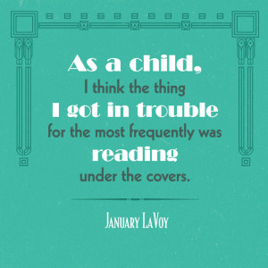As a child, I think the thing I got in trouble for the most frequently was reading under the covers. Reading after lights out. Reading when I was supposed to be [insert chore here]-ing. There was no sadness in my life that reading couldn’t transport me away from, no feeling of teenage loneliness or anxiety that could touch me when I was guessing riddles under a mountain in Middle-Earth, or pursuing a clown under a sewer grate in Derry, Maine. Books were, and often still are, my salvation. If you had told me that someday I’d make my living reading books out loud, I’d have thought that surely, you were making fun of me.
I started acting onstage when I was a child, in school and community productions, and received undergraduate and graduate degrees in theatre and performance. And in all my years of study, I was taught over and over again to respect the sanctity of the words as written. Make the choices as bold and strange and foolish as possible; but for heaven’s sake, say all the damn words, in the order in which they were written. (A splash of OCD in my DNA was and is a massive asset in this regard.) A role is yours to do with as you wish, but only to the extent that you honor the one explicit thing the playwright has asked of you:
Say. These. Words.
Turns out, that’s the number one directive in audiobooks, too: Say all the words in the right order.
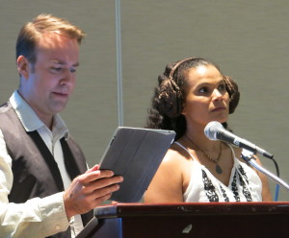
January performs as Princess Leia alongside Marc Thompson’s Luke Skywalker at ALA Annual 2015
I’ve never been terribly inclined toward improvisation in my acting — I always prefer to have a road map before I begin creating character and shaping impulses. So, in that fundamental sense, I’m well suited to the job.
And I LOVE it.
But this is where it can get tricky. How much of my interpretation of the characters is right, and how much is wrong? Where is the line between inhabiting, enhancing, and embellishing? How can I be sure that the voice I’m lending to the character is anything like what the author originally intended?
The answer, of course, is that I can never be sure. I rely heavily on the input of the many wonderful directors that I’m blessed to collaborate with, and I mine as much as I possibly can from every descriptor the author gives me in the text, and then…I dive in. I have as much fun as I can, and I try to preserve for the listener the experience that I had the first time I read the book. Did I gasp when I read that sentence? Turn up the drama just a bit. Did I tear up reading about a character’s supposed death, only to learn 100 pages later that he survived? Then I’d better make sure I play that death to the hilt, so that the listener gets the full experience of both the sorrow and the joy. A suspense-filled murder mystery? Careful those voices don’t tip the identity of the killer, whom we met on page 50!
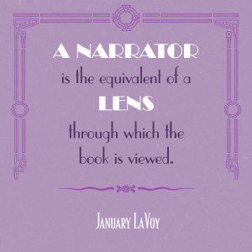The best analogy I can find for what we narrators do, is this: a narrator is the equivalent of a lens through which the book is viewed. Much like an eyeglass, the prescription (i.e. the casting) must be right. The lens doesn’t change anything about the substance of what is seen, but it can sharpen it. And the lens is doing its job to perfection when the person wearing it (i.e. the listener) forgets that it’s there. That is the truest part of the analogy for me.
Because if I’ve done my job right…I disappear.
—January LaVoy

