Braille and Talking Books @ Taylor Community Library
12303 Pardee Rd., Taylor, MI 48180
http://www.taylor.lib.mi.us 734-287-4840

Dear Patron:
Our records indicate that you have Talking Book Equipment checked out, but you have not used our service in a while.
If you would still like to continue receiving talking books, please contact Braille and Talking Books @ Taylor Community Library at 734-287-4840 to update your account.
Otherwise, please return all equipment, which belongs to the United States Government and we will cancel your account.

Players:
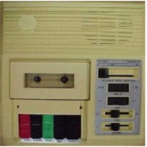 | 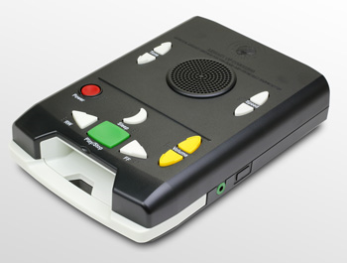 | 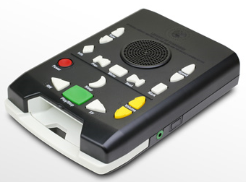 | 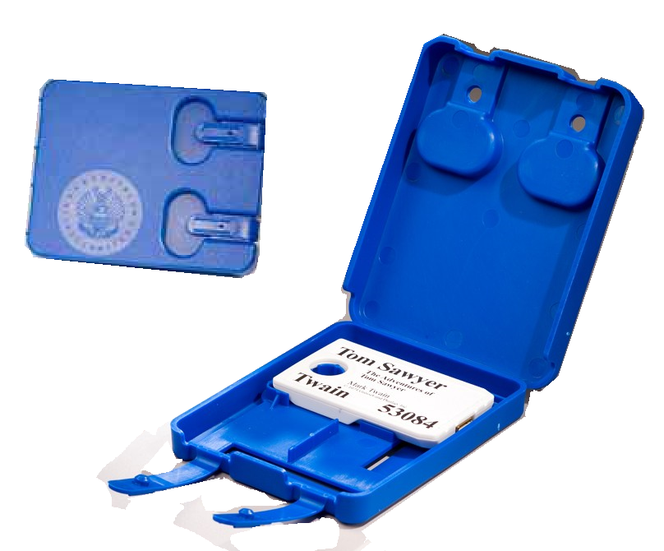
C01 | DS | DA | DB - See below

Book Cartridges:
DB | DB | DB | DB
DB | DB | DB | DB
DB | DB | DB | DB

We have included a postage free mailing label for your convenience. Simply affix this label to the box that you use to return the equipment.
If you no longer have the equipment or have questions about returning it, please contact Braille and Talking Books @ Taylor Community Library at 734-287-4840.

