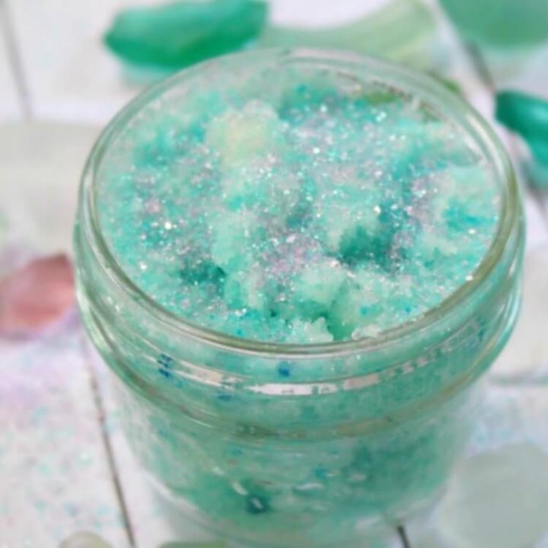
Mermaid Sugar Scrub
Materials:
1 cup Granulated sugar
¼ cup Coconut oil
Essential oils (optional)
Soap colorant or food coloring (optional)
Food safe glitter or sprinkles (optional)
Containers with lid for storage
Measuring spoons
Stir stick or spoon
Note: Leave out colorants for an allergy-free option. You could also use natural items for color, such as tea bags, green leaves, or flower petals.
Instructions:
• Mix together the coconut oil and the granulated sugar. A good ratio to begin with is 4 parts sugar to one part oil, but you can add more oil or more sugar to get the consistency that you like.
• If using, add in a couple of drops of food coloring and/or sugar sprinkles, and mix well.
•Once everything has been mixed, add a few drops of essential oils, if desired.
- Yield: 1 jar of sugar scrub
Top of Form

Notes:
If the scrub is not as solid as you would like, add more sugar. If you feel it is too dry, add in a dab of coconut oil until you get the consistency you want.

How to Store and Gift Homemade Mermaid Foot Scrub
- Store the mermaid sugar scrub in an airtight container for up to the life of the oil you use (coconut oil is about 24 months).
- Sugar scrubs are best when packaged in single-use containers. If water enters the scrub, mold or bacteria can develop.
- Storing sugar scrubs away from the shower is best, and outside of the bathroom is even better. Hermetic jars (with the seal) are best for scrub storage.
- Storing a sugar scrub in the refrigerator can be refreshing on tired feet, but it won’t extend the life of the scrub.
- If gifting, add a tag or sticker which has tips on use and storage.
- Vary the essential oils to the mixture to turn your mermaid sugar scrub into a calming, aromatherapy enriched experience for any occasion.
- For more fun sugar scrub and bath salts recipes, visit RufflesandRainboots.com

