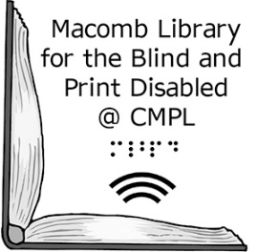Macomb Library for the Blind and  
 Print Disabled @ CMPL

**Date**

Dear **Name**,

Thank you for using the Macomb Library for the Blind & Print Disabled. Our records indicate that your status is *Inactive*, as you last used our service on **date.** We are assuming that you are no longer interested in receiving materials. If this is correct please return the digital talking book machine loaned to you to the Library. According to our records you have machine, serial number **_____________.**

We appreciate your assistance with this matter. This equipment is the property of the United States Government and it will be loaned to other patrons. Machines can be sent back to us free of charge via the U.S. Post Office. A mailing card is enclosed. If you no longer have the box the machine came in we’d be happy to send one to you. If you no longer have the equipment, or have further questions about returning it, please contact us at 586-286-1580 or toll free at 855-203-5274.

Sincerely,

Macomb LBPD @ CMPL Staff

40900 Romeo Plank Road, Clinton Township, MI 48038-2955

(586) 286-1580, toll free 855-203-5274, [www.cmpl.org/mlbph](http://www.cmpl.org/mlbph), mlbph@cmpl.org

A partnership between the Clinton-Macomb Public Library and Macomb County