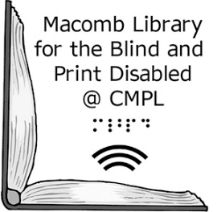Macomb Library for the Blind and  
 Print Disabled @ CMPL

Dear Patron,

Thank you for using the Macomb Library for the Blind & Print Disabled @ CMPL talking book service. According to our records you have a digital talking book machine, serial number ___________________ that should be returned to the Macomb Library for the Blind. Thank you for helping us out in this matter as this equipment is the property of the United States Government and will be passed along to other patrons.

Machines can be sent back to us free of charge via the U.S. Post Office. If you need a mailing card to send the machine, please contact us. If you no longer have the equipment, or have further questions about returning it, also contact us at 586-286-1580 or toll free at 855-203-5274.

Sincerely,

Macomb LBPD @ CMPL Staff

40900 Romeo Plank Road, Clinton Township, MI 48038-2955

(586) 286-1580, toll free 855-203-5274, [www.cmpl.org/mlbph](http://www.cmpl.org/mlbph), mlbph@cmpl.org

A partnership between the Clinton-Macomb Public Library and Macomb County