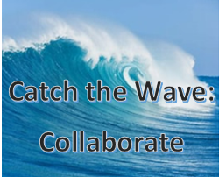
Call for Presenters/ Panel Participants
Please email Angela Fisher Hall at afisherhall@apls.state.al.us with your name, state, and session interest to present or be part of a panel. Include a brief synopsis of the content. Organization of presentations and panels will be based on volume of interest, and length of content.
- (1 hr.) Wave of Support: Ereader Examined. Includes lessons learned on distribution, ways to maximize use, encourage braille literacy.
  - AL and KY confirmed, Other states welcomed.

- (30-45 min) Turn the Tide: Youth Engagement! Who has built a successful youth program, with proven success stories; or, new ideas they hope will bring results.

- (1 hr.) Wave of Success: Remote Strategies. Includes best practices for Remote programming, Hybrid programming, and creating digital communities.

- (30 min) Turn the Tide: Best of what's new in tech Who has tested the latest in technology, assistive technology.

- (1 hr.) Wave of Information: Outreach Initiatives Includes remote outreach, new approaches that worked, proven success stories.

- (30 min) Brain Coral Sessions (concurrent breakout sessions):
- Applications Digital from the Start and Electronic Storage
- Tactiles in the Library
- Working with patrons with multiple disabilities.

- (1 hr.) Turn the Tide: Programming. Open for proposals, share what has worked, what you are proud of, and what you feel is innovative and you are waiting for results!

- (30 min) Turn the Tide: Innovative Partnerships Partnering with someone unexpected? An organization you tried by chance, and it worked out better than you hoped?

Thank you for your help as we put together a conference that fits the theme of Collaboration!
-The 2023 Northern-Southern Conference Planning Committee

