# What Is the Braille and Talking Book Library?

The Michigan Braille and Talking Book Library (BTBL) provides library service in audio or braille format to eligible patrons free of charge. If you cannot see well enough to read regular print or cannot handle printed materials because of a physical disability, we can help!

This program is a part of a national network of cooperating libraries, made possible by the National Library Service for the Blind and Print Disabled (NLS), Library of Congress. Materials and equipment are loaned free of charge via postage-free mail.

Once enrolled in the program, you will receive on loan the portable Digital Talking Book Player required to read the audio books and magazines. As a patron, you will have access to audio books, braille books, magazines, and BARD which enables you to download books yourself.

# 

BSBP Braille and Talking Book Library

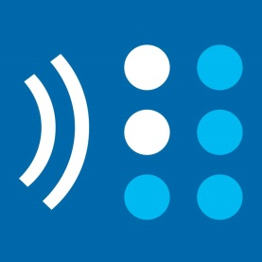

# Contact Us:

**Toll Free: 1-800-992-9012**

{

Email: btbl@michigan.gov

www.michigan.gov/btbl

Library Hours:

Open for Calls: M – F, 8am to 5pm

Lobby Open: M – F, 10am to 5pm

The library is closed on all recognized state holidays.

Braille and Talking Book Library, Bureau of Services for Blind Persons, Labor & Economic Opportunity, is an equal opportunity employer/program.

BSBP Braille and Talking Book Library





**BARD**

{

Braille and Audio Reading Download

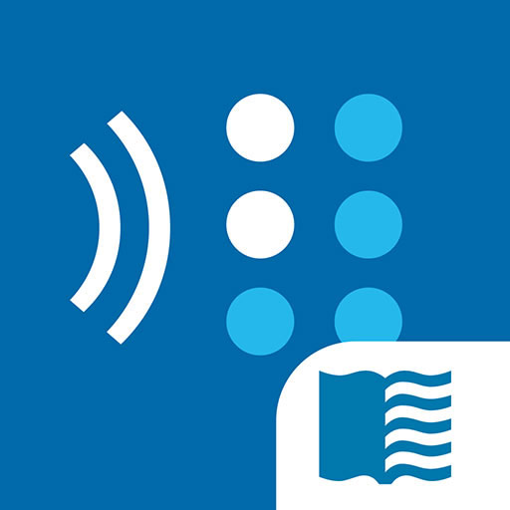

***Download the books you want, when you want them.***

# What is BARD?

The Braille and Audio Reading Download (BARD) is a free web-based service that provides access to thousands of audio books, braille books, magazines, and music scores.

Download books to a flash drive to use with the Digital Talking Book Player, or go mobile with the free BARD Mobile App for compatible devices such as iPads, iPhones and Android products.

BARD allows patrons to get books without waiting for mail delivery! The BARD website and mobile app are password-protected, and all files are in an electronically downloadable form of compressed audio or formatted braille.

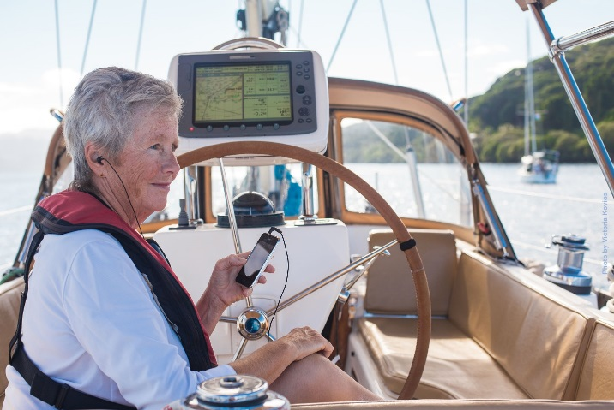

**Sign up for BARD at https://nlsbard.loc.gov**

# What is Available?

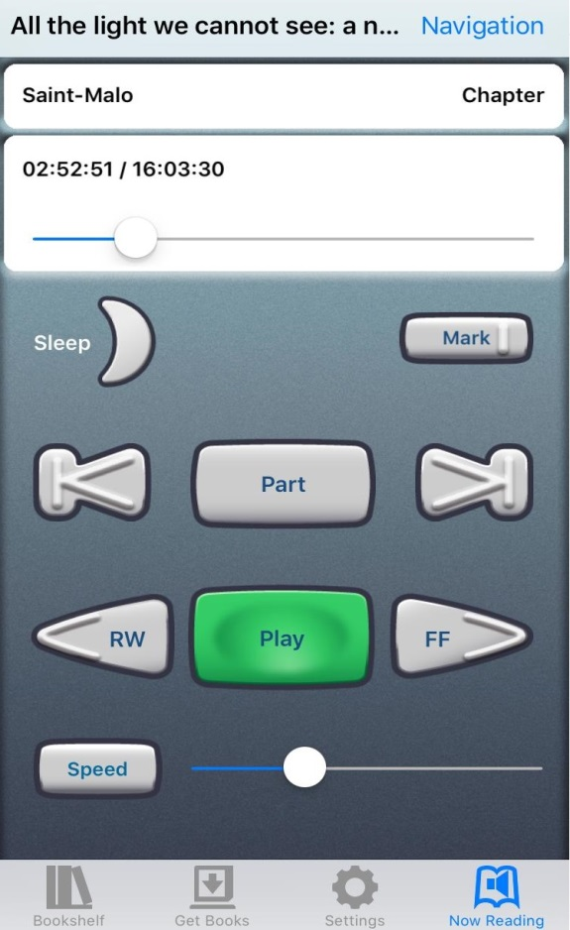Patrons may access most of the books and magazines in the NLS collection, which have been selected on the basis of their appeal across a wide range of interests. Thousands of audio and braille fiction and nonfiction titles are available, including some in languages other than English. Issues of more than 90 magazine titles are also available. NLS adds new titles regularly, including a growing number of locally produced materials and music scores.

# Eligibility

You are eligible for BARD if you are a registered patron of the Braille and Talking Book Library (BTBL). Call the library at 1-800-992-9012 to request an application for service.

**Already a BTBL patron?** Sign up for BARD immediately by visiting https://nlsbard.loc.gov.

# BARD Mobile

**“Being able to download titles and manage my reading list independently has made an outstanding service so much better. The BARD Mobile app for the iPhone has also been so wonderful, since it makes it so easy to take books with you anywhere. I truly cannot imagine my life without the NLS program.”**

— Peggy, NLS patron since 1962