Family Craft Activity
Aquarium with Angel fish
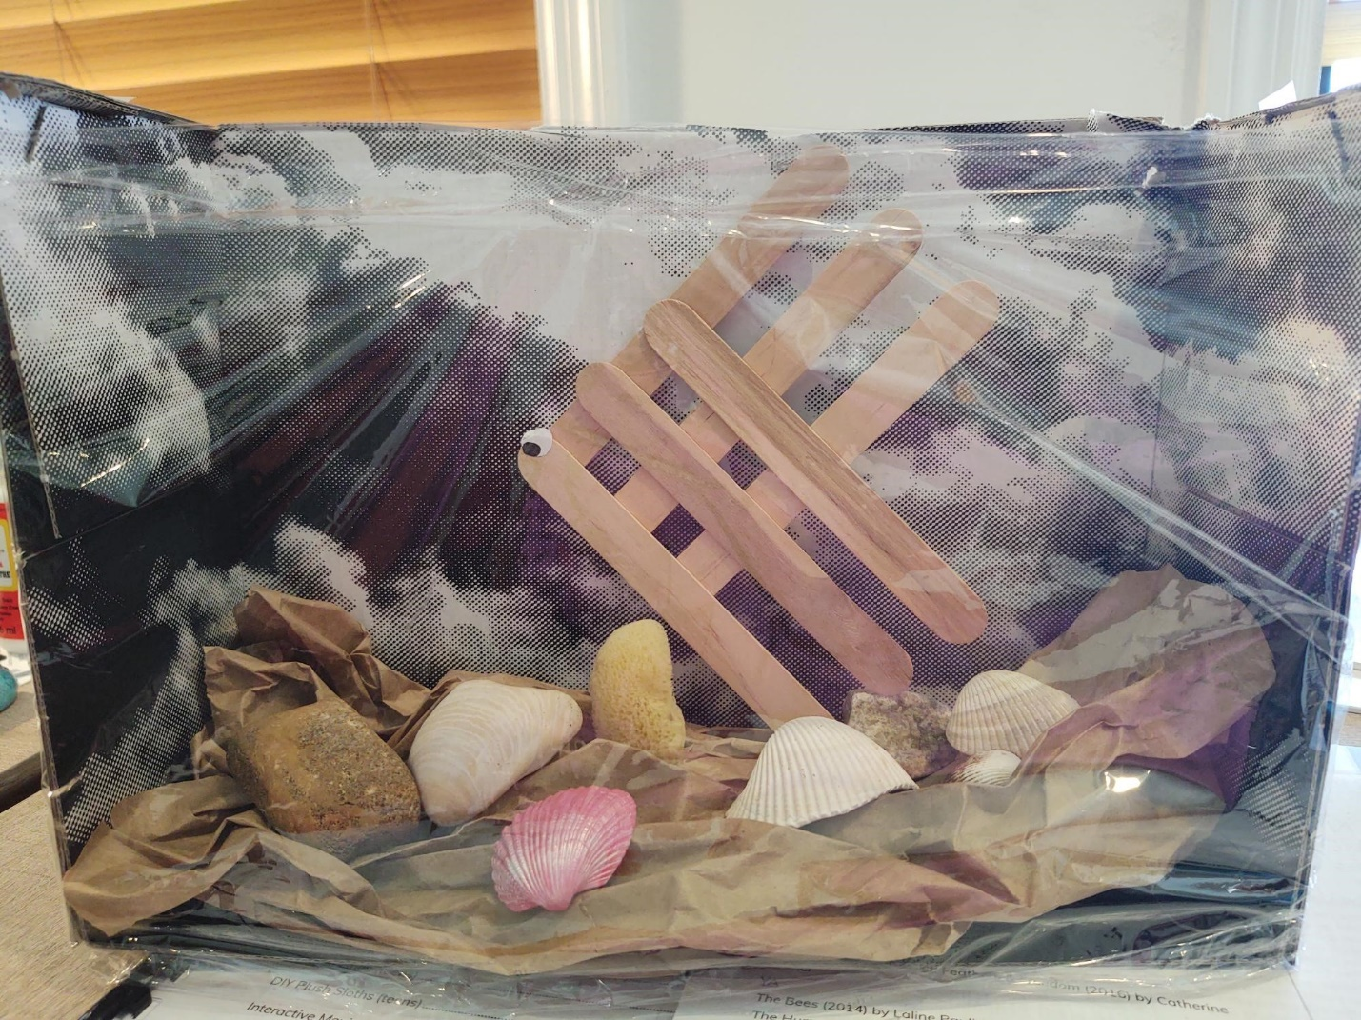

YOU WILL NEED:
- 1 shoebox
- Clear plastic wrap
- Brown lunch bag
- Craft (popsicle) sticks
- Googly eye, or small circle of white paper with black dot
- Seashells, rocks, old pieces of sponges, fuzzy pipe cleaners
- Glue
- Scissors
Angel fish:
- Place 3 popsicle sticks in a row with at least half an inch between them. Try to keep them straight and the spacing even.
- Place a drop of glue on each popsicle stick on one end. Line a popsicle stick up and place it down onto the glue. Your goal is to make a diamond grid pattern with the remaining popsicle sticks.
- Use a dot of glue to secure the eye.
- Allow to dry.
Aquarium:
You will use the bottom only of a regular shoebox.
Carefully cut one long side of the shoebox off. You will have 3 sides left, two short and one long. Face the box towards you, like a little stage.
Next, take the brown lunch bag and crinkle/roll/twist. You may need to cut some off the length. This will make your “sandy” bottom.
Third, use fuzzy pipe cleaners and cut, bend, shape at various lengths for seaweed and coral. Add rocks and shells to the bottom. Tear sponge in different sizes. Stand these up inside the paper bag crinkles.
Prop angel fish up against the back of the shoebox. Glue or tape if needed.
Tear off a piece of plastic wrap long enough to cover the front of the aquarium, and wrap around the sides. Tape in place. Done!
You now have your very own AQUARIUM!

